Supplementary material
Sup1

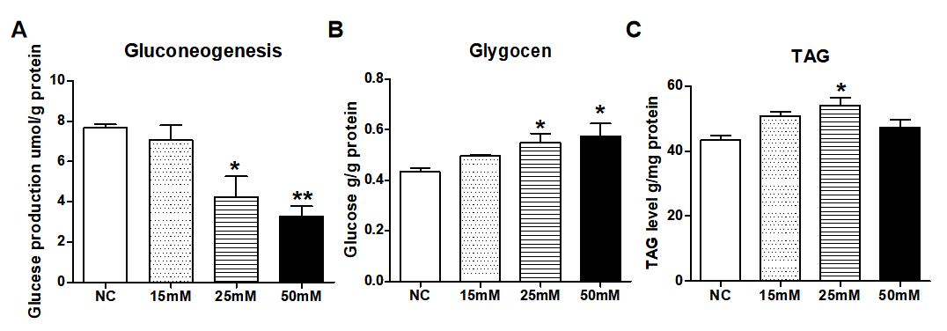
Supplementary Figure 1. L02 cell model of excessive MMA accumulation. A) Glucose production, B) Glycogen reserve, and C) TAG levels in L02 cells exposed to different concentrations of MMA (15, 25, 50 mM) for 12 h.

Sup2
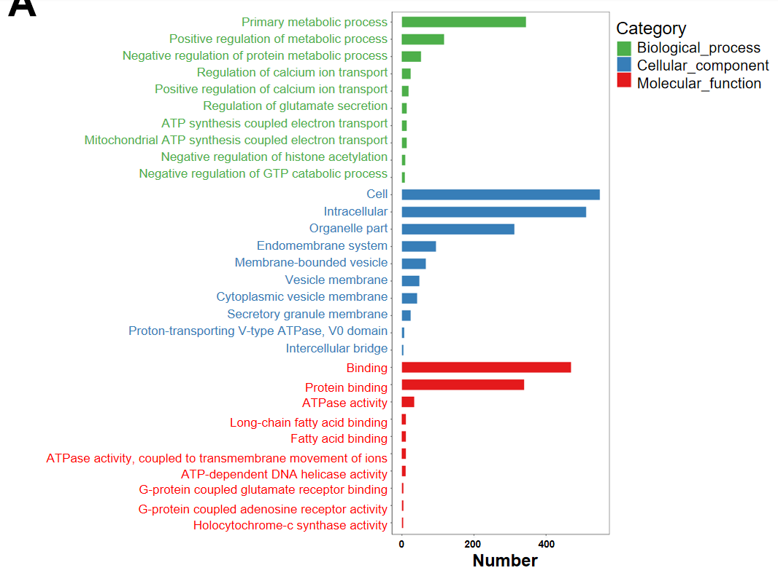
Supplementary Figure 2. Differentially expressed lncRNAs induced by MMA that are involved in the Ca²⁺ signaling pathway. GO analysis of differentially expressed lncRNAs induced by 25 mM MMA for 12 h.

Sup3

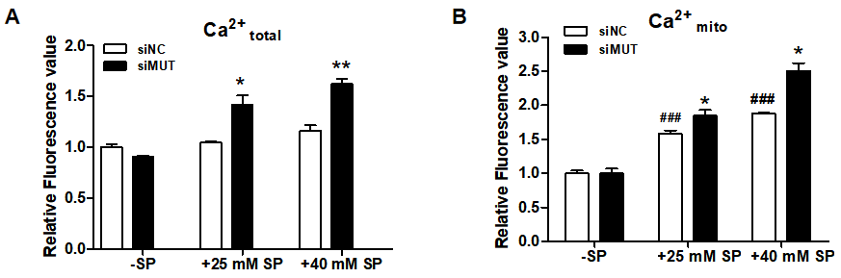
Supplementary Figure 3. The Ca²⁺ in mitochondria and ER are excessive in hepatocytes after exposure to MMA. A) Knockdown of MUT by siRNA for 24 h and the addition of 25 mM PA and 40 mM PA for 24 h to determine Ca²⁺_{total} levels in L02 cells. B) Knockdown of MUT by siRNA for 24 h followed by the addition of 25 mM PA and 40 mM PA for 24 h to determine Ca²⁺_{mito} levels in L02 cells.

Sup4

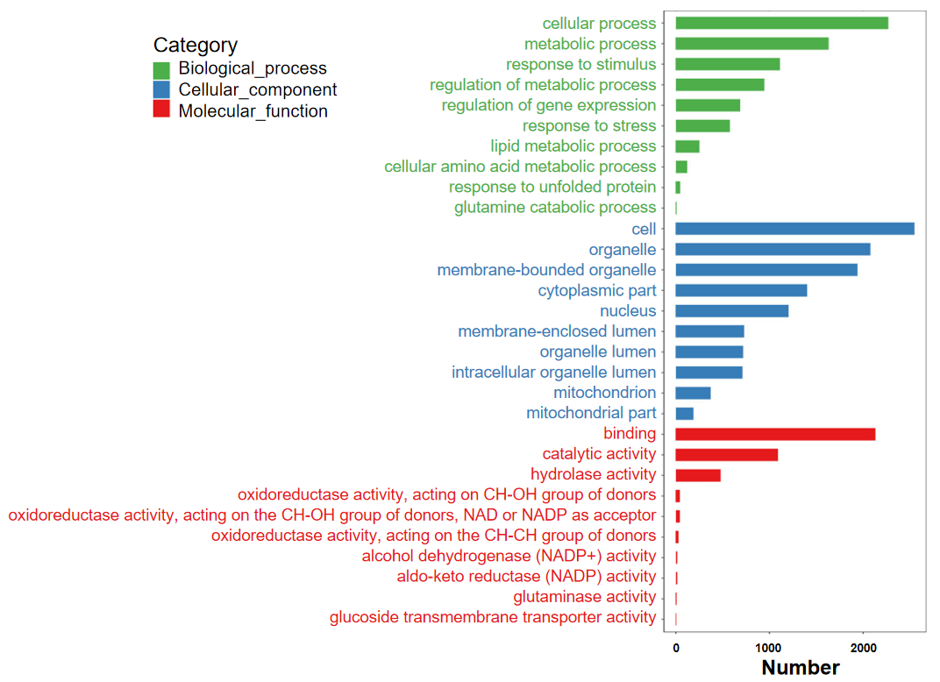
Supplementary Figure 4. Differentially expressed mRNA induced by MMA that are involved in mitophagy. GO analysis of DEmRs induced by 25 mM MMA for12 h.

Sup Table 1 Primer sequences for RT-PCR.

Gene |  | Primer Sequence
GAPDH | forward | GAAGGTGAAGGTCGGAGTCAAC
GAPDH | reverse | CAGAGTTAAAAGCAGCCCTGGT
RP11-783K16.5 | forward | TGCTACCAGGCTTGAACAG
RP11-783K16.5 | reverse | CAGGCACAGAGGAAGACAT
RP1-69D17.4 | forward | GCACATGTCTATTTGGGCCA
RP1-69D17.4 | reverse | GCTTTCCAGCACTCTCGTTT
RP11-9N20.3 | forward | AGAGTTACATTCTCCCTGCTG
RP11-9N20.3 | reverse | GAAGGTTCTGTTTGGTTAGG
ND1 | forward | ACACTAGCAGAGACCAACCG
ND1 | reverse | GAAGAATAGGGCGAAGGGGC
ACTB | forward | TCACCCACACTGTGCCCATCTACGA
ACTB | reverse | CAGCGGAACCGCTCATTGCCAATGG
SQSTM1 | forward | AAATGGGTCCACCAGGAAACTGGA
SQSTM1 | reverse | TCAACTTCAATGCCCAGAGGGCTA
BCL2 | forward | TAAGGCGGATTTGAATCTC
BCL2 | reverse | ATAATAGGGATGGGCTCAAC
NBR1 | forward | GTTGCTGCCTCTGCATACAA
NBR1 | reverse | TTTCTTCAGCAGCCGTAGGT
GABARAPL1 | forward | TCGGAAAAAGGAAGGAGAAA
GABARAPL1 | reverse | TGGCCAACAGTAAGGTCAGA
MBTPS2 | forward | TGGACTGTCGTCTACCTGACC
MBTPS2 | reverse | AGCAGTTTGCCATCTTATGTGG
SYVN | forward | CTTCACCGTTTTTCGGGATGA
SYVN | reverse | CCAGGAGGAACATAAGAGAGACA
CREB3L2 | forward | CAGAGAAGAGTGTGTCAATGGAG
CREB3L2 | reverse | CTGGTGGTAATGTGGGTGAAG
CCL2 | forward | CAGCCAGATGCAATCAATGCC
CCL2 | reverse | TGGAATCCTGAACCCACTTCT
YOD1 | forward | CAGCGAATCCTCGTCGGATAC
YOD1 | reverse | AAGCACAGGCAAAGTTTCCCT
TPP1 | forward | CCTCCACACGGTGCAAAAATG
TPP1 | reverse | CTCTGCTTGTCGGATGCTCAG
FAM134B | forward | CTTGACCGACCCAGTGAGG
FAM134B | reverse | CAGTGGGCAAACCAAGGCT
FAM134C | forward | TTTGCCCTGACATCTCTTCGT
FAM134C | reverse | CTCATTGTCTAATGCGTCGGG

