Identification of potential regional sources of ambient criteria air pollutants at a national controlled air quality observation site in Guiyang
Haiyan Sun², Yuan Yang^{3**}, Peng Xu^{1*}, Jinjuan Li¹, Minxia Cao², Yonghong Wang⁴, Li Sheng⁵, Fengming Zhang⁶
1.College of Resources and Environmental Engineering, Guizhou Karst Environmental Ecosystems Observation and Research Station, Ministry of Education, Key Laboratory of Karst Georesources and Environment, Ministry of Education, Guizhou University, Guiyang 550025, China
2. Guizhou Purelue Technology Co., Ltd., Guizhou, 550000, China
3. Guizhou Research and Designing Institute of Environmental Sciences: Guizhou Academy of Environmental Science and Design, Guiyang, 550081, China
4. Guizhou Eco-Environmental Monitoring Center
5. CMA Earth System Modelling and Prediction Centre (CEMC) & State Key Laboratory of Severe Weather of CMA, Beijing, 100081 China
6. Anshun Eco-Environmental Monitoring Center
Submitted to:
*Corresponding author: Peng Xu (xupeng@gzu.edu.cn)
**Corresponding author: Yuan Yang (gzhky_yy@163.com)
This supplementary document consists of 10 Figures.

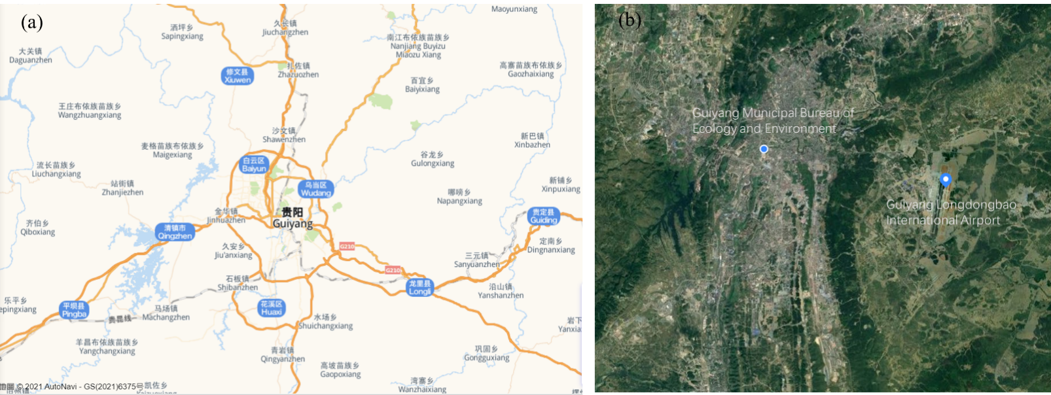
Figure S1. (a) The location of Guiyang and its surrounding environment, the base map was extracted from amap (https://lbs.amap.com/demo/javascript-api/example/map/map-english/) by the authors; (b) The location of Guiyang Municipal Ecology and Environment Bureau and Guiyang Longdongbao International Airport, and base map was extracted from fengyunditu (http://www.fengyunditu.com/?ver=so-wx-1552) by the authors.

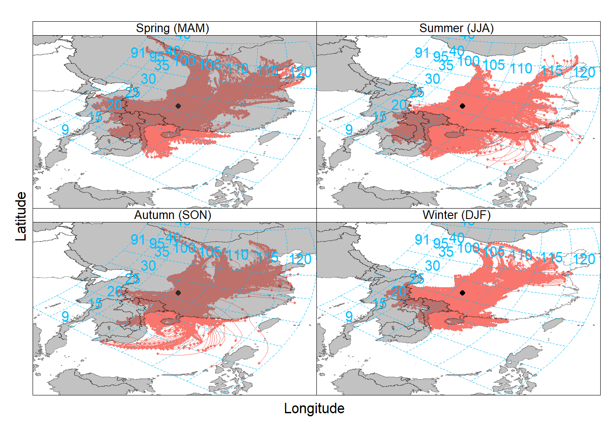
Figure S2. The seasonality of 48-hour HYSPLIT back trajectories at the altitude of 500 m centred on sampling site in Guiyang from 1 January 2016 to 31 December 2020. The black dot represents the sampling site.
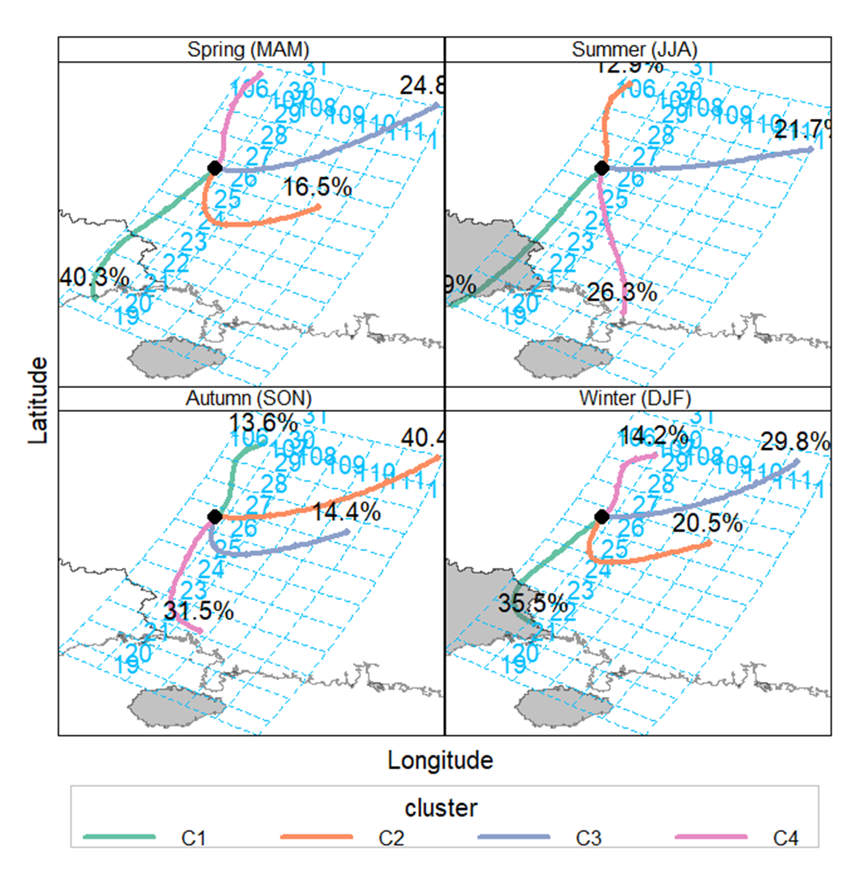
Figure S3. The seasonality of average trajectories obtained after clustering analysis and the percentage of clusters (%) from different directions during the sampling period from 1 January 2016 to 31 December 2020.
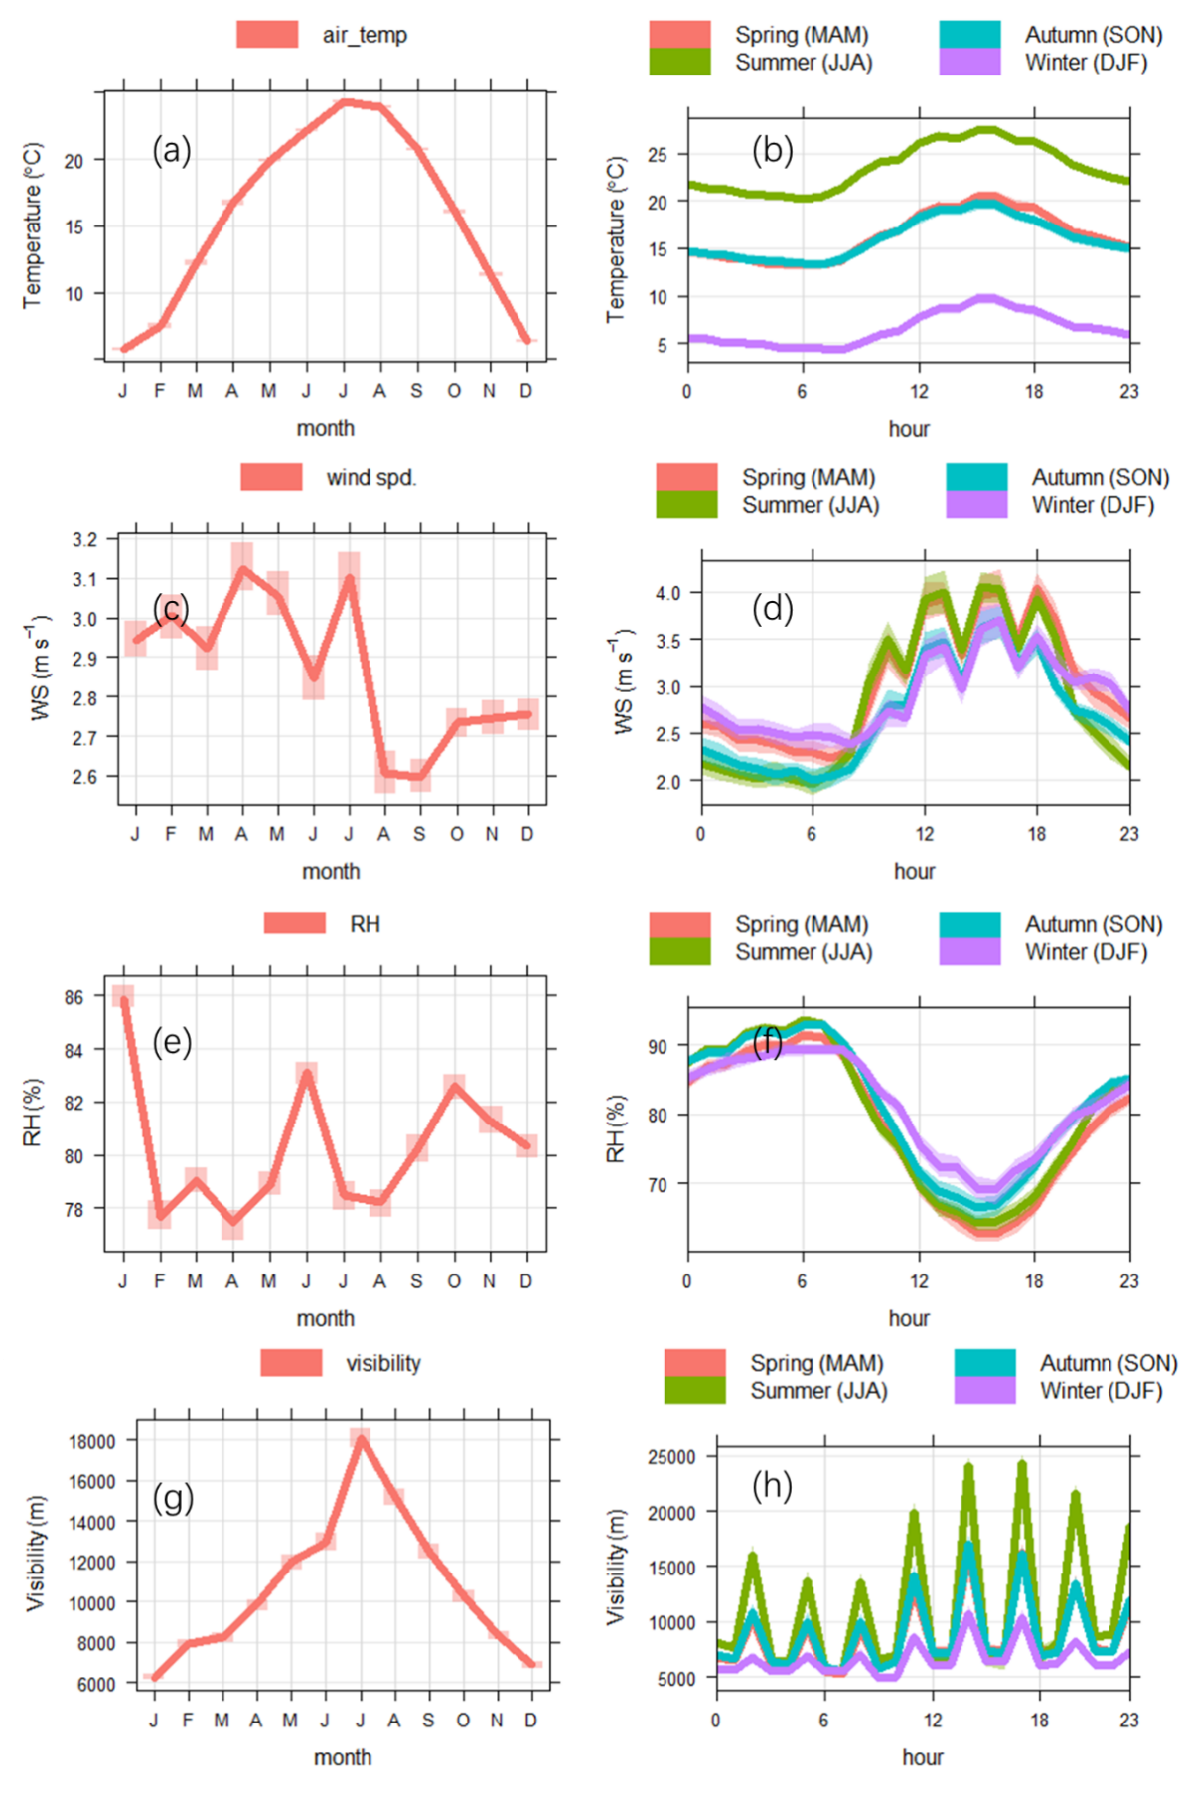
Figure S4. Monthly and diurnal statistics of ambient temperature, wind speed, relative humidity, visibility and pressure from 1 January 2016 to 31 December 2020. The solid lines correspond to the means, and the shaded areas indicate 95% confidence intervals.
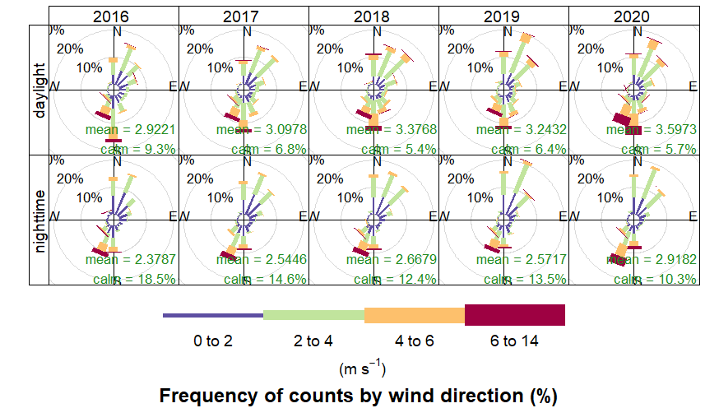
Figure S5. Wind rose plots split by year and daylight based on frequencies of hourly data in Guiyang from 1 January 2016 to 31 December 2020. Wind speeds are split into the intervals shown by the scale in each panel. The grey circles show the % frequencies.
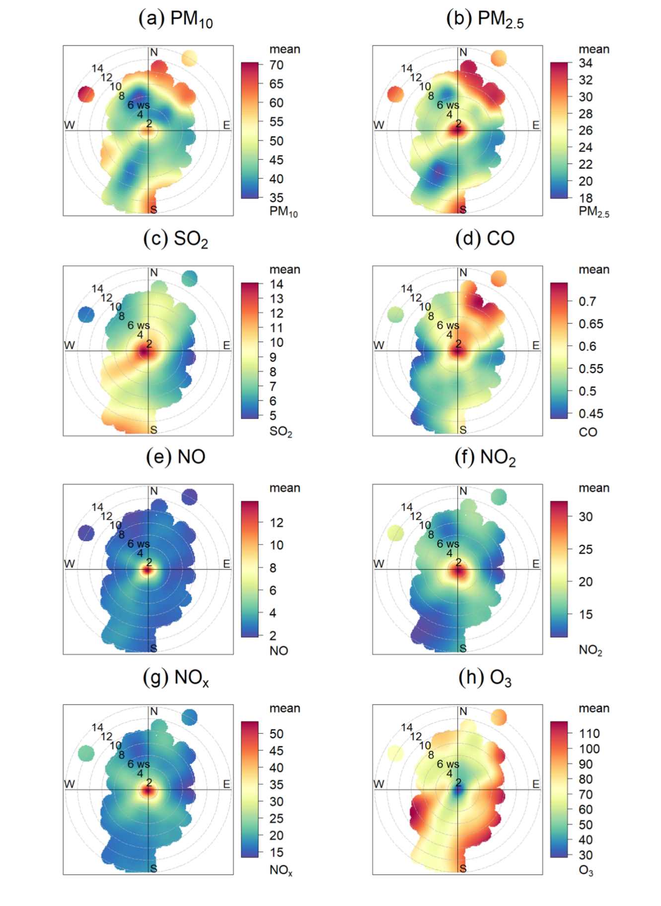
Figure S6. Bivariate polar plots for PM₁₀ (a), PM_{2.5} (b), SO₂ (c), CO (d), NO (e), NO₂ (f), NO_{x} (g) and O₃ (h) concentrations based on hourly average data in Guiyang from 1 January 2016 to 31 December 2020. The color scale shows the concentrations of pollutants in μg m⁻³ (or mg m⁻³ specially for CO), and the radial scale shows the wind speed (m s⁻¹), which increases from the center of the plot radially outwards.
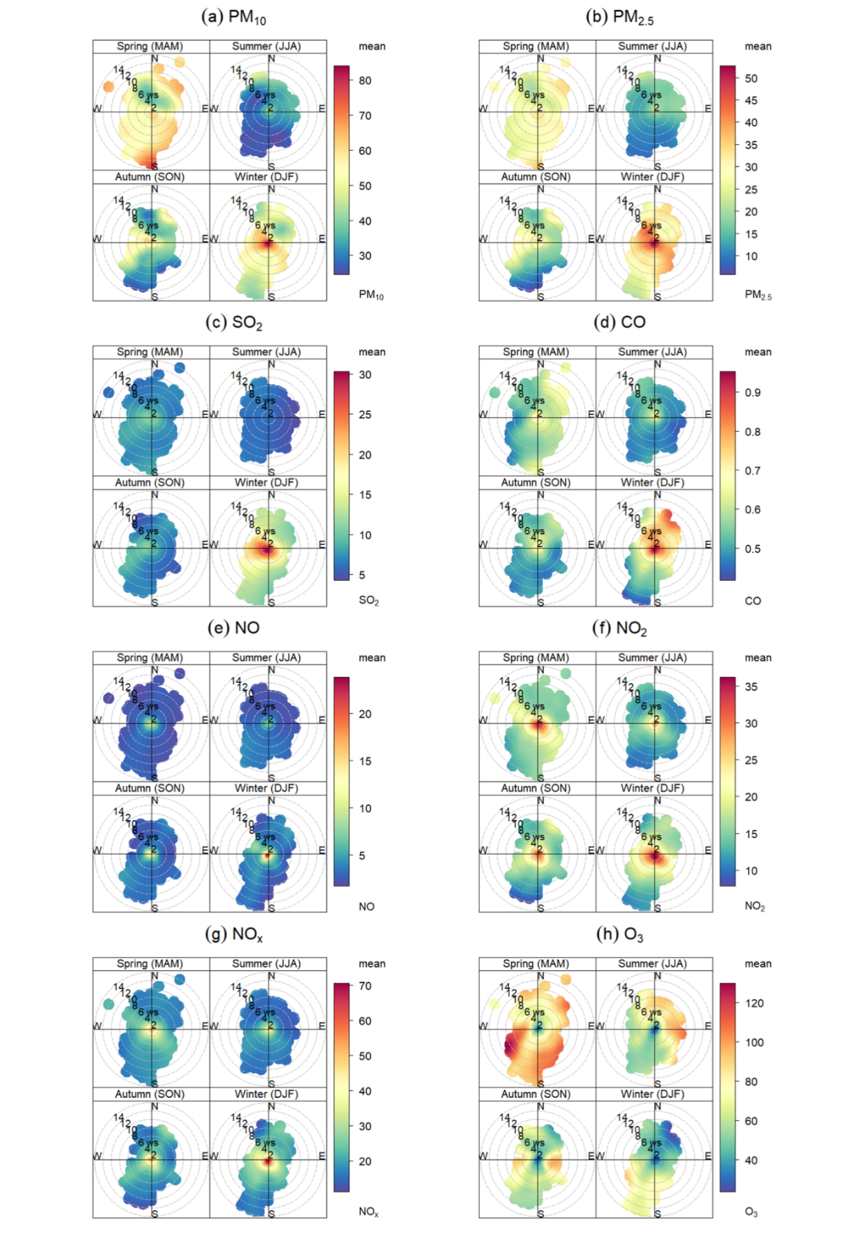
Figure S7. Seasonal bivariate polar plots for PM₁₀ (a), PM_{2.5} (b), SO₂ (c), CO (d), NO (e), NO₂ (f), NO_{x} (g) and O₃ (h) concentrations based on hourly average data in Guiyang from 1 January 2016 to 31 December 2020. The color scale shows the concentrations of pollutants in μg m⁻³ (or mg m⁻³ specially for CO), and the radial scale shows the wind speed (m s⁻¹), which increases from the center of the plot radially outwards.
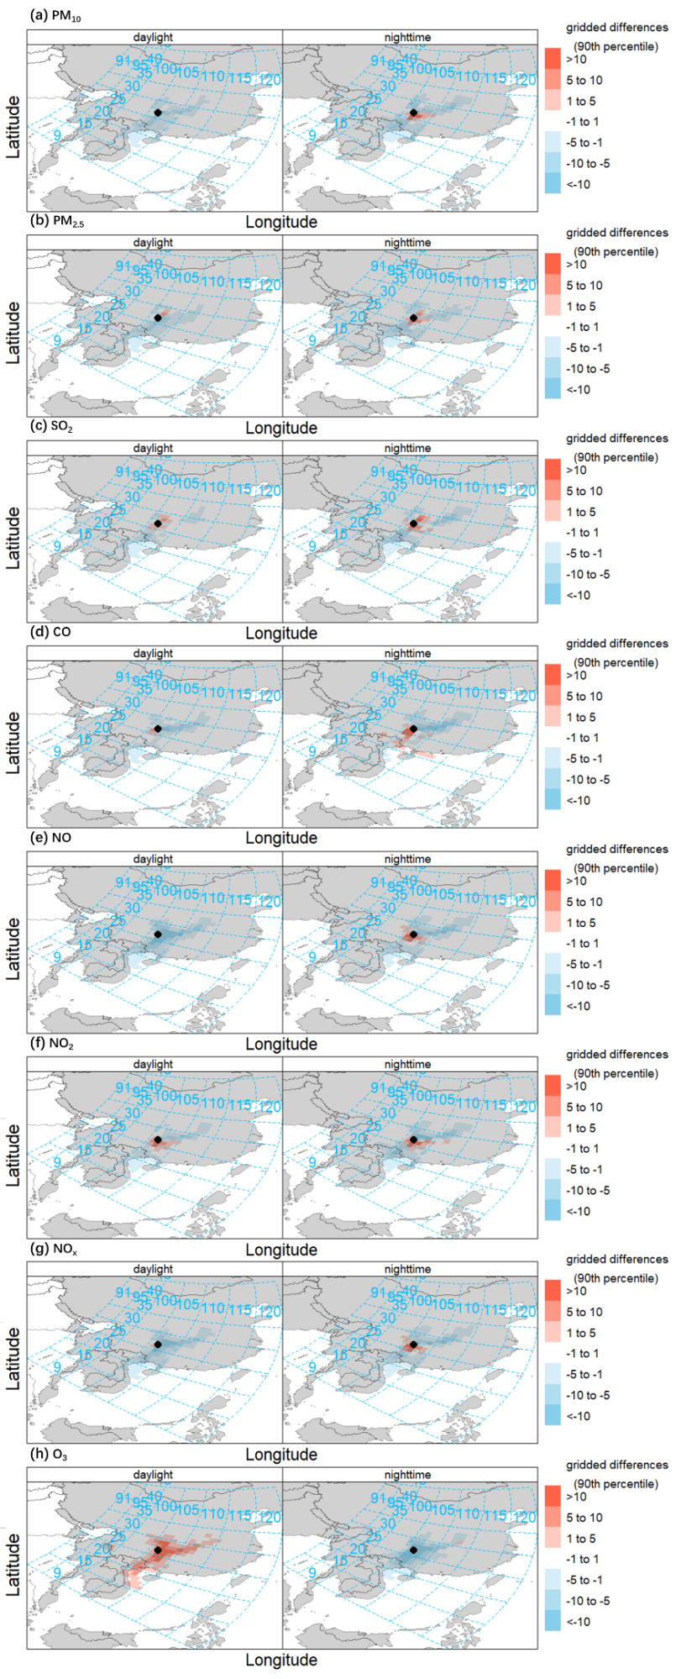
Figure S8. The daylight and nighttime differences of gridded back trajectory frequencies showing the percentage difference in occurrence for high PM₁₀, PM_{2.5}, SO₂, CO, NO, NO₂, NO_{x} and O₃ concentrations (90th percentile) compared with conditions over the full season. The black dot represents the sampling site.
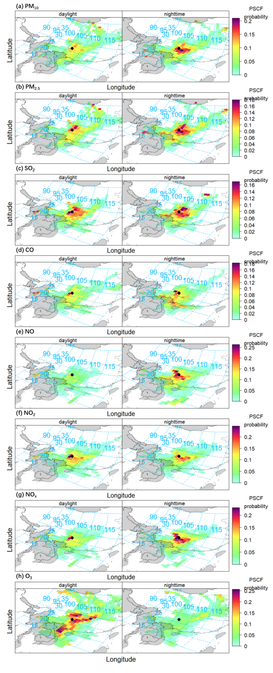
Figure S9. The daylight and nighttime differences of PSCF probabilities for PM₁₀, PM_{2.5}, SO₂, CO, NO, NO₂, NO_{x} and O₃ concentrations (90th percentile). The black dot represents the sampling site.
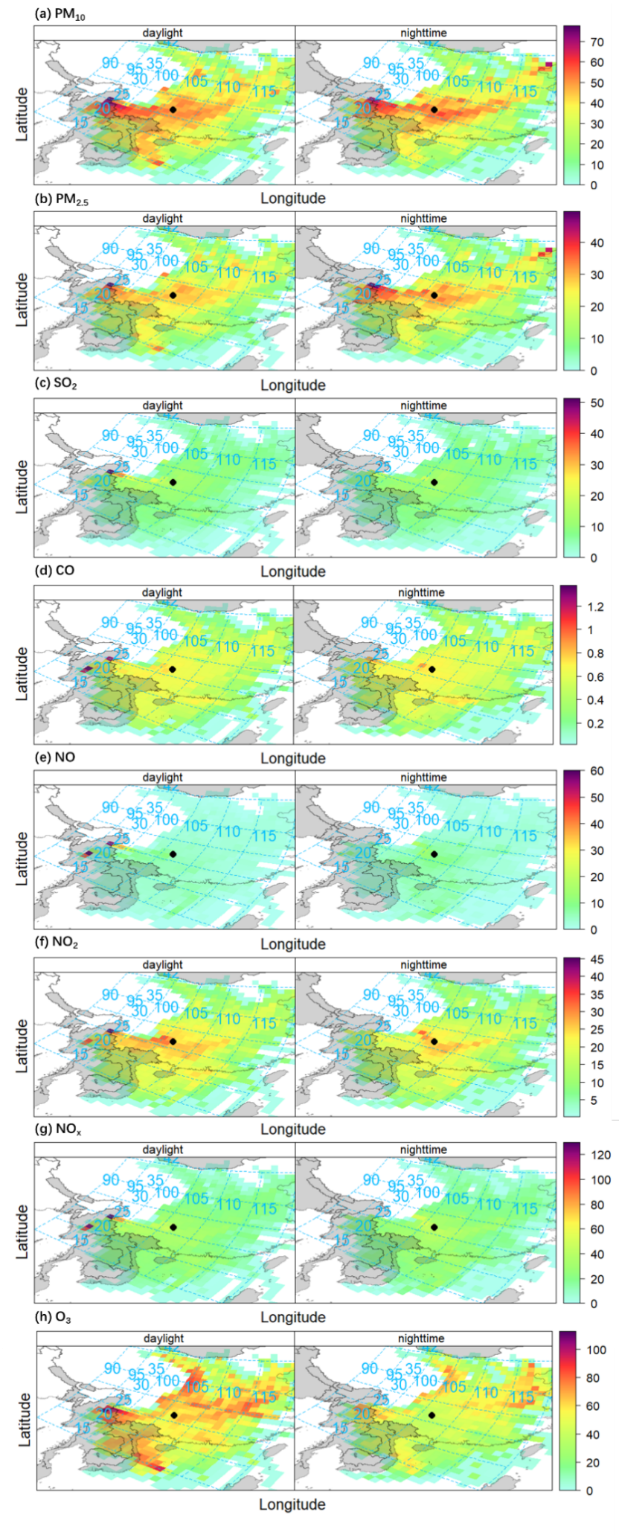
Figure S10. The daylight and nighttime differences of gridded back trajectory concentrations showing mean PM₁₀, PM_{2.5}, SO₂, CO, NO, NO₂, NO_{x} and O₃ concentrations using the CWT approach. The black dot represents the sampling site.

