Supplementary material

Table S1: Results of zero-infated binomial Generalised Linear Model (GLM) for the proportion of partial larvae eaten. The table shows the estimated coefficients (Estimate), standard errors (SE), and significance levels (P-value) for the predictor variables. Intercept refers to the group clawless.
Predictors | Estimate | SE | P-value
Intercept | -4.492 | 0.793 | <0.001
One claw | 0.173 | 1.019 | 0.64
Both claws | 0.514 | 0.971 | 0.10
Prey density | 0.064 | 0.030 | 0.036
One claw: Prey density | -0.014 | 0.040 | 0.727
Both claw: Prey density | -0.022 | 0.039 | 0.600
Deviance = 318.2
AIC = 332.2

Zero-inflated model:
 | Estimate | SE | P-value
Intercept | 0.775 | 0.441 | 0.055

Anova:

Variable | Sum s1 | Df | P value
Group | 0.242 | 2 | 0.884
Prey density | 11.741 | 1 | <0.001
Group:prey density | 0.275 | 2 | 0.871

Table S2: Interaction strength (IS) results of the linear model. To this prey density, crayfish group and their interaction were added as predictors.
Predictor | Estimate | Standard error | P-value
Intercept | 0.761 | 0.101 | <0.001
Clawless + one claw | 0.022 | 0.152 | 0.751
Clawless + both claws | 0.022 | 0.152 | 0.861
One claw + one claw | 0.253 | 0.152 | 0.091
One claw + both claws | 0.081 | 0.152 | 0.571
Both claws + both claws | -0.091 | 0.152 | 0.542
Prey density | -0.011 | 0.004 | 0.003
Clawless + one claw: prey density | -0.0009 | 0.005 | 0.863
Clawless + both claws: prey density | 0.0009 | 0.005 | 0.864
One claw + one claw: prey density | -0.007 | 0.005 | 0.196
One claw + both claws: prey density | -0.004 | 0.005 | 0.467
Both claws + both claws: prey density | 0.003 | 0.005 | 0.531

Anova output

Variable | Sum s1 | Df | P value
Group | 0.221 | 5 | 0.561
Prey density | 3.682 | 1 | <0.001
Group:prey density | 0.263 | 5 | 0.464

Table S3: No trophic interaction strength (ISNT) results of the linear model. To this prey density, crayfish group and their interaction were added as predictors.
Predictor | Estimate | Standard error | P-value
Intercept | -0.254 | 0.043 | <0.001
Clawless + one claw | -0.066 | 0.096 | 0.490
Clawless + both claws | -0.022 | 0.096 | 0.816
One claw + one claw | -0.035 | 0.096 | 0.717
One claw + both claws | 0.224 | 0.096 | 0.021
Both claws + both claws | 0.042 | 0.096 | 0.658
Prey density | 0.005 | 0.001 | <0.001
Clawless + one claw: prey density | 0.002 | 0.003 | 0.551
Clawless + both claws: prey density | 0.001 | 0.003 | 0.907
One claw + one claw: prey density | 0.002 | 0.003 | 0.462
One claw + both claws: prey density | -0.007 | 0.003 | 0.061
Both claws + both claws: prey density | -0.003 | 0.003 | 0.378
R² = 0.04

Anova output

Variable | Sum s1 | Df | P value
Group | 0.232 | 5 | 0.548
Prey density | 0.679 | 1 | 0.0007
Group:prey density | 0.334 | 5 | 0.332

Sensitivity analyses
Experiment 1
The natural mortality of prey was 2.08 % and thus, it was not needed to correct for background prey mortality. As in the main body of the manuscript, all three functional responses among marbled crayfish were classified as hyperbolic type-II, owing to a significantly negative first-order term for each claw treatment group (Table S1). In addition, there were no statistical differences among functional responses of the three claw groups of crayfish (Figure S1). Likewise, attack rates and handling times did not differ significantly among groups (Figure S2). Crayfish maximum feeding rates ranged from 7.81 to 8.33 prey per hour, while the FRR ranged from 20.85 to 25.23 (Table S4).

Table S4: First-order terms and P-values from logistic regression of prey killed as a function of prey density for each tested group and functional response parameters from the Rogers’ random predator equation per hour. The parameters a and h refers to attack rate and handling time, respectively. 1/hT refers to maximum feeding rate and FRR refers to functional response ratio (a/h).
Group | Estimate | Standard error | P-value | a (P-value) | h (P-value) | 1/hT | FRR
Both claws | -0.063 | 0.006 | <0.001 | 2.789 | 0.121 (<0.001) | 8.264 | 23.049
One claw | -0.063 | 0.006 | <0.001 | 2.502 | 0.120 (<0.001) | 8.333 | 20.853
Clawless | -0.083 | 0.006 | <0.001 | 3.230 | 0.128 (<0.001) | 7.812 | 25.234

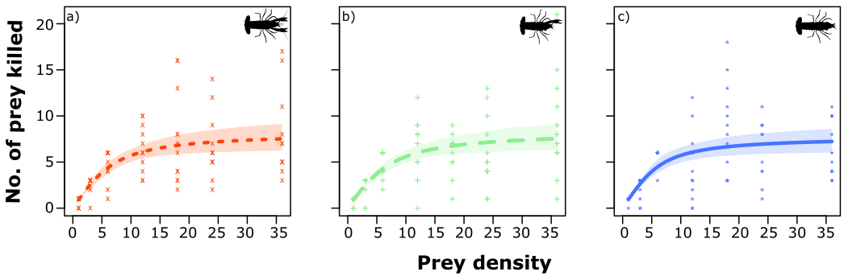
Figure S1: Functional responses from the Rogers’ random predator equation with 95 % non-parametric bootstrapped (n = 999) confidence intervals for each tested group of crayfish: a) Both claws, b) One claw, c) Clawless. Points represent raw data.

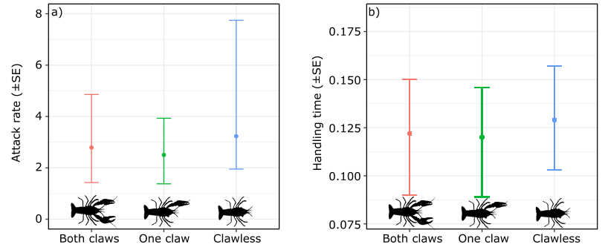
Figure S2: Non-parametric bootstrapped parameters (n = 999) for attack rate a) and handling time b) estimates from Rogers’ random predator equation with 95 % confidence intervals considering each tested group of crayfish. Points represent the initial estimate from the random predator equation.

Experiment 2

The natural mortality of prey was 1.05 % and thus, it was not needed to correct for background prey mortality. The interaction strength showed a context dependency according to the prey density available and did not differ with the claw groups (Table S5). The non-trophic interaction strengths were generally negative, suggesting that most of the interactions between crayfish groups were predominantly antagonistic (Figure S3). Non-trophic interactions did not significantly differ among crayfish combinations, but were significantly affected by prey density (P = 0.001), but not significant affect by the interaction of both crayfish group and prey density (P = 0.493) (Table S6).

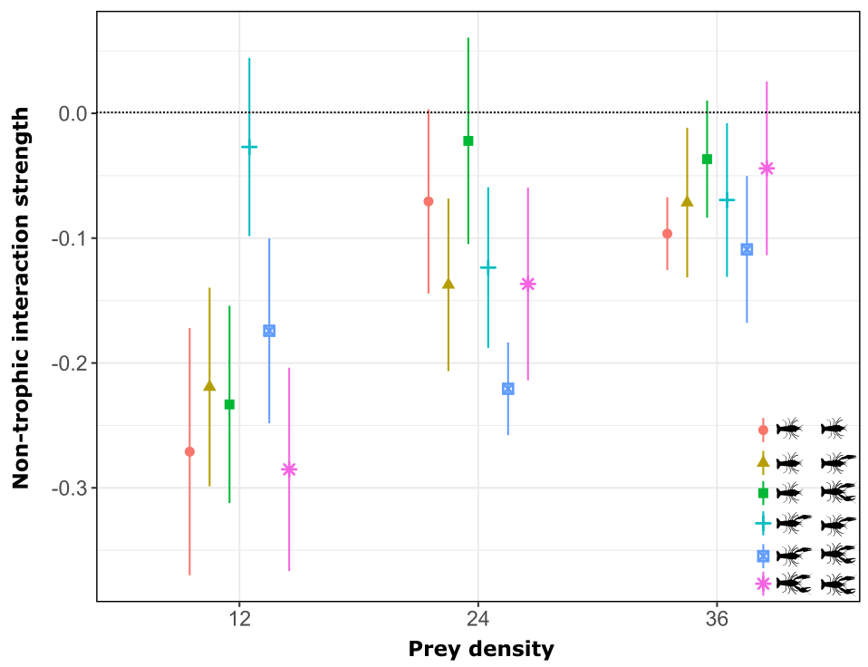

Figure S3: Non-trophic interaction strengths across each tested group of crayfish (i.e., both claws, one claw, and clawless) and across prey densities. The error bars refer to the standard error (SE). The dotted line indicates expected values in the absence of non-trophic effects. Each color and shape refer to each treatment evaluated in this study.

Table S5: Interaction strength (IS) results of the linear model. To this prey density, crayfish group and their interaction were added as predictors.
Predictor | Estimate | Standard error | P-value
Intercept | 0.762 | 0.101 | <0.001
Clawless + one claw | 0.013 | 0.152 | 0.932
Clawless + both claws | 0.024 | 0.152 | 0.891
One claw + one claw | 0.251 | 0.152 | 0.092
One claw + both claws | 0.061 | 0.152 | 0.671
Both claws + both claws | -0.082 | 0.152 | 0.542
Prey density | -0.011 | 0.004 | 0.002
Clawless + one claw: prey density | -0.0002 | 0.005 | 0.962
Clawless + both claws: prey density | 0.001 | 0.005 | 0.813
One claw + one claw: prey density | -0.007 | 0.005 | 0.204
One claw + both claws: prey density | -0.003 | 0.005 | 0.574
Both claws + both claws: prey density | 0.003 | 0.005 | 0.52

Anova output

Variable | Sum sq | Df | P value
Group | 0.240 | 5 | 0.513
Prey density | 0.611 | 1 | 0.001
Group:prey density | 0.312 | 5 | 0.363

Table S6: No trophic interaction strength (ISNT) results of the linear model. To this prey density, crayfish group and their interaction were added as predictors.
Predictor | Estimate | Standard error | P-value
Intercept | -0.320 | 0.101 | 0.002
Clawless + one claw | 0.032 | 0.151 | 0.843
Clawless + both claws | 0.021 | 0.151 | 0.853
One claw + one claw | 0.281 | 0.151 | 0.061
One claw + both claws | 0.082 | 0.151 | 0.552
Both claws + both claws | -0.072 | 0.151 | 0.614
Prey density | 0.007 | 0.004 | 0.071
Clawless + one claw: prey density | -0.001 | 0.005 | 0.841
Clawless + both claws: prey density | 0.0009 | 0.005 | 0.871
One claw + one claw: prey density | -0.009 | 0.005 | 0.114
One claw + both claws: prey density | -0.004 | 0.005 | 0.432
Both claws + both claws: prey density | 0.002 | 0.005 | 0.632

Anova output

Variable | Sum sq | Df | P value
Group | 0.239 | 5 | 0.533
Prey density | 3.843 | 1 | <0.001
Group:prey density | 0.255 | 5 | 0.493

