Supplementary Figure 1. Distribution of Add Health Resilience Instrument Scores

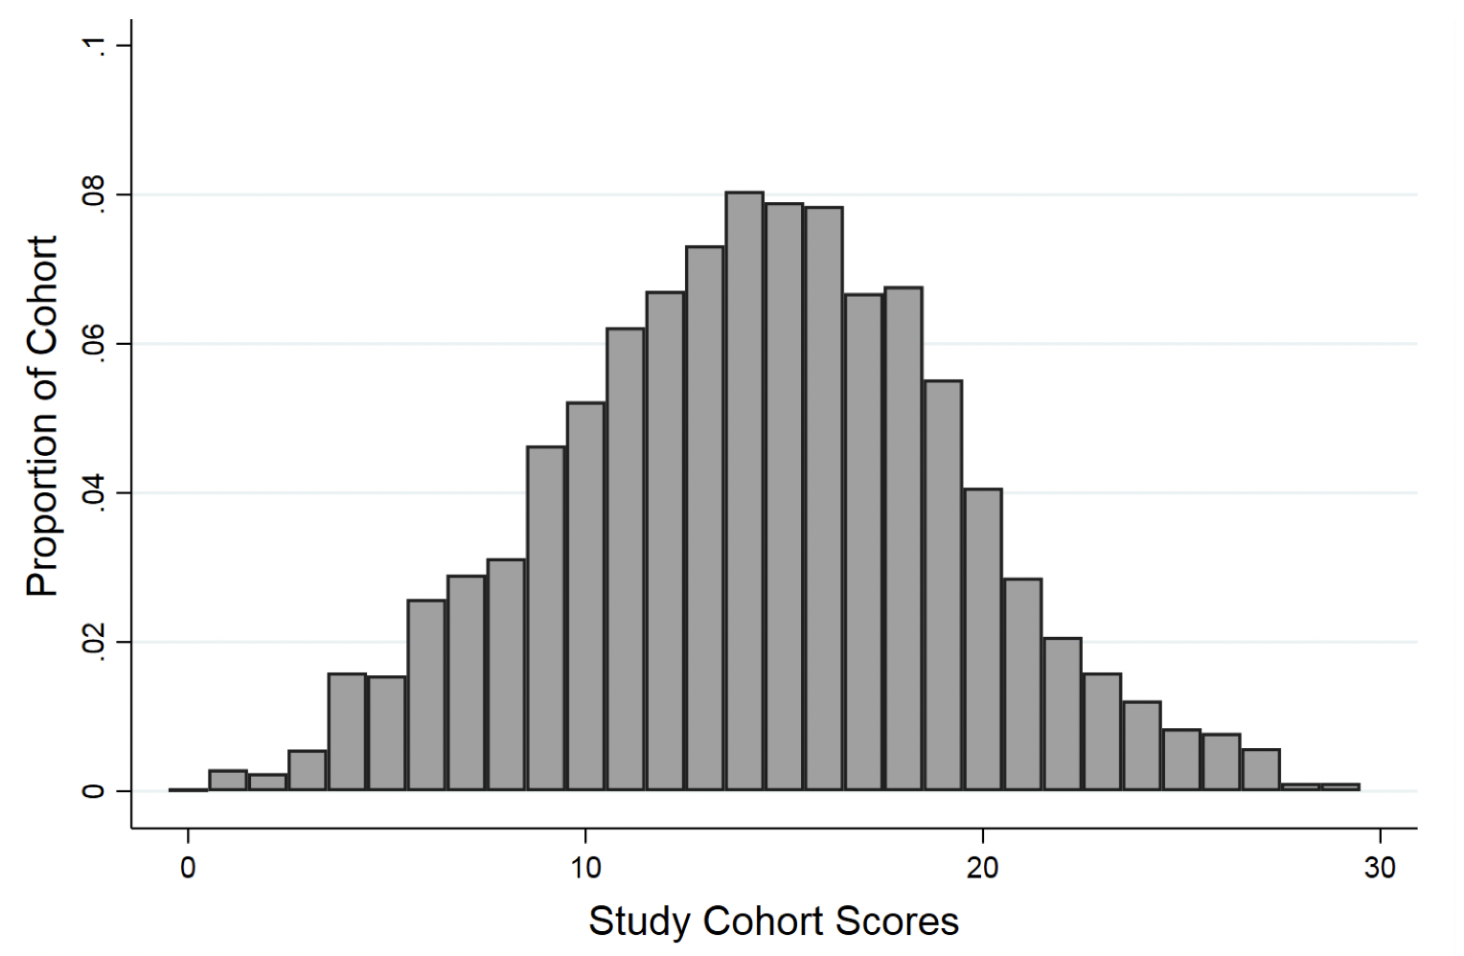

Supplementary Figure 2. Evidence of the AHRI’s Construct Validity using CESD-10 Scores

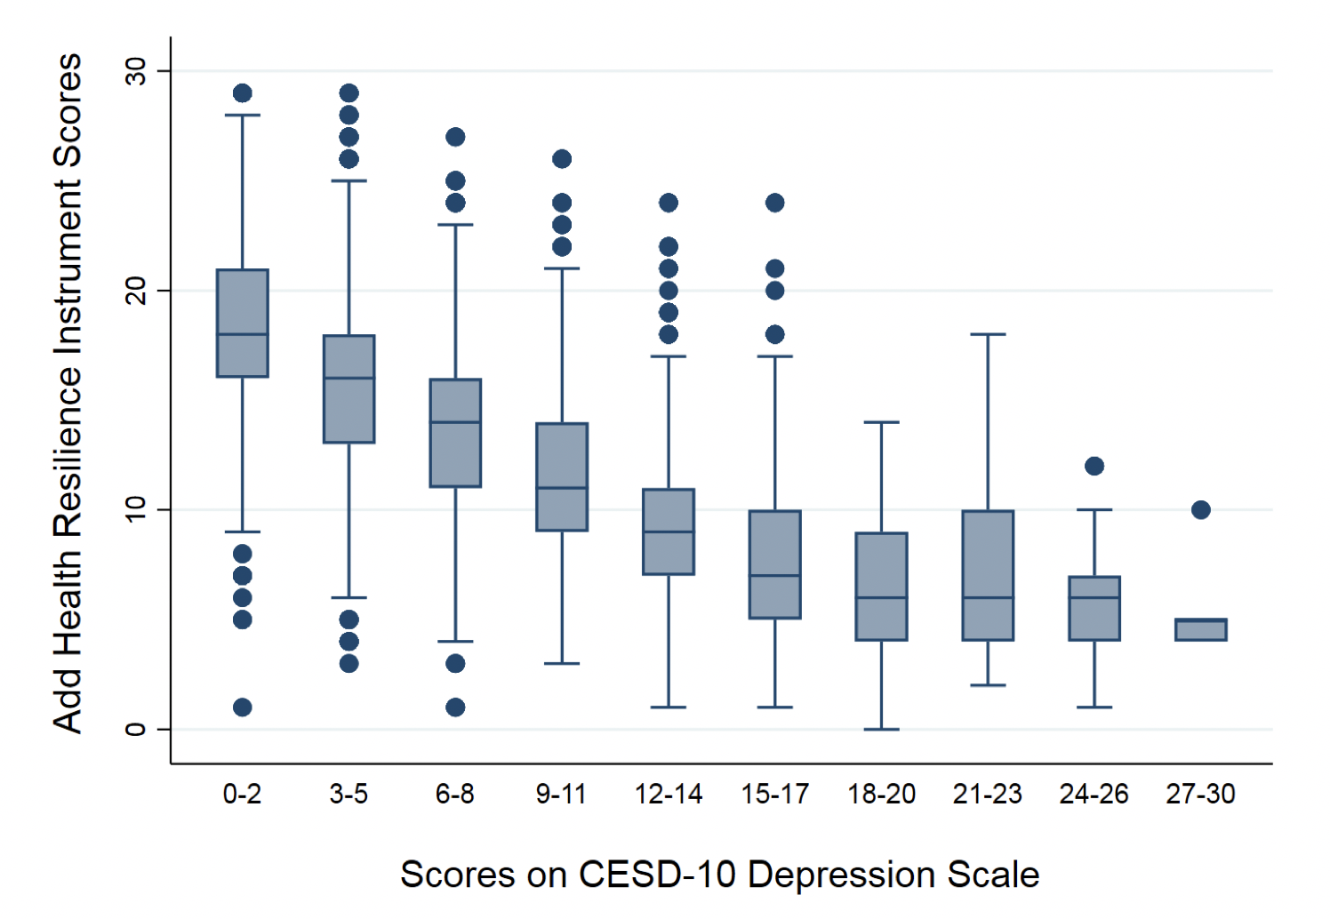

Supplementary Table 1. Full Pattern Matrix for Add Health Resilience Instrument
Item Number | Item | Factor 1 | Factor 2 | Factor 3
1 | There are many things that interfere with what I want to do. | 0.3590 | 0.0192 | 0.2706
2 | There is little I can do to change the important things in my life. | 0.6578 | 0.0371 | -0.0548
3 | Other people determine most of what I can and cannot do. | 0.6935 | -0.0090 | -0.0065
4 | There is really no way I can solve the problems I have. | 0.6819 | 0.0003 | 0.0251
5 | I go out of my way to avoid having to deal with problems in my life. | 0.3540 | 0.0475 | 0.0938
6 | In the last 30 days, I have often felt that difficulties were piling up so high that I could not overcome them. | 0.0582 | 0.0385 | 0.5904
7 | I often feel isolated from others. | -0.0125 | 0.0013 | 0.5413
8 | In the last 30 days, I have often felt unable to control the important things in my life. | -0.0371 | -0.0267 | 0.7453
9 | In the last 30 days, I have often felt confident in my ability to handle my personal problems. | 0.0841 | 0.1368 | 0.4289
10 | I am not easily bothered by things. | -0.1028 | 0.3250 | 0.1646
11 | Overall, I expect more good things to happen to me than bad. | 0.0369 | 0.5388 | -0.0247
12 | I'm always optimistic about my future. | -0.0221 | 0.4896 | -0.0084
13 | I hardly ever expect things to go my way. | 0.1512 | 0.3425 | 0.0686

Supplementary Table 2. Correlation Matrix Between Factors
Factors | Factor 1 | Factor 2 | Factor 3
Factor 1 | 1 | - | -
Factor 2 | .7105 | 1 | -
Factor 3 | .3414 | .4923 | 1

