Promoting electrocatalytic methanol oxidation through Mn-generated oxygen vacancies on NiMn LDH/N-enriched carbon matrix

Tao Wang,* Shiru Cheng, Zhen Wang, Juhong Zhou, Hui Zhao, Kefa Sheng, and Binbin Jiang*
Anhui Provincial Key Laboratory of Functional Coordination Compounds and Nanomaterials, School of Chemistry and Chemical Engineering, Anqing Normal University, Anqing, 246001, P. R. China

* wangtao@aqnu.edu.cn; jiangbb@ aqnu.edu.cn

Materials
The NiCl₂·6H₂O, urea MnCl₂·4H₂O and Methanol were supported by Sinopharm Chemical Reagent Co., Ltd. The oxide graphene was purchased from Nanjing XFNANO Materials Tech Co. Ltd. The Nafion (5 wt %) was obtained from Sigma-Aldrich Co. Other reagents were analytical reagent grade without further purification. The distilled water was used throughout the experiments (Resistivity > 18.2 MΩ·cm).
Materials characterizations
The structure of the composite was characterized by XRD (Philips X'pert PRO MPD diffractometer) with Cu Kα radiation (λ = 0.15406 nm). SEM was carried out by Zeiss Supra 55. TEM, HRTEM, HAADF-STEM and elemental mapping by EDS were characterized using a FEI Tecnai F20 transmission electron microscope with the accelerating voltage of 200 kV. The chemical states of catalysts were analyzed by XPS through Kratos AXIS UltraDLD ultrahigh vacuum surface analysis system with Al Kα radiation (1486 eV) as a probe.
The synthesis of N-enrich carbon matrix
The graphite carbon nitride and graphene oxide were dispersed in 10 mL and 50 mL double distilled water, respectively. Then the two dispersions were mixed by continuous stirring and the pH was adjusted to 10 with 30% ammonia solution. After the hydrazine hydrate (680 μl, 50 wt%) was added, the mixed solution was transferred into a Teflon-lined autoclave and heated at 80 °C for 3h. The obtained N-enrich carbon matrix was denoted as NCM.

Fig. S1 The TEM image of Ni(OH)₂/NCM

Fig. S2 The high resolution of Ni XPS spectrum of Ov-NiMn LDH/NCM.

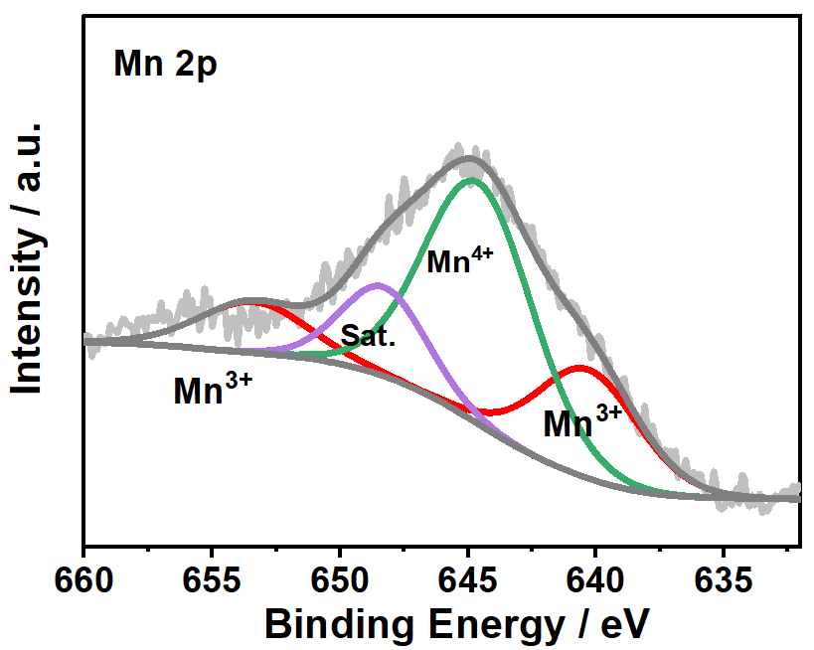

Fig. S3. The high resolution of Mn XPS spectrum of Ov-NiMn LDH/NCM.

Fig. S4 (A) CV curves of Ni(OH)₂/NCM in 0.1 M KOH with different scan rate; (B) the relationship between the current density and scan rates.

