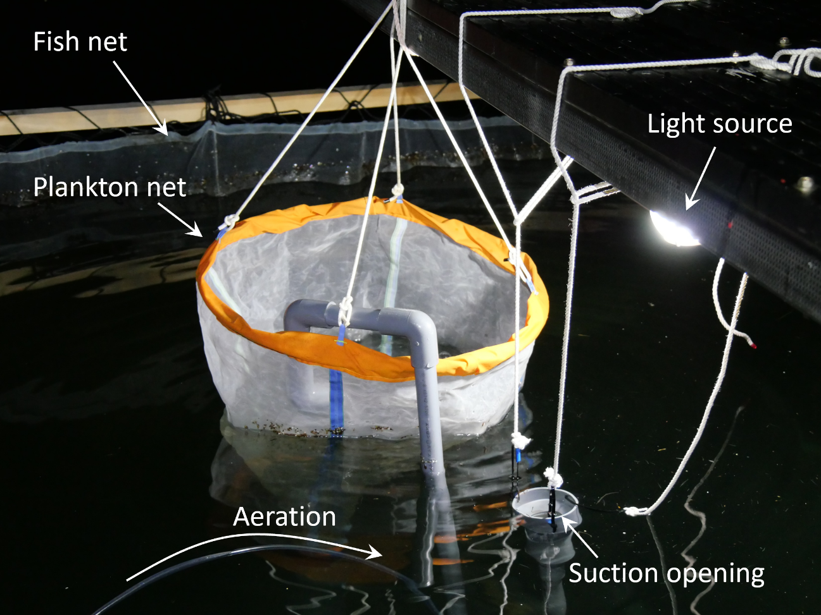

Figure S1
Picture of the light trap used for collecting wild zooplanktons.

