Chelating Effect of Alizarin-Oxalate on La³⁺ and Nd³⁺ in Acidic, Basic and Neutral Medium: A DFT study
Anindita Patiª, T. K. Kundu^{a,*} and Snehanshu Pal^{b}

ªDepartment of Metallurgical and Materials Engineering, Indian Institute of Technology Kharagpur, Kharagpur, West Bengal, India-721302.
^{b}Department of Metallurgical and Materials Engineering, Indian Institute of Engineering Science and Technology, Howrah, West Bengal, India- 711103.
* Corresponding Author: Prof. T. K. Kundu, Department of Metallurgical and Materials Engineering, Indian Institute of Technology Kharagpur, Kharagpur, West Bengal, India-721302.
Email: tkkundu@metal.iitkgp.ac.in

Supplementary Information (SI):
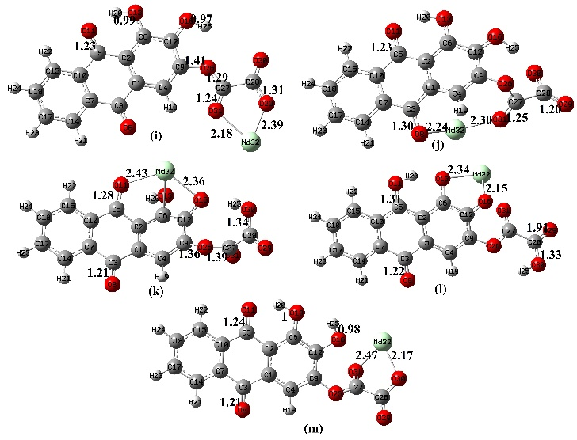
(a)
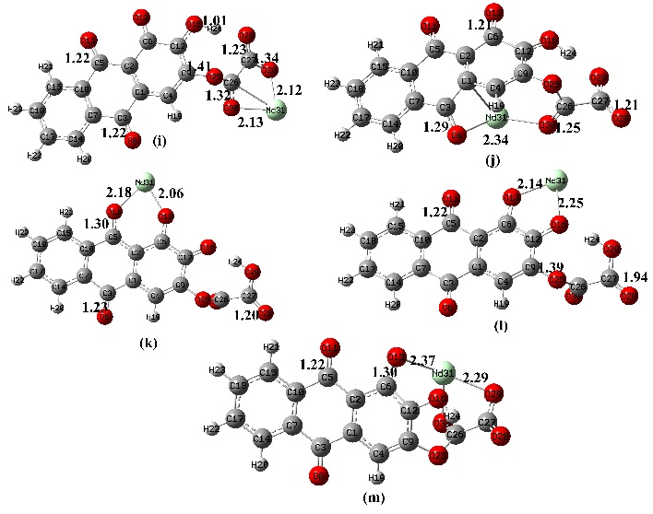
(b)
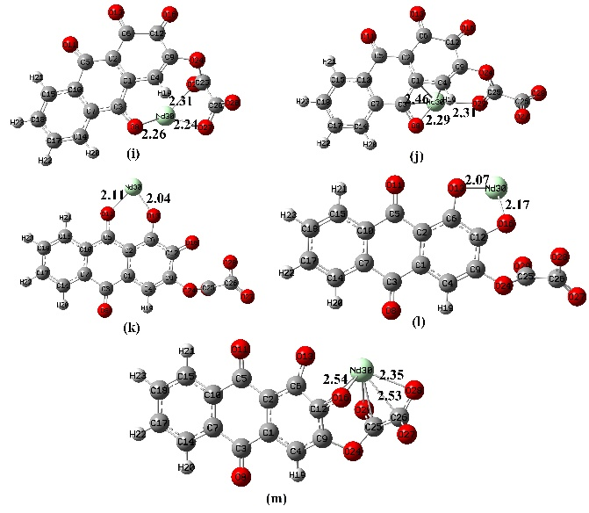
(c)
Figure SI.1.a. AR-Ox-Nd complexes in acidic medium (i) AR-Ox-a-Nd1 (j) AR-Ox-a-Nd2 (k) AR-Ox-a-Nd3 (l) AR-Ox-a-Nd4 (m) AR-Ox-a-Nd5 SI.1.b. AR-Ox-Nd complexes in neutral medium (i) AR-Ox-n-Nd1 (j) AR-Ox-n-Nd2 (k) AR-Ox-n-Nd3 (l) AR-Ox-n-Nd4 (m) AR-Ox-n-Nd5 SI.1.c. AR-Ox-Nd complexes in alkaline medium (i) AR-Ox-b-Nd1 (j) AR-Ox-b-Nd2 (k) AR-Ox-b-Nd3 (l) AR-Ox-b-Nd4 (m) AR-Ox-b-Nd5
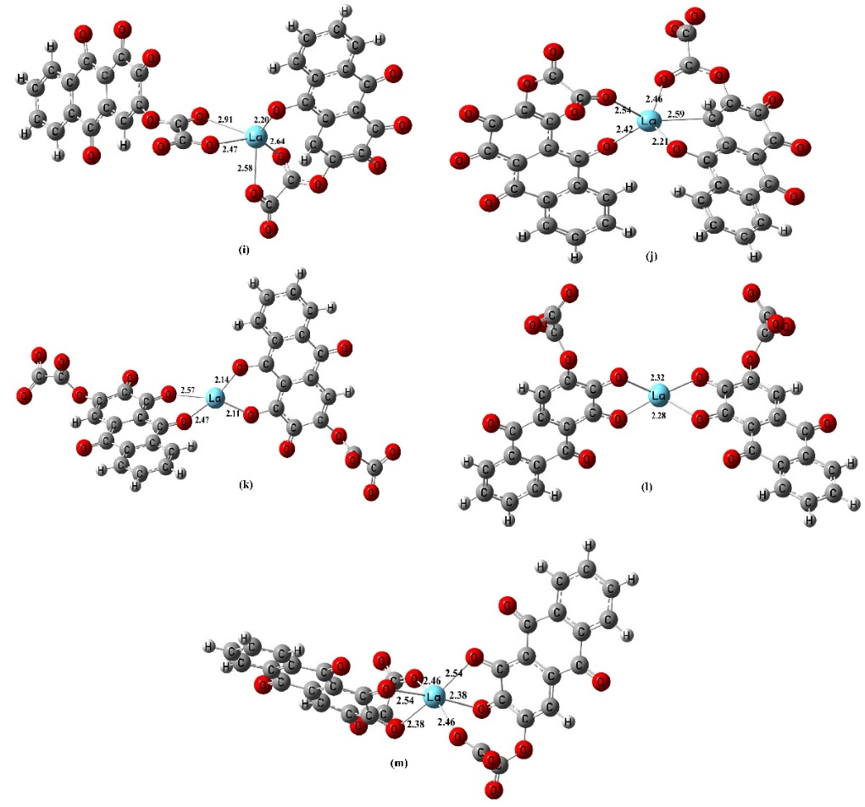
Figure SI.2. (AR-Ox)₂-La complexes in alkaline medium (i) (AR-Ox)₂-b-La1 (j) (AR-Ox)₂-b-La2 (k) (AR-Ox)₂-b-La3 (l) (AR-Ox)₂-b-La4 (m) (AR-Ox)₂-b-La5
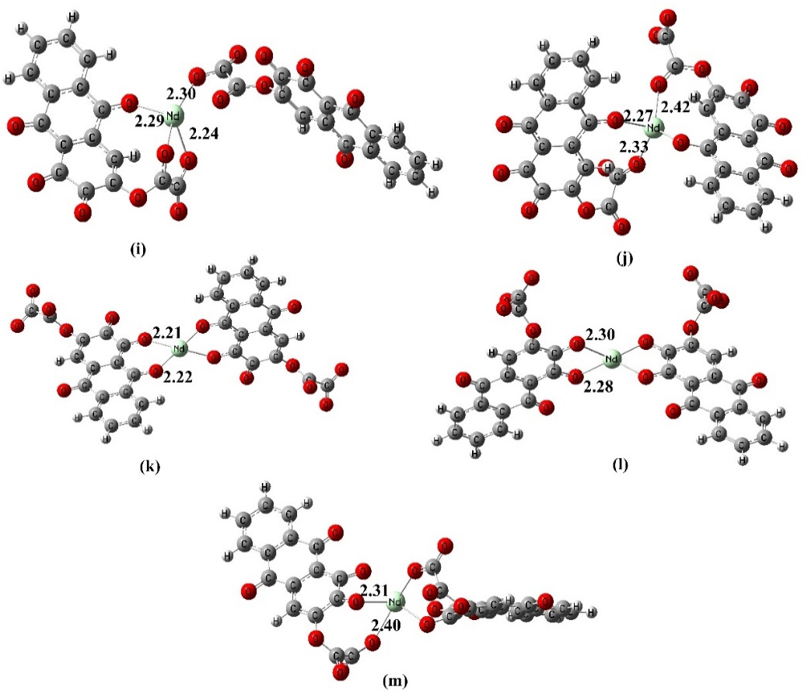
Figure SI.3. (AR-Ox)₂-Nd complexes in alkaline medium (i) (AR-Ox)₂-b-Nd1 (j) (AR-Ox)₂-b-Nd2 (k) (AR-Ox)₂-b- Nd3 (l) (AR-Ox)₂-b- Nd4 (m) (AR-Ox)₂-b-Nd5

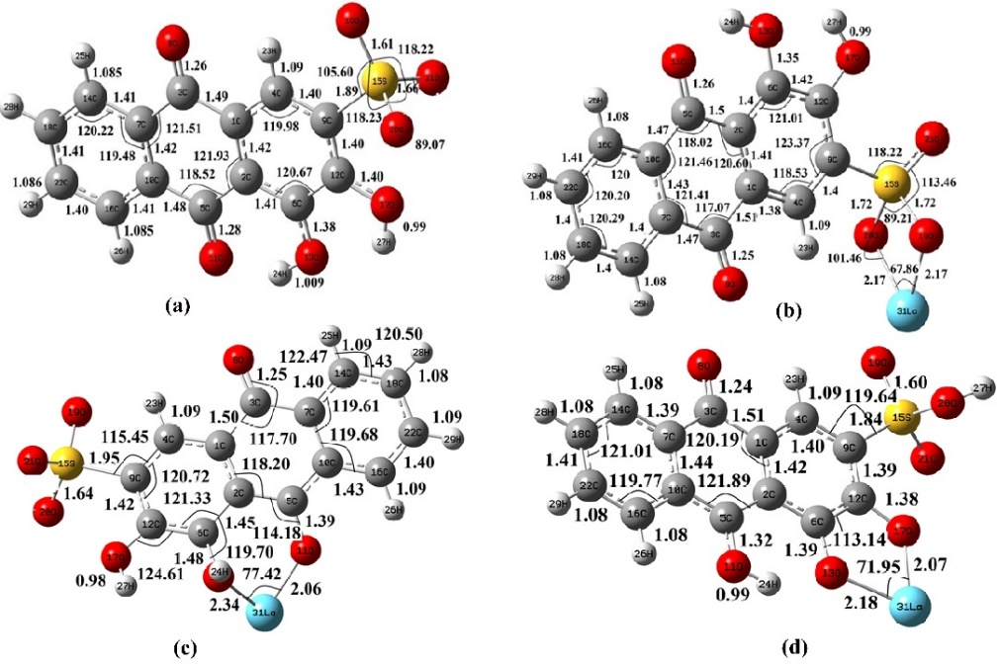
Fig.SI.4. Optimized structures of (a) ARS (alizarin red s) (b) ARS-La1 (Complex consisting of alizarin red s with La placed between 19O and 20 O) (c) ARS-La2 (Complex consisting of alizarin red s with La placed between 11O and 13O) (d) ARS-La3 (Complex consisting of alizarin red s with La placed between 13O and 17O)
Table SI.1: Interaction energy, Gibb’s free energy, Enthalpy, Entropy of the ARS complexes
Properties | ARS-La1 (Kcal/mol) | ARS-La2(Kcal/mol) | ARS-La3 (Kcal/mol)
Interaction Energy | -86.82 | -270.73 | -120.62
ΔG (Gibb’s free energy at room temperature, i.e., 298.15 K) | -1148.12 | -1082.39 | -1183.82
ΔH (Change in enthalpy at room temperature, i.e., 298.15 K) | -1104.52 | -1092.26 | -1196.21
ΔS (Change in entropy at room temperature, i.e. 298.15 K ) | 0.0002 | 0.0003 | 0.0003

Section SI.1.
IR Spectrum Analysis:
As mentioned earlier, hyperconjugation weakens the X-H bond, leading to a redshift. On the other hand, the s character of the bond strengthens the X-H bond, resulting in a blue shift. As seen in IR spectrum analysis values in Table 6.7 and Figure 6.7., on complexation of ARS with La ion O-H bond, the ARS-La1 complex shows reduced frequency, i.e., redshift. The O-H bonds elongate as upon complex formation of ARS with lanthanum ion in the ARS-La1 O-H bond weakens. In the case of ARS-La2, and ARS-La3, the O-H bond shows increased frequency, i.e., blue shift. The O-H bond contracts upon complex formation of ARS with lanthanum ion in ARS-La2 and ARS-La3 O-H bond stronger. On complexation of ARS with La ion C-H bond (symmetric stretching) in ARS-La1, ARS-La2, and ARS-La3 shows increased frequency, i.e., blue shift. The C-H bonds contract upon complex formation of ARS with lanthanum ion in ARS-La1, ARS-La2, and ARS-La3. On complexation of ARS with La ion C-H bond (asymmetric stretching) in ARS-La1 and ARS-La3 shows increased frequency, i.e., blue shift. The C-H bonds contract upon complex formation of ARS with lanthanum ion in ARS-La1 and ARS-La3. In the case of ARS-La2 complex C-H bond shows reduced frequency, i.e., redshift. The C-H bond elongates upon complex formation of ARS with lanthanum ion in ARS-La2 and thus weakens. The C=O bond shows increased frequency, i.e., blue shift upon complex formation of ARS with La ion in case of ARS-La1, ARS-La2, ARS-La3. The C=O bond contracts and becomes stronger upon complex formation. The C=C bond shows increased frequency, i.e., blue shift on complex formation of ARS with lanthanum ion. The C=C bond contracts and becomes stronger upon complex formation. The C-S bond shows decreased frequency, i.e., a red shift in the case of ARS-La1 complex formation that shows the C-S bond elongates and becomes weak on complex formation. The C-S bond shows increased frequency, i.e., a blue shift in the case of ARS-La2 and ARS-La3 that shows the C-S bond contracts and becomes stronger on complex formation. The S-O bond shows the increase in frequency, i.e., blue shift on complex formation of ARS with lanthanum ion. This shows S-O bond contracts and becomes stronger on complex formation. The changes in the frequency of La-O bond on complex formation are in the order ARS-La3 > ARS-La1 > ARS-La2. The frequency reduces in the order ARS-La3 > ARS-La1 > ARS-La2, which shows the La-O bond elongates and weakens in the order ARS-La3 > ARS-La1 > ARS-La2. This shows strong La-O bond is formed in the case of ARS-La3 complex formation. The calculated and analysed data of the IR spectrum analysis corroborates with the experimental and theoretical data from the literature (Jason M. Keith et al., 2012) (Qiong Jia et al., 2009).
Table Section SI.1: Types of vibrations of different bonds in ARS and ARS-La complexes
Type of vibrations | Bond | Calculated values cm⁻¹ (ARS molecule) | Calculated values cm⁻¹ (ARS-La1 complex) | Calculated values cm⁻¹ (ARS-La2 complex) | Calculated values cm⁻¹ (ARS-La3 complex) | Experimental values(cm⁻¹) (Jason M. Keith et al., 2012)  (Qiong Jia et al., 2009) | Calculated values(cm⁻¹) (Qiong Jia et al., 2009)
Symmetric stretching | O-H | 3505.88 | 3476.28 | 3673.41 | 3649.17 | 3468  3430  3624 – 3544 | 3423  3447
Symmetric stretching | C-H | 3257.18 | 3278.15 | 3258.34 | 3280.61 | 2920
Asymmetric stretching | C-H | 3243.95 | 3263.85  3252.63  3248.73 | 3242.91  3237.24  3230.83 | 3265.06  3258.32  3251.99
Rocking (bending) | C-H | 1451.97 | 1523.15  1492.86  1353.69 | 1512.87 | 1525.92  1504.65  1325.24
Symmetric stretching | C=O | 1634.00  1576.00 | 1682.48  1673.05 | 1644.69  1599.57 | 1702.74  1630.00 | 1639  1637 | 1636  1635, 1617  1637, 1668
Symmetric stretching | C=C | 1561  1526  1471 | 1630.18  1615.10  1605.92  1554.67 | 1583.88  1558.94  1532.40 | 1648.62  1637.38  1603.00  1593.03 | 1588  1456 | 1572  1448
Stretching | C-S | 920 | 900.43  867.01  485.12 | 1019.01  954.01 | 1044.02  877.73 | 842
Symmetric stretching | S-O | 1020.00 | 1052.87 | 896.16 | 916.16 | 1068 | 1070
Symmetric stretching | O-La-O | - | 584.03 | 426.65 | 737.74  690.44
Bending | O-La-O | - | 628.65  (scissoring) | 426.65  (scissoring) | 572.5(scissoring)  565.16 (twisting)
Scissoring | C-OH | 295.36 | 364.58 | 376.77 | 240.44

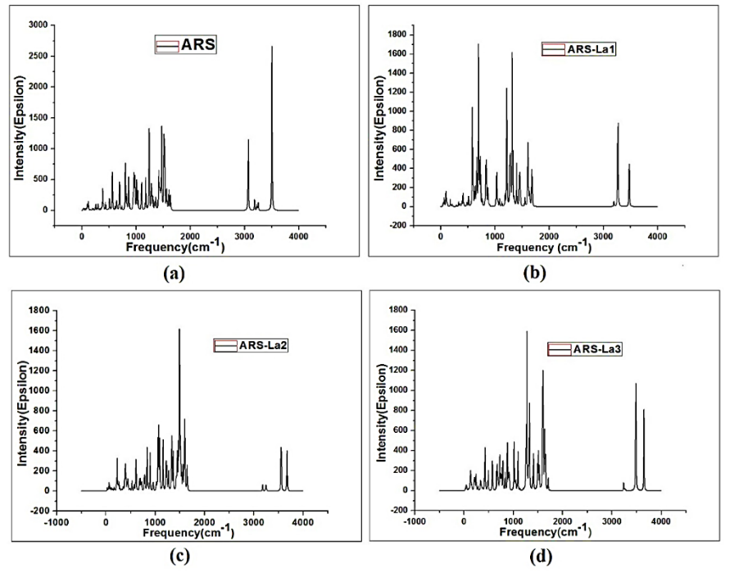
Figure Section SI.1. IR spectrum of (a) ARS (b) ARS-La1 (c) ARS-La2 (d) ARS-La3
Table SI.2. QTAIM parameters of La-O/ La-C bonds in AR-Ox-La complexes in acidic & neutral medium and (AR-Ox)₂-La complexes in alkaline medium
Complexes | Bonds | $$ρ$$ | $$|G|$$ | $$|v|$$ | $$∇^{2}ρ$$ | $$\left|v\right|/|G|$$
AR-Ox-a-La1 | La-O29 | 0.10 | 0.10 | 0.12 | 0.29 | 1.25
 | La-O31 | 0.29 | 0.04 | 0.15 | -1.02 | 4.25
AR-Ox-a-La2 | La-O8 | 0.10 | 0.09 | 0.12 | 0.26 | 1.31
 | La-O31 | 0.08 | 0.08 | 0.09 | 0.27 | 1.14
 | La-C3 | 0.04 | 0.03 | 0.04 | 0.13 | 1.08
 | La-C4 | 0.05 | 0.03 | 0.04 | 0.09 | 1.31
AR-Ox-a-La3 | La-O11 | 0.10 | 0.09 | 0.12 | 0.27 | 1.28
 | La-O13 | 0.06 | 0.06 | 0.06 | 0.23 | 1.03
 | La-O16 | 0.08 | 0.07 | 0.08 | 0.22 | 1.19
 | La-C6 | 0.04 | 0.05 | 0.05 | 0.18 | 1.05
 | La-C12 | 0.06 | 0.04 | 0.06 | 0.11 | 1.35
AR-Ox-a-La4 | La-O13 | 0.04 | 0.04 | 0.04 | 0.17 | 0.96
 | La-O16 | 0.10 | 0.09 | 0.12 | 0.27 | 1.28
 | La-O31 | 0.12 | 0.12 | 0.17 | 0.28 | 1.40
 | La-C12 | 0.05 | 0.05 | 0.05 | 0.18 | 1.08
AR-Ox-a-La5 | La-O30 | 0.10 | 0.10 | 0.13 | 0.29 | 1.27
 | La-O31 | 0.06 | 0.05 | 0.06 | 0.20 | 1.07
AR-Ox-n-La1 | La-O28 | 0.13 | 0.13 | 0.18 | 0.29 | 1.43
 | La-O30 | 0.11 | 0.11 | 0.15 | 0.27 | 1.36
 | La-C26 | 0.05 | 0.06 | 0.06 | 0.21 | 1.07
AR-Ox-n-La2 | La-O8 | 0.08 | 0.07 | 0.08 | 0.23 | 1.17
 | La-O30 | 0.06 | 0.06 | 0.07 | 0.23 | 1.08
 | La-C4 | 0.06 | 0.04 | 0.06 | 0.11 | 1.33
AR-Ox-n-La3 | La-O11 | 0.13 | 0.13 | 0.18 | 0.34 | 1.36
 | La-O13 | 0.16 | 0.17 | 0.25 | 0.35 | 1.48
AR-Ox-n-La4 | La-O13 | 0.12 | 0.12 | 0.15 | 0.30 | 1.35
 | La-O16 | 0.09 | 0.09 | 0.11 | 0.27 | 1.22
AR-Ox-n-La5 | La-O13 | 0.07 | 0.07 | 0.08 | 0.22 | 1.17
 | La-O29 | 0.09 | 0.08 | 0.10 | 0.25 | 1.24
(AR-Ox)₂-b-La1 | La-O8 | 0.04 | 0.04 | 0.04 | 0.14 | 0.86
 | La-O27 | 0.10 | 0.10 | 0.12 | 0.29 | 1.24
 | La-O29 | 0.03 | 0.03 | 0.03 | 0.13 | 0.85
 | La-O57 | 0.02 | 0.02 | 0.01 | 0.07 | 0.74
 | La-O59 | 0.05 | 0.05 | 0.05 | 0.19 | 0.98
(AR-Ox)₂-b-La2 | La-O8 | 0.05 | 0.05 | 0.05 | 0.22 | 1.07
 | La-O27 | 0.04 | 0.04 | 0.04 | 0.17 | 0.96
 | La-O37 | 0.05 | 0.05 | 0.05 | 0.20 | 0.99
 | La-O58 | 0.09 | 0.09 | 0.12 | 0.28 | 1.23
(AR-Ox)₂-b-La3 | La-O11 | 0.05 | 0.05 | 0.05 | 0.20 | 1.01
 | La-O13 | 0.04 | 0.04 | 0.04 | 0.16 | 0.93
 | La-O40 | 0.11 | 0.12 | 0.15 | 0.33 | 1.37
 | La-O42 | 0.12 | 0.12 | 0.16 | 0.35 | 1.41
(AR-Ox)₂-b-La4 | La-O13 | 0.32 | 0.38 | 0.86 | -0.38 | 2.70
 | La-O16 | 0.07 | 0.07 | 0.08 | 0.24 | 1.10
 | La-O42 | 0.08 | 0.08 | 0.09 | 0.26 | 1.15
 | La-O45 | 0.74 | 0.07 | 0.08 | 0.25 | 0.11
(AR-Ox)₂-b-La5 | La-O16 | 0.05 | 0.04 | 0.04 | 0.16 | 0.91
 | La-O13 | 0.05 | 0.05 | 0.05 | 0.20 | 1.00
 | La-O16 | 0.06 | 0.06 | 0.07 | 0.22 | 1.04
 | La-O42 | 0.06 | 0.06 | 0.07 | 0.22 | 1.04
 | La-O45 | 0.05 | 0.05 | 0.05 | 0.20 | 1.00
 | La-O57 | 0.05 | 0.04 | 0.04 | 0.16 | 0.91

Table SI.3. QTAIM parameters of Nd-O/Nd-C bonds in AR-Ox-Nd complexes in acidic & neutral mediums and (AR-Ox)₂-Nd complexes in alkaline medium
Complexes | Bonds | $$ρ$$ | $$∇^{2}ρ$$ | $$|v|$$ | $$|G|$$ | $$\left|v\right|/|G|$$
AR-Ox-a-Nd1 | Nd-O29 | 0.10 | 0.32 | 0.13 | 0.10 | 1.23
 | Nd-O31 | 0.06 | 0.22 | 0.06 | 0.06 | 1.05
AR-Ox-a-Nd2 | Nd-O31 | 0.09 | 0.27 | 0.10 | 0.08 | 1.20
 | Nd-O8 | 0.07 | 0.27 | 0.08 | 0.08 | 1.08
AR-Ox-a-Nd3 | Nd-O11 | 0.05 | 0.20 | 0.05 | 0.05 | 1.04
 | Nd-O13 | 0.06 | 0.22 | 0.07 | 0.06 | 1.10
 | Nd-O16 | 0.05 | 0.24 | 0.06 | 0.06 | 1.00
 | Nd-C6 | 0.05 | 0.12 | 0.05 | 0.04 | 1.28
AR-Ox-a-Nd4 | Nd-O13 | 0.04 | 0.19 | 0.05 | 0.05 | 0.98
 | Nd-O16 | 0.07 | 0.23 | 0.07 | 0.07 | 1.11
 | Nd-O31 | 0.11 | 0.31 | 0.14 | 0.11 | 1.28
AR-Ox-a-Nd5 | Nd-O28 | 0.10 | 0.31 | 0.13 | 0.10 | 1.25
 | Nd-O30 | 0.08 | 0.27 | 0.09 | 0.08 | 1.15
 | Nd-O31 | 0.03 | 0.13 | 0.03 | 0.03 | 0.90
AR-Ox-n-Nd1 | Nd-O28 | 0.12 | 0.32 | 0.16 | 0.12 | 1.32
 | Nd-O30 | 0.11 | 0.32 | 0.15 | 0.12 | 1.30
AR-Ox-n-Nd2 | Nd-O8 | 0.06 | 0.24 | 0.07 | 0.06 | 1.06
 | Nd-O30 | 0.07 | 0.24 | 0.07 | 0.07 | 1.11
AR-Ox-n-Nd3 | Nd-O11 | 0.12 | 0.41 | 0.18 | 0.14 | 1.28
 | Nd-O13 | 0.09 | 0.37 | 0.13 | 0.11 | 1.16
AR-Ox-n-Nd4 | Nd-O13 | 0.13 | 0.34 | 0.18 | 0.13 | 1.37
 | Nd-O16 | 0.10 | 0.31 | 0.13 | 0.10 | 1.24
AR-Ox-n-Nd5 | Nd-O13 | 0.05 | 0.19 | 0.06 | 0.05 | 1.08
 | Nd-O16 | 0.07 | 0.24 | 0.07 | 0.07 | 1.10
 | Nd-O28 | 0.09 | 0.30 | 0.11 | 0.09 | 1.19
 | Nd-O29 | 0.09 | 0.30 | 0.12 | 0.10 | 1.21
(AR-Ox)₂-b-Nd1 | Nd-O27 | 0.05 | 0.21 | -0.03 | 0.04 | 1.00
 | Nd-O29 | 0.06 | 0.23 | -0.07 | 0.06 | 1.10
 | Nd-O57 | 0.07 | 0.27 | -0.09 | 0.77 | 0.11
(AR-Ox)₂-b-Nd2 | Nd-O8 | 0.08 | 0.29 | -0.09 | 0.08 | 1.12
 | Nd-O27 | 0.06 | 0.24 | -0.07 | 0.06 | 1.04
 | Nd-O37 | 0.08 | 0.27 | -0.10 | 0.08 | 1.19
 | Nd-O58 | 0.05 | 0.19 | -0.04 | 0.05 | 0.98
(AR-Ox)₂-b-Nd3 | Nd-O11 | 0.09 | 0.33 | -0.11 | 0.10 | 1.15
 | Nd-O13 | 0.08 | 0.32 | -0.11 | 0.09 | 1.15
 | Nd-O40 | 0.08 | 0.32 | -0.11 | 0.09 | 1.15
 | Nd-O42 | 0.08 | 0.33 | -0.11 | 0.10 | 1.15
(AR-Ox)₂-b-Nd4 | Nd-O13 | 0.37 | -0.30 | -1.10 | 0.51 | 2.15
 | Nd-O16 | 0.07 | 0.26 | -0.08 | 0.07 | 1.12
 | Nd-O42 | 0.10 | 0.33 | -0.13 | 0.10 | 1.22
 | Nd-O45 | 0.09 | 0.30 | -0.11 | 0.09 | 1.18
(AR-Ox)₂-b-Nd5 | Nd-O16 | 0.05 | 0.22 | -0.06 | 0.06 | 1.01
 | Nd-O28 | 0.07 | 0.25 | -0.08 | 0.07 | 1.11
 | Nd-O45 | 0.05 | 0.22 | -0.06 | 0.06 | 1.01
 | Nd-O57 | 0.05 | 0.18 | -0.05 | 0.05 | 1.05

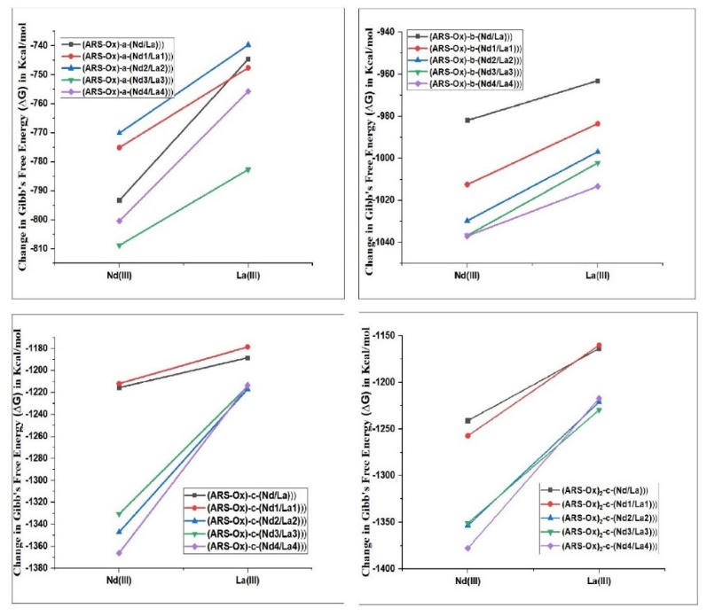
Fig.SI.5. Change in Gibb’s Free Energy of (a) (ARS-Ox)-a-(Nd/La) (b) (ARS-Ox)-n-(Nd/La) (c) (ARS-Ox)-b-(Nd/La) (d) (ARS-Ox)₂-b-(Nd/La) complexes.
Table SI.4: Change in enthalpy, entropy, and Gibb’s free energy of the AR-Ox-Nd complexes in acidic, neutral, and alkaline medium and (AR-Ox)₂-Nd complexes in alkaline medium at 298.15 K
Complexes | ($∆_{r}H^{0})$ at 298.15 K (Kcal/mol) | ($∆_{r}G^{0})$ at 298.15 K (Kcal/mol) | ($∆_{r}S^{0})$ (Kcal mol⁻¹ K⁻¹)
AR-Ox-a-Nd1 | -789.96 | -793.31 | 0.01
AR-Ox-a-Nd2 | -771.94 | -775.11 | 0.01
AR-Ox-a-Nd3 | -765.33 | -770.11 | 0.02
AR-Ox-a-Nd4 | -805.56 | -808.82 | 0.01
AR-Ox-a-Nd5 | -796.36 | -800.43 | 0.01
AR-Ox-n-Nd1 | -975.28 | -981.98 | 0.02
AR-Ox-n-Nd2 | -1007.49 | -1012.48 | 0.02
AR-Ox-n-Nd3 | -1023.41 | -1029.71 | 0.02
AR-Ox-n-Nd4 | -1030.08 | -1036.67 | 0.02
AR-Ox-n-Nd5 | -1032.32 | -1036.95 | 0.01
AR-Ox-b-Nd1 | -1207.15 | -1215.53 | 0.03
AR-Ox-b-Nd2 | -1202.46 | -1211.88 | 0.03
AR-Ox-b-Nd3 | -1337.92 | -1347.02 | 0.03
AR-Ox-b-Nd4 | -1323.95 | -1330.55 | 0.02
AR-Ox-b-Nd5 | -1359.03 | -1366.09 | 0.02
(AR-Ox)₂-b-Nd1 | -1230.84 | -1240.98 | 0.03
(AR-Ox)₂-b-Nd2 | -1247.86 | -1257.12 | 0.03
(AR-Ox)₂-b-Nd3 | -1345.66 | -1353.36 | 0.03
(AR-Ox)₂-b-Nd4 | -1343.78 | -1350.87 | 0.02
(AR-Ox)₂-b-Nd5 | -1367.68 | -1377.78 | 0.03
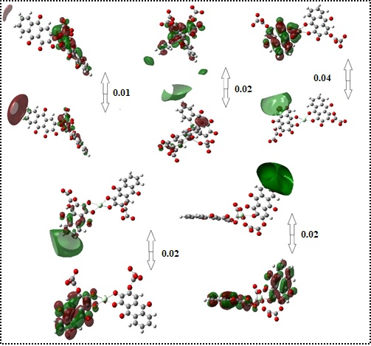
(i)
(m)
(k)
(l)
(j)

Figure SI.6. HOMO-LUMO gap of (AR-Ox)₂-Nd complexes in alkaline medium (i) (AR-Ox)₂-b-Nd1 (j) (AR-Ox)₂-b-Nd2 (k) (AR-Ox)₂-b-Nd3 (l) (AR-Ox)₂-b-Nd4 (m) (AR-Ox)₂-b- Nd5

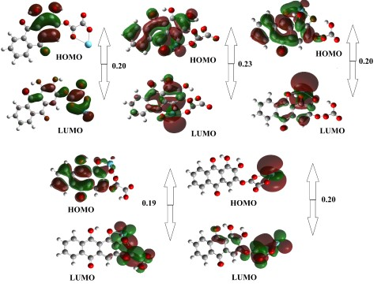
(a)
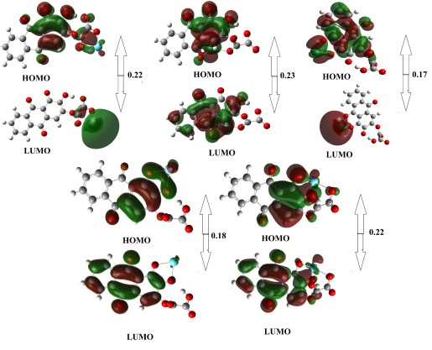
(b)
Figure SI.7.a. HOMO-LUMO Gap of AR-Ox-La complexes in acidic medium (i) AR-Ox-a-La1 (j) AR-Ox-a-La2 (k) AR-Ox-a-La3 (l) AR-Ox-a-La4 (m) AR-Ox-a-La5 SI.6.b. AR-Ox-La complexes in neutral medium (i) AR-Ox-n-La1 (j) AR-Ox-n-La2 (k) AR-Ox-n-La3 (l) AR-Ox-n-La4 (m) AR-Ox-n-La5
(i)
(m)
(k)
(l)
(j)

Figure SI.8. HOMO-LUMO gap of (AR-Ox)₂-Nd complexes in alkaline medium (i) (AR-Ox)₂-b-Nd1 (j) (AR-Ox)₂-b-Nd2 (k) (AR-Ox)₂-b-Nd3 (l) (AR-Ox)₂-b-Nd4 (m) (AR-Ox)₂-b- Nd5

Table SI.5. Stout-Politzer HOMO-LUMO composition of O, C and La atoms (%) in AR-Ox-La complexes in acidic and neutral medium
Systems | Frontier orbitals | Orbital Compositions (%)
 |  | O atoms | C atoms | La atom
AR-Ox-a-La1 | HOMO | 28.13 | 34.84 | 13.85
AR-Ox-a-La1 | LUMO | 31.64 | 32.97 | 12.27
AR-Ox-a-La2 | HOMO | 33.24 | 36.97 | -
AR-Ox-a-La2 | LUMO | 38.85 | 37.12 | 7.65
AR-Ox-a-La3 | HOMO | 31.45 | 32.14 | -
AR-Ox-a-La3 | LUMO | 26.72 | 38.10 | 2.85
AR-Ox-a-La4 | HOMO | 30.58 | 34.47 | -
AR-Ox-a-La4 | LUMO | 32.31 | 38.53 | 92.13
AR-Ox-a-La5 | HOMO | 36.50 | 33.49 | -
AR-Ox-a-La5 | LUMO | 39.37 | 36.67 | 87.23
AR-Ox-n-La1 | HOMO | 28.76 | 22.64 | 13.45
 | LUMO | 36.43 | 20.74 | 10.44
AR-Ox-n-La2 | HOMO | 28.67 | 24.38 | 3.88
 | LUMO | 22.56 | 27.43 | 9.44
AR-Ox-n-La3 | HOMO | 34.87 | 36.42 | 3.44
 | LUMO | 31.56 | 34.52 | 3.45
AR-Ox-n-La4 | HOMO | 30.73 | 33.73 | 5.09
 | LUMO | 33.46 | 38.42 | 7.44
AR-Ox-n-La5 | HOMO | 30.34 | 36.74 | 6.87
 | LUMO | 21.67 | 39.33 | 7.98

Table.SI.6. Ionization Potential (IP), Electroaffinity (EA), Electronegativity (χ), Chemical potential (µ), Chemical Hardness (ƞ) and Electrophilicity index (ꙍ) of AR-Ox-Nd and (AR-Ox)₂-Nd complexes alkaline medium
Complexes | HOMO | LUMO | IP | EA | χ | η | ω
AR-Ox-b-Nd1 | -0.08 | -0.01 | 0.08 | 0.01 | 0.05 | 0.03 | 0.03
AR-Ox-b-Nd2 | -0.10 | -0.02 | 0.10 | 0.02 | 0.06 | 0.04 | 0.05
AR-Ox-b-Nd3 | -0.07 | -0.01 | 0.07 | 0.01 | 0.04 | 0.03 | 0.03
AR-Ox-b-Nd4 | -0.12 | -0.03 | 0.12 | 0.03 | 0.07 | 0.05 | 0.06
AR-Ox-b-Nd5 | -0.07 | 0.004 | 0.07 | 0.00 | 0.03 | 0.04 | 0.01
(AR-Ox)₂-b-Nd1 | 0.20 | 0.28 | -0.20 | -0.28 | -0.24 | 0.04 | 0.72
(AR-Ox)₂-b-Nd2 | 0.19 | 0.28 | -0.19 | -0.28 | -0.24 | 0.05 | 0.61
(AR-Ox)₂-b-Nd3 | 0.22 | 0.32 | -0.22 | -0.32 | -0.27 | 0.05 | 0.73
(AR-Ox)₂-b-Nd4 | 0.22 | 0.26 | -0.22 | -0.26 | -0.24 | 0.02 | 1.44
(AR-Ox)₂-b-Nd5 | 0.24 | 0.28 | -0.24 | -0.28 | -0.26 | 0.02 | 1.69

Table SI.7. Stabilization energies (E²) corresponding to higher intra and inter-unit NBO interaction regions of AR-Ox-La complexes in acidic and neutral medium .
Complexes | Unit | Donor NBO | Type | Acceptor NBO | Type | E²
AR-Ox-a-La1 | Within unit 1 | LP C12 | n | LP* C6 | n* | 1039.56
 | From unit 1 to 2 | CR(O29) | core | RY* La32 | Rydberg | 60.63
AR-Ox-a-La2 | Within unit 1 | LP C12 | n | LP* C6 | n* | 326.93
 | From unit 1 to 2 | CR(O31) | core | RY* La32 | Rydberg | 83.50
AR-Ox-a-La3 | Within unit 1 | BD*(2) C7-C10 | Л* | BD*(2) C15-C18 | Л* | 112.41
 | From unit 1 to 2 | CR(O11) | core | RY* La32 | Rydberg | 43.94
AR-Ox-a-La4 | Within unit 1 | BD*(2) C1-C2 | Л* | BD*(2) C4-C9 | Л* | 103.71
 | From unit 1 to 2 | CR (O16) | core | RY* La32 | Rydberg | 65.49
AR-Ox-a-La5 | Within unit 1 | LP C12 | n | LP* C6 | n* | 1632.73
 | From unit 1 to 2 | CR(O30) | core | RY* La32 | Rydberg | 61.38
AR-Ox-n-La1 | Within unit 1 | LP O16 | n | LP* H24 | n* | 245.21
 | From unit 1 to 2 | CR(O30) | core | RY* La31 | Rydberg | 64.67
AR-Ox-n-La2 | Within unit 1 | BD*(2) C14-C17 | Л* | BD*(2) C15-C18 | Л* | 142.01
 | From unit 1 to 2 | BD*(2) C1-C2 | Л* | LP* La31 | n* | 29.10
AR-Ox-n-La3 | Within unit 1 | CR(O11) | core | BD*(2) C27-O28 | Л* | 137.13
 | From unit 1 to 2 | CR(O13) | core | RY* La31 | Rydberg | 40.08
AR-Ox-n-La4 | Within unit 1 | BD*(2) C7-C10 | Л* | BD*(1) C15-C18 | σ * | 101.10
 | From unit 1 to 2 | CR(O13) | core | RY* La31 | Rydberg | 47.96
AR-Ox-n-La5 | Within unit 1 | LP C12 | n | LP* C6 | n* | 477.55
 | From unit 1 to 2 | LP O29 | n | LP* La31 | n* | 29.27

Table SI.8. Stabilization energies (E²) corresponding to higher intra and inter-unit NBO interaction regions of (AR-Ox)₂-Nd complexes.
Complexes | Unit | Donor NBO | Type | Acceptor NBO | Type | Stabilization Energy ( E⁽²⁾)
(AR-Ox)₂-b-Nd1 | 1 | BD*(2)(C1-C2) | Л* | RY(O58) | 1-center Rydberg | 2678.56
 | 1 to 2 | CR(Nd) | core | BD*(2)(C17-C18) | Л* | 671.20
(AR-Ox)₂-b-Nd2 | 1 | CR (O8) | core | BD*(2)(C46-C47) | Л* | 968.20
 | 1 to 2 | CR (O8) | core | RY(Nd) | 1-center Rydberg | 624.25
(AR-Ox)₂-b-Nd2 | 1 | BD*(1) O53-C54 | σ * | BD*(2)(C17-C18) | Л* | 2821.84
 |  | CR(O42) | core | RY (Nd) | 1-center Rydberg | 424.18
(AR-Ox)₂-b-Nd4 | 1 | BD*(2)(C9 - C12) | Л* | BD*(2)(C2 – C6) | Л* | 2875.97
 | 1 to 2 | BD*(2)(C3 – C40) | Л* | RY(Nd) | 1-center Rydberg | 374.75
(AR-Ox)₂-b-Nd5 | 1 | LP(C12) | n | LP*(C6) | n* | 2654.69
 | 1 to 2 | BD*(2)(C15 – C18) | Л* | RY(Nd) | 1-center Rydberg | 984.15

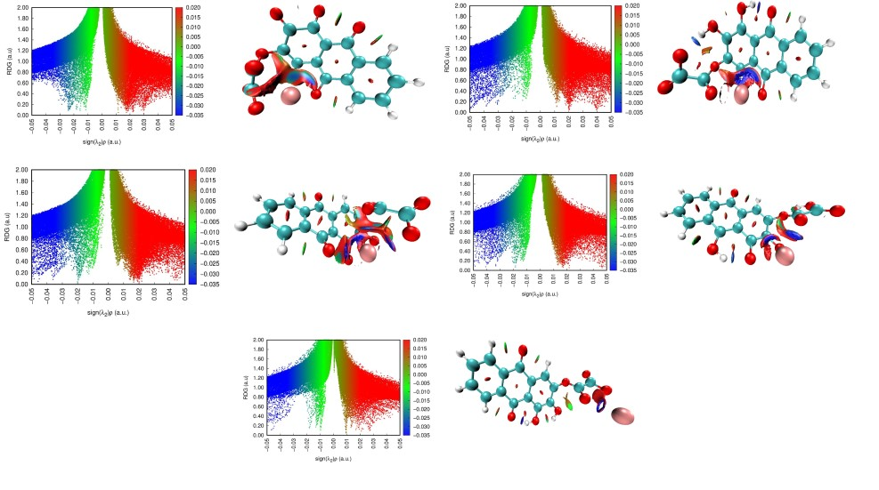
(a)
(m)
(i)
(l)
(k)
(j)

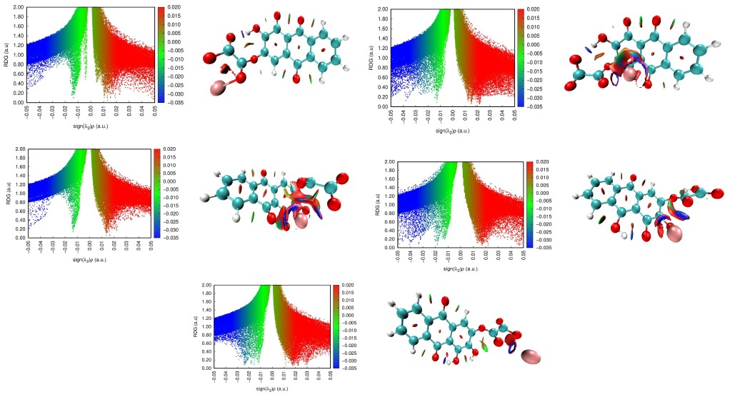
(b)
(l)
(k)
(m)
(j)
(i)
Figure SI.9.a. RDG plots of AR-Ox-La complexes in acidic medium (i) AR-Ox-a-La1 (j) AR-Ox-a-La2 (k) AR-Ox-a-La3 (l) AR-Ox-a-La4 (m) AR-Ox-a-La5 SI.9.b. AR-Ox-La complexes in neutral medium (i) AR-Ox-n-La1 (j) AR-Ox-n-La2 (k) AR-Ox-n-La3 (l) AR-Ox-n-La4 (m) AR-Ox-n-La5
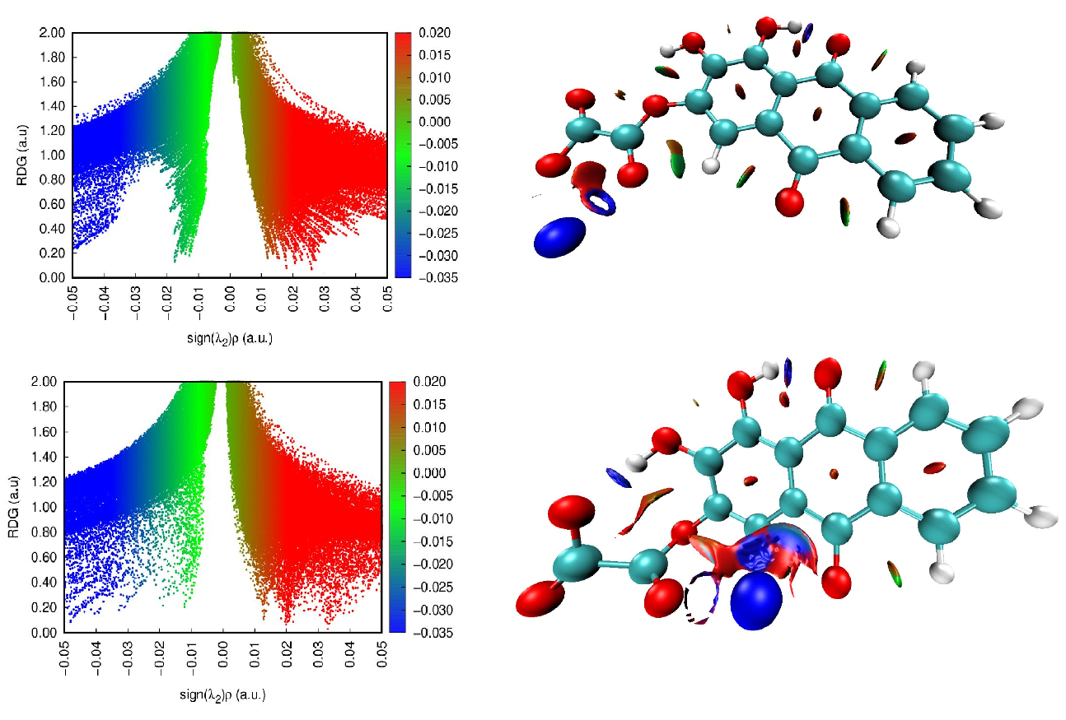
(j)
(i)
(a)
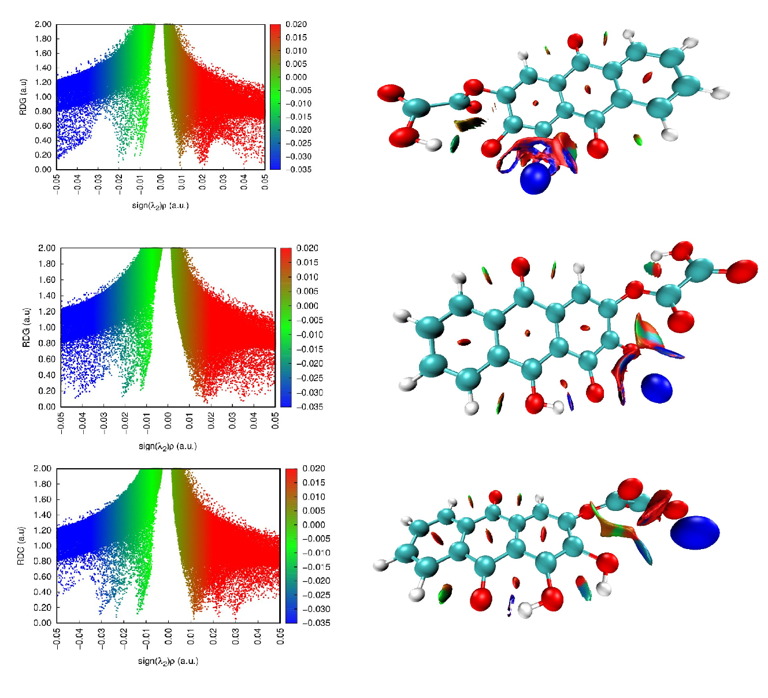
(a)
(m)
(l)
(k)
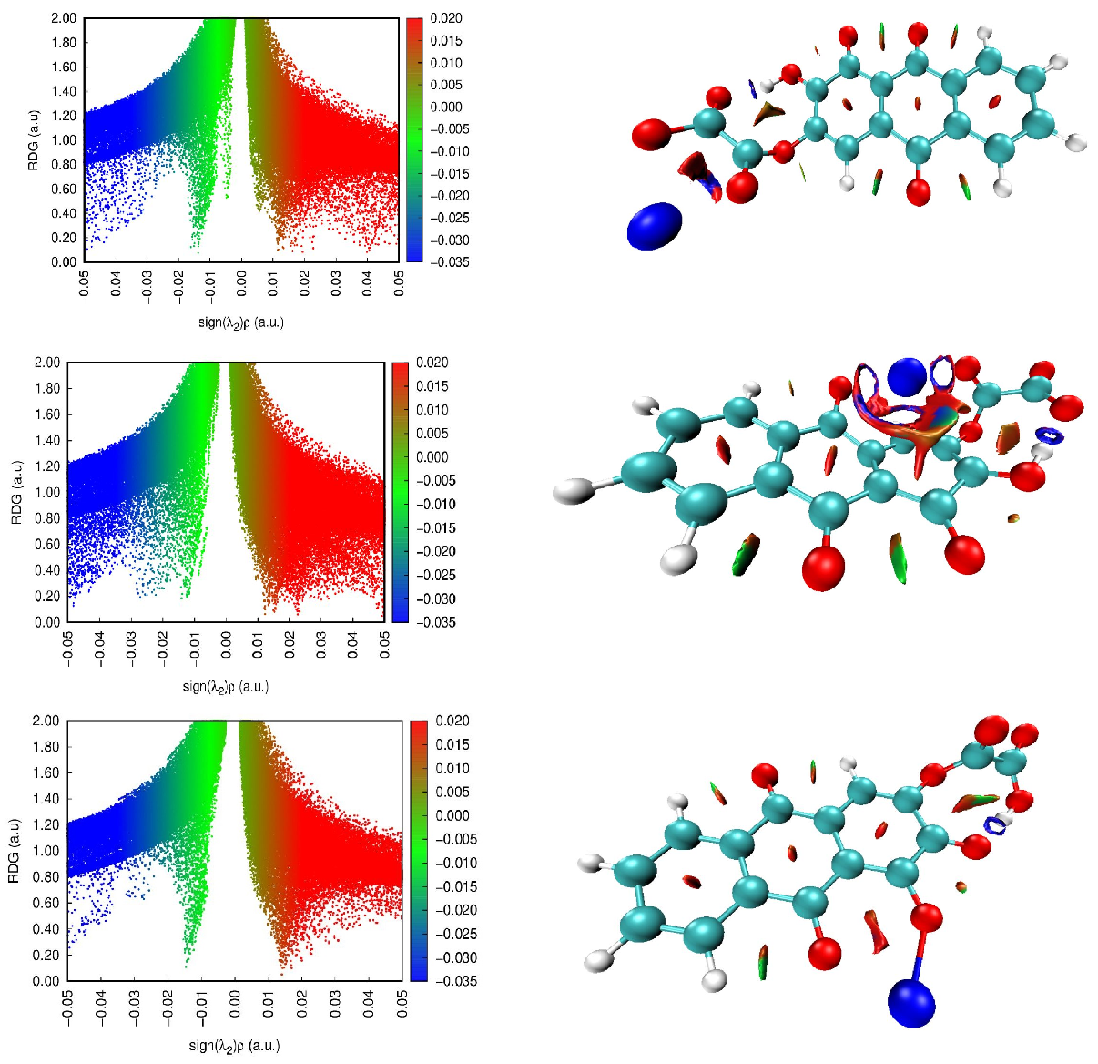
(i)
(j)
(k)
(b)
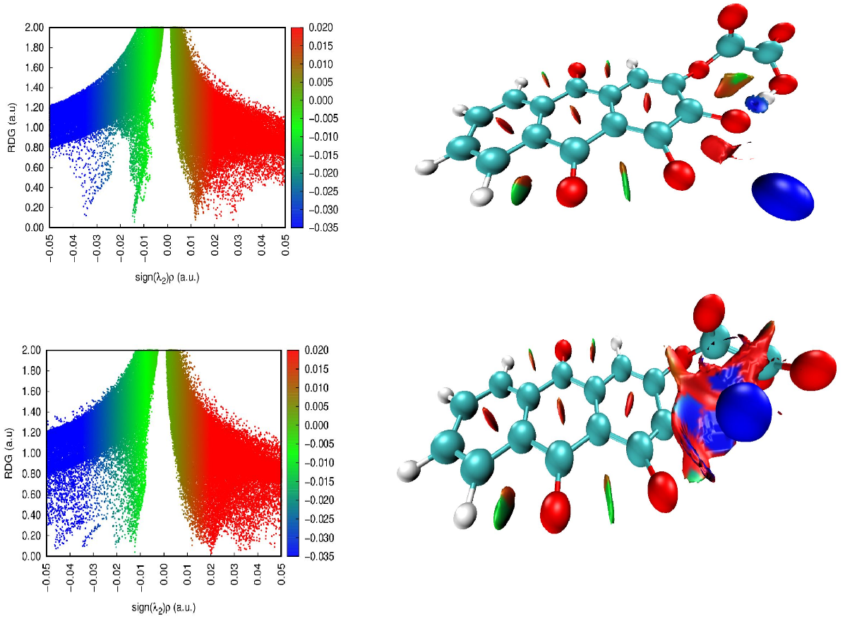
(b)
(l)
(m)
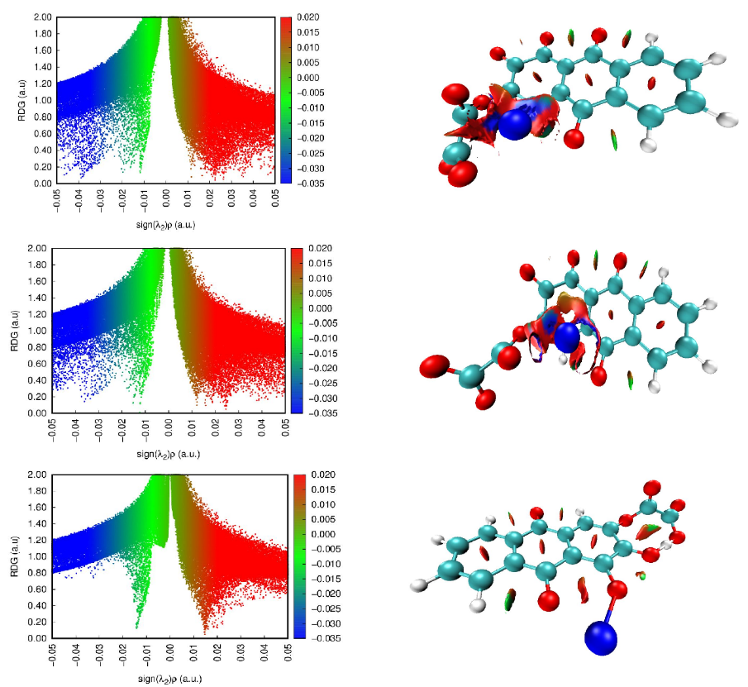
(i)
(j)
(k)
(c)
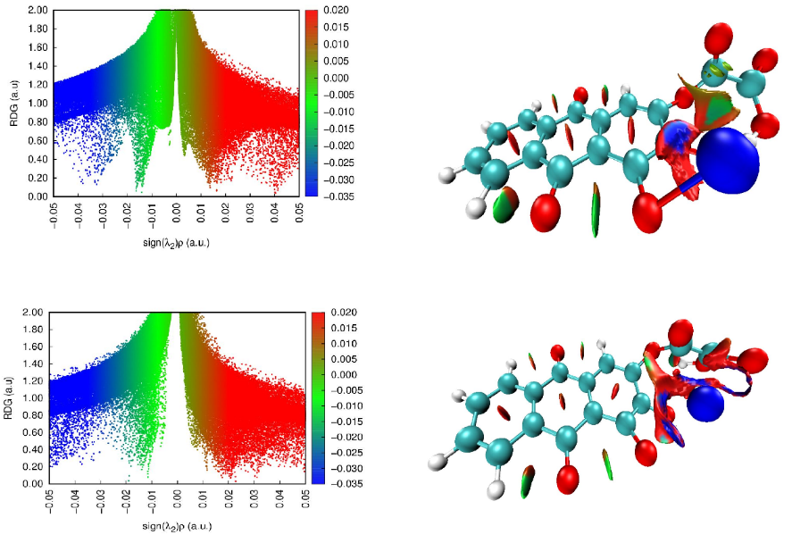
(m)
(l)
(c)
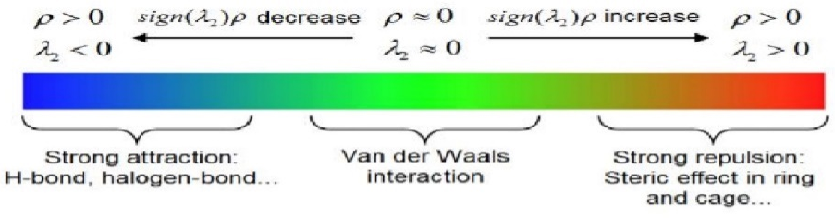
Figure SI.10 a. RDG plots and NCI iso-surfaces of AR-Ox-Nd complexes in acidic medium (i) AR-Ox-a-Nd1 (j) AR-Ox-a-Nd2 (k) AR-Ox-a-Nd3 (l) AR-Ox-a-Nd4 (m) AR-Ox-a-Nd5 SI.10 b. AR-Ox-Nd complexes in neutral medium (i) AR-Ox-n-Nd1 (j) AR-Ox-n-Nd2 (k) AR-Ox-n-Nd3 (l) AR-Ox-n-Nd4 (m) AR-Ox-n-Nd5 SI.10 c. AR-Ox-Nd complexes in alkaline medium (i) AR-Ox-b-Nd1 (j) AR-Ox-b-Nd2 (k) AR-Ox-b-Nd3 (l) AR-Ox-b-Nd4 (m) AR-Ox-b-Nd5

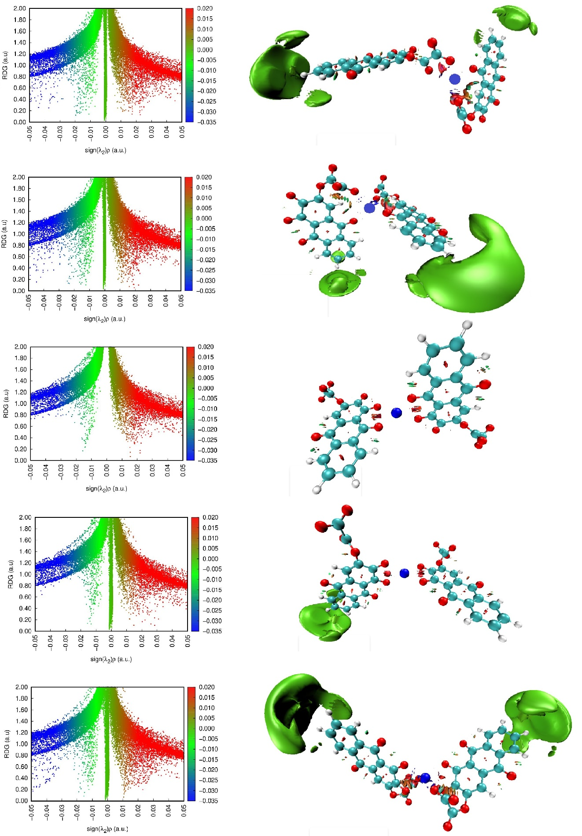
(m)
(l)
(k)
(j)
(i)
Figure SI.11. (AR-Ox)₂-Nd complexes in alkaline medium (i) (AR-Ox)₂-b-Nd1 (j) (AR-Ox)₂-b-Nd2 (k) (AR-Ox)₂-b-Nd3 (l) (AR-Ox)₂-b-Nd4 (m) (AR-Ox)₂-b-Nd5

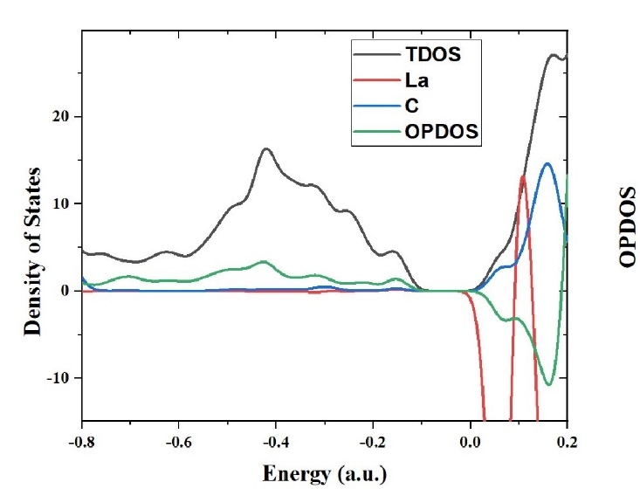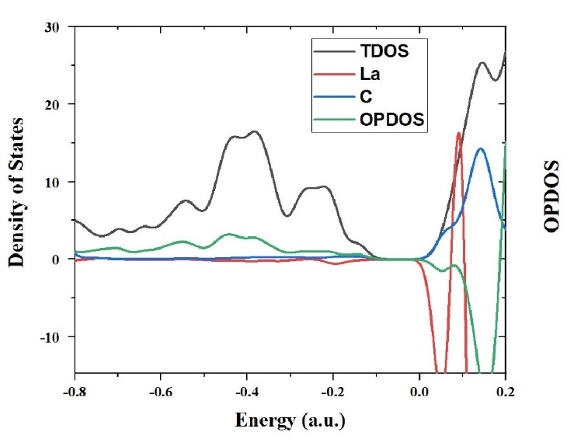
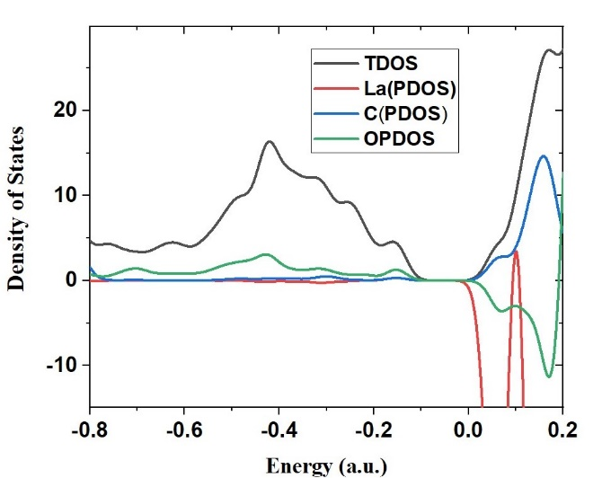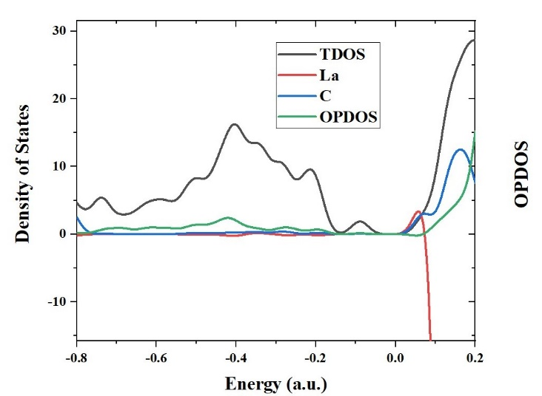
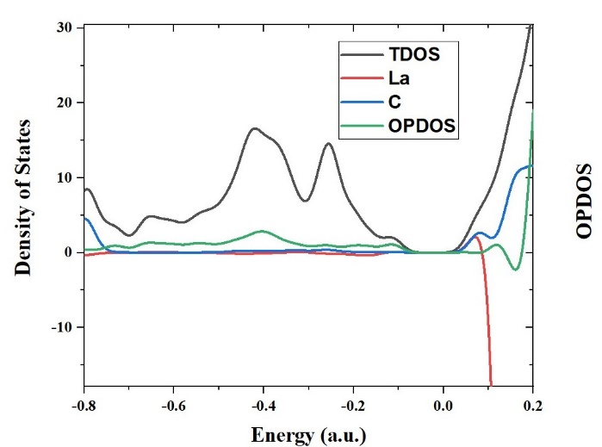
Figure SI.12. TDOS, OPDOS, PDOS of (La(III)), PDOS (Carbon (C) atoms) for (i) AR-Ox-b-La1 (j) AR-Ox-b-La2 (k) AR-Ox-b-La3 (l) AR-Ox-b-La4 (m) AR-Ox-b-La5 complexes.
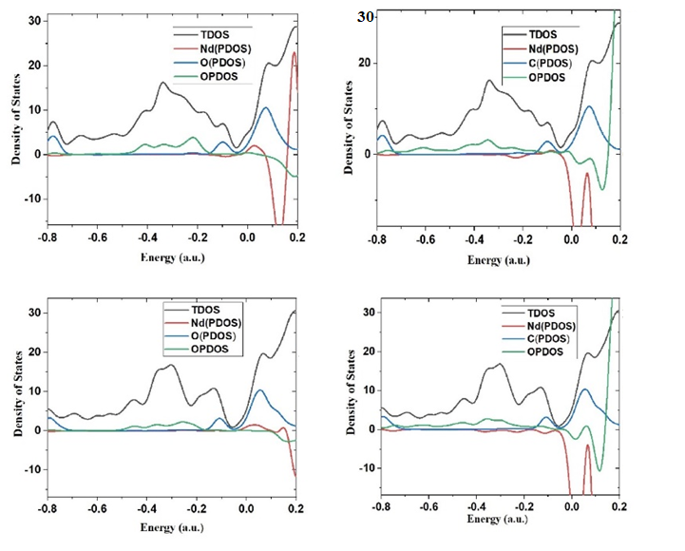
(j)
(i)
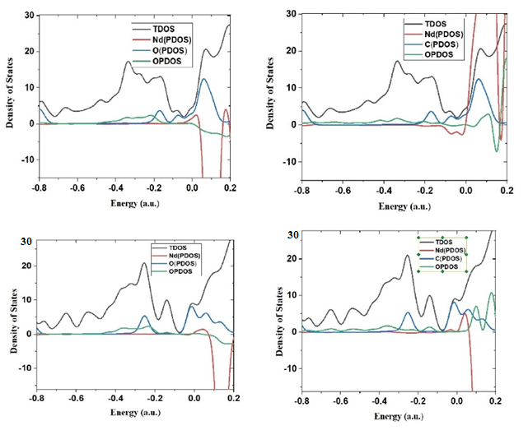
(l)
(k)
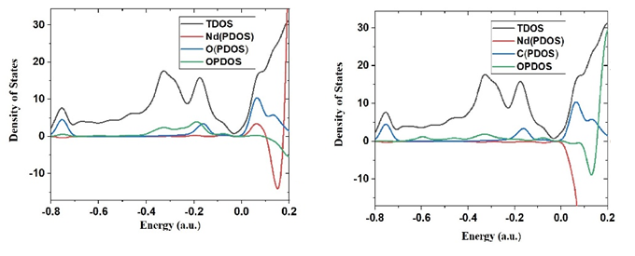
(m)
Figure SI.13. TDOS, OPDOS, PDOS of (Nd(III)) (a) PDOS (Oxygen (O)atoms) (b) PDOS (Carbon (C) atoms) for (i)AR-Ox-b-Nd1 (j) AR-Ox-b-Nd2 (k) AR-Ox-b-Nd2 (l) AR-Ox-b-Nd3 (m) AR-Ox-b-Nd4 complexes.

