Supplementary information associated to the manuscript titled:
Sowing summer grain crops early in late winter: Effects on root growth, water use, and yield
By Dongxue Zhao et al.,

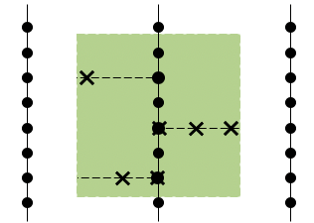
Figure S1. Sampling arrangement. X’s represent equidistant root core sampling locations

Table S1. Fixed effects testing results from the linear mixed model analysis of above-ground biomass, grain yield (GY, t ha⁻¹), grain number (GN, grains m⁻²), grain weight (GW, g per thousand of grains), main stem grain yield (MSGY, t ha⁻¹), main stem grain number (MSGN, grains m⁻²), main stem grain weight (MSGW, g per thousand of grains), tiller yield (TiGY, t ha⁻¹), tiller grain number (TiGN, grains m⁻²), tiller grain weight (TiGW, g per thousand of grains), pre-flowering water use (Pre-WU, mm), post-flowering water use (Post-WU, mm), total water use (TotalWU, mm) and water use efficiency (WUE, kg ha⁻¹ mm⁻¹) for the late winter, spring, and summer sown sorghum in the 2019/20 and 2020/21 seasons. The model used season (S), time of sowing (TOS), irrigation (Irri), plant density (Pop) and genotype (G) and their interactions as fixed factors, and a core nested structure of season and plots as random effects.
Model parameter | GY | GN | GW | MSGY | MSGN | MSGW | TiGY | TiGN | TiGW | PreWU | PostWU | TotalWU | WUE
(Intercept) | <0.0001 | <0.0001 | <0.0001 | <0.0001 | <0.0001 | <0.0001 | 0.001 | <0.0001 | <0.0001 | <0.0001 | 0.0002 | <0.0001 | <0.0001
S | <0.0001 | <0.0001 | 0.003 | <0.0001 | 0.001 | 0.004 | <0.0001 | <0.0001 | 0.001 | <0.0001 | 0.003 | <0.0001 | 0.001
TOS | <0.0001 | <0.0001 | <0.0001 | <0.0001 | <0.0001 | <0.0001 | <0.0001 | <0.0001 |  | <0.0001 | <0.0001 | <0.0001 | <0.0001
Irri | <0.0001 | <0.0001 | 0.408 | <0.0001 | <0.0001 |  | <0.0001 | <0.0001 |  | <0.0001 | <0.0001 | <0.0001 | 0.022
Pop | 0.001 | 0.005 | <0.0001 | <0.0001 | <0.0001 | <0.0001 | <0.0001 | <0.0001 | <0.0001 | <0.0001 |  | <0.0001 | 0.001
G | <0.0001 | <0.0001 | <0.0001 | <0.0001 | <0.0001 | <0.0001 | <0.0001 | <0.0001 | <0.0001 | <0.0001 | <0.0001 | <0.0001 | <0.0001
S: TOS | 0.004 | 0.034 | 0.002 |  |  | 0.002 | <0.0001 | <0.0001 | <0.0001 | <0.0001 | <0.0001 | <0.0001 | 0.0007
S: Irri | 0.021 |  |  |  |  |  | 0.009 |  |  | 0.03 | <0.0001 | <0.0001 | <0.0001
TOS: Irri |  |  |  |  |  |  |  | 0.005 |  | <0.0001 | 0.025 | <0.0001 | 0.005
S: Pop |  |  |  | <0.0001 | <0.0001 |  | <0.0001 | 0.002 | <0.0001 | <0.0001 |  | 0.0001
TOS: Pop |  |  | <0.0001 | 0.004 | 0.041 | <0.0001 | <0.0001 | 0.002 | 0.006 |  |  | <0.0001 | 0.019
Irri: Pop |  |  | 0.006 | 0.009 |  |  |  |  |  |  |  | 0.037
S: G | 0.002 | 0.000 | 0.000 | 0.000 | 0.000 | 0.000 | 0.000 | 0.001 | 0.000 | <0.0001 | <0.0001 | 0.007 | 0.011
TOS: G | 0.011 | 0.005 | 0.000 | 0.000 | 0.000 | 0.000 |  |  | 0.000 | 0.007 | 0.004 | <0.0001 | 0.021
Irri: G |  |  |  |  |  | 0.033 |  |  |  |  |  | 0.006
Pop: G |  |  |  |  |  |  |  |  |  | 0.05 |  | <0.0001
S: TOS: Irri | 0.000 | 0.013 |  |  |  |  | 0.000 | 0.000 |  | <0.0001 | <0.0001 | <0.0001 | <0.0001
S: TOS: Pop |  |  | 0.025 |  |  |  |  |  | 0.000
S: Irri: Pop |  |  |  |  |  |  |  |  |  |  | 0.037
TOS: Irri: Pop |  |  |  |  |  |  |  |  |  |  |  | 0.025
S: TOS: G | 0.000 | 0.001 | 0.008 | 0.000 | 0.001 |  | 0.001 | 0.002 | 0.000 | 0.023 | 0.0001 | 0.002 | 0.0004
S: Irri: G |  |  |  |  |  |  |  |  |  |  | 0.015
TOS: Irri: G |  |  |  |  |  |  |  |  |  |  | <0.0001
S: Pop: G |  |  |  |  |  |  |  |  |  | <0.0001 |  | <0.0001
TOS: Pop: G |  |  |  |  |  |  |  |  |  | 0.003 |  | <0.0001
Irri: Pop: G
S: TOS: Irri: Pop | 0.020 | 0.035 |  |  |  |  |  |  |  |  |  |  | 0.041
S: TOS: Irri: G |  |  |  |  |  |  |  |  |  | 0.002 | <0.0001 | 0.002
S: TOS: Pop: G |  |  |  |  |  |  |  |  |  | <0.0001 |  | <0.0001
S: Irri: Pop: G |  |  |  |  |  |  | 0.046
TOS: Irri: Pop: G
S: TOS: Irri: Pop: G | 0.002 |  |  |  |  |  |  |  |  |  |  |  | 0.014

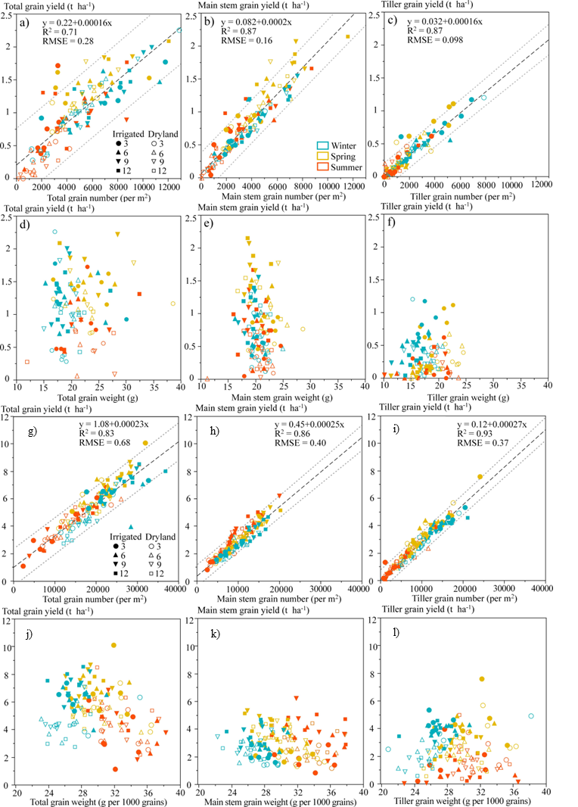
Figure S2. Relationship between grain yield and grain number and grain yield and grain number for the total grain, main stem and tillers in the 2019/20 (a-f) and 2020/21 (g-l) season. The fitted line and the associated 95% prediction interval are given as dashed lines and dotted lines, respectively. Values were estimated means for the three replicates from the linear mixed model as indicated in Table S2.
The relationships between grain yield and grain number were analysed using simple linear regression embedded in JMP 16 (SAS Institute, 2021). The 95% prediction interval was calculated to assess the prediction uncertainty of the linear regression. Values are the predicted means for differences between the four-way interactions (TOS×irrigation×plant density×genotype) at each season.

Table S2. Results from the linear mixed model of root traits, exploring the factorial combination of time of sowing (TOS, late winter, spring, and summer), and irrigation (dryland and irrigation), and their interactions in the 2019/20 and 2020/21 season.
 | 2019-2020 |  |  |  | 2020-2021
 |  | Mean | Term | p |  | Mean | Term | p
Root length  (cm core⁻¹) |  | 663.1 | TOS main effect | 0.000*** |  | 927.7 | ns | > 0.05
Root diameter  (mm) |  | 0.003 | TOS main effect | 0.000*** |  | 0.003 | ns | > 0.05
Total root surface area  (cm² core⁻¹) |  | 4.2 | TOS main effect | 0.014* |  | 5.6 | ns | > 0.05
Root length density  (cm cm⁻³) |  | 0.208 | TOS main effect | 0.000*** |  | 0.291 | ns | > 0.05
Root length: shoot weight  (cm core⁻¹ g⁻¹) |  | 12.3 | TOS main effect | 0.023* |  | 16 | ns | > 0.05
Shoot dry weight  (g pl⁻¹) |  | 46 | TOS × Irrigation main effect | 0.030* |  | 64 | ns | > 0.05
Root dry weight  (g core⁻¹) |  | 0.135 | ns | > 0.05 |  | 0.145 | ns | > 0.05
Root volume  (cm³ core⁻¹) |  | 0.004 | ns | > 0.05 |  | 0.007 | ns | > 0.05
Specific root length  (cm g⁻¹) |  | 5100.7 | ns | > 0.05 |  | 6923.6 | ns | > 0.05

Table S3. Results (p values) from the linear mixed model analysis on the root traits at the across-depth level for the main effects including depth, time of sowing (TOS), and irrigation (Irri) and their interactions for a sorghum crop (Genotype E) sown at 9 pl m⁻² in the 2019-2020 and 2020-2021 seasons at Nangwee, Queensland, Australia.
Source of variation | Root length | Root dry weight | Specific root length | Surface area | Root volume | Root length density | Root diameter
2019-2020
Depth | 0.00*** | 0.000*** | 0.658 | 0.000*** | 0.000*** | 0.000*** | 0.000***
TOS | 0.741 | 0.819 | 0.025* | 0.240 | 0.278 | 0.992 | 0.002**
Irri | 0.225 | 0.480 | 0.673 | 0.366 | 0.189 | 0.186 | 0.240
Depth: TOS | 0.002** | 0.645 | 0.400 | 0.085 | 0.124 | 0.009** | 0.047*
Depth: Irri | 0.245 | 0.691 | 0.368 | 0.274 | 0.795 | 0.032* | 0.550
TOS: Irri | 0.391 | 0.912 | 0.475 | 0.147 | 0.111 | 0.699 | 0.029*
Depth: TOS: Irri | 0.193 | 0.260 | 0.076 | 0.136 | 0.026* | 0.198 | 0.082
2020-2021
Depth | 0.000*** | 0.000*** | 0.166 | 0.000*** | 0.000*** | 0.000*** | 0.000***
TOS | 0.879 | 0.435 | 0.297 | 0.631 | 0.806 | 0.912 | 0.417
Irri | 0.949 | 0.313 | 0.602 | 0.674 | 0.876 | 0.805 | 0.415
Depth: TOS | 0.371 | 0.073 | 0.756 | 0.274 | 0.020* | 0.833 | 0.410
Depth: Irri | 0.881 | 0.445 | 0.154 | 0.609 | 0.085 | 0.874 | 0.071
TOS: Irri | 0.517 | 0.577 | 0.848 | 0.221 | 0.206 | 0.609 | 0.444
Depth: TOS: Irri | 0.225 | 0.500 | 0.447 | 0.692 | 0.525 | 0.473 | 0.021*
Where *, ** and *** represents the significant level ≤ 0.05, ≤ 0.01 and ≤ 0.001, respectively.

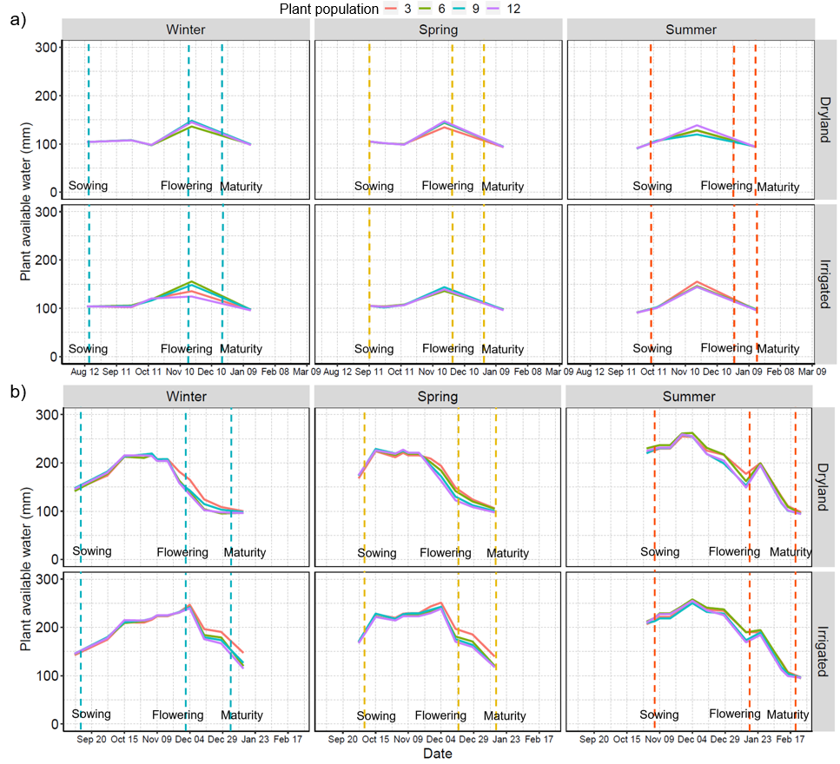
Figure S3. Time course of plant available water content (mm) derived from the electromagnetic induction (EMI) surveys in the (a) 2019-2020 and (b) 2020-2021 seasons at Nangwee, Queensland, Australia. Vertical dashed lines indicate the times of sowing, flowering, and maturity.

