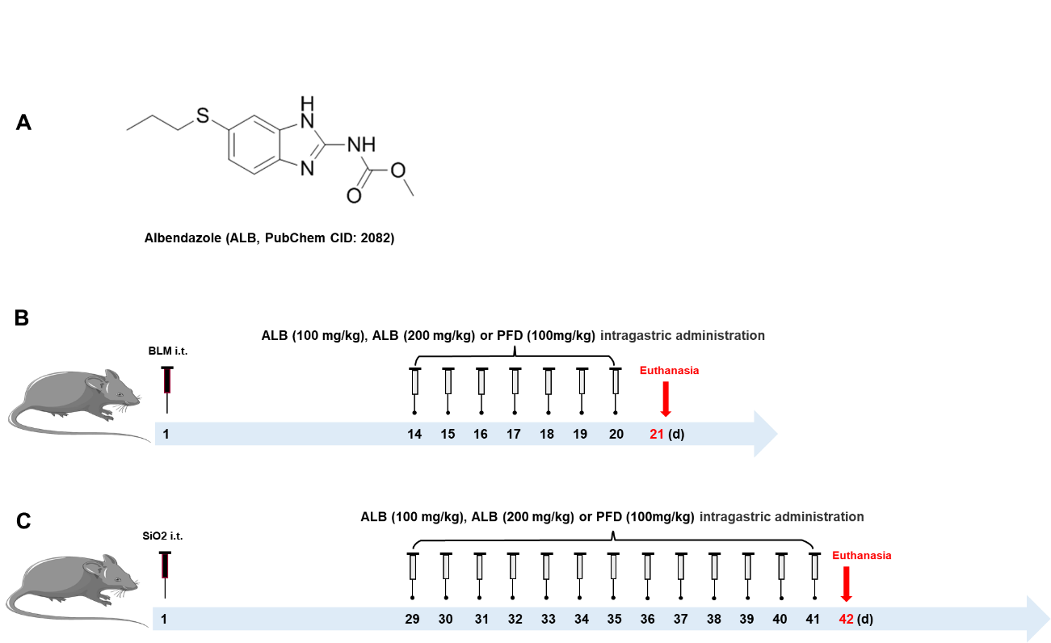
Supplementary figure 1. A: Chemical structure of ALB. B: BLM-induced mouse model of pulmonary fibrosis and the drug-delivery method used for ALB. C: SiO₂-induced mouse model of silicosis and the drug-delivery method used for ALB.
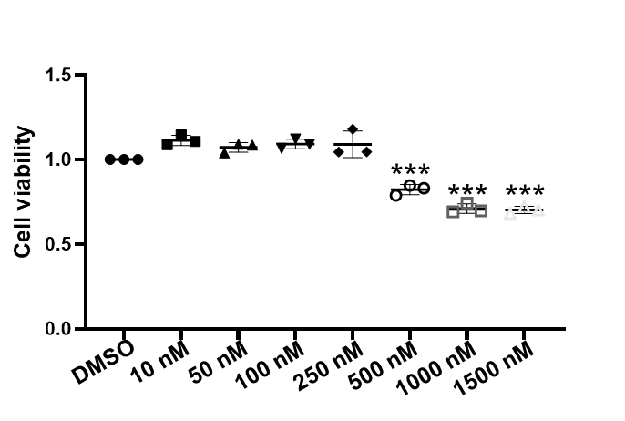
Supplementary figure 2. Effect of ALB on the viability of fibroblasts via CCK8. The data are represented as the mean ± SEM of three independent experiments. ***, p < 0.001.
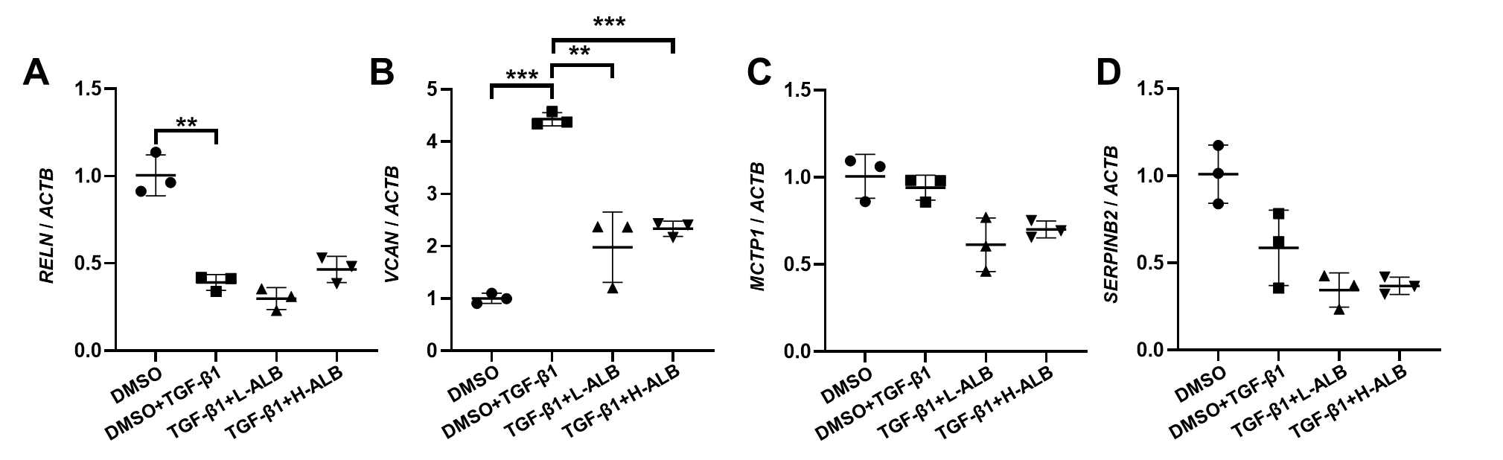
Supplementary figure 3. RT-PCR analysis of RELN (A), VCAN (B) and MCTP1 (C) and SERPINB2 (D) expression in fibroblast following TGF-β and ALB treatment. The data are represented as the mean ± SEM of three independent experiments. **, p < 0.01; ***, p < 0.001.
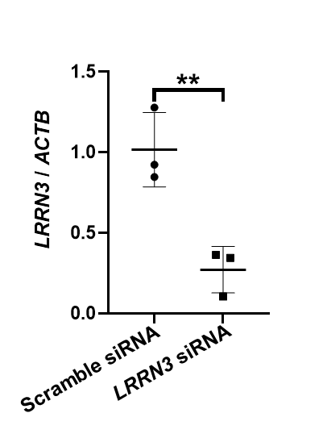
Supplementary figure 4. RT-PCR analysis of LRRN3 in fibroblast following LRRN3 siRNA transduction. The data are represented as the mean ± SEM of three independent experiments. **, p < 0.01.

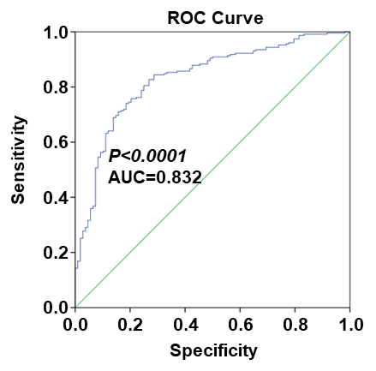
Supplementary figure 5. ROC curve of LRRN3 for IPF diagnosis.

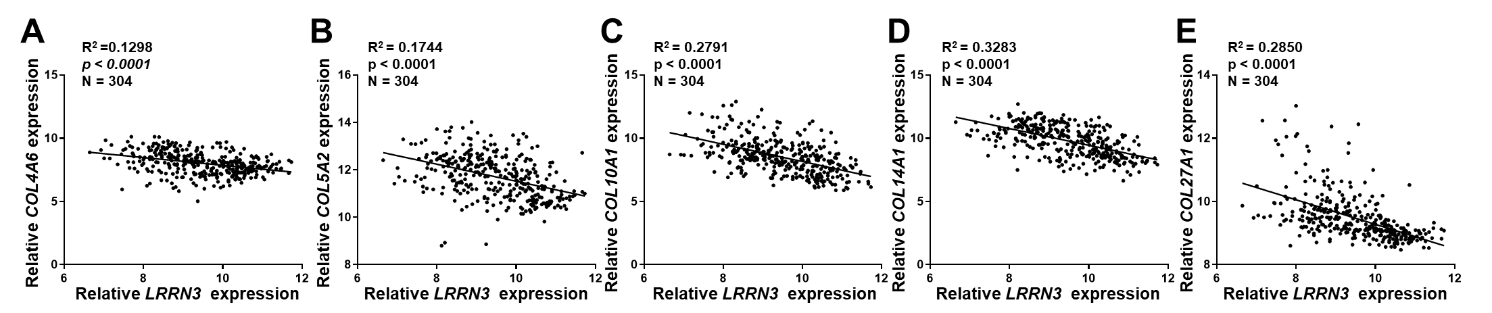
Supplementary figure 6. The correlation between the expression of LRRN3 and COL4A6 (A), COL5A2 (B), COL10A1 (C), COL14A1 (D) and COL17A1 (E) in the dataset of GSE47460.

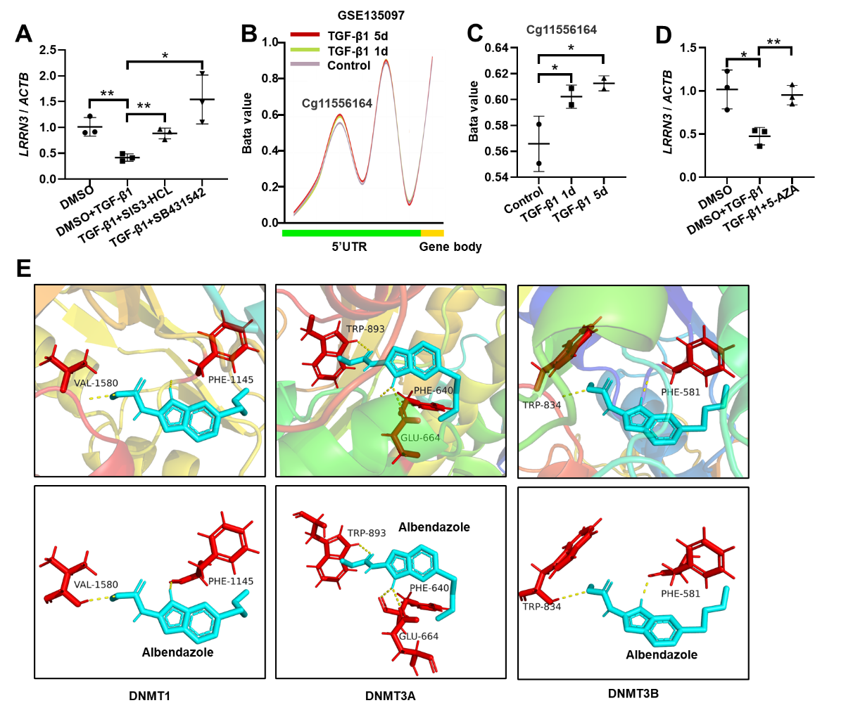
Supplementary figure 7. A: RT-PCR analysis of LRRN3 in fibroblasts following SB431542 and SIS3-HCL treatment. B-C: Distribution characteristics and β-value analysis of CpG sites within the DMRs located in LRRN3. D: RT-PCR analysis of LRRN3 in fibroblasts after 5-aza treatment. E: Prediction diagram for the interaction between Albendazole and DNMT1, DNMT3a and DNMT3b, respectively. The data are represented as the mean ± SEM of three independent experiments. *p < 0.05; **p < 0.01; ***p < 0.001.

