Pre-movement muscle co-contraction associated with motor performance deterioration under high reward conditions

Authors
Naoki Senta¹, Junichi Ushiba², Mitsuaki Takemi^{1*}

Affiliations
- Graduate School of Science and Technology, Keio University, Yokohama, Japan
- Faculty of Science and Technology, Keio University, Yokohama, Japan


Supplementary figure 1. Time course of standard deviation (SD) of endpoint error calculated over trials within a session. Endpoint error is defined as the distance between the ball endpoint and the centerline of the target. Each line represents the performance of one individual. Participants were then categorized as high performers (red lines) or low performers (blue lines) as described in the Materials and methods.
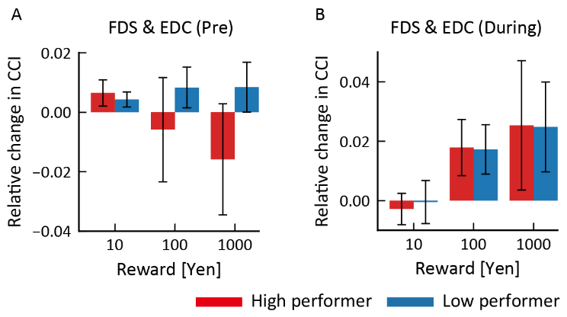
Supplementary figure 2. Changes in co-contraction index (CCI) Changes in CCI for flexor digitorum superficialis (FDS) and extensor digitorum communis (EDC) muscles within the pre-movement period (Pre) and movement period (During). Results for both HP and LP groups are shown as mean ± SEM.
Supplementary table 1. Statistical analysis of CCI modulation by amount of monetary reward and participant subgroups.
Pre movement, ANOVA
Cases | FDS-EDC | FCR-ECR | BB-TB
Reward | F(1.94, 23.22) = 0.33 | F(1.31, 15.67) = 0.91 | F(1.54, 18.44) = 2.63
Subgroup | F(1, 12) = 1.12 | F(1, 12) = 0.02 | F(1, 12) = 3.35
Reward × Subgroup | F(1.94, 23.22) = 0.92 | F(1.31, 15.67) = 1.84 | F(1.54, 18.44) = 4.61*
*p<0.05
During movement, ANOVA
Cases | FDS-EDC | FCR-ECR | BB-TB
Reward | F(1.52, 18.18) = 3.67 | F(1.65, 19.74) = 6.16* | F(1.58, 18.96) = 2.08
Subgroup | F(1, 12) = 9.90×10⁻⁴ | F(1, 12) = 1.48 | F(1, 12) = 1.57
Reward × Subgroup | F(1.52, 18.18) = 0.01 | F(1.65, 19.74) = 2.54 | F(1.58, 18.96) = 0.47
*p<0.05
Post-Hoc test, BB-TB CCI in pre-movement
Subgroup, Reward (Yen) | Subgroup, Reward (Yen) | t value
HP, 1 | LP, 1 | 1.36×10⁻¹⁵
 | HP, 10 | 0.21
 | HP, 100 | 0.85
 | HP, 1,000 | 0.36
LP, 1 | LP, 10 | -0.33
 | LP, 100 | -0.35
 | LP, 1,000 | -3.86*
HP, 10 | LP, 10 | -0.52
 | HP, 100 | -1.06
 | HP, 1,000 | 0.15
LP, 10 | LP, 100 | -0.02
 | LP, 1,000 | -3.53*
HP, 100 | LP, 100 | 0.48
 | HP, 1,000 | 1.21
LP, 100 | LP, 1,000 | -3.51*
HP, 1000 | HP, 1,000 | -4.05**
*p<0.05, **p<0.01, corrected
Post-Hoc test, FCR-ECR CCI during movement
Reward (Yen) | Reward (Yen) | t value
1 | 10 | -0.21
 | 100 | -1.62
 | 1,000 | -3.81*
10 | 100 | -1.41
 | 1,000 | -3.60*
100 | 1,000 | -2.19
*p<0.05, corrected

