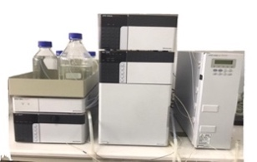
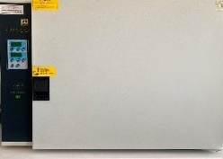
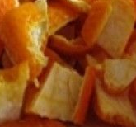
Grapefruit peel
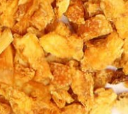
Phenolics
*Catechin
*Rutin
*Kaempferol
*Coumaric acid
Fatty acids
*Oleic
*Linoleic
*Palmitic

Conventional treatment
Mandarin peel
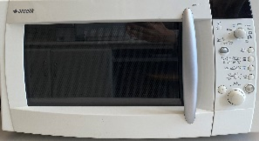
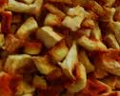
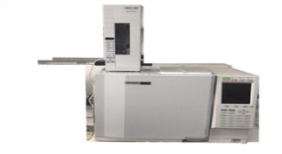
Orange peel

Microwave treatment

Graphical Abstract: In this study, the effects of oven and microwave drying techniques on antioxidant capacity values, total phenol, carotenoid, flavonoid results, fatty acids, and individual phenolic constituents of bitter orange, mandarin and grapefruit peels were investigated.

