Title: A comprehensive tool in recycling plant-waste of Gossypium barbadense L agricultural and industrial waste extracts containing Gossypin and Gossypol: Hepatoprotective, anti-inflammatory and antioxidant effects

Mona A. Mohammed¹*, Nagat M. Amer², Heba M. I. Abdallah ³, Mai S. Saleh²

^{1*} Medicinal and Aromatic Plants Research Department, Pharmaceutical and Drug Industries Research Institute, National Research Centre, Dokki, Giza, Egypt. Affiliation ID: 60014618.

² Environmental and Occupational Medicine Department, Environmental and Climate Change Research Institute, National Research Centre, Dokki, Giza, Egypt

³ Pharmacology Department, Medical Research and Clinical Studies Institute, National Research Centre, Dokki, Giza, Egypt

*Corresponding authors.
Mona A. Mohammed: on.ibrahim@ nrc.sci.eg
monaarafamohammed@yahh.com

STD
 | ConC. µg/ml | Area
Gossypin | 10 | 430.66
Gossypol | 20 | 420.01
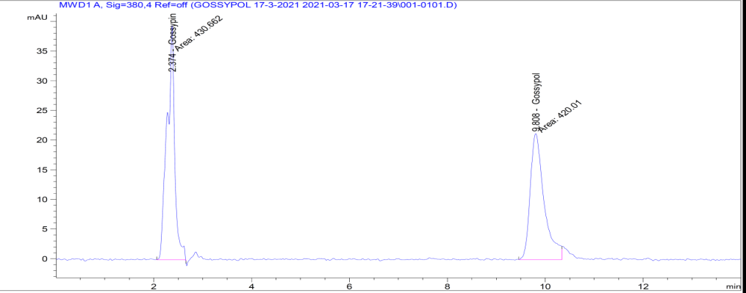

Fig S1 HPLC of standard Gossypin and Gossypol.

Total Agricultural _waste

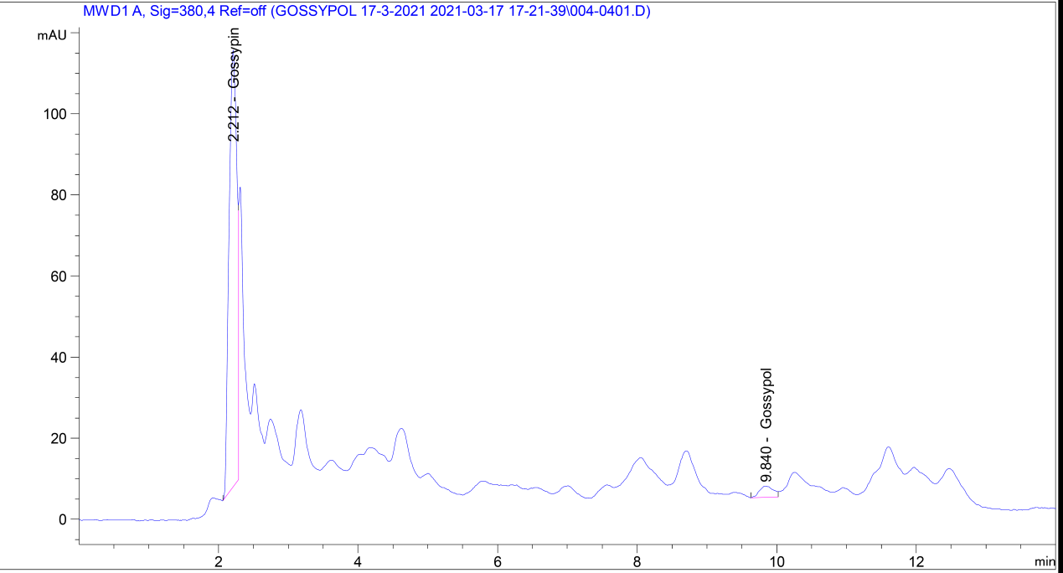
Pet. Ether_ Fraction

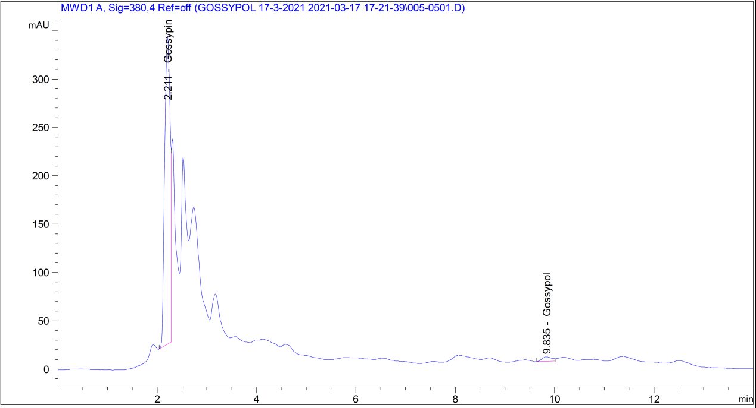
CH₂CL₂_ Fraction

EtOAc_Fraction
_ fraction

BuOH_Fraction
_ fraction

H₂O_Fraction
_ fraction

Pre_H₂O_Fraction
_ fraction

Industrial waste
_ fraction

Fig S2 Determination of gossypin and gossypol by HPLC in eight samples.

Table S1. In vitro ABTS+ and DPPH antioxidant activity of Standards.
Sample/ Conc µg/ml | DPPH |  |  |  | ABTS
Sample/ Conc µg/ml | vit C | trolox | Gossypin | Gossypol | vitc | trolox | Gossypin | Gossypol
30 | 100 ± 0.00 | 100 ± 0.00 | 100 ±0.00 | 100 ± 0.0 | 100 ± 0.00 | 100 ± 0.00 | 100 ± 0.00 | 100 ± 0.02
20 | 78.80 ± 0.56 | 80.35 ± 0.52 | 90.25 ± 0.25 | 100 ± 0.0 | 90.23 ± 0.85 | 83.55 ± 0.81 | 90.25 ± 0.25 | 100 ± 0.23
10 | 70.91 ± 0.89 | 75.58 ± 0.75 | 80.26 ± 0.21 | 90.25 ± 0.12 | 83.63 ± 0.86 | 80.77 ± 1.02 | 73.26 ± 0.54 | 82.25 ± 0.25
5 | 65.62 ± 0.94 | 60.59 ± 0.85 | 70.26 ± 0.54 | 80.26 ± 0.09 | 40.03 ± 0.99 | 63.42 ± 0.85 | 71.32 ± 0.69 | 70.26 ± 0.15
2.5 | 24.93 ± 0.33 | 37.20 ± 0.42 | 60.32 ± 0.69 | 70.26 ± 0.25 | 26.19 ± 0.25 | 45.21 ± 0.89 | 52.00 ± 0.25 | 68.25 ± 0.02
1.5 | 20.51 ± 0.52 | 30.55 ± 0.96 | 50 ± 0.25 | 70.32 ± 0.15 | 20.52 ± 0.65 | 24.20 ± 0.85 | 39.56 ± 0.12 | 42.00 ± 0.25
1 | - | - | 40.56 ±0.12 | 50.23 ± 0.45 | - | - | - | -
IC50 | 3.078 | 5.168 | 4.249 | 2.024 | 0.1107 | 0.7652 | 4.728 | 2.738

Table S2. In vitro DPPH antioxidant activity of different extracts cotton waste.
DPPH/Conc  Ug/ml | 1 | 2 | 3 | 4 | 5 | 6 | 7 | 8
20 | 92.36 ± 0.07 | 89.190± 0.05 | 90.23 ± 0.05 | 90.44 ± 0.070 | 79.37 ± 0.070 | 86.70 ± 0.20 | 65.68 ± 0.07 | 89.79 ± 0.18
15 | 86.52 ± 0.04 | 86.70 ± 0.00 | 80.32 ± 0.04 | 90.20 ±0.07 | 72.82 ± 0.07 | 83.85 ±0.00 | 48.84 ± 0.07 | 70.26 ± 0.14
10 | 85.62 ± 0.08 | 83.16 ±0.08 | 67.45 ± 0.07 | 90.10 ± 0.00 | 64.40 ± 0.12 | 78.92 ± 0.08 | 35.41 ± 0.14 | 60.56 ±0.07
5 | 83.50 ± 0.08 | 80.06± 0.08 | 45.74 ± 0.01 | 85.91± 0.08 | 56.47± 0.08 | 77.69± 0.01 | 23.58± 0.00 | 50.35 ± 0.16
2.5 | 60.28 ± 0.06 | 52.86± 2.46 | 40.42 ± 0.05 | 70.21± 0.07 | 30.25± 0.01 | 60.27± 0.04 | 5.27± 0.04 | 45.70 ± 0.37
1 | 41.24± 0.01 | 40.25± 0.02 | 27.72± 0.08 | 60.29± 0.05 | - | 42.33± 0.02 | - | 35.26± 0.05
0.5 | - | - | 10.28± 0.06 | 40.42 ± 0.08 | - | - | - | -
IC50 | 1.056 | 1.894 | 10.12 | 0.6612 | 0.8908 | 1.094 | 42.05 | 2.892
- 1=total agricultural waste , 2=pet ether fraction, 3=dichloromethane fraction, 4=ethylacetate fraction, 5=butanol fraction,6= water fraction, 7=pre_H2O fraction and 8=industrial fraction
Table S3. In vitro ABTS⁺ antioxidant activity of different extracts cotton waste.
ABTS/Conc  Ug/ml | 1 | 2 | 3 | 4 | 5 | 6 | 7 | 8
20 | 90.06 ± 0.04 | 89.56 ± 0.13 | 60.24 ± 0.01 | 90.76 ± 0.13 | 88.33 ± 0.04 | 89.84 ± 0.47 | 77.35 ± 4.84 | 90.21 ± 0.13
15 | 89.20 ± 0.01 | 88.92 ± 0.01 | 53.68 ± 0.27 | 90.12 ± 0.13 | 84.76 ± 0.23 | 89.29 ± 0.01 | 81.16 ± 0.01 | 90.21± 0.13
10 | 83.65 ± 0.01 | 87.81 ± 0.27 | 35.28 ± 0.42 | 88.82 ± 0.32 | 81.99± 0.01 | 78.44 ± 0.32 | 48.56± 0.89 | 82.17 ± 0.16
5 | 76.74 ± 0.02 | 80.22 ± 0.06 | 20.24 ± 0.03 | 84.30 ± 0.16 | 79.04 ± 0.16 | 75.26 ± 0.01 | 42.84 ± 0.42 | 70.35 ± 0.16
2.5 | 60.25 ± 0.01 | 60.28 ± 0.04 | 5.18 ± 0.11 | 70.21± 0.08 | 40.24 ± 0.03 | 60.27 ± 0.05 | 30.25 ± 0.01 | 57.71 ± 0.37
1 | 40.25 ± 0.01 | 41.62 ± 0.60 | - | 60.37 ± 0.15 | 40.24 ± 0.02 | 41.538 1.35 | - | 45.31± 0.05
0.5 | - | - | - | - | - | 48.48 ± 0.42 | - | -
IC50 | 1.519 | 1.252 | 18.18 | 1.366 | 0.9706 | 1.927 | 34.78 | 4.461
- 1=total agricultural waste , 2=pet ether fraction, 3=dichloromethane fraction, 4=ethylacetate fraction, 5=butanol fraction,6= water fraction, 7=pre_H2O fraction and 8=industrial fraction

