Appendix I

Appendix I presents the geometry of under-study structure, giving details for concrete and steel members.

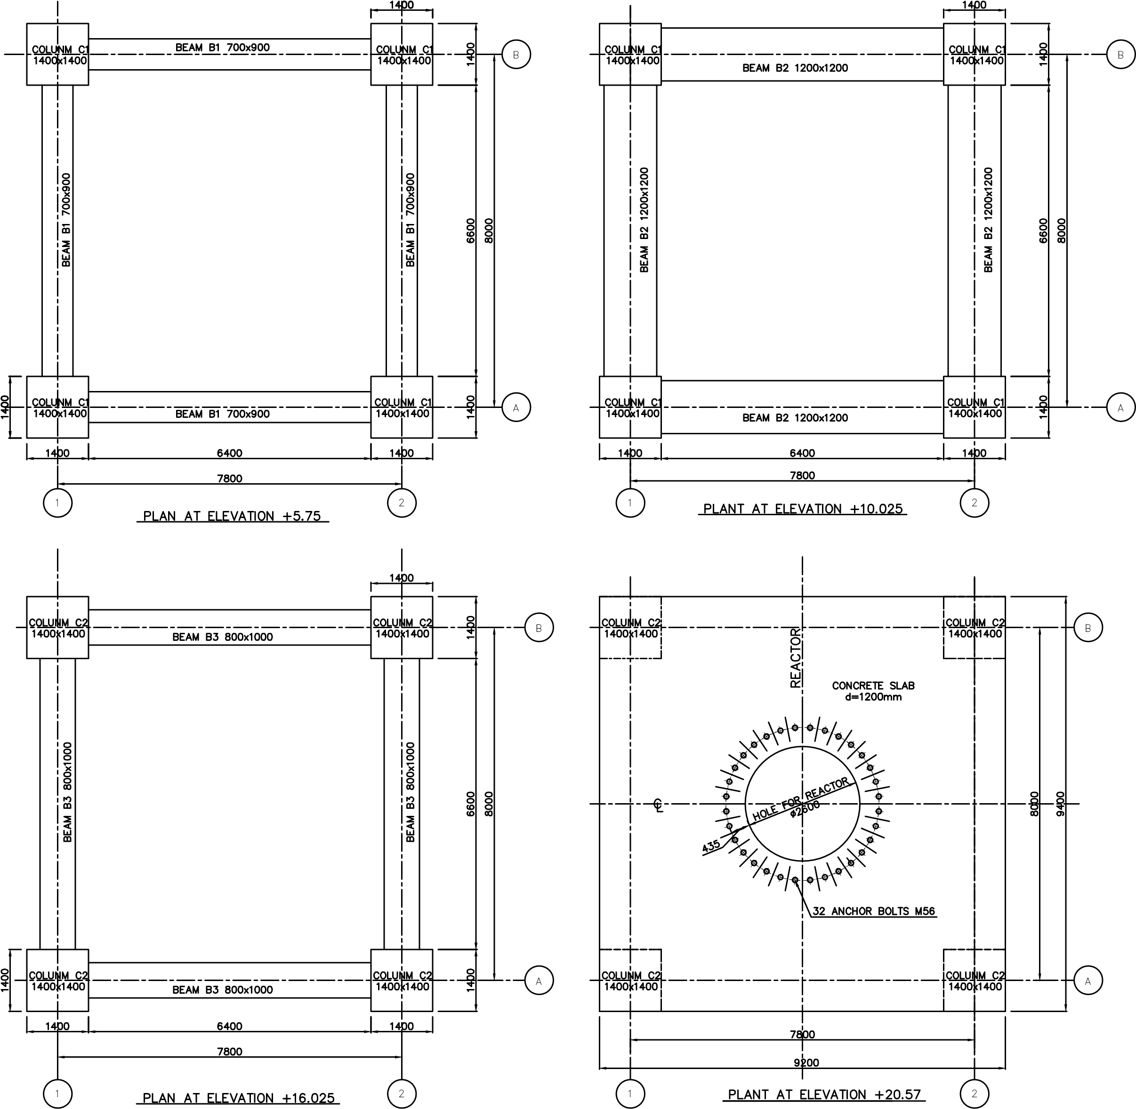

Figure 25: Concrete members of structure, elevations +5.75m, +10.025m, +16.025m & +20.57m

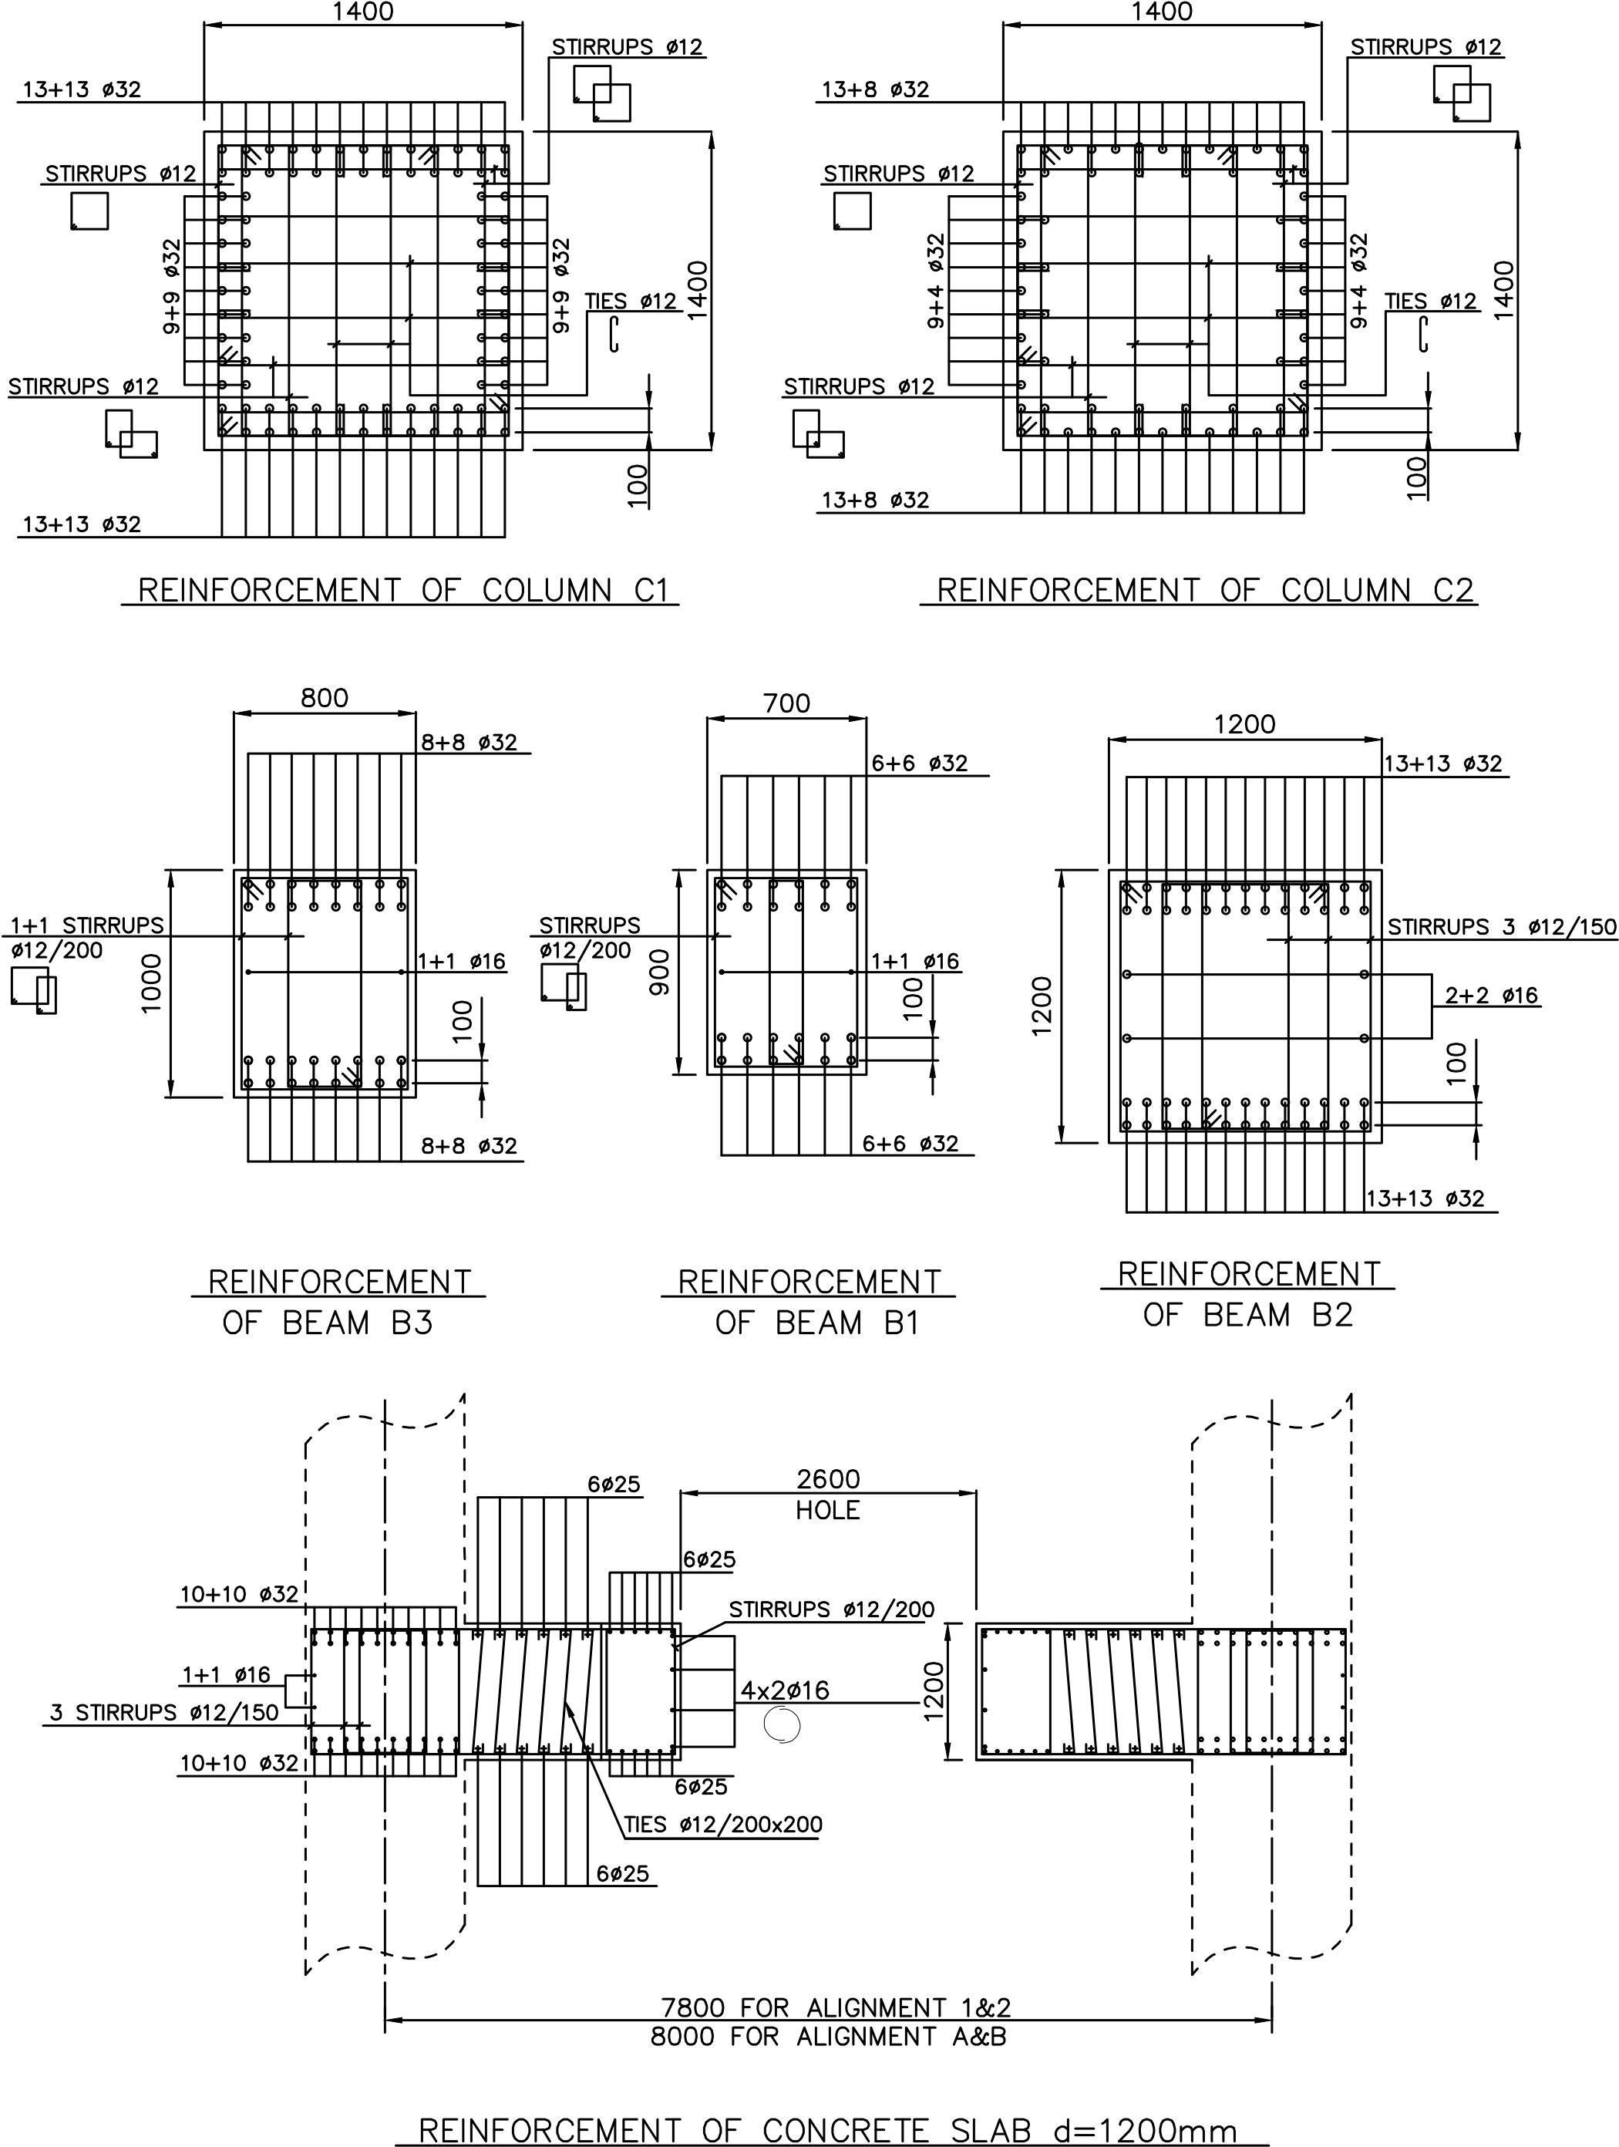

Figure 26: Details of reinforcement for concrete columns C1, C2, concrete beams B1, B2, B3 and concrete slab d=1200mm

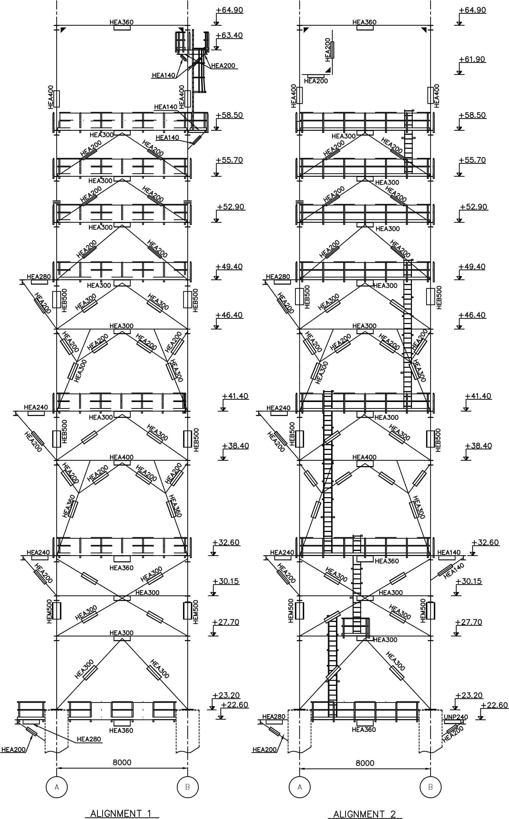

Figure 27: Detail presentation of steel sections for alignments 1 & 2
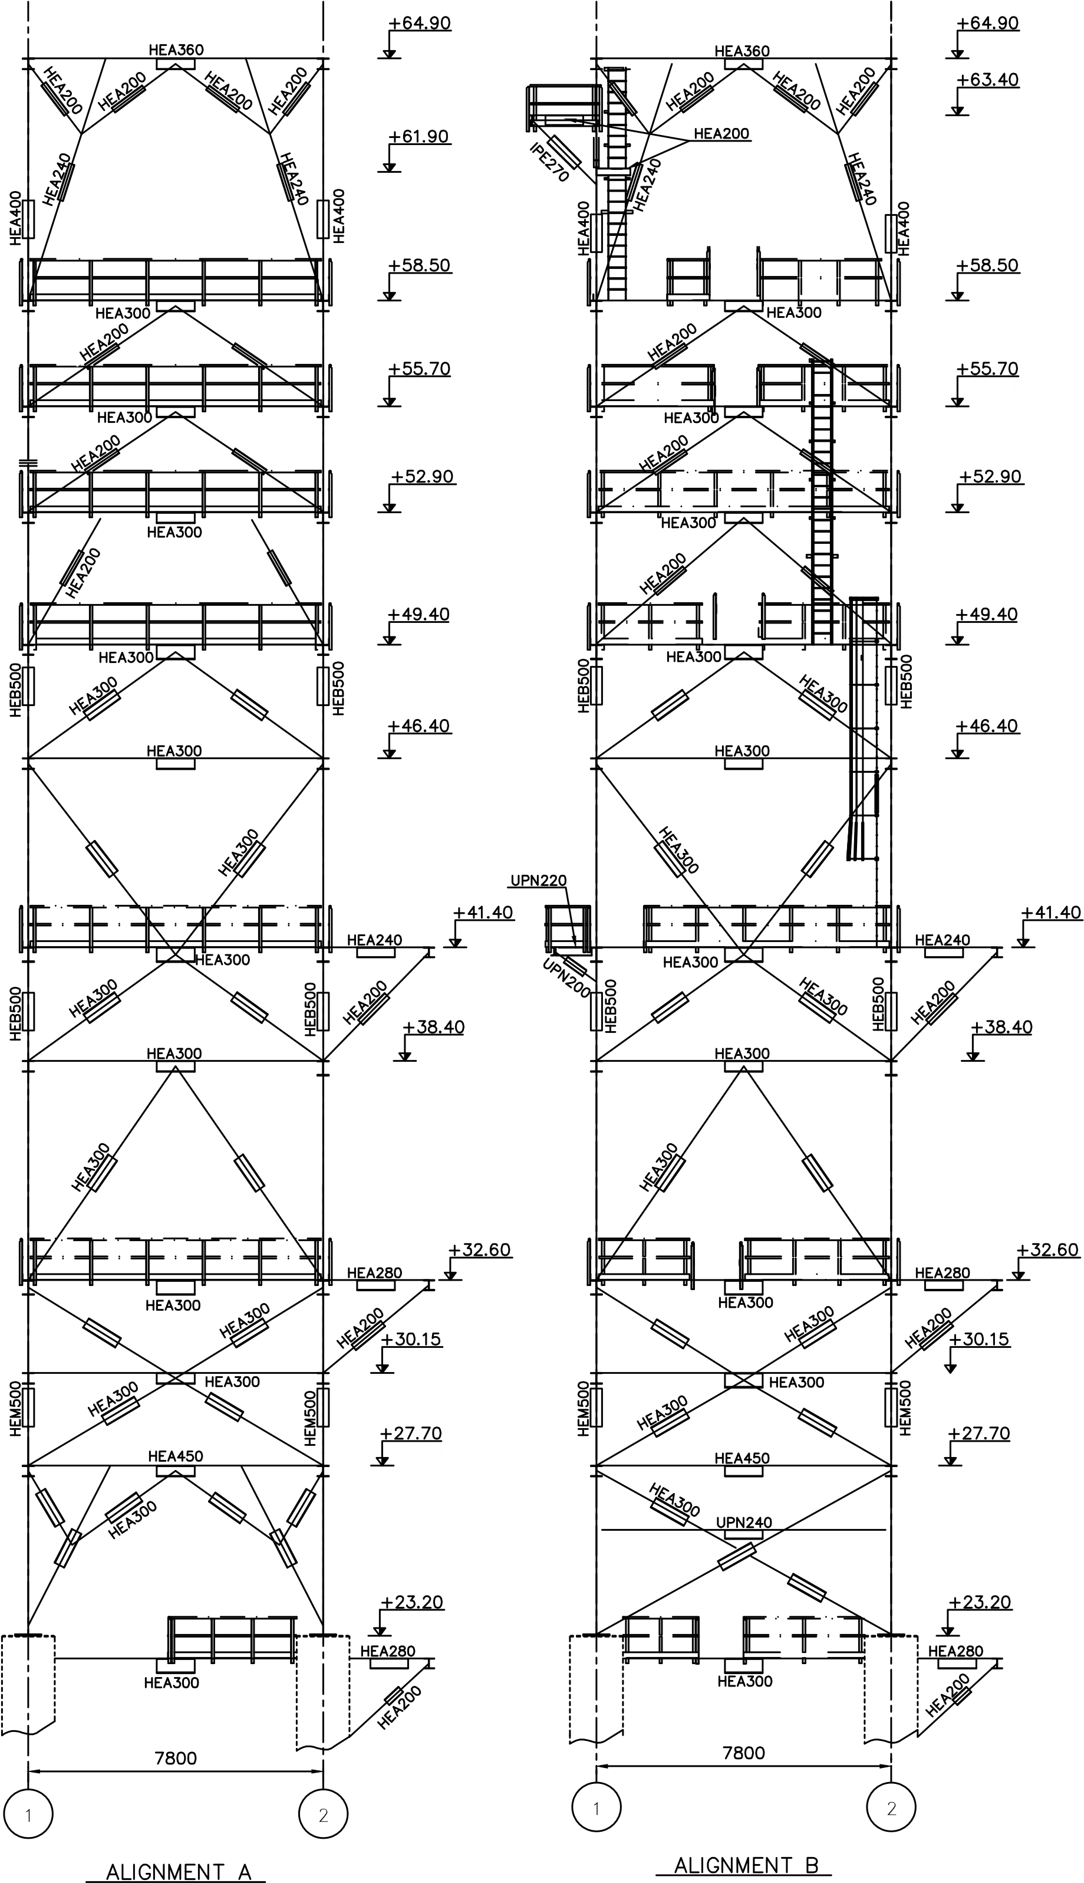

Figure 28: Detail presentation of steel sections for alignments A & B

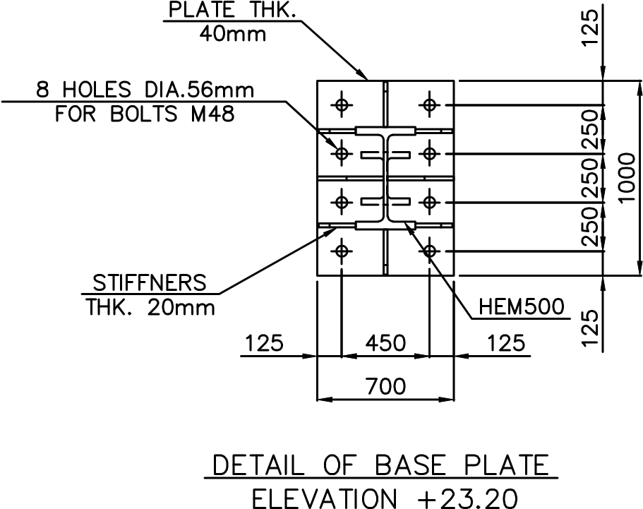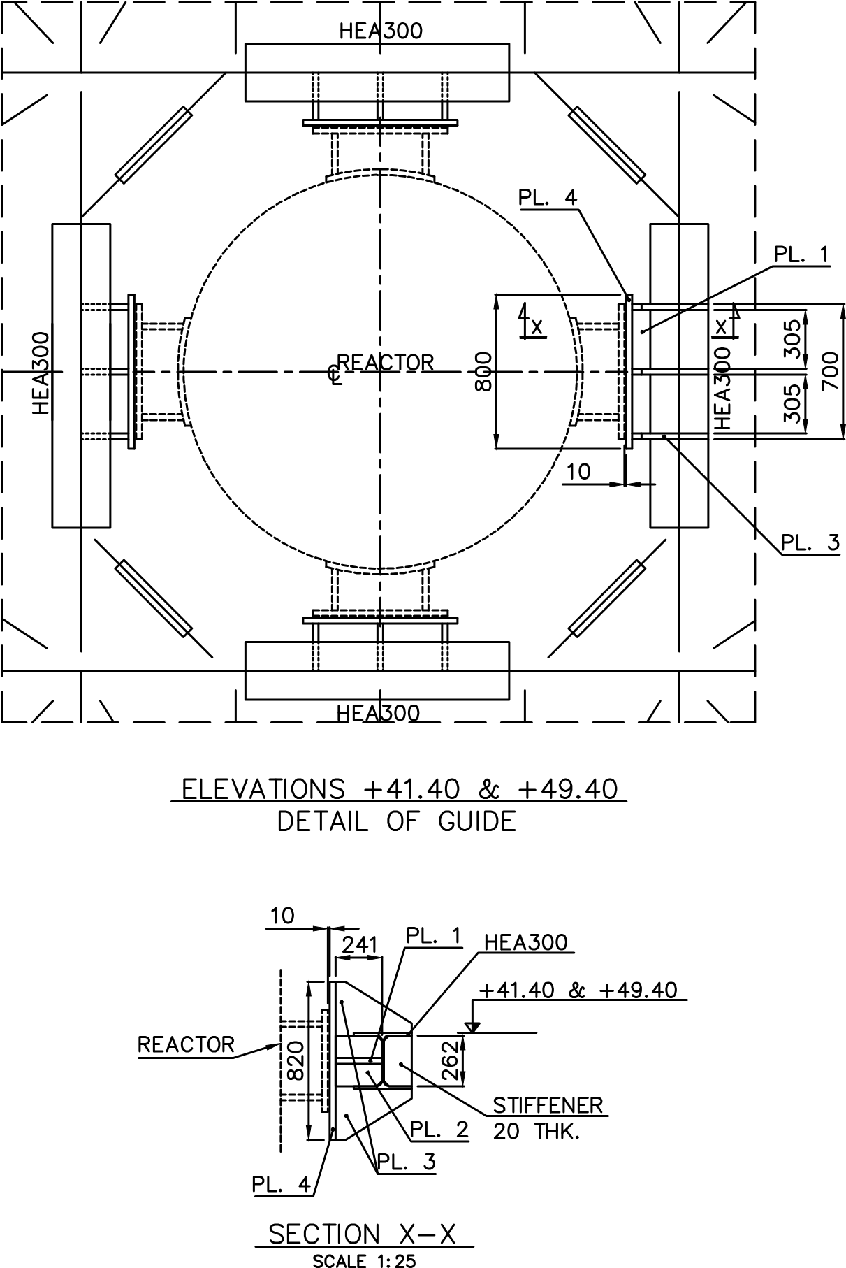

Figure 29: (left) Detail of base plate-connection between concrete and steel members of structure, (right) detail of guides

Appendix II

Table 7. Number of modes, modal mass participation and cumulative modal mass participation
Nº Mode | Period | Mass Participation UX | Mass Participation UY | Mass Participation RZ | SumUX | SumUY | SumRZ
 | Sec | % | % | % | % | % | %
1 | 0,957219 | 0,967 | 67,919 | 0,196 | 0,967 | 67,919 | 0,196
2 | 0,945865 | 69,854 | 0,996 | 0,21 | 70,82 | 68,915 | 0,406
3 | 0,562138 | 2,871 | 0,488 | 67,064 | 73,691 | 69,402 | 67,47
4 | 0,548923 | 0,033 | 15,169 | 0,488 | 73,724 | 84,571 | 67,958
5 | 0,502866 | 11,927 | 0,004982 | 8,421 | 85,651 | 84,576 | 76,379
6 | 0,415466 | 0,001434 | 0,005122 | 0,000187 | 85,652 | 84,582 | 76,379
7 | 0,354485 | 0,000161 | 1,434 | 0,044 | 85,653 | 86,016 | 76,423
8 | 0,313689 | 0,008231 | 5,3E-06 | 0,005944 | 85,661 | 86,016 | 76,429
9 | 0,300984 | 7,59E-06 | 0,024 | 4,53E-05 | 85,661 | 86,04 | 76,429
10 | 0,288807 | 0,000752 | 0,005456 | 0,001806 | 85,662 | 86,045 | 76,431
11 | 0,283306 | 0,000138 | 2,1E-05 | 7,528 | 85,662 | 86,045 | 83,959
12 | 0,265434 | 0,00124 | 0,006798 | 0,001207 | 85,663 | 86,052 | 83,96
13 | 0,253271 | 0,155 | 0,00052 | 1,83E-05 | 85,818 | 86,052 | 83,96
14 | 0,225109 | 0,131 | 0,002107 | 0,000436 | 85,949 | 86,055 | 83,961
15 | 0,217151 | 0,15 | 3,43E-05 | 0,004178 | 86,099 | 86,055 | 83,965
16 | 0,213064 | 0,755 | 1,36E-05 | 0,012 | 86,854 | 86,055 | 83,977
17 | 0,207652 | 0,346 | 0,089 | 4,45E-08 | 87,2 | 86,143 | 83,977
18 | 0,206271 | 0,145 | 0,186 | 0,008381 | 87,345 | 86,329 | 83,985
19 | 0,20189 | 0,001598 | 0,001852 | 7,22E-06 | 87,347 | 86,331 | 83,985
20 | 0,198655 | 1,2E-06 | 6,44E-06 | 5,63E-09 | 87,347 | 86,331 | 83,985
21 | 0,19782 | 0,000557 | 0,016 | 1,71E-06 | 87,347 | 86,347 | 83,985
22 | 0,190019 | 5,63E-06 | 5,03E-06 | 6,44E-06 | 87,347 | 86,347 | 83,985
23 | 0,186339 | 3,02E-05 | 0,005371 | 1,33E-05 | 87,347 | 86,352 | 83,985
24 | 0,185891 | 5,09E-07 | 0,000187 | 6,49E-07 | 87,347 | 86,353 | 83,985
25 | 0,174565 | 0,00033 | 0,000127 | 1,02E-06 | 87,348 | 86,353 | 83,985
26 | 0,172806 | 0,000853 | 0,09 | 0,000526 | 87,349 | 86,443 | 83,986
27 | 0,168884 | 0,091 | 3,874 | 0,034 | 87,44 | 90,317 | 84,02
28 | 0,168488 | 0,016 | 1,211 | 0,00187 | 87,456 | 91,528 | 84,022
29 | 0,167333 | 0,001007 | 0,001862 | 5,2E-05 | 87,457 | 91,53 | 84,022
30 | 0,163062 | 1,9E-06 | 6,91E-05 | 9,83E-08 | 87,457 | 91,53 | 84,022
31 | 0,162084 | 0,065 | 0,012 | 0,003067 | 87,522 | 91,542 | 84,025
32 | 0,160661 | 4,456 | 0,165 | 0,265 | 91,977 | 91,707 | 84,29
33 | 0,159441 | 0,00201 | 7,86E-05 | 5,1E-05 | 91,979 | 91,707 | 84,29
34 | 0,157816 | 0,009607 | 0,213 | 0,004112 | 91,989 | 91,92 | 84,294
35 | 0,157376 | 0,009214 | 0,00153 | 0,000486 | 91,998 | 91,921 | 84,295
36 | 0,156613 | 0,105 | 0,465 | 0,0002 | 92,103 | 92,387 | 84,295
37 | 0,153689 | 0,051 | 0,007271 | 0,006277 | 92,154 | 92,394 | 84,301
38 | 0,151225 | 1,43E-05 | 0,004332 | 0,000381 | 92,154 | 92,398 | 84,301
39 | 0,150492 | 1,756 | 0,596 | 0,464 | 93,91 | 92,994 | 84,765
40 | 0,147319 | 0,142 | 0,374 | 0,105 | 94,052 | 93,367 | 84,871
41 | 0,145611 | 2,82E-05 | 0,000135 | 2,86E-05 | 94,052 | 93,368 | 84,871
42 | 0,14298 | 0,023 | 0,374 | 0,031 | 94,075 | 93,741 | 84,901
43 | 0,142643 | 0,017 | 0,394 | 0,026 | 94,092 | 94,135 | 84,927
44 | 0,136334 | 0,00921 | 0,022 | 1,03E-05 | 94,102 | 94,157 | 84,927
45 | 0,135456 | 9,98E-05 | 0,000135 | 2,79E-07 | 94,102 | 94,158 | 84,927
46 | 0,133697 | 0,09 | 0,003162 | 0,156 | 94,192 | 94,161 | 85,084
47 | 0,132063 | 9,74E-12 | 2,43E-10 | 1,17E-09 | 94,192 | 94,161 | 85,084
48 | 0,132061 | 1,86E-11 | 8,62E-10 | 2,83E-12 | 94,192 | 94,161 | 85,084
49 | 0,130424 | 0,002651 | 0,000886 | 0,553 | 94,194 | 94,162 | 85,637
50 | 0,128353 | 0,00057 | 0,008942 | 0,24 | 94,195 | 94,171 | 85,877
51 | 0,1276 | 0,000752 | 0,015 | 0,000172 | 94,196 | 94,185 | 85,877
52 | 0,126119 | 0,01 | 0,001999 | 5,254 | 94,206 | 94,187 | 91,131

