Appendix
The appendix contains Figure S1 and Figure S2, cited in the text.
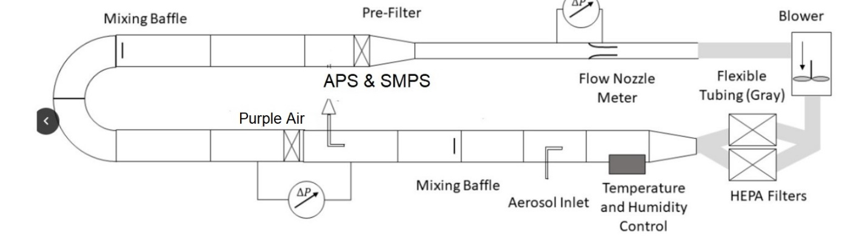Figure S1. A Schematic Diagram of the ASHRAE 52.2 Standard Recirculating Wind Tunnel System Used for Calibration.

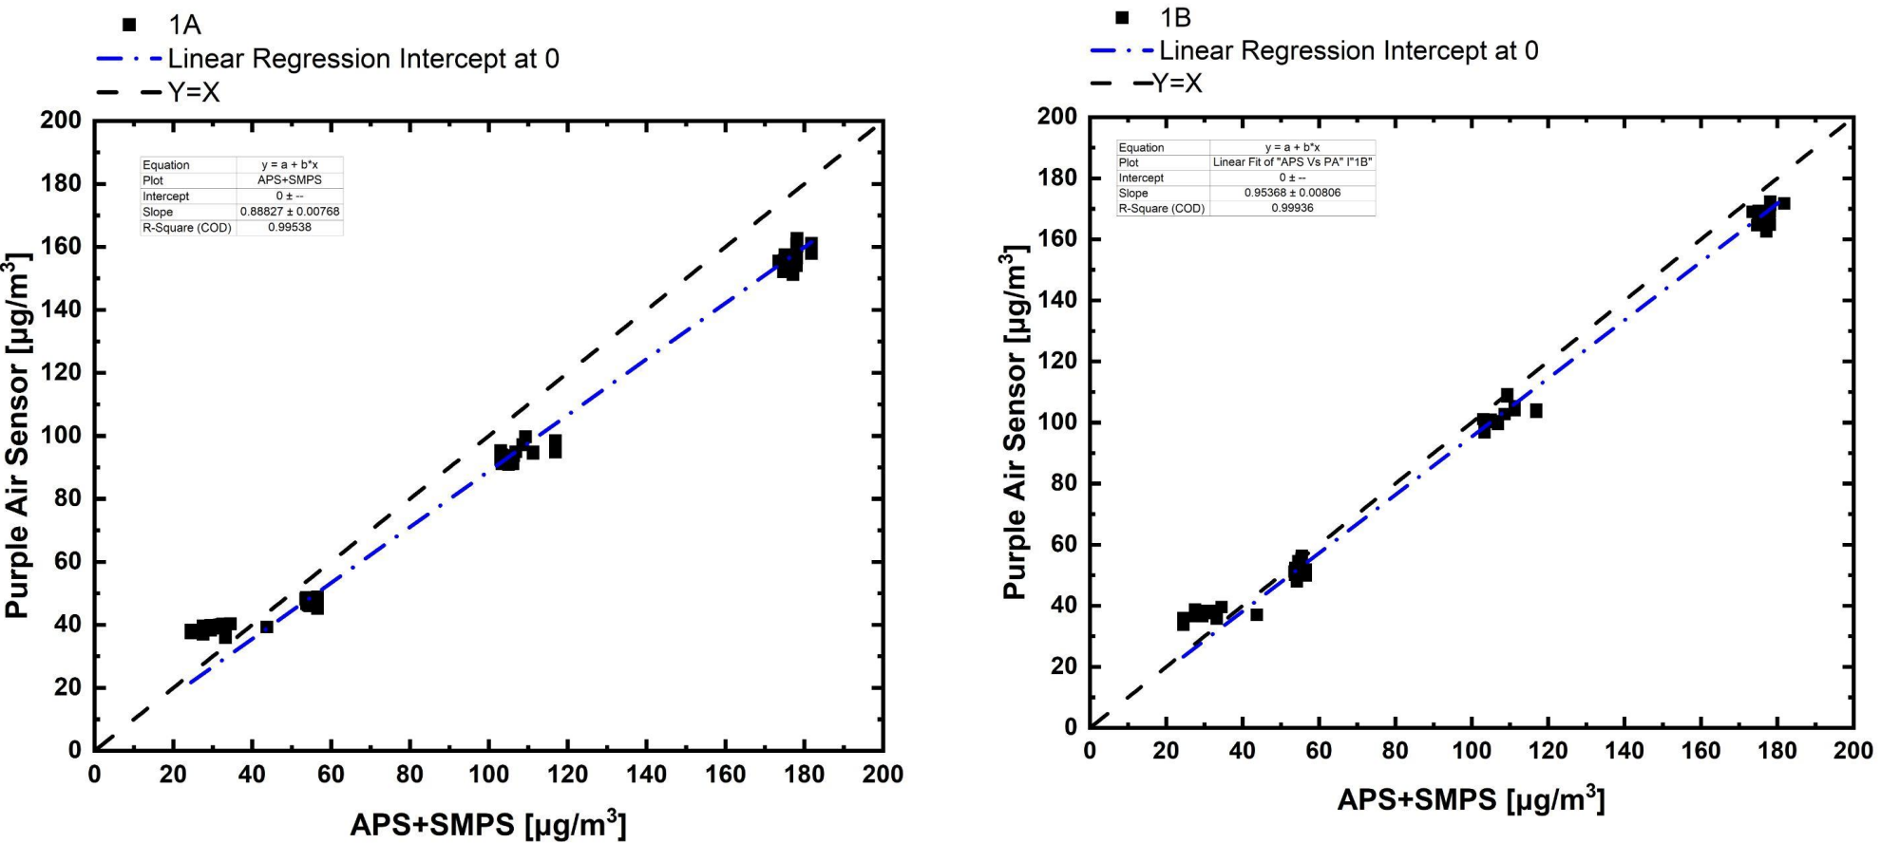
Figure S2. Example of linear calibration regressions for one Purple Air sensor: calibration of Channel A is on the left, and calibration of Channel B is on the right.

Survey Questions

Start of Block: Introduction

Home Intro
Home Environment Survey
The purpose of the following survey is to allow us to better understand your current home environment.
We ask that you complete this survey while you are at home. If you have any questions throughout the process, please contact to Well Living Lab Representative at 507-258-4192.

End of Block: Introduction

Start of Block: General Home Information

Reside_Year How many months have you been living in your current place? Please answer it as month (i.e., 3 year 2 months -> 38 months)
________________________________________________________________

MM080_HC30 Type of housing:
- House (1)
- Flat/Apartment (2)
- Other (3) ________________________________________________

House Size Size of your home:
- < 1000 ft2 (1)
- 1000 - 2000 ft2 (2)
- 2000 - 4000 ft2 (3)
- > 4000 ft2 (4)

House Heating Heating:
- Electric Heating (1)
- Central Air HVAC Heating (2)
- Radiators (4)
- Don't Know (3)

House Ventiliation How do you ventilate your house?
- I can open Windows/Doors to access outdoor air (Natural Ventilation) (1)
- I have a Central Air or similar system (Mechanical Ventilation) (2)
- I can open Windows and Doors or use Central Air or similar system (Hybrid System) (3)
- I don't know (4)

Stove Type What type of stove top you have at home?
- Electric (1)
- Gas (2)
- I don't know (4)
- Others (3) ________________________________________________

MM080_HC34 Please answer the following questions.
 | Yes (1) | No (2)
Is there wall-to-wall carpeting in your room? (1)
Are there furry animals or birds in your home? (2)
Is there a smoker in the household? (3)
Does anyone in the household smoke indoors? (4)
Are there signs of moisture/mold damage? (5)
Is there a street with heavy traffic (e.g. highway, freeway, busy intersections) close to your dwelling? (6)

End of Block: General Home Information

Start of Block: Behavior and Habits at Home

Emory_16M What percentage of your non-work day do you typically spend in your home?
- 0 - 25% (1)
- 26% - 50% (2)
- 51% - 75% (3)
- 76% - 100% (4)

Cook How often do you usually cook the following meals at home?
 | Always (1) | Almost always (2) | 1-3 times per week (3) | Never (4)
Breakfast (1)
Lunch (2)
Dinner (3)

Cooking Method What methods of cooking do you use at home (Multiple answers are allowed):
- Frying (1)
- Deep Frying (2)
- Boiling (3)
- Broiling (4)
- Microwave (5)
- Steam (6)
- Baking (7)
- Roasting (8)
- Toasting (9)
- Stewing (10)
- BBQ (11)

Cook Fatty Food How frequently do you cook red meat, chicken, fish or bacon?
- Never (1)
- Rarely (2)
- Sometimes (3)
- Often (4)
- Always (5)

Stove Hood Do you have a stove hood above your kitchen stove at home?
- Yes (1)
- No (2)
- I don't know (4)

Stove Hood Yes If YES, then how frequently do you use the stove hood while cooking at home?
- Never (1)
- Rarely (2)
- Sometimes (3)
- Often (4)
- Always (5)

Stove Hood No If NEVER, what are the reasons you are not using stove hood?
- What I cook does not generate that much smoke. (1)
- The hood fan is too noisy. (2)
- My kitchen has a window(s) or door and I use it instead. (3)
- I do not see the point in using it. (4)
- Others (Please specify): (5) ________________________________________________

Stove Hood Yes2 If YES, does the stove hood vent to the outside?
- Yes (1)
- No (2)
- I don't know (3)

Open Window Do you open windows while cooking at home?
- Yes (1)
- No (2)
- I don't know (3)
- I do not have operable windows (4)

Window Yes If YES, then how frequently do you open windows at home?
- Never (1)
- Rarely (2)
- Sometimes (3)
- Often (4)
- Always (5)

Door Do you close doors to other spaces when you cook in the kitchen?
- Yes (1)
- No (2)
- I don't know (3)

Air Filter Do you have portable air filters at home?
- Yes (1)
- No (2)
- I don't know (4)

Air Filter Reason If Yes, what is the reason you use filters for?
________________________________________________________________

Smell sensitivity How sensitive are you to cooking smells at home?
- Sensitive (1)
- Somewhat Sensitive (2)
- Neutral (3)
- Somewhat Not Sensitive (4)
- Not Sensitive (5)

Smell bother Do cooking smells that linger in the space bother you?
- Yes (1)
- No (2)
- I don't know (3)

Cook Air Change Do you experience any change in indoor air quality during or after cooking?
- Yes (1)
- No (2)
- I don't know (3)

Cook Symptom Do you experience any symptoms such as cough, headache, etc. during or after cooking?
- Yes (1)
- No (2)
- I don't know (4)

End of Block: Behavior and Habits at Home

Start of Block: Home Indoor Env Evaluation

Q66 How do you agree with the statement:
I am satisfied with the indoor environment at my home as a whole.
- Strongly Agree (1)
- Agree (2)
- Somewhat Agree (3)
- Neutral (4)
- Somewhat Disagree (5)
- Disagree (6)
- Strongly Disagree (7)

Q67 Are you satisfied with the air quality at your home?
- Very Satisfied (1)
- Satisfied (2)
- Slightly Satisfied (3)
- Neutral (4)
- Slightly Dissatisfied (5)
- Dissatisfied (6)
- Very Dissatisfied (7)

Q68 If slightly dissatisfied, dissatisfied of very dissatisfied, What is the problem with indoor air quality at your home (check all that apply).
- Stuffy Air (4)
- Odors (5)
- Smoky Air (6)
- Dusty Air (7)
- Others (Please specify): (8) ________________________________________________

Q69 How do you perceive air quality at your home?
- Very Good (1)
- Good (2)
- Slightly Good (3)
- Neutral (4)
- Slightly Bad (5)
- Bad (6)
- Very Bad (7)

Q70 What is your indoor air quality preference at your home?
- (I prefer) Much Better Air Quality (1)
- (I prefer) Better Air Quality (2)
- No Change (3)

Q71 Are you satisfied with the air temperature at your home?
- Very Satisfied (1)
- Satisfied (2)
- Slightly Satisfied (3)
- Neutral (4)
- Slightly Dissatisfied (5)
- Dissatisfied (6)
- Very Dissatisfied (7)

Q72 If slightly dissatisfied, dissatisfied or very dissatisfied, How do you perceive air temperature at your home?
- Hot (1)
- Warm (2)
- Slightly warm (3)
- Neutral (4)
- Slightly cool (5)
- Cool (6)
- Cold (7)

Q73 What is your air temperature preference at your home?
- Warmer (1)
- No Change (2)
- Cooler (3)

Q74 Are you satisfied with the light level at your home?
- Very Satisfied (1)
- Satisfied (2)
- Slightly Satisfied (3)
- Neutral (4)
- Slightly Dissatisfied (5)
- Dissatisfied (6)
- Very Dissatisfied (7)

Q75 If slightly dissatisfied, dissatisfied of very dissatisfied, What is the problem with light level at your home (write the answer).
________________________________________________________________

Q76 How do you perceive light levels at your home?
- Very Dark (1)
- Dark (2)
- Slightly Dark (3)
- Neutral (4)
- Slightly Bright (5)
- Bright (6)
- Very Bright (7)

Q77 What is your light level preference at your home?
- Brighter (1)
- No Change (2)
- Darker (3)

Q78 Are you satisfied with the sound level at your home?
- Very Satisfied (1)
- Satisfied (2)
- Slightly Satisfied (3)
- Neutral (4)
- Slightly Dissatisfied (5)
- Dissatisfied (6)
- Very Dissatisfied (7)

Q79 If slightly dissatisfied, dissatisfied of very dissatisfied, What is the problem sound levels at your home (write the answer).
________________________________________________________________

Q80 How do you perceive sound levels at your home?
- Very Quiet (1)
- Quiet (2)
- Slightly Quiet (3)
- Neutral (4)
- Slightly Loud (5)
- Loud (6)
- Very Loud (7)

Q81 What is your sound level preference at your home?
- Louder (1)
- No Change (2)
- Quieter (3)

End of Block: Home Indoor Env Evaluation

