Supporting Information
Unravelling protein corona formation on pristine and leached microplastics
Amanda L Dawson^{1*}, Utpal Bose^{1,2}, Dongdong Ni¹, Joost LD Nelis¹
¹CSIRO Agriculture and Food, 306 Carmody Rd, St Lucia, QLD 4067, Australia
²Australian Research Council Centre of Excellence for Innovations in Peptide and Protein Science, School of Science, Edith Cowan University, 270 Joondalup Dr, Joondalup, WA 6027, Australia
*Corresponding Author
E-mail contact: amanda.dawson@csiro.au

Supplementary Methods
Pilot study: Optimisation of washing steps and conditions
To ensure washing was sufficient in complex matrices, a pilot study was carried out. Wash supernatant was collected from the microplastic suspensions after every wash for 4 washes for protein content analysis. Protein concentrations in the supernatant and wash buffer were quantified using a Bradford Assay using a Bradford colorimetric assay. Supernatant and wash samples were diluted 10x, 20x and 40x with water. Standards were generated with BSA ranging from 7.8 μg/mL to 500 μg/mL. Sample dilutions and standards (10 μL) were added to 200 μL of Bradford Reagent (BioRad: 1:5 in H₂O), incubated for 5 min at RT and read at 595 nm. Results are presented in Figure S1. Three washes were deemed suitable for removing unbound protein solution.

Table S1 Peptide MRM transitions for BSA protein digested with trypsin. RT, retention time (min); Q1 m/z, precursor ion mass-to-charge ratio (m/z); z, charge state; Q3 m/z, fragment ion m/z; CE, collision energy in V.
Peptide | RT (min) | Q1 m/z | z | Q3 m/z | Fragment | CE
LVNELTEFAK | 5.42 | 582.319 | 2+ | 595.309  708.393  951.478 | y5+  y6+  y8+ | 27.5  27.5  27.5
YLYEIAR | 4.39 | 464.250 | 2+ | 488.283  651.346  764.430 | y4+  y5+  y6+ | 21.7  21.7  21.7
AEFVEVTK | 3.69 | 461.748 | 2+ | 476.271  575.340  722.408 | y4+  y5+  y6+ | 21.6  21.6  21.6
SLHTLFGDELCK | 5.38 | 473.903 | 3+ | 868.387  721.319  664.297 | y7+  y6+  y5+ | 23.4  23.4  23.4
LVTDLTK | 3.66 | 395.239 | 2+ | 676.388  577.319  476.271 | y6+  y5+  y4+ | 23.1  23.1  23.1

Supplementary Results
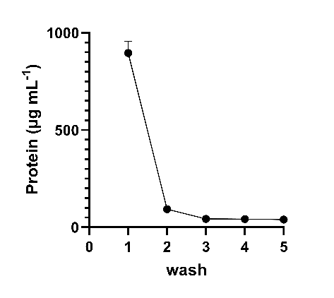
Figure S1 Protein concentration in the supernatant/ wash liquid after successive washes and centrifugation. The protein concentration was measured by Bradford Assay

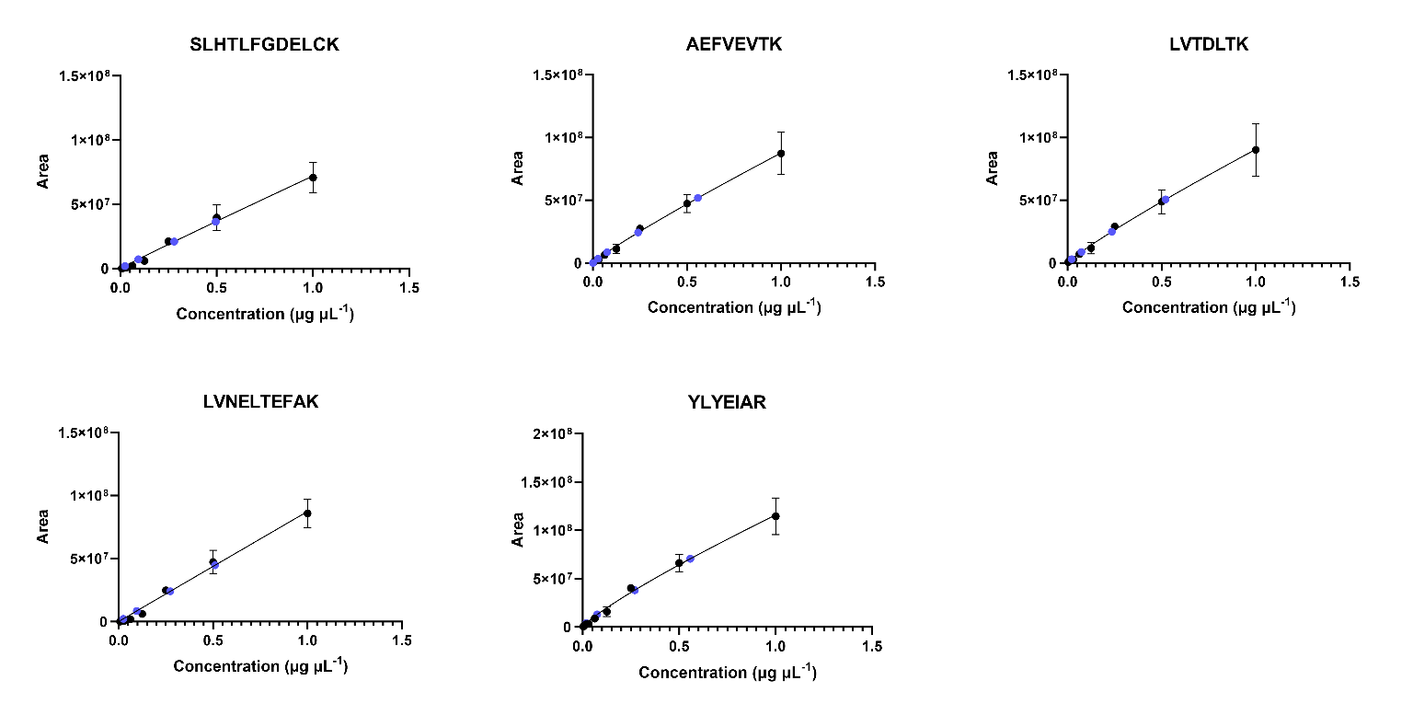
Figure S2 Interpolated recovery of the plastic corona extracts and negative controls (blue circles) for the five BSA peptides.

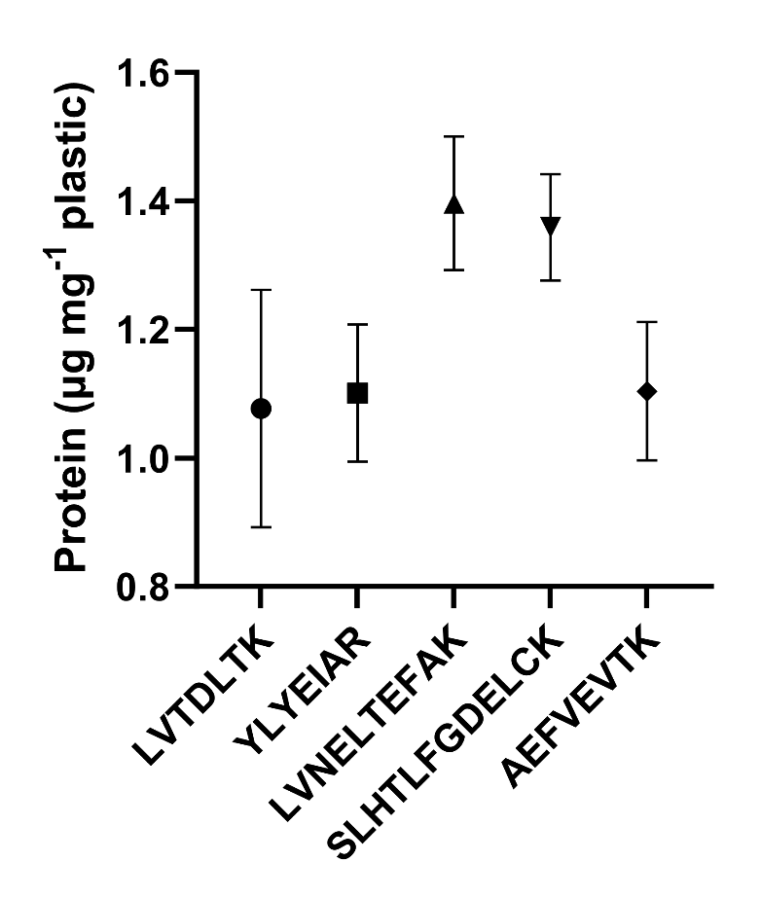

Figure S3 Concentration of protein extracted from the corona formed on the small beads across the five BSA peptides.

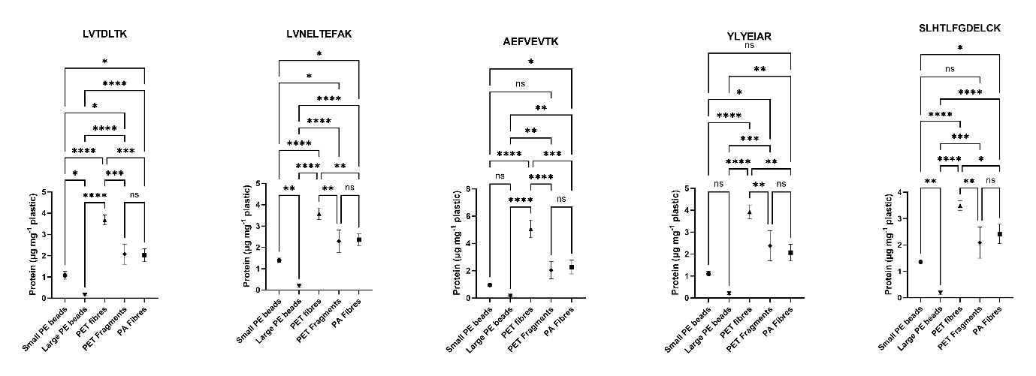
Figure S4 Concentration of protein extracted from the corona formed on all plastic types for the five BSA peptides. Asterisks denote significant differences (ANOVA with Tukey post hoc,*p<0.05, **p<0.01,***p<0.001, ****p<0.0001).

Table S2 Microplastic (MP) physiochemical characteristics and corresponding protein corona concentration. Polyethylene (PE), Polyamide (PA), Polyethylene terephthalate (PET), recycled PET (rPET). Standard deviation is given in brackets().
Polymer | Nominal Shape | MP Treatment | Length  (µm) | Width  (µm) | Surface Area:Volume ratio | ζ-potential (mV) | Surface Roughness (nm) | Protein Concentration  (µg mg⁻¹ plastic)
Standards
PE | Bead (Small) | Pristine | 64.79 (20.29) | 54.60  (7.80) | 0.1085  (0.044) | -16.21 (11.70) | 96.46  (17.75) | 1.396  (0.104)
PE | Bead (Large) | Pristine | 592.9 (32.72) | 578.3  (31.09) | 0.01031  (0.001) | -12.14 (4.76) | 62.98 (13.03 | 0.1891  (0.038)
PA | Fibre | Pristine | 87.01 (20.79) | 22.75 (5.74) | 0.2099 (0.347) | -7.598 (0.689) | 5.242  (1.452) | 2.359  (0.271)
PET | Fibre | Pristine | 447.3  (136.5) | 20.65  (2.73) | 0.2022  (0.027) | -36.20  (4.74) | 36.10  (14.03) | 3.587  (0.267)
PET | Fragment | Pristine | 42.85  (33.63) | 27.12  (22.11) | 0.2947  (0.217) | -17.78  (3.03) | 42.88 (29.61) | 2.380  (0.517)
Environmentally Relevant
rPET | Fibre | Pristine | 44.54  (37.33) | 16.93  (11.45) | 0.4824  (0.393) | -26.42  (3.94) | - | 5.627  (0.671)
 |  | Leached | - | - | - | -43.01  (1.30) | - | 6.150  (0.418)
PET | Fibre | Pristine | 36.61  (31.50) | 15.68  (11.80) | 0.5005  (0.370) | -38.92  (4.18) | - | 7.078  (0.986)
 |  | Leached | - | - | - | -43.44  (3.41) | - | 6.421  (0.650)
PA | Fibre | Pristine | 45.80  (42.74) | 19.70  (15.25) | 0.4445  (0.362) | -41.82  (6.69) | - | 3.572  (1.34)
 |  | Leached | - | - | - | -48.81  (4.08) | - | 6.512  (0.966)
Cotton | Fibre | Pristine | 39.51  (34.48) | 14.67  (9.39) | 0.5104  (0.365) | -40.31  (0.73) | - | 50.90  (4.176)
 |  | Leached | - | - | - | -45.29  (7.15) | - | 59.49  (4.923)

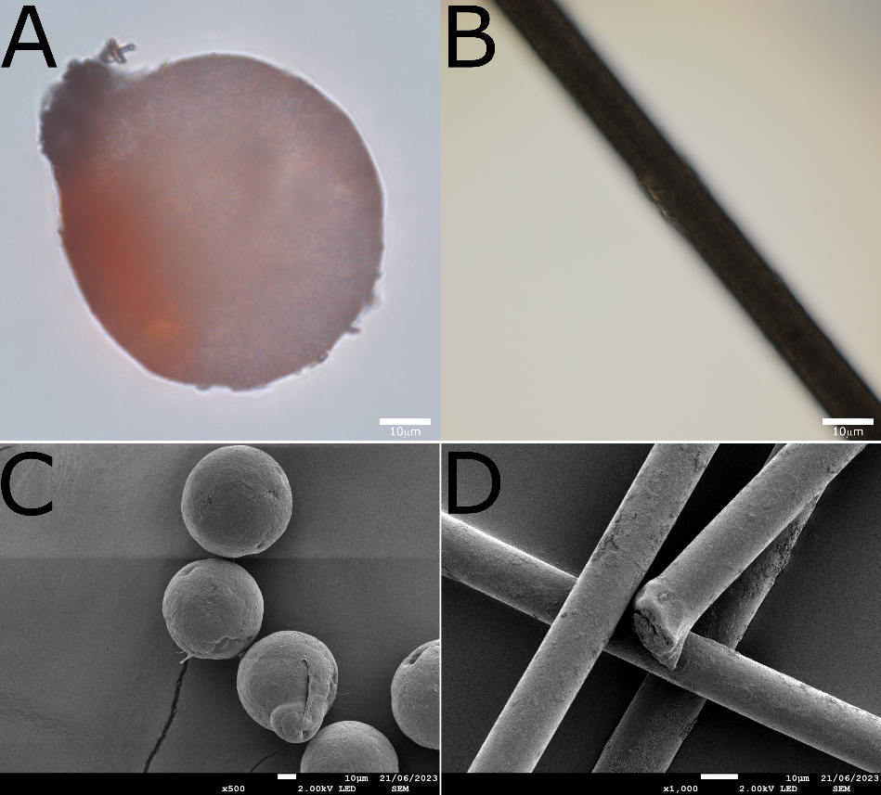
Figure S5 Brightfield micrographs of A) PE beads and B) PET fibres with BSA aggregates visible; C) SEM micrographs of PE beads and D) PET fibres.
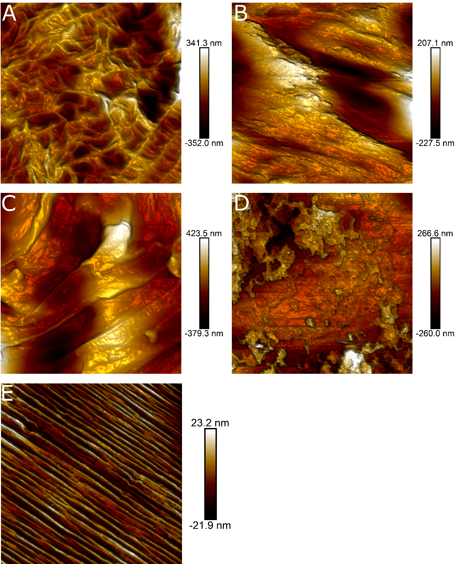
Figure S6 Surface structure of the microplastics standards measured by atomic force microscopy, A) small polyethylene (PE) beads; B) large PE beads; C) polyethylene terephthalate (PET) fragments and D) PET fibres. Atomic force microscopy scan areas were 15µm, 5µm, 2µm and 5µm, respectively.

