Supporing Information
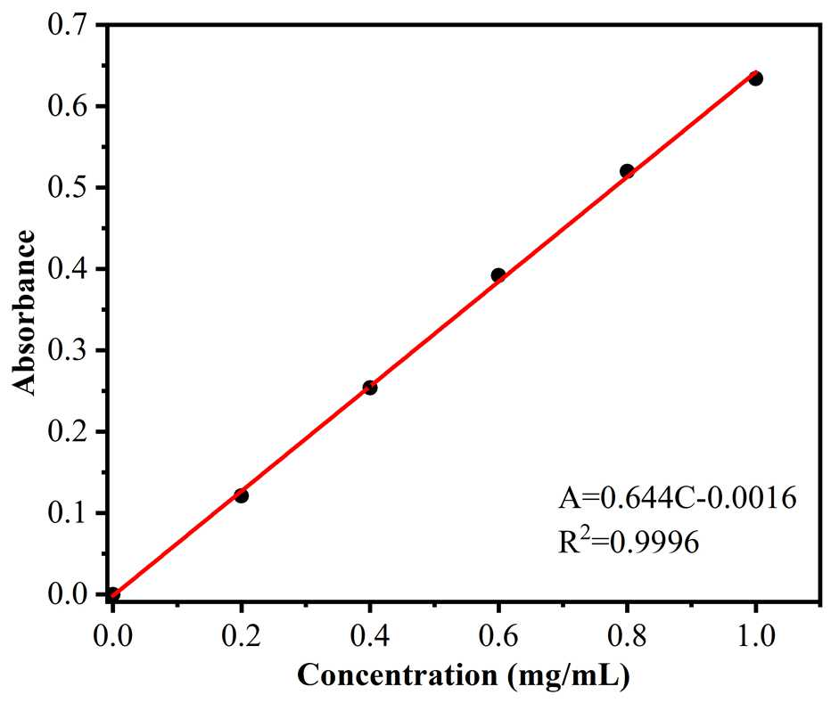
Fig. 1s Standard curve of BSA
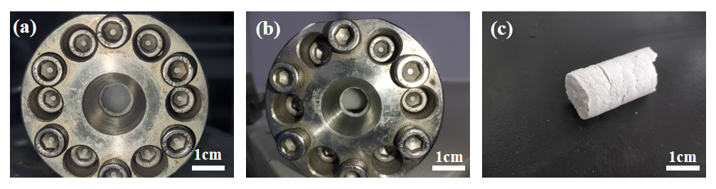
Fig. 2s the CO₂-in-water high interval phase emulsion (H₂O/CO₂ 2/8) using P(VAc₃₆)-g-MPEG₁₉₀₀ as the surfactant (a), and the HIPE is broken after 30 h (b), PADM-based monoliths material prepared by the polymerization of HIPE (c).
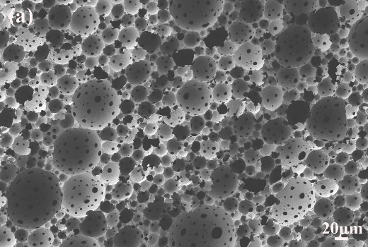
Fig. 3s PAM-PDEAEMA porous material prepared by (PVAc₃₆)-g-PMePEG₁₉₀₀ (a) under the condition of DEAEMA 0.50 g/mL

