Supplementary Materials for Archives of Microbiology
Halomonas salipaludis sp. nov., isolated from the saline-alkali wetland soil
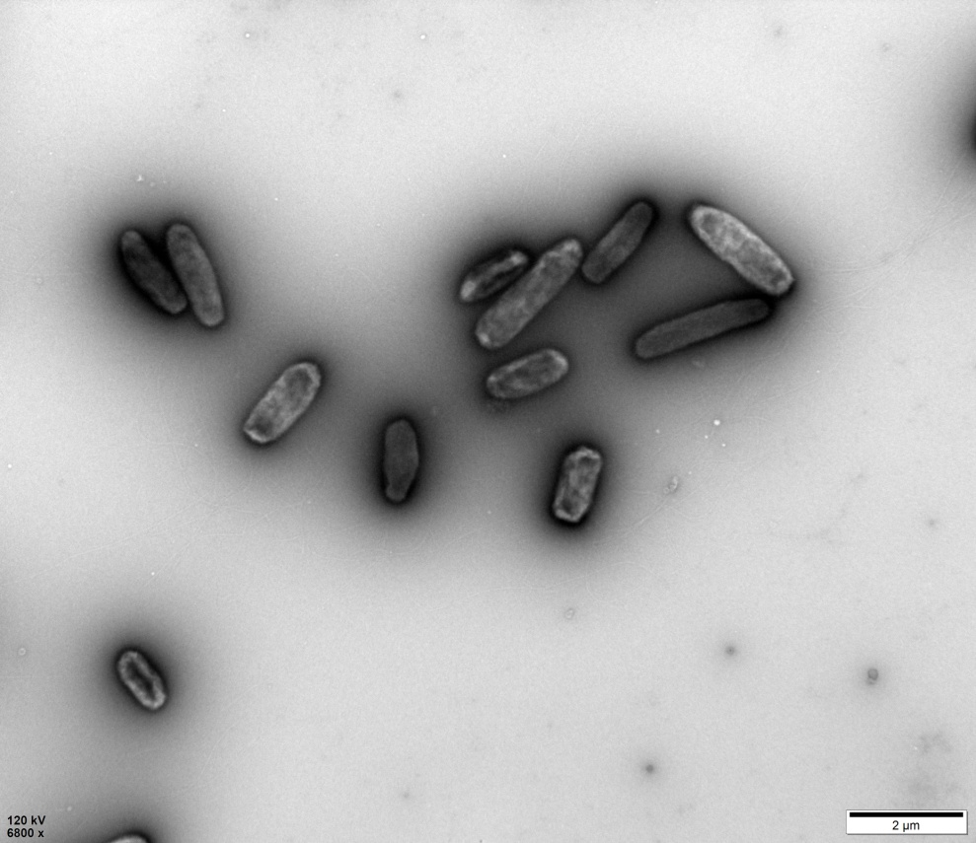
Supplementary Fig. S1 Transmission electron micrographs (TEM) of cells of strain WRN001^{T} after 24 h of incubation on DifcoTM marine 2216 agar plate at 37 ℃. Scale bars are shown on the images.
Supplementary Fig. S2 Polar lipids profiles of strains WRN001^{T} (a), Halomonas qiaohouensis YIM QH88^{T} (b) and Halomonas socia NY-011^{T} (c). All the polar lipids from 3 strains mentioned above were determined by the Leibniz institute DSMZ-German Collection of Microorganisms and Cell Cultures GmbH (Deutsche Sammlung von Mikroorganismen und Zellkulturen GmbH) in this study, and the TLC plates were stained by 10 % phosphomolybdic acid in 95 % ethanol for detection of total lipids (Shown above), 0.2 % ninhydrin in 1-butanol for aminolipids (not shown), molybdenum blue reagent (Sigma) for phospholipids (not shown) and Dragendorff's reagent (Sigma) for cholines (not shown).
The polar lipids of the strain WRN001T (a) and its close relatives Halomonas qiaohouensis YIM QH88^{T} (b) and Halomonas socia NY-011^{T} (c) are very similar, however, their differences are mainly at Aminolipid（AL), Aminoglycolipid (GNL) and Lipid (L).
Abbreviations: F, first dimension of TLC; S, second dimension of TLC; L, Lipid; PL, Phospholipid; PC, Phophatidylcholine; PG, Phosphatidylglycerol; PE, Phosphatidylethanolamine; DPG, Diphosphatidylglycerol; GNL, Aminoglycolipid.
Supplementary Fig. S3 Neighbor-joining (NJ) phylogenetic tree based on 16S rRNA gene sequences showing the relationships between strain WRN001^{T} and related taxa. Bootstrap values >50 % (1000 replicates) are shown. Scale bar, 0.01 substitutions per nucleotide position. Zymobacter palmae T109^{T} (D14555) was used as an outgroup. GenBank accession numbers are indicated for each strain.
Halomonas qiaohouensis YIM QH88 (KC237714)
Halomonas qiaohouensis YIM QH103 ^{T} (KC237713)
Halomonas salipaludis WRN001^{T}

Halomonas socia NY-011 ^{T} (JF766572)
Halomonas pantelleriense DAM9661 ^{T} (X93493)
Halomonas rifensis HK31 ^{T} (HM026177)
Halomonas anticariensis FP35 ^{T} (AY489405)
Halomonas flava YIM 94343 ^{T} (HQ832736)
Halomonas qijiaojingensis YIM 93003 ^{T} (HQ832735)
Halomonas korlensis XK1 ^{T} (EU085033)
Halomonas ilicicola SP8 ^{T} (EU218533)
Halomonas muralis LMG 20969 ^{T} (AJ320530)
Halomonas salifodinae BC7 ^{T} (EF527873)
Halomonas pacifica DSM 4742 ^{T} (L42616)
Halomonas koreensis SS20 ^{T} (AY382579)
Halomonas stenophila N12 ^{T} (HM242216)
Halomonas ventosae Al12 ^{T} (AY268080)
Halomonas aestuarii Hb3 ^{T} (KX090359)
Halomonas saccharevitans AJ275 ^{T} (EF144149)
Halomonas denitrificans M29 ^{T} (AM229317)
Halomonas cupida DSM 4740 ^{T} (L42615)
Zymobacter palmae T109 ^{T} (D14555)
100
59
82
88
75
99
81
53
97
0.01
Supplementary Fig. S4 Maximum parsimony (MP) phylogenetic tree based on 16S rRNA gene sequences showing the relationships between strain WRN001^{T} and related taxa. Bootstrap values >50% (1000 replicates) are shown. GenBank accession numbers are indicated for each strain.
Halomonas salifodinae BC7 ^{T} (EF527873)
Halomonas pacifica DSM 4742 ^{T} (L42616)
Halomonas koreensis SS20 ^{T} (AY382579)
Halomonas stenophila N12 ^{T} (HM242216)
Halomonas ventosae Al12 ^{T} (AY268080)
Halomonas denitrificans M29 ^{T} (AM229317)
Halomonas aestuarii Hb3 ^{T} (KX090359)
Halomonas saccharevitans ^{T} AJ275 (EF144149)
Halomonas cupida ^{T} DSM 4740 (L42615)
Halomonas qiaohouensis ^{T} YIM QH88 (KC237714)
Halomonas qiaohouensis ^{T} YIM QH103 (KC237713)
Halomonas salipaludis WRN001^{T}

Halomonas socia ^{T} NY-011 (JF766572)
Halomonas pantelleriense ^{T} DAM9661 (X93493)
Zymobacter palmae ^{T}109 (D14555)
Halomonas muralis ^{T} LMG 20969 (AJ320530)
Halomonas korlensis ^{T} XK1 (EU085033)
Halomonas ilicicola ^{T} SP8 (EU218533)
Halomonas anticariensis ^{T} FP35 (AY489405)
Halomonas flava ^{T} YIM 94343 (HQ832736)
Halomonas qijiaojingensis ^{T} YIM 93003 (HQ832735)
Halomonas rifensis ^{T} HK31 (HM026177)
94
55
70
99
95
62
92
63
0.01
Supplementary Table. S1 The average nucleotide identity (ANI) and dDDH values (%) between the genomes of strain WRN001^{T}, and closely related genomes in GenBank.
Most closely related genomes in GenBank | Accession number | ANIb value [%] | ANIm value [%] | dDDH value [%]
Halomonas lkalitolerans 1513^{T} | GCA_001971685.1 | 88.86 | 91.39 | 42.20
Halomonas pantelleriensis AAP^{T} | GCA_900102875.1 | 87.00 | 89.03 | 35.10
Halomonas alkalicola A11-A^{T} | GCA_003182195.1 | 77.95 | 85.40 | 23.00
Halomonas lactosivorans KCTC 52281^{T} | GCA_003254665.1 | 77.80 | 85.51 | 23.10
Halomonas shengliensis CGMCC 1.6444^{T} | GCA_900104135.1 | 77.73 | 85.74 | 23.20
Halomonas pacifica NBRC 102220^{T} | GCA_007989625.1 | 77.63 | 85.50 | 23.00
Halomonas ventosae CECT 5797^{T} | GCA_004363555.1 | 77.28 | 85.21 | 22.70
Halomonas denitrificans DSM_18045^{T} | GCA_003056305.1 | 77.25 | 85.36 | 22.60
Halomonas urmiana TBZ3^{T} | GCA_005780185.1 | 77.16 | 85.24 | 22.80
Halomonas aestuarii Hb3^{T} | GCA_001886615.1 | 76.90 | 85.13 | 22.30
Halomonas saccharevitans CGMCC 1.6493^{T} | GCA_900116405.1 | 76.77 | 85.09 | 22.40
Halomonas nitroreducens 11S^{T} | GCA_003966155.1 | 76.53 | 84.87 | 22.00
Halomonas anticariensis FP35^{T} | GCA_000409775.1 | 74.85 | 84.01 | 20.60
Halomonas cupida DSM 4740^{T} | GCA_900142755.1 | 73.01 | 83.97 | 21.00
Halomonas huangheensis BJGMM-B45^{T} | GCA_001431725.1 | 72.32 | 83.64 | 20.70

