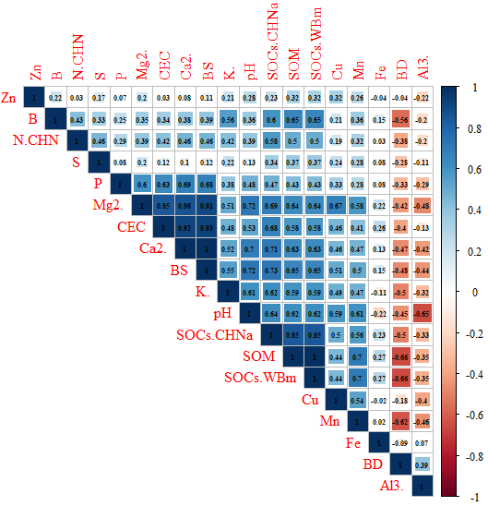
Supplementary Material 1. Pearson’s correlation matrix.

