Supplementary information
Minimally invasive determination of PDAC subtype and therapy-induced subtype switch by means of circulating cell-free RNA.
Martin Metzenmacher¹, Marija Trajkovic-Arsic^{2,3,4}, Phyllis Cheung^{2,3,4}, Timm Reißig^{2,3,4}, Nils von Neuhoff⁵, O'Kane Grainne⁶, Ramotar Stephanie⁶, Anna Dodd⁶, Steven Gallinger⁶, Muckenhuber Alexander⁷, Jennifer J Knox, Volker Kunzmann⁸, Peter A. Horn⁹, Jörg D. Hoheisel¹⁰, Jens T. Siveke^{2,3,4} and Smiths S. Lueong^{2,3,4,}*
This file contines:
Supplementary figures 1 & 2

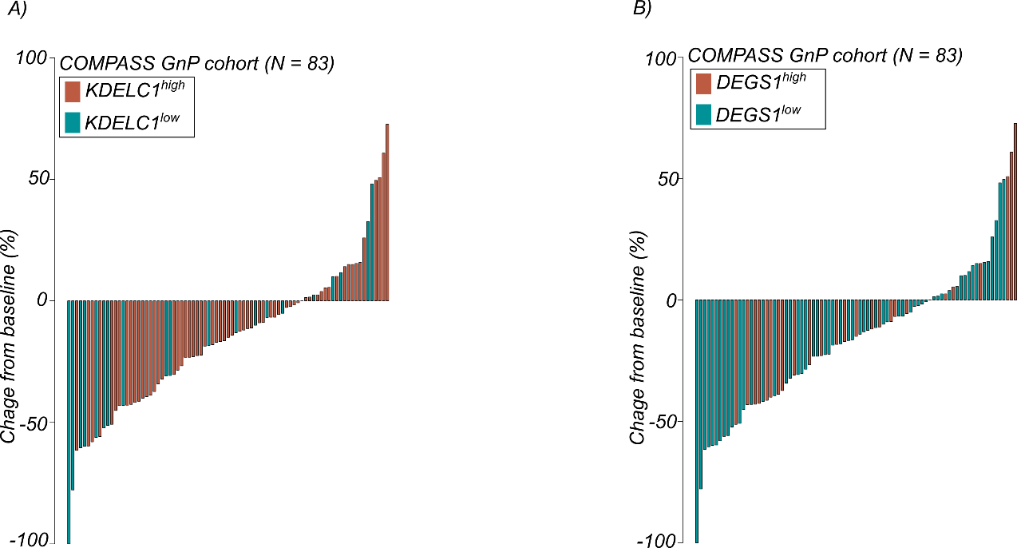
Figure S1

Figure S1: Overexpression of KDELC1 and DEGS1 is not associated with response to GnP in the COMPASS cohort. Waterfall plots show the distribution of the best overall response to treatments in patients within the COMPASS cohort. Patients are dichotomized to either KDELC1^{high} and KDELC1^{low} expression tumor tissue (A) or DEGS1^{high} and DEGS1^{low} (B) respectively. Dichotomization is based on a predetermined cut-off defined in the Cox proportional hazards analysis.

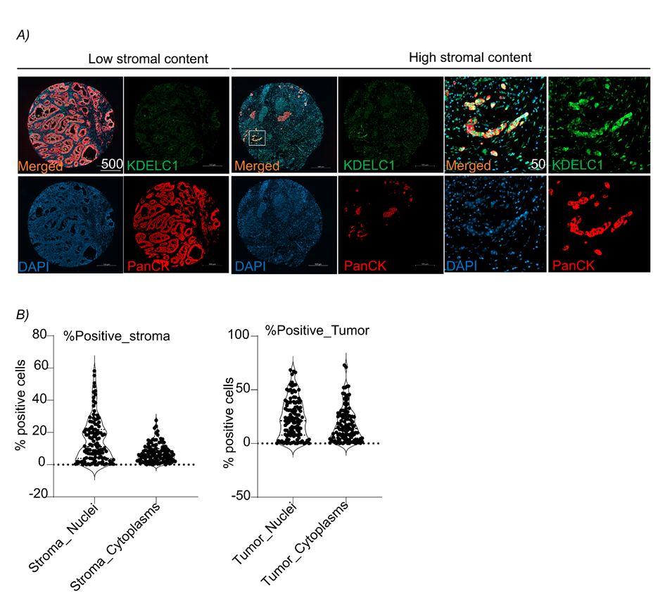
Figure S2

Figure S2: Compartmentalized proteomic analysis of KDELC1 expression in PDAC tumor samples by means of multiplex immunofluorescence. A) Representative images of KDELC1 expression in tumors with low (left panel) and high (right panel) stromal content. B) Quantitative analysis of KDELC1 protein expression in tumor and stroma cells.

