Supplementary Material

Table S1. Regression models tested for plantation practices and management options. In the models tested, ‘×’ symbol accounts for the interactions between factors. Regression models were calculated using ’lm’ function; AIC, BIC and R² with ‘glance’ function and Log-likelihood with ‘lmtest’ function of R software. The selected model is marked in bold font.
Model Tested | AIC | BIC | Log-likelihood | Adjusted R²
Model 1: Yield ~ planting density + irrigation + organic + label + vine age + organic × label + vine age × label + vine age × label + irrigation × label + planting density × label | 30961 | 31078 | -15461 | 0.422
Model 2: Yield ~ planting density + irrigation + organic + label + vine age + organic × label + vine age × label + vine age × label + irrigation × label | 30958 | 31063 | -15462 | 0.418
Model 3: Yield ~ planting density + irrigation + organic + label + vine age + organic ×Label + vine age × label | 30956 | 31037 | -15465 | 0.416
Model 4: Yield ~ irrigation + organic + label + vine age + vine age × label | 30954 | 31028 | -15465 | 0.415
Model 5: Yield ~ irrigation + organic + label + vine age + vine age × label | 30963 | 31025 | -15472 | 0.412
Model 6: Yield ~ organic + label + vine age + vine age × label | 30993 | 31042 | -15488 | 0.409
Model 7: Yield ~ organic + vine age + label | 31000 | 31037 | -15494 | 0.406
Model 8: Yield ~ label + vine age + vine age × label | 31102 | 31145 | -15544 | 0.404
Model 9: Yield ~ vine age + label | 31109 | 31146 | -15549 | 0.389

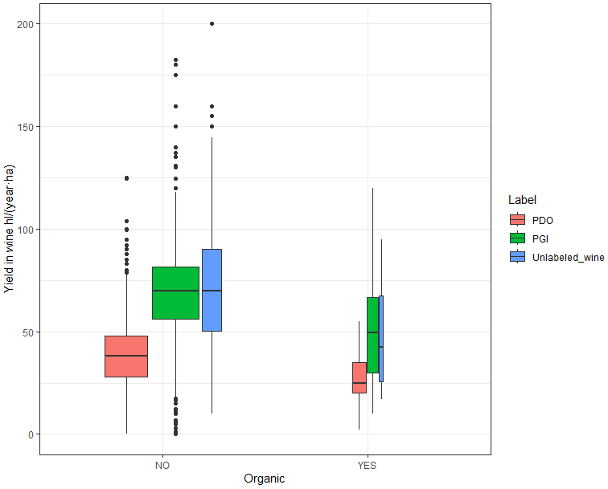
Figure S1. Yield distribution of Organic and Conventional plots according to the wine labels of the plots. The wine labels of the plots are indicated in colors: PDO (Protected Designation of Origin) and PGI (Protected Geographical Indication). The boxplots represent the distribution in quartiles with median lines inside boxes and filled dots are outliers. The box width is proportional to the class sample size. Letters correspond to Wilcoxon signed-rank test.

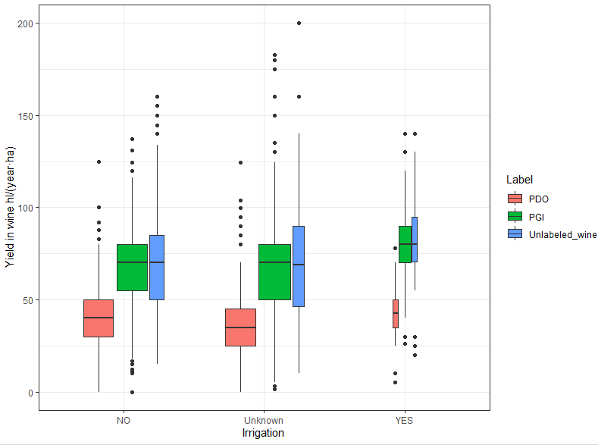
Figure S2. Yield distribution of Irrigated, Non-Irrigated and Unknown irrigation according to the wine labels of the plots. The wine labels of the plots are indicated in colors: PDO (Protected Designation of Origin) and PGI (Protected Geographical Indication). The boxplots represent the distribution in quartiles with median lines inside boxes and filled dots are outliers. The box width is proportional to the class sample size. Letters correspond to Wilcoxon signed-rank test.

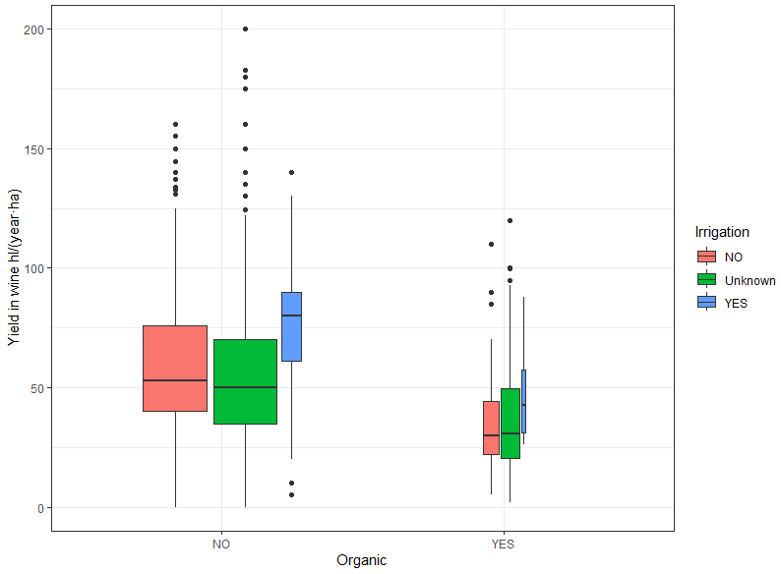
Figure S3. Yield distribution of Organic and Conventional plots according to the irrigation of the plots. The boxplots represent the distribution in quartiles with median lines inside boxes and filled dots are outliers. The box width is proportional to the class sample size. Letters correspond to Wilcoxon signed-rank test.

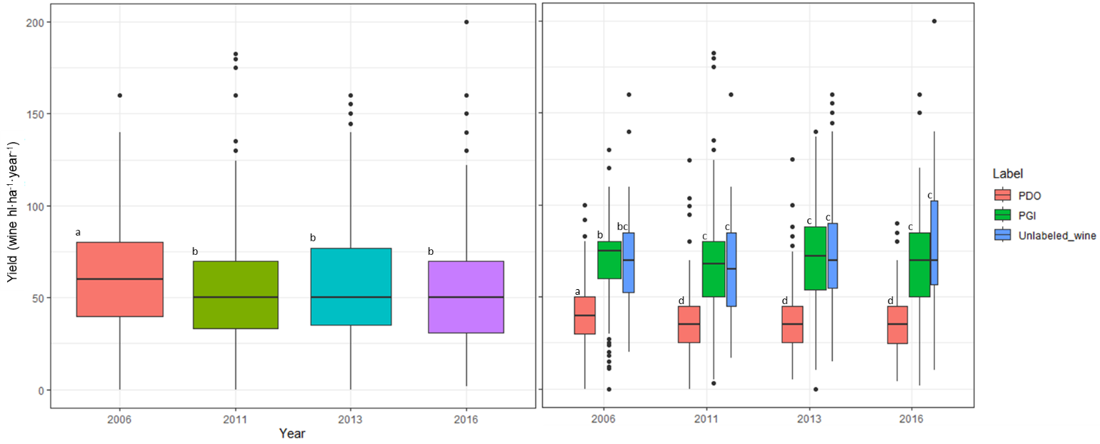
Figure S4. Yield distribution according to the year of the survey (left caption) and including wine labels in colors (right caption). The boxplots represent the distribution in quartiles with median lines inside boxes and filled dots are outliers. The box width is proportional to the class sample size. Letters correspond to Wilcoxon signed-rank test.

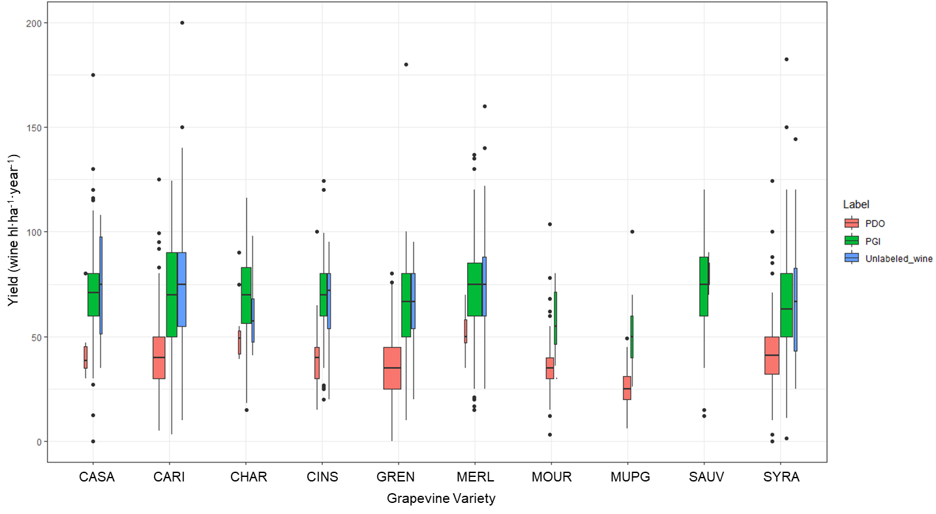
Figure S5. Grapevine yield for 10 most grown cultivated varieties and wine labels. The boxplots represent the distribution in quartiles with median lines inside boxes and filled dots are outliers. The box width is proportional to the class sample size. The varieties abbreviations are: CASA for Cabernet Sauvignon; CARI for Carignan; CHAR for Chardonnay; CINS for Cinsaut (or Cinsault); GREN for Grenache Noir; MERL for Merlot; MOUR for Mourvèdre; MUPG for Muscat Petit Grain; SAUV for Sauvignon Blanc; SYRA for Syrah.

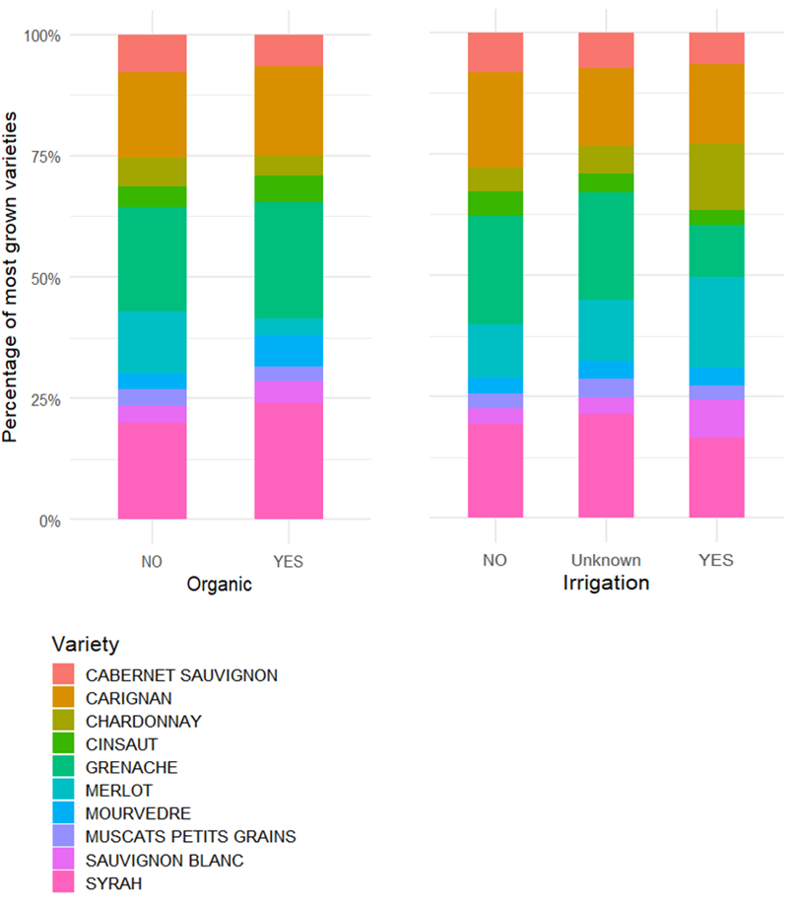
Figure S6. Percentage of most grown varieties (n= 2905) for Organic and Irrigation management.

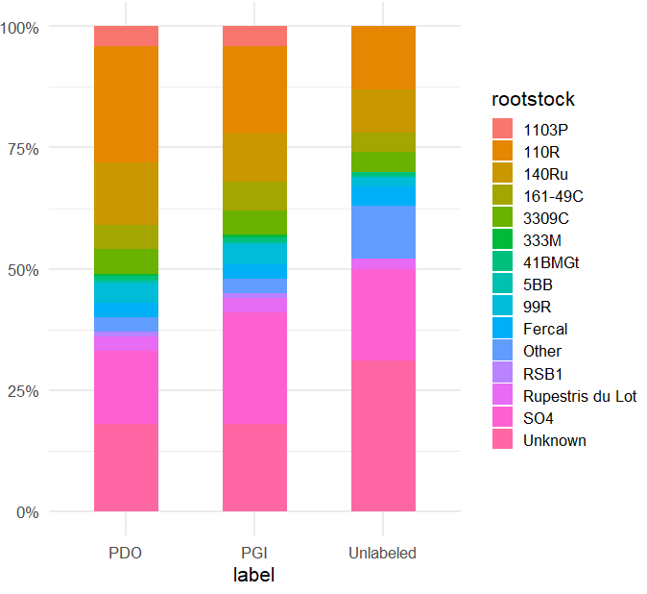
Figure S7. Percentage of most grown rootstocks and unknown ones (n= 3507) for main wine labels.

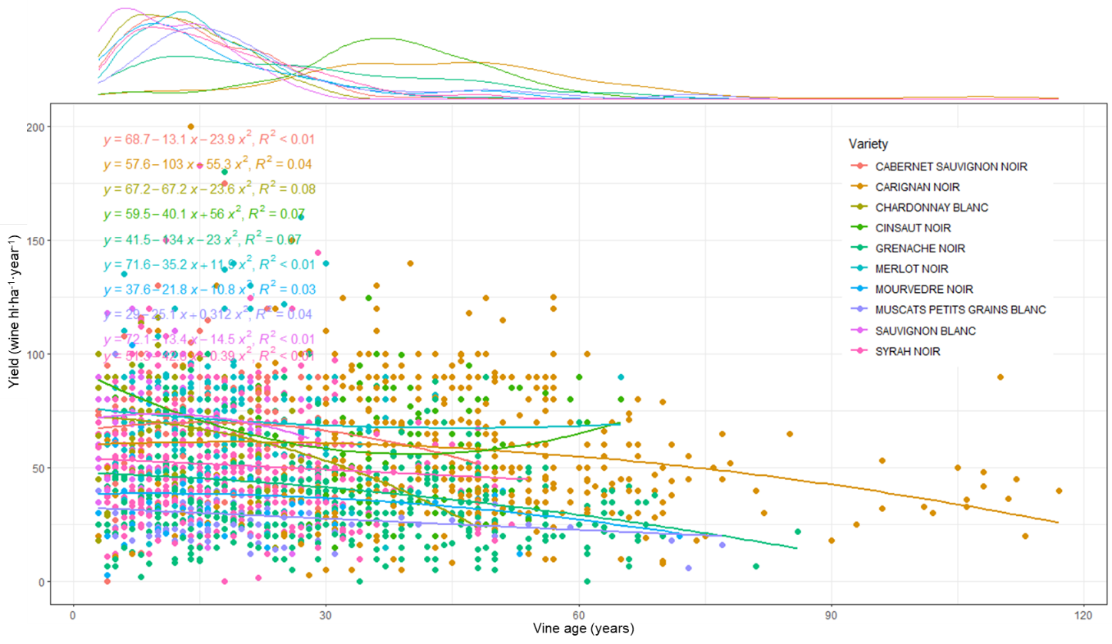
Figure S8. Yield according to vine age and grapevine varieties. In the scatterplot, each point corresponds to a vineyard plot. Lines correspond to multiple linear regressions according to each wine label, equations for each wine label are described with coefficients of determination. On top, the number of plots is distributed according to the vine age with colors for each variety.

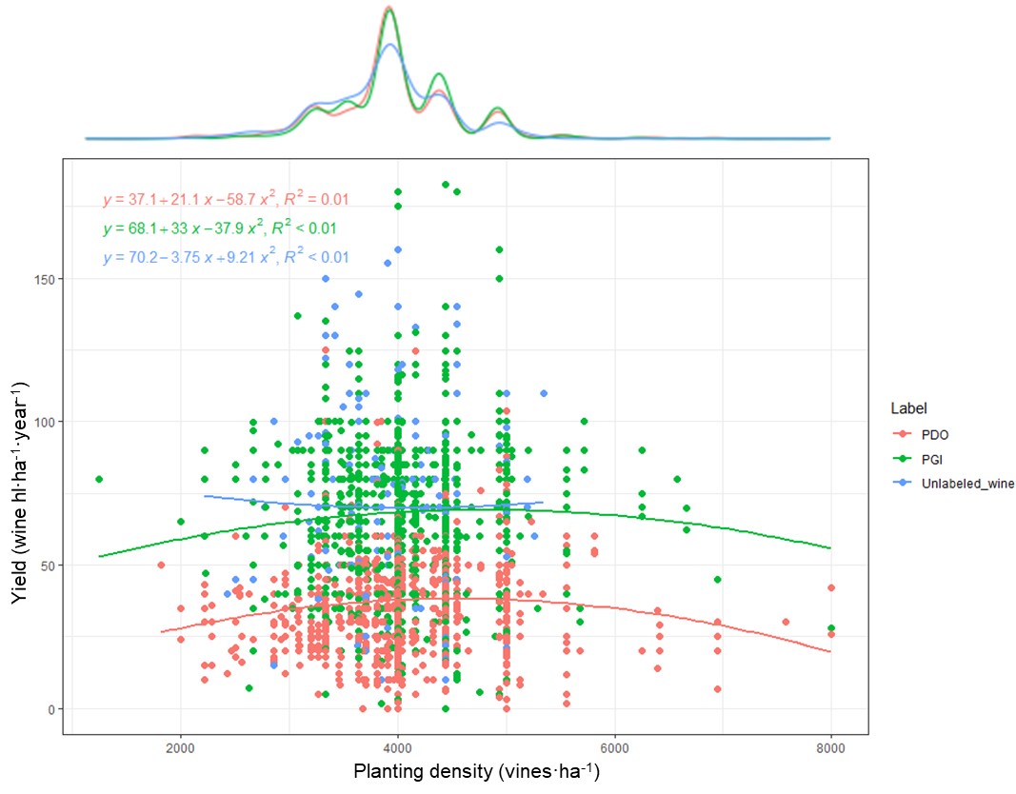

Figure S9. Yield according to planting density and wine labels. In the scatterplot, each point corresponds to a vineyard plot. Lines correspond to multiple linear regressions according to each wine label, equations for each wine label are described with coefficients of determination. On top, the number of plots is distributed according to their planting density, lines are colored by wine label.

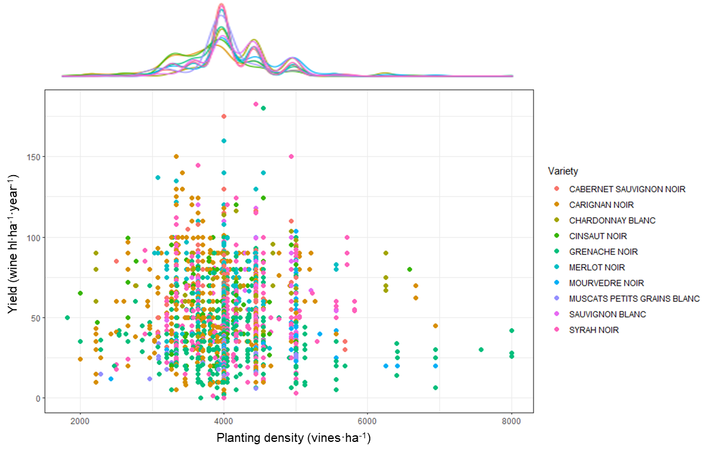
Figure S10. Yield according to planting density and wine labels. In the scatterplot, each point corresponds to a vineyard plot. Lines correspond to multiple linear regressions according to each wine label, equations for each wine label are described with coefficients of determination. On top, the number of plots is distributed according to their planting density with colors for each variety.

