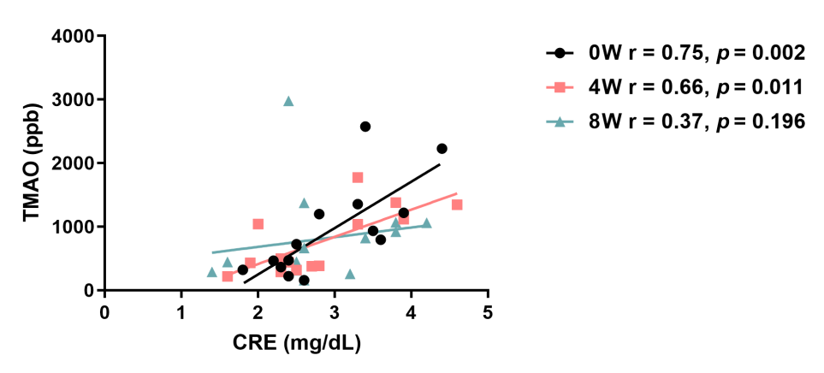

Supplementary Figure S1. Spearman’s correlation of CRE and TMAO before, between, and after Lm intervention. r represented Spearman’s correlation coefficient. 0W: baseline before Lm intervention; 4W: 4-week Lm intervention; 8W: 8-week Lm intervention. CRE, creatinine; TMAO, trimethylamine-N-oxide.

