Supporting information for

Wood-based Transparent Luminescent Materials

Shuodong Wang¹, Jinzhi He¹, Chunguang Yin¹, Haohao Liu¹, Jing Guo², Yang Zhang¹, Wenhuan Yao³, Zebing Zeng¹* and Sheng Xie^{1,4}*
¹Shenzhen Research Institute of Hunan University, Nanshan District, Shenzhen 518000; State Key Laboratory of Chemo/Biosensing and Chemometrics, College of Chemistry and Chemical Engineering, Hunan University, Changsha 410082, China;
²Furong College, Hunan University of Arts and Science, Changde 415000, China;
³College of Chemistry and Chemical Engineering, Northwest Normal University, Lanzhou 730070, P. R. China;
⁴AIE Institute, Guangzhou Development District, Huangpu, Guangzhou 510530, China;
Table of Contents
1.Experimental section
2.Supplementary figures and tables
3.References

- Experimental section
Materials: The dried balsa wood (118.6 ± 3.7 mg/cm³) with a thickness of 1.0 mm was acquired from Alibaba Co. Ltd., China. Sodium chlorite (NaClO₂, 80%) and glacial acetic acid (CH₃COOH) were procured from Meryer (Shanghai) Chemical Technology Co., Ltd., China. Methyl methacrylate (MMA, 99%) was purchased from Beijing InnoChem Science & Technology Co., Ltd. All commercial chemicals scarcely require additional purification prior to use.

Characterizations: Frequently, neutral alumina or silica gel (200–300 mesh) were used for column chromatography. Thin layer chromatography (TLC) was used to monitor reactions using neutral alumina or silica gel GF254 plates, and reactions were then viewed under UV light. Nuclear magnetic resonance (¹H NMR and ¹³C NMR) data were recorded on a 400 MHz spectrometer. With CDCl₃ (¹H: δ = 7.26, ¹³C: δ = 77.16) or DMSO-d₆ (¹H: δ = 2.50, ¹³C: δ = 39.52) serving as the internal standard, chemical shifts are presented as values (ppm). The acid hydrolysis method was used to determine the compositional content of the wood, specifically the Technical Association of Pulp and Paper Industry Standard Method T 222-om-83. The morphology and structure of the NW, DW, and AIE-TWs were characterized by scanning electron microscopy (SEM, IGMAHD) at an accelerating voltage of 10.0 kV. The fluorescence quantum yields of AIE-TWs and AIE-PMMAs were measured by using an integrating sphere on an Edinburgh FLS1000 machine. FTIR spectra were captured using a SHIMADZU IRSpirit-T. Molecular weight distribution of the synthesized products were determined through an analytical approach employing a Waters 1515 Gel Permeation Chromatography (GPC) system, which featured a Waters 2414 Refractive Index Detector in conjunction with a column system. Tetrahydrofuran (THF) was employed as the eluent, and measurements were conducted at a consistent flow rate of 1 mL min⁻¹. Transmittance spectra were recorded on a Shimadzu UV-3600 plus. Optical photographs of the samples were obtained using Canon EOS 6D. Thermal Analysis (TG) and Derivative Thermogravimetry (DTG) was performed using a HITACHI STA300 instrument at a heating rate of 10 ℃/min from 50 ℃ to 800 ℃ in a nitrogen atmosphere. Fluorescence confocal imaging of AIE-TWs were carried out by using a Zeiss LMS 980 laser scanning confocal microscopy.

Delignification¹: The dried balsa wood samples were first immersed in a boiling 1.5 % w/w NaClO₂ solution, with CH₃COOH added to adjust the pH to 4.6. It took about 8 hours for the samples to turn completely white. The wood samples were then carefully rinsed in hot distilled deionized water to remove residual chemicals. After that, the wood samples were then placed in pure ethanol, a mixed solution of ethanol and acetone, and finally preserved in acetone.

Fabrication of Transparent Wood: Into a two-necked round bottom flask, methyl methacrylate (MMA) and 2,2′-Azobis (2- methylpropionitrile) (AIBN, 0.3 wt%) as initiator were added. The mixture was pre-polymerized at 75 °C for 15 min under nitrogen. The reaction was then stopped by cooling the mixture in an ice-water bath. The selected AIEgen dye was dissolved in dry DMF (1 mL) and slowly added to the mixture. The delignified wood sample was then immersed in a prepolymerized MMA solution for 30 minutes under vacuum. The vacuum infiltration was repeated three times to achieve complete infiltration. Before further polymerisation, the infiltrated wood was placed between two glass slides and wrapped in aluminium foil. In the final step, heating the infiltrated wood sample in an oven at 70 °C for 4 hours completed the polymerisation process.

Preparation of the dye TTBPE

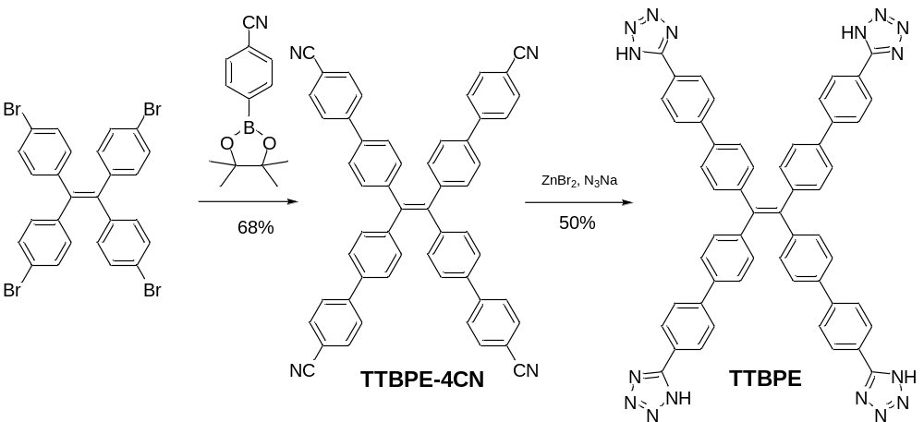
Supplementary Scheme 1. Synthetic procedure of TTBPE.

Synthesis of TTBPE-4CN²: To a 50 mL two-necked round bottom flask, tetrakis(4-bromophenyl)ethylene (192 mg, 0.3 mmol), 4-cyanophenylboronic acid pinacol ester (366 mg, 1.6 mmol), Pd[P(C₆H₅)₃]₄ (50 mg, 0.07 mmol), K₂CO₃ (372 mg, 2.7 mmol) were added under nitrogen. Then, 10 mL THF and 1 mL of deionized water were injected with a syringe and refluxed overnight. The mixture was filtered, the solid was extracted with CH₂Cl₂ (50 mL × 3) and the combined organic layer was washed with water and dried with Na₂SO₄. The mixture was filtered and the solvent was removed under reduced pressure. The residue was purified by silica gel column chromatography (petroleum ether/ ethyl acetate = 4/1, v/v) to afford the entitled compound as a white solid (150 mg, 68 % yield). ¹H NMR (400 MHz, CDCl₃) δ 7.67 (q, J = 8.3 Hz, 16H), 7.42 (d, J = 8.3 Hz, 8H), 7.21 (d, J = 8.3 Hz, 8H). ¹³C NMR (100 MHz, CDCl₃) δ 144.74, 143.61, 140.68, 137.45, 132.57, 132.11, 127.39, 126.71.
Synthesis of TTBPE³: Into a 25 mL two-necked round bottom flask, TTBPE-4CN (150 mg, 0.21 mmol), NaN₃ (106 mg, 1.63 mmol), ZnBr₂ (137 mg, 0.61 mmol) and DMF (8 mL) were added under nitrogen. The suspension was heated at 120ºC and stirred for 24 hours under a nitrogen condition. After the reaction was completed, aqueous HCl solution (3 M) was added to the above mixture until the pH decreased to 1. The mixture was then filtered, and the solid was dissolved in NaOH solution (0.25 M) and stirred when the white precipitate of zinc hydroxide was observed. The zinc hydroxide was removed by filtration and the mixture was then acidified to pH 1 with 3M hydrochloric acid to afford the entitled compound as a yellow solid. (95 mg, 50% yield). ¹H NMR (400 MHz, DMSO-d₆) δ 8.10 (d, J = 8.2 Hz, 8H), 7.92 (d, J = 8.2 Hz, 8H), 7.69 (d, J = 8.1 Hz, 8H), 7.24 (d, J = 8.0 Hz, 8H). ¹³C NMR (100 MHz, DMSO-d₆) δ155.06, 143.08, 141.75, 140.24, 136.96, 131.69, 127.52, 127.32, 126.33, 123.10.

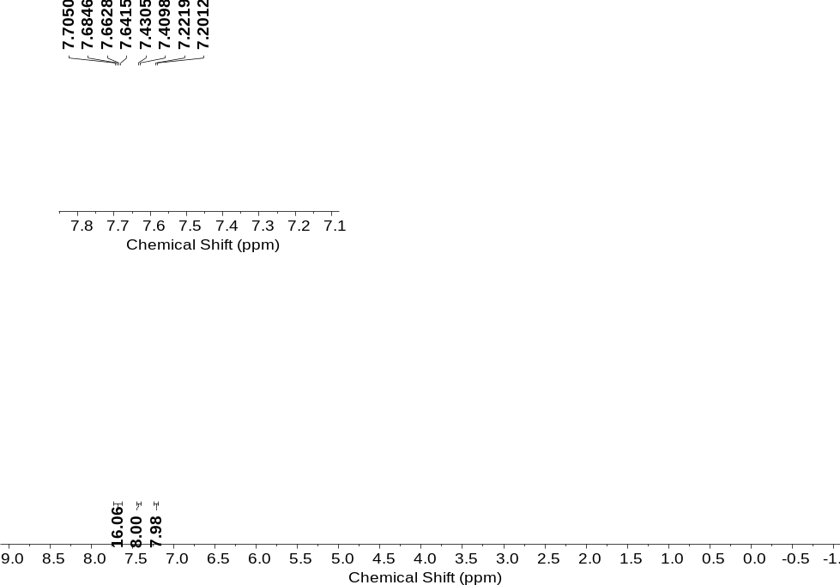
Supplementary Fig. 1. ¹H NMR spectrum (400 MHz) of TTBPE-4CN in CDCl₃ at 298 K.

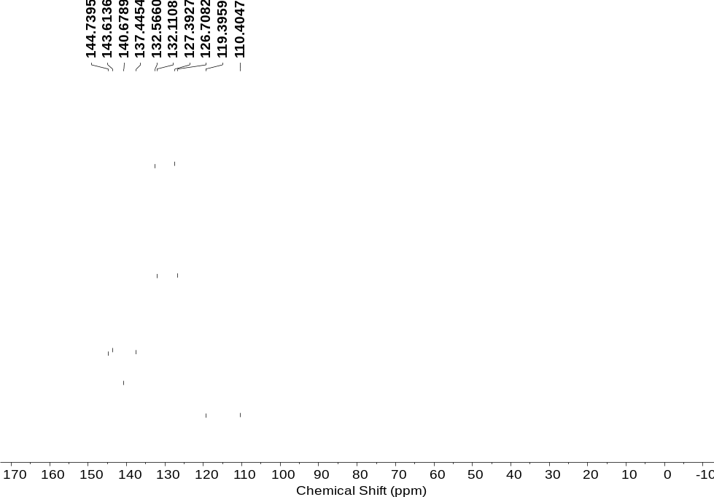
Supplementary Fig. 2. ¹³C NMR spectrum (100 MHz) of TTBPE-4CN in CDCl₃ at 298 K.

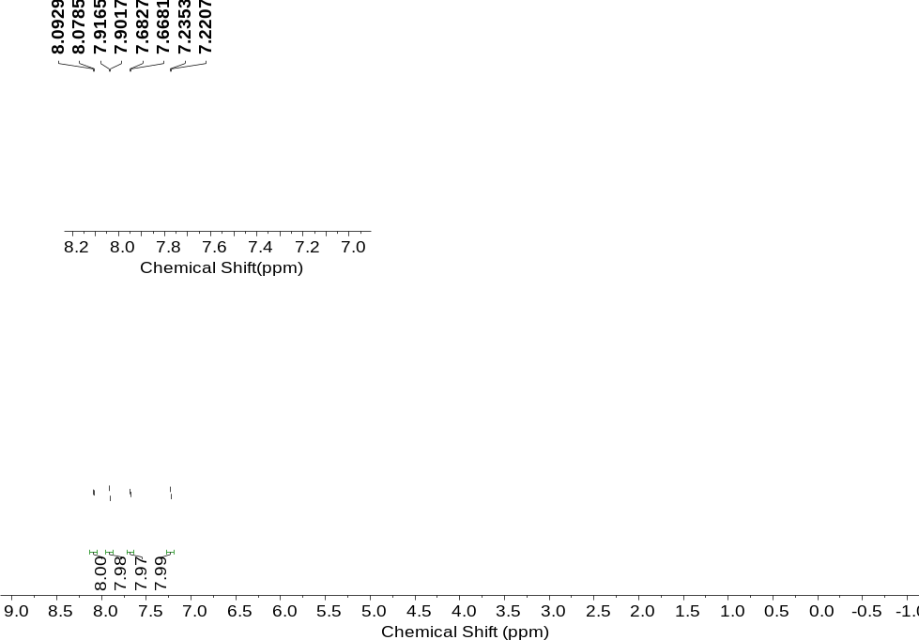
Supplementary Fig. 3. ¹H NMR spectrum (400 MHz) of TTBPE in DMSO-d₆ at 298 K.
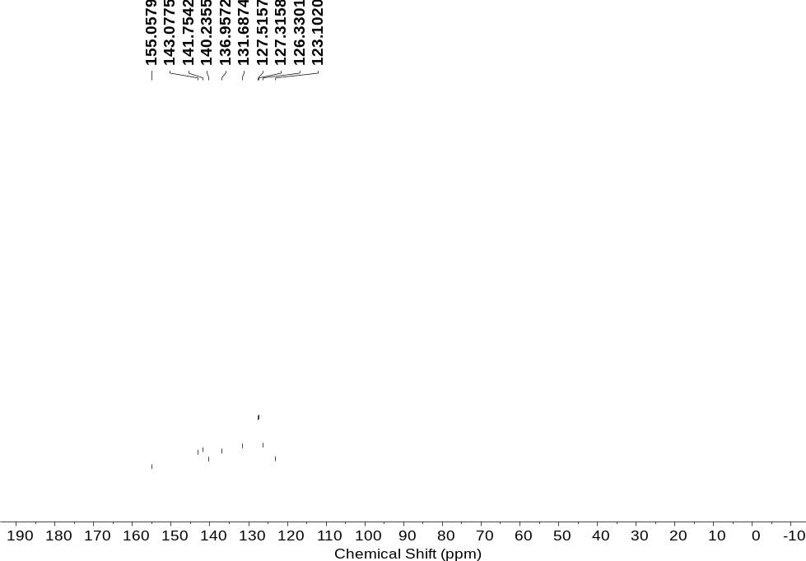
Supplementary Fig. 4. ¹³C NMR spectrum (100 MHz) of TTBPE in DMSO-d₆ at 298 K.

- Supplementary Figures and Tables

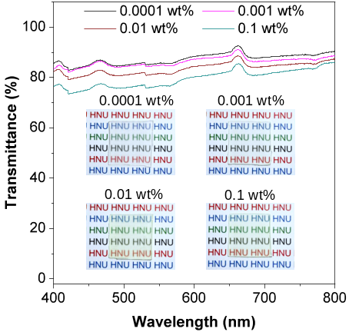
Supplementary Fig. 5. Optical transmittance of TTBPE-doped transparent woods. Inset Optical images of TTBPE-TW composites under daylight.
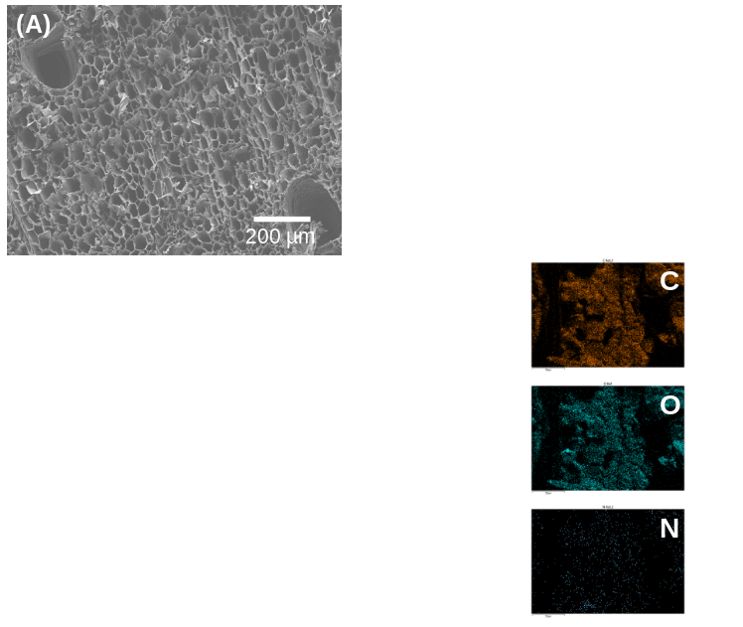
Supplementary Fig. 6. Cross-sectional SEM images of (A) natural wood, (B) delignified wood, (C) TTBPE-doped TW and corresponding EDS mapping image of C, O, and N elements of TTBPE-doped TW.

Supplementary Table 1. Optical properties of TTBPE and TTBPE-doped materials at different states
 | λ_{ex} [nm] | λ_{em} [nm] | τ (τ₁, τ₂) [ns] | Ф_{F} [%]ª | K_{r} [10⁸S⁻¹]^{b} | K_{nr} [10⁸S⁻¹]^{c}
DMF | NA^{d} | NA | 2.4 (1.8, 4.2) | 1 | 0.05 | 4.12
H₂O | 370 | 535 | 5.2 (2.1, 5.6) | 55 | 1.06 | 0.86
Powder | 460 | 550 | 4.7 (3.4, 7.8) | 53 | 1.13 | 1.00
TTBPE-PMMA 0.0001 wt% | NA | NA | 2.3 (0.6, 7.4) | <1 | 0.05 | 4.30
TTBPE-PMMA 0.001 wt% | 364 | 465 | 2.4 (0.9, 6.9) | 9 | 0.38 | 3.79
TTBPE-PMMA 0.01 wt% | 365 | 482 | 2.1 (0.9, 2.7) | 35 | 1.64 | 3.12
TTBPE-PMMA 0.1 wt% | 363 | 474 | 1.6 (1.6, 0.1) | 70 | 4.38 | 1.88
TTBPE-TW 0.0001 wt% | 377 | 466 | 2.5 (1.6, 5.1) | 18 | 0.72 | 3.28
TTBPE-TW 0.001 wt% | 373 | 482 | 2.3 (1.8, 4.4) | 45 | 1.93 | 2.41
TTBPE-TW 0.01 wt% | 375 | 493 | 2.2 (1.3, 2.7) | 64 | 2.89 | 1.66
TTBPE-TW 0.1 wt% | 366 | 484 | 2.2 (1.6, 3.3) | 71 | 3.23 | 1.32
MMA 0.0001 wt% | 365 | 525 | 2.6 (0.7, 4.1) | 2 | 0.08 | 3.77
MMA 0.001 wt% | 365 | 535 | 2.2 (0.6, 9.6) | 2 | 0.09 | 4.45
MMA 0.01 wt% | 405 | 530 | 1.5 (1.4, 1.5) | 2 | 0.13 | 6.53
MMA 0.1 wt% | 393 | 539 | 1.5 (1.4, 5.7) | 2 | 0.13 | 6.53
a) Absolute quantum yields measured by an integrating sphere. b) k_{r}: radiative decay rate. c) k_{nr}: nonradiative decay rate. d) NA: Not available.

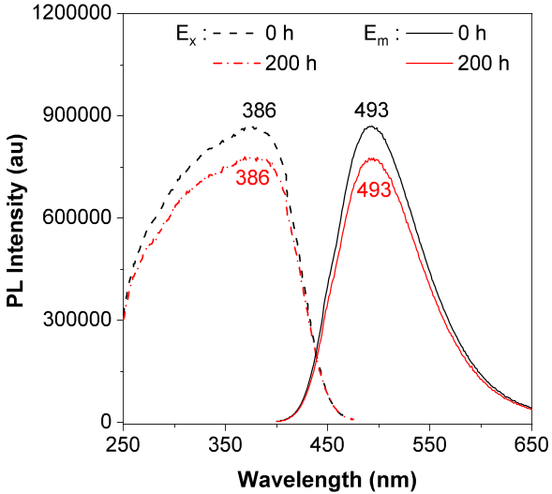
Supplementary Fig. 7. Excitation (dashed lines) and emission (solid lines) spectra of TTBPE-doped TW ([TTBPE] = 0.1 wt%) at initial and after irradiation (By UV-light) over 200 h.

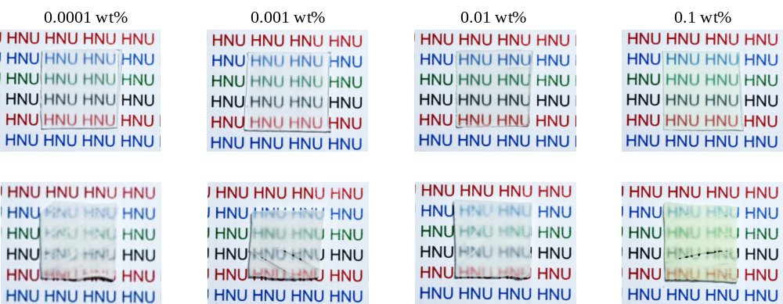
Supplementary Fig. 8. Optical images of TPE-4TA-TWs composites under daylight. Top TPE-4TA-TWs, bottom T-TPE-4TA-TWs.

Supplementary Table 2. Optical properties of TPE-4TA and TPE-4TA-doped materials at different states
 | λ_{ex} [nm] | λ_{em} [nm] | τ (τ₁, τ₂) [ns] | Ф_{F} [%]ª | K_{r} [10⁸S⁻¹]^{b} | K_{nr} [10⁸S⁻¹]^{c}
MeOH | NA^{d} | NA | NA | 0.2 | NA | NA
Powder | 380 | 500 | 6.3 (4.1, 9.5) | 65 | 1.03 | 0.56
TPE-4TA-PMMA 0.0001 wt% | 371 | 454 | 2.0 (0.5, 9.2) | 2 | 0.11 | 4.90
TPE-4TA-PMMA 0.001 wt% | 367 | 464 | 2.3 (0.6, 3.9) | 17 | 0.75 | 3.60
TPE-4TA-PMMA 0.01 wt% | 350 | 468 | 3.2 (1.4, 3.6) | 65 | 2.04 | 1.08
TPE-4TA-PMMA 0.1 wt% | 392 | 477 | 3.6 (2.2, 4.2) | 95 | 2.64 | 0.14
TPE-4TA-TW 0.0001 wt% | 361 | 474 | 3.2 (1.4, 3.7) | 15 | 0.47 | 2.66
TPE-4TA-TW 0.001 wt% | 368 | 478 | 3.2 (1.6, 3.7) | 33 | 1.04 | 2.08
TPE-4TA-TW 0.01 wt% | 374 | 486 | 3.4 (1.7, 3.9) | 68 | 2.00 | 0.94
TPE-4TA-TW 0.1 wt% | 396 | 490 | 3.8 (1.2, 4.0) | 99 | 2.59 | 0.04
T-TPE-4TA-TW 0.0001 wt% | 381 | 469 | 3.1 (1.3, 3.6) | 6 | 0.18 | 3.05
T-TPE-4TA-TW 0.001 wt% | 380 | 476 | 3.5 (2.1, 4.1) | 22 | 0.64 | 2.22
T-TPE-4TA-TW 0.01 wt% | 395 | 487 | 3.7 (1.5, 3.9) | 67 | 1.82 | 0.88
T-TPE-4TA-TW 0.1 wt% | 408 | 492 | 4.0 (2.4, 4.6) | 87 | 2.18 | 0.32
MMA 0.0001 wt% | 350 | 500 | 3.6 (0.9, 4.0) | 0.1 | 0.03 | 2.78
MMA 0.001 wt% | 350 | 505 | 3.2 (0.7, 5.0) | 0.2 | 0.06 | 3.12
MMA 0.01 wt% | 377 | 520 | 0.5 (0.5, 0.5) | 0.5 | 0.10 | 19.90
MMA 0.1 wt% | 383 | 516 | 0.5 (0.5, 0.5) | 0.1 | 0.02 | 19.98
a) Absolute quantum yields measured by an integrating sphere. b) k_{r}: radiative decay rate. c) k_{nr}: nonradiative decay rate. d) NA: Not available.

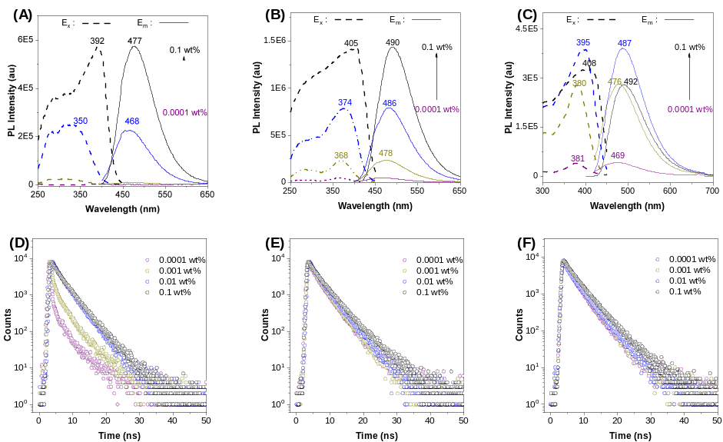
Supplementary Fig. 9. Excitation (dashed lines) and emission (solid lines) spectra of (A) TPE-4TA-PMMAs, (B) TPE-4TA-TWs, and (C) T-TPE-4TA-TWs; Fluorescence decay curves of (D) TPE-4TA-PMMAs, (E) TPE-4TA-TWs, and (F) T-TPE-4TA-TWs.

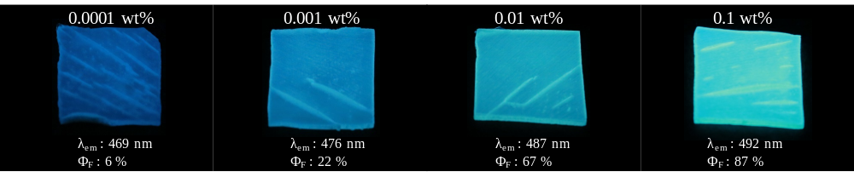
Supplementary Fig. 10. Optical images of T-TPE-4TA-TWs composites under UV light.

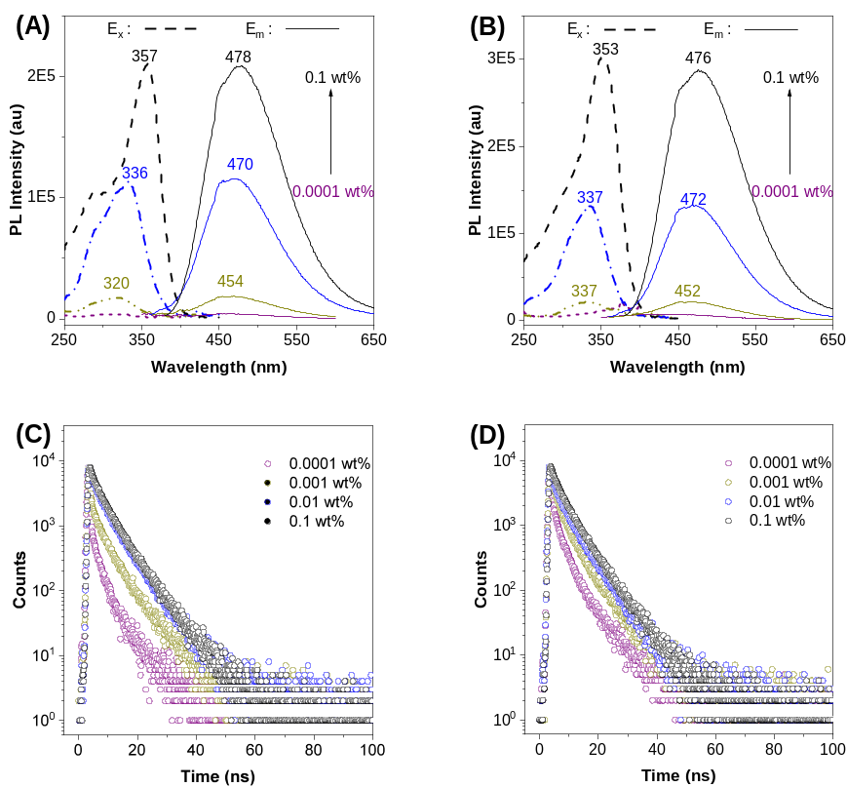
Supplementary Fig. 11. Excitation (dashed lines) and emission (solid lines) spectra of (A) TPE-PMMAs, and (B) TPE-TWs; Fluorescence decay curves of (C) TPE-PMMAs, and (D) TPE-TWs.

Supplementary Table 3. Optical properties of TPE and TPE-doped materials at different states
 | λ_{ex} [nm] | λ_{em} [nm] | τ (τ₁, τ₂) [ns] | Ф_{F} [%]ª | K_{r} [10⁸S⁻¹]^{b} | K_{nr} [10⁸S⁻¹]^{c}
THF | NA^{d} | NA | 3.7 (0.8, 4.6) | 0.2 | 0.005 | 2.70
MeOH | 370 | 475 | 5.1 (1.4, 5.8) | 22 | 1.42 | 1.54
powder | 380 | 450 | 1.5 (1.5, 1.5) | 27 | 1.82 | 4.85
TPE-PMMA 0.0001 wt% | 313 | 446 | 2.7 (0.7, 11.9) | 5 | 0.17 | 3.54
TPE-PMMA 0.001 wt% | 320 | 454 | 3.9 (0.6, 6.6) | 20 | 0.51 | 2.06
TPE-PMMA 0.01 wt% | 336 | 470 | 5.0 (1.2, 5.5) | 28 | 0.56 | 1.44
TPE-PMMA 0.1 wt% | 357 | 478 | 5.3 (1.3, 5.7) | 39 | 0.74 | 1.14
TPE-TW 0.0001 wt% | 317 | 447 | 2.9 (0.7, 4.7) | 7 | 0.27 | 3.19
TPE-TW 0.001 wt% | 337 | 452 | 4.0 (1.1, 5.0) | 22 | 0.56 | 1.94
TPE-TW 0.01 wt% | 337 | 472 | 4.8 (1.1, 5.5) | 61 | 1.27 | 0.81
TPE-TW 0.1 wt% | 353 | 476 | 5.3 (1.8, 5.9) | 78 | 1.48 | 0.41
a) Absolute quantum yields measured by an integrating sphere. b) k_{r}: radiative decay rate. c) k_{nr}: nonradiative decay rate. d) NA: Not available.

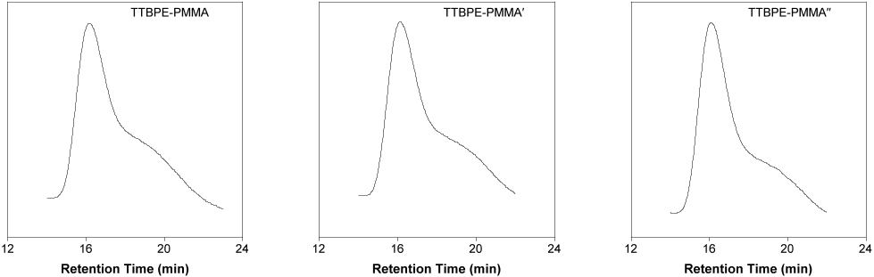
Supplementary Fig. 12. Gel Permeation Chromatography (GPC) curves of TTBPE-PMMA ([TTBPE] = 0.001 wt%) samples from different sites (eluent: THF, polystyrene standards).

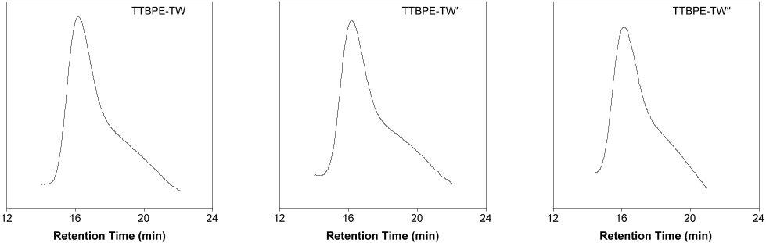
Supplementary Fig. 13. Gel Permeation Chromatography (GPC) curves of TTBPE-TW ([TTBPE] = 0.001 wt%) samples from different sites (eluent: THF, polystyrene standards).

Supplementary Table 4. Summary of the GPC results of TTBPE-PMMA and TTBPE-TW ([TTBPE] = 0.001 wt%) samples from Fig. 12-13
Entry | Mn (kDa) | Mw (kDa) | Mz (kDa) | Polydispersity (Mw/Mn)
TTBPE--PMMA′ | 552.7 | 1411.97 | 2235.2 | 2.555
TTBPE-PMMA′′ | 600.5 | 1488.8 | 2363.3 | 2.479
TTBPE-PMMA′′′ | 600.6 | 1680.39 | 2668.6 | 2.798
TTBPE--TW′ | 910.8 | 2171.41 | 3328.9 | 2.384
TTBPE-TW′′ | 1020.7 | 2409.04 | 3656.2 | 2.36
TTBPE-TW′′′ | 1702.1 | 2634.1 | 3705.4 | 1.548

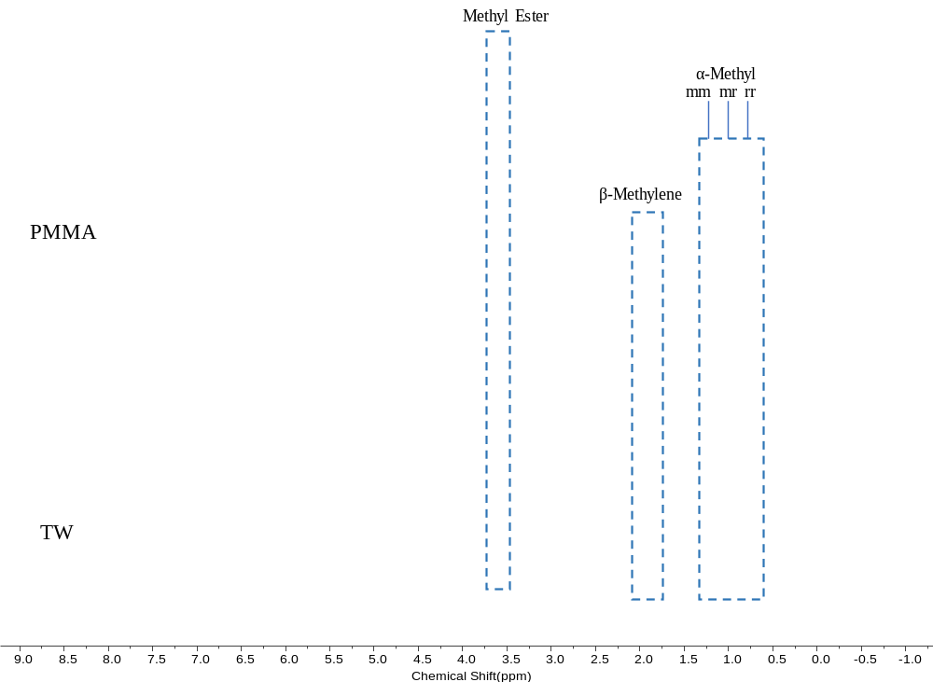
Supplementary Fig. 14. ¹H NMR spectrum (400 MHz) of TTBPE-PMMA and TTBPE-TW with 0.001 wt% dye content in CDCl₃ at 298 K.

Supplementary Table 5. Summary of the NMR results of TTBPE-PMMA and TTBPE-TW samples from Supplementary Fig.14
Entry | NMR triad content |  |  | NMR diad content
Entry | mm % | mr % | rr % | m % | r %
TTBPE-PMMA | 9.86 | 34.01 | 56.12 | 21.87 | 78.13
TTBPE-TW | 6.76 | 33.78 | 59.46 | 23.65 | 76.35

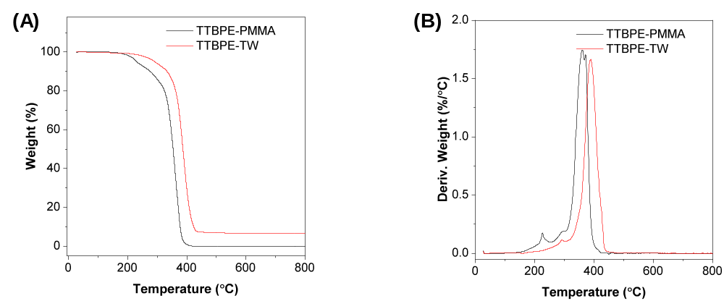
Supplementary Fig. 15. TG (A) and DTG (B) (under N₂) curves of the TTBPE-PMMA and TTBPE-TW with 0.001 wt% dye content samples.

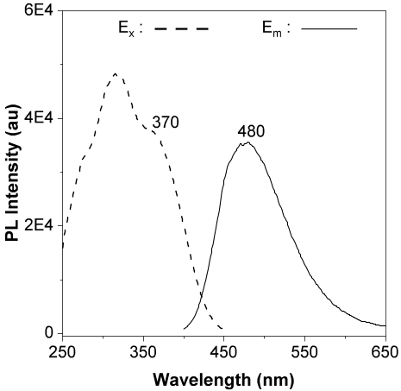
Supplementary Fig. 16. Excitation (dashed lines) and emission (solid lines) spectra of TTBPE-TW with 0.001 wt% dye content. (Sample prepared by direct immersion in dye solution prior to polymer filling).

Supplementary Table 6. Optical properties of TTBPE-TW ([TTBPE] = 0.001 wt%) directly immersed in dye solution before polymer filling
 | λ_{ex} [nm] | λ_{em} [nm] |  | τ (τ₁, τ₂) [ns] | Ф_{F} [%]ª | K_{r} [10⁸S⁻¹]^{b} | K_{nr} [10⁸S⁻¹]^{c}
TTBPE-TW | 370 |  | 480 | 1.8 (1.4, 3.1) | 41 | 2.32 | 3.23
a) Absolute quantum yields measured by an integrating sphere. b) k_{r}: radiative decay rate. c) k_{nr}: nonradiative decay rate.

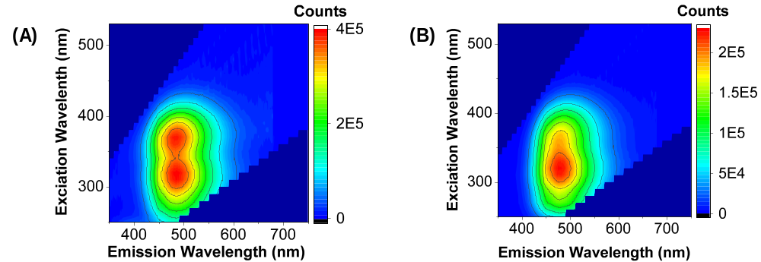
Supplementary Fig. 17. 2D excitation–emission matrix spectra of (A) TTBPE-TW with 0.001 wt% dye content, and (B) the corresponding TTBPE-TW sample directly immersed in dye solution before polymer filling.

Supplementary Fig. 18. CLSM images of DW. SYTO45 channel: Ex/Em= 405 nm/420−600 nm; Magnification: 20×.

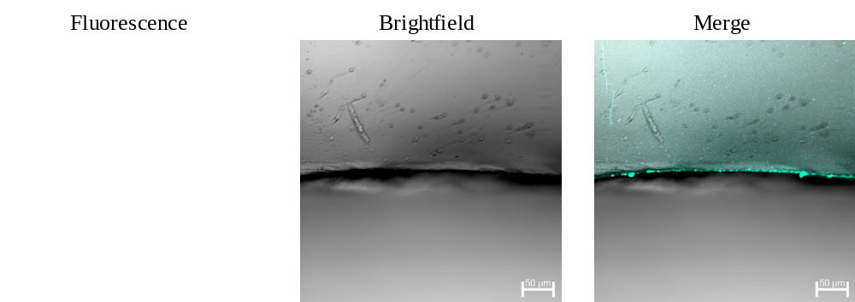
Supplementary Fig. 19. CLSM images of TTBPE-PMMA ([TTBPE] = 0.0001 wt%). SYTO45 channel: Ex/Em= 405 nm/420−600 nm; Magnification: 20×.

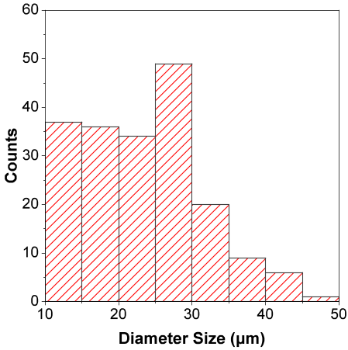
Supplementary Fig. 20. Diameter size distribution of cross-sections of TTBPE-stained transparent wood sample.

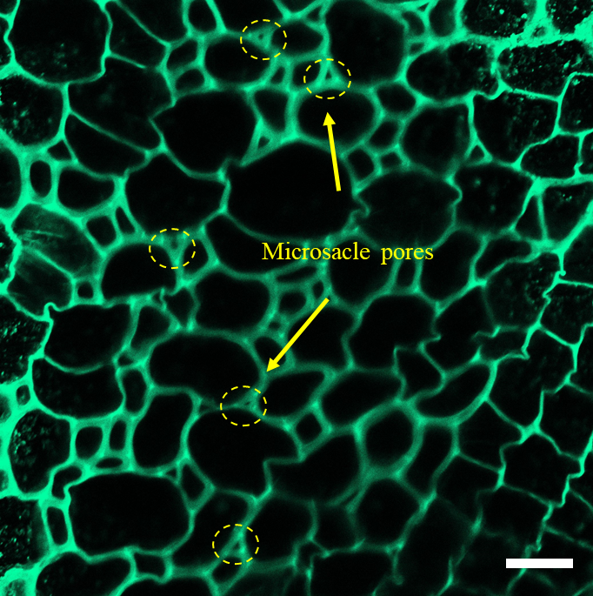
Supplementary Fig. 21. CLSM emission images of TTBPE-TW ([TTBPE] = 0.0001 wt%), demonstrating the microscale pores generated during the delignification process. SYTO45 channel: Ex/Em= 405 nm/420−600 nm; Magnification: 20×. Scale bar = 50 μm.

Supplementary Fig 22. Z-stack images of surface of TTBPE-TW ([TTBPE] = 0.01 wt%) with 5 μm increments; SYTO45 channel: Ex/Em= 405 nm/420−600 nm; Magnification: 40×. Scale bar = 50 μm.

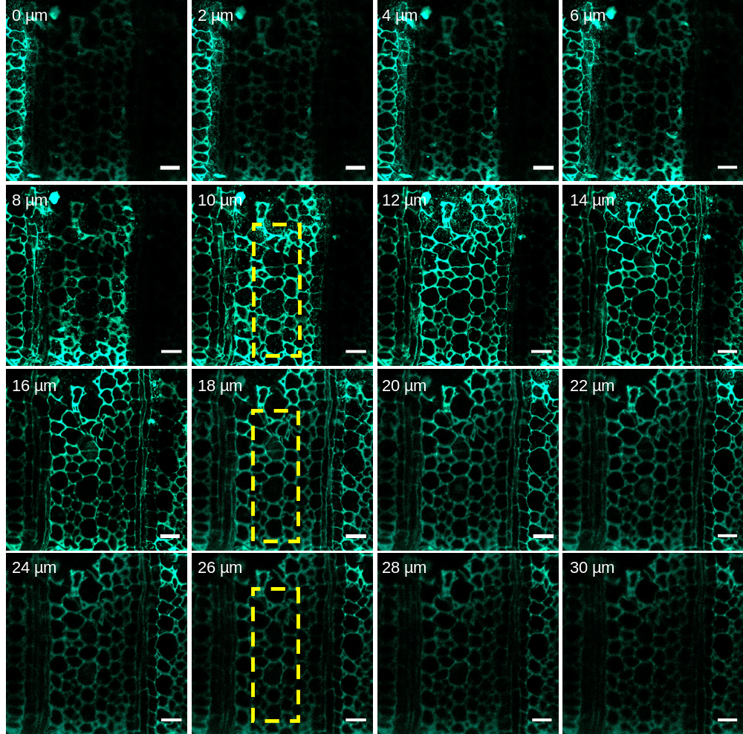
Supplementary Fig. 23. Z-stack images of cross-sections of TTBPE-TW ([TTBPE] = 0.001 wt%) with 2 μm increments; SYTO45 channel: Ex/Em= 405 nm/420−600 nm; Magnification: 20×. Scale bar = 50 μm.

References
- Li, Y., Fu, Q., Yu, S., Yan, M.&Berglund, L. Optically Transparent Wood from a Nanoporous Cellulosic Template: Combining Functional and Structural Performance. Biomacromolecules 17, 1358-1364 (2016).
- Xie, S. et al. Fluorogenic Ag⁺–Tetrazolate Aggregation Enables Efficient Fluorescent Biological Silver Staining. Angew. Chem. Int. Ed. 57, 5750-5753 (2018).
- Tu, Y. et al. Specific and Quantitative Detection of Albumin in Biological Fluids by Tetrazolate-Functionalized Water-Soluble AIEgens. ACS Appl. Mater. Interfaces 11, 29619-29629 (2019).

