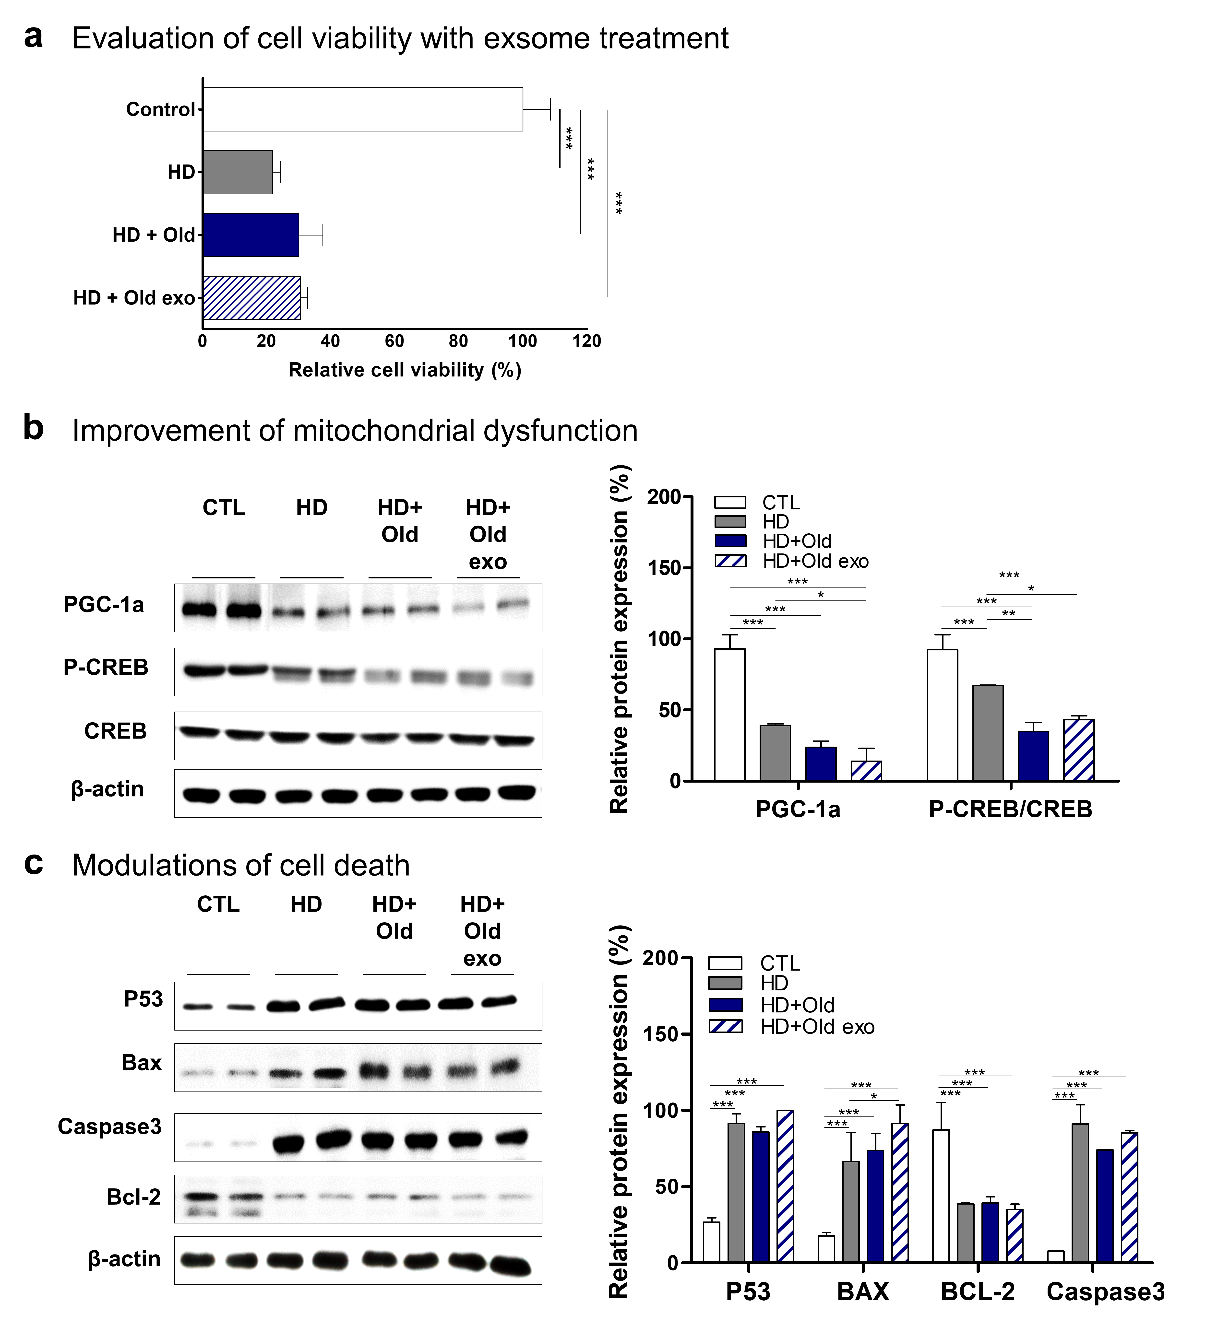
Figure S8. Modulation of molecular pathology of HD by treatment of exosomes from old serum. a Evaluation of cell viability with exosome treatment. b, c Improvement of mitochondrial dysfunction and modulation cell death, respectively.

