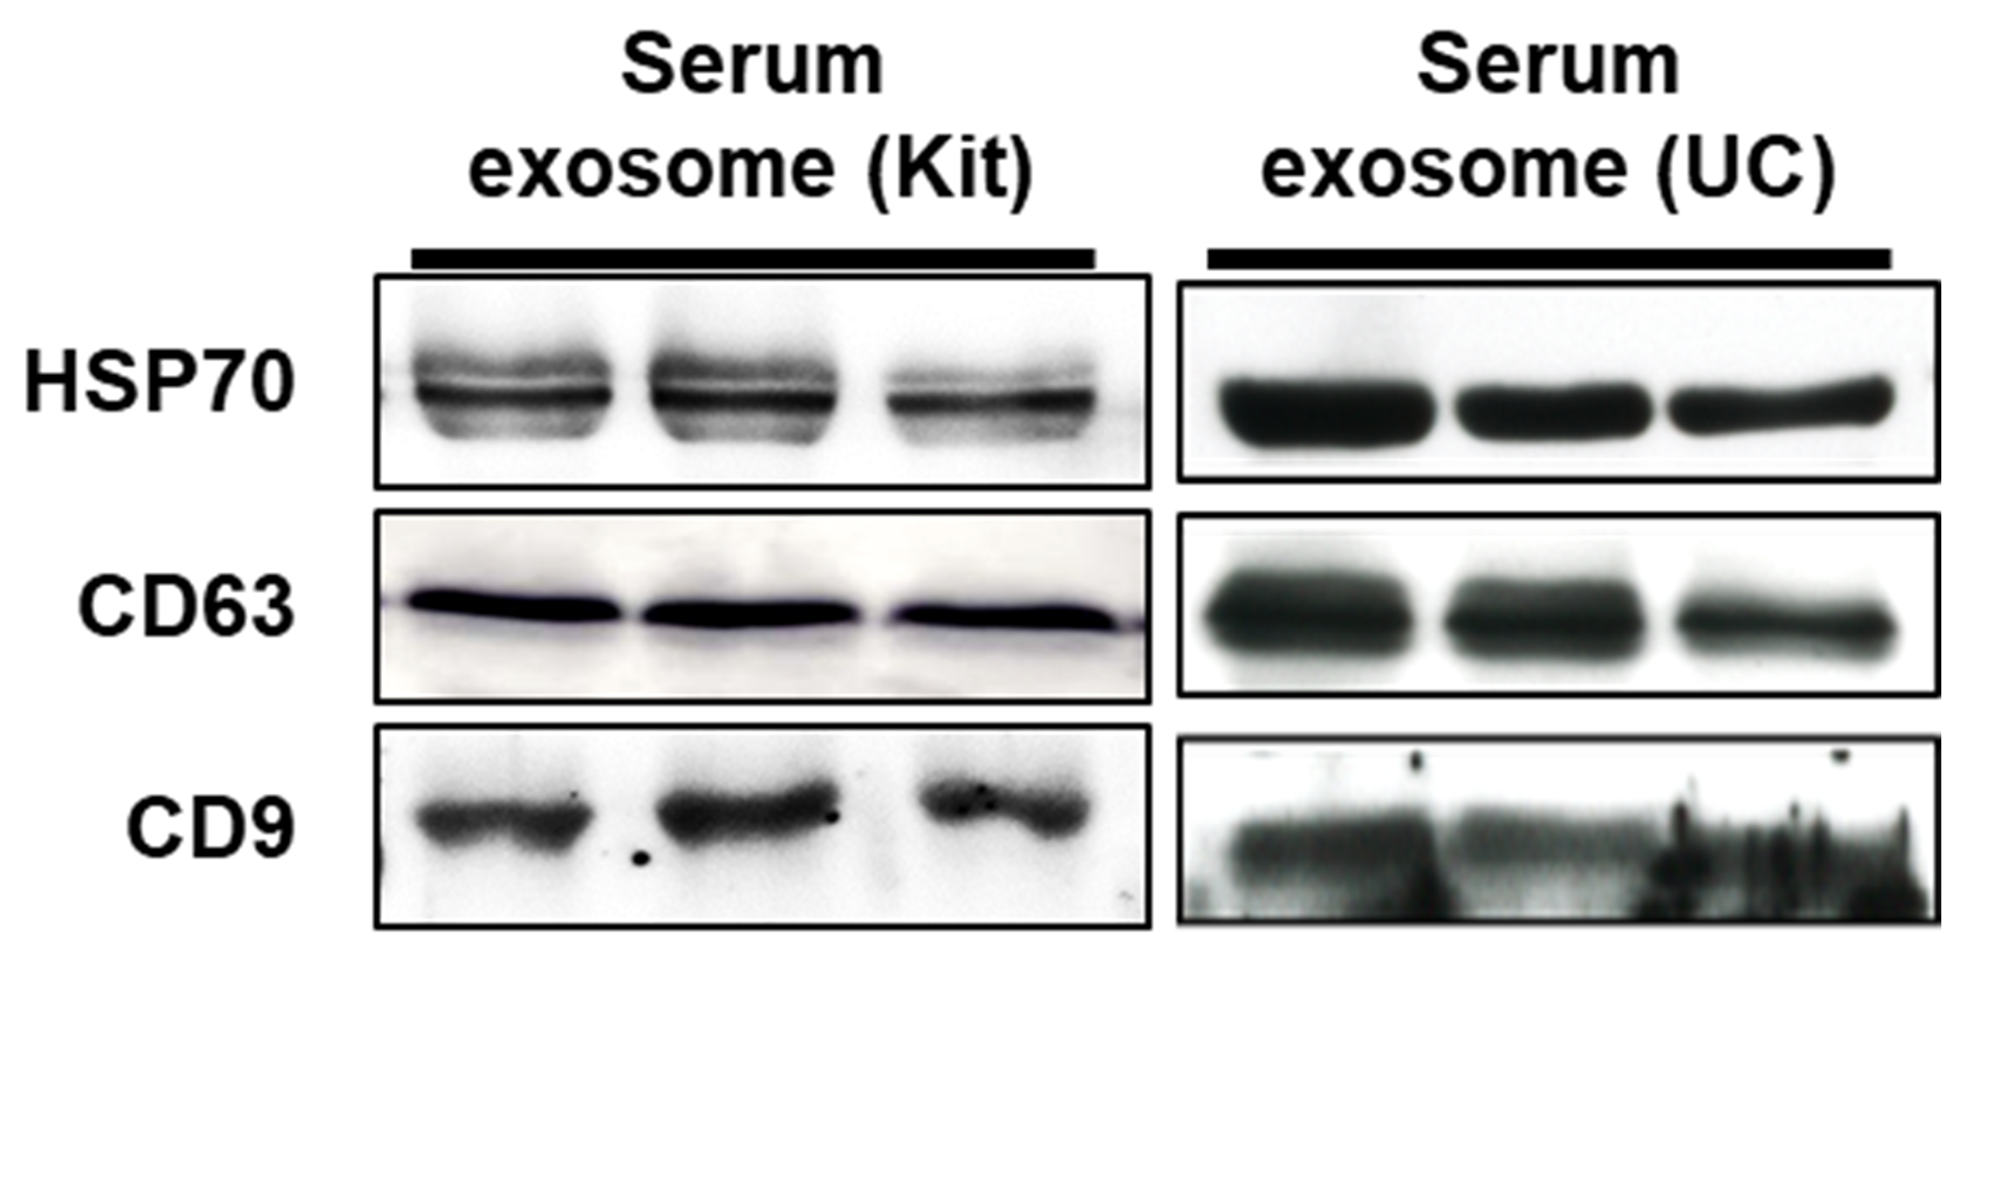
Figure S7. Exosomes isolated by Exokit and ultracentrifuge methods

