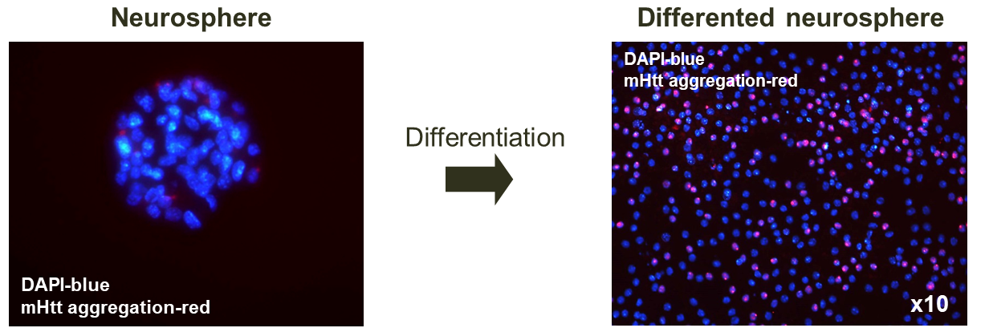
Figure S6. Identification of mHtt aggregation in the nucleus after differentiation.

