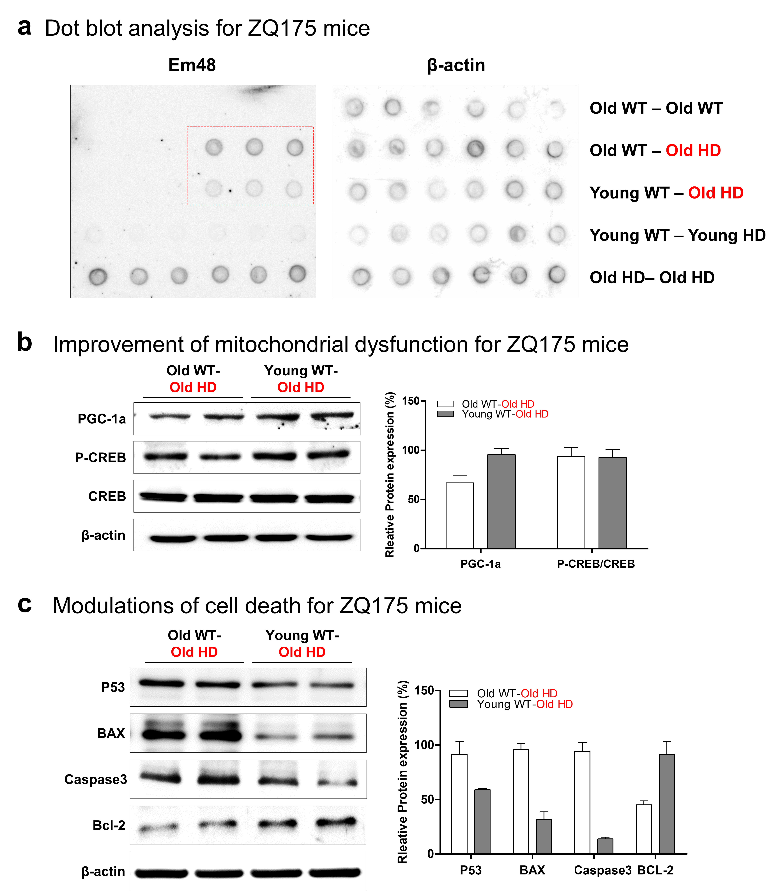
Figure S4. Modulation of molecular pathology of HD by parabiosis in the case of ZQ175 mice.
a Examination of mHtt aggregation of parabionts by dot blot analysis. b Improvement of mitochondrial dysfunction. c Modulation of cell death.

