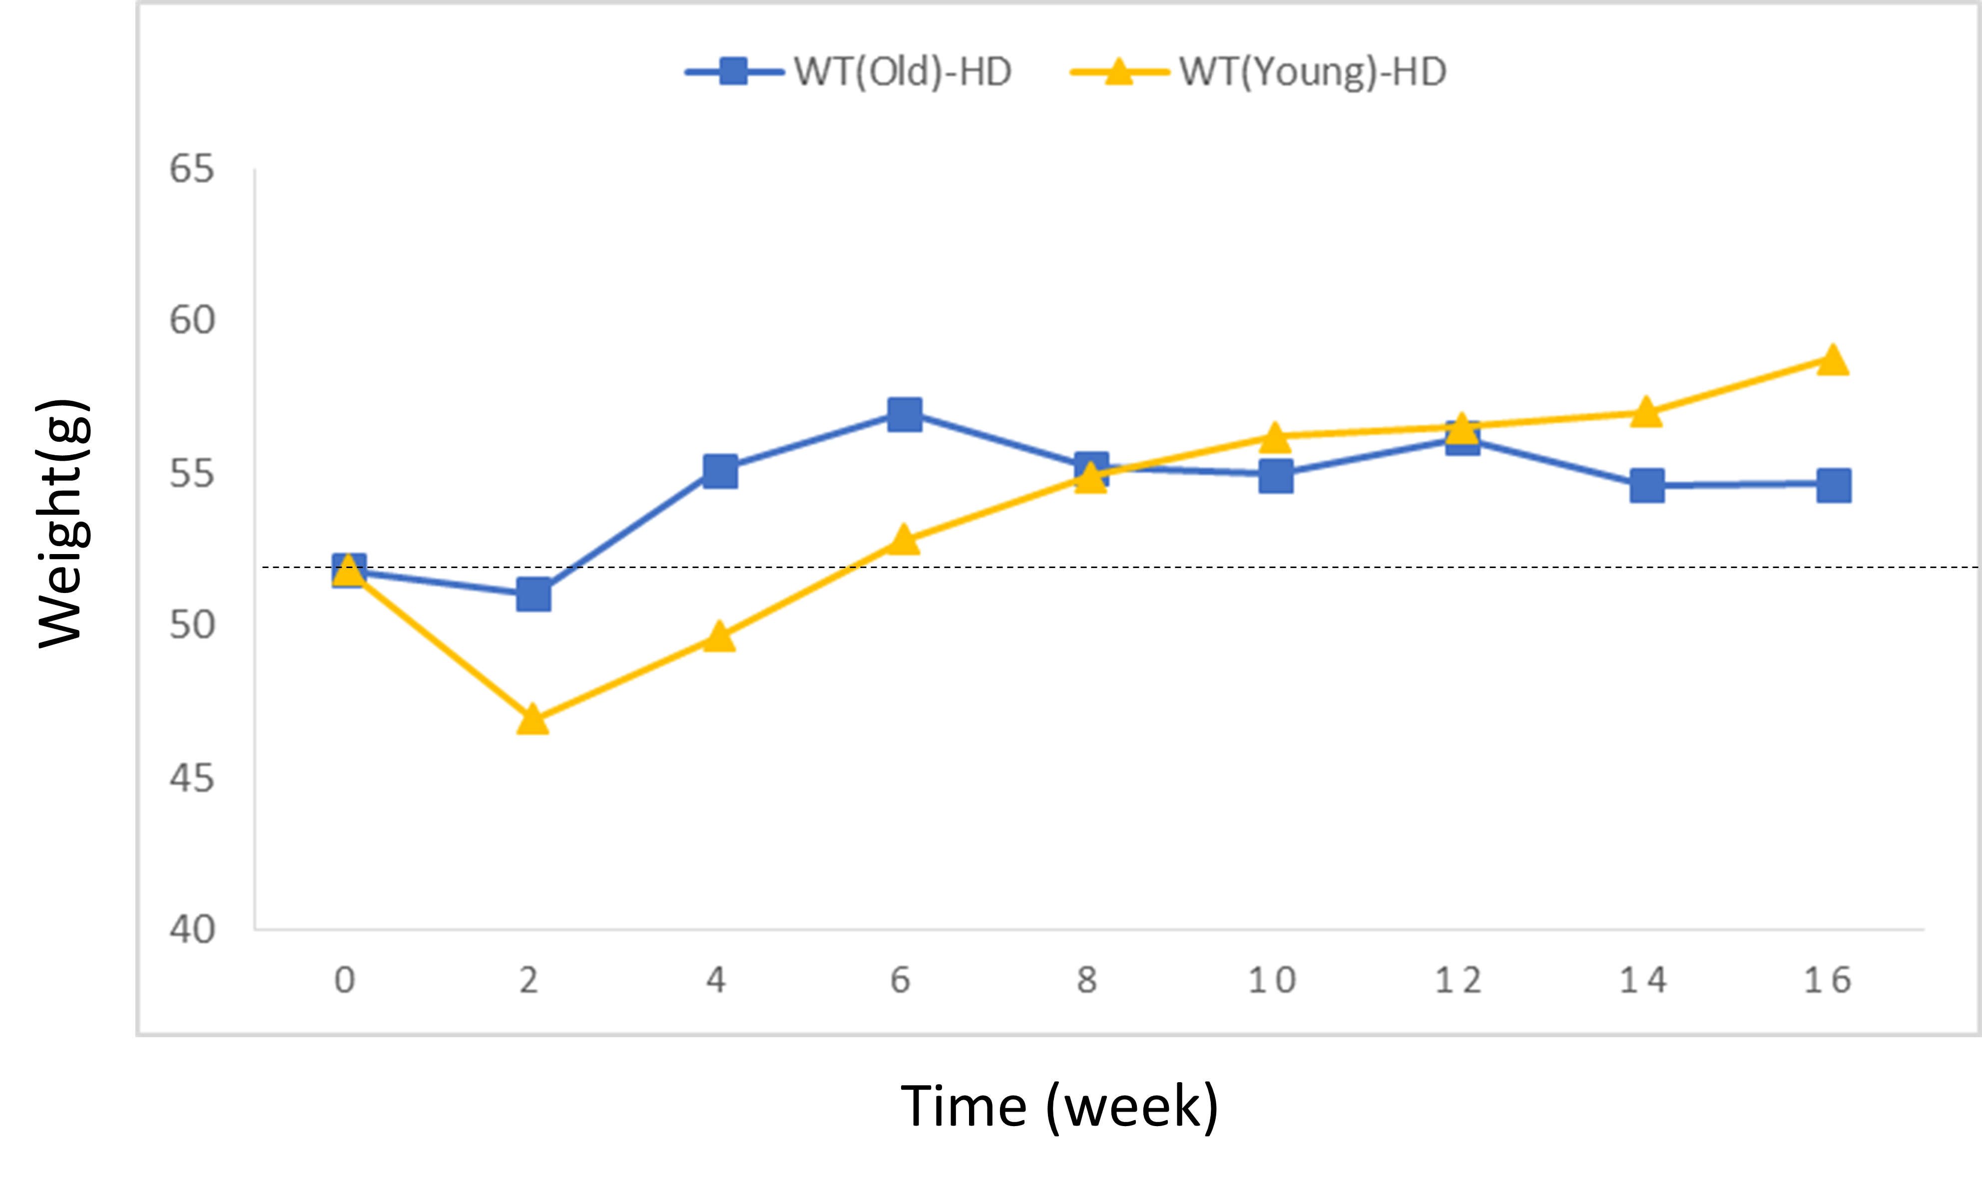
Figure S3. Comparison of body weight of ZQ175 mice paired with the old wild-type and young wild-type.

