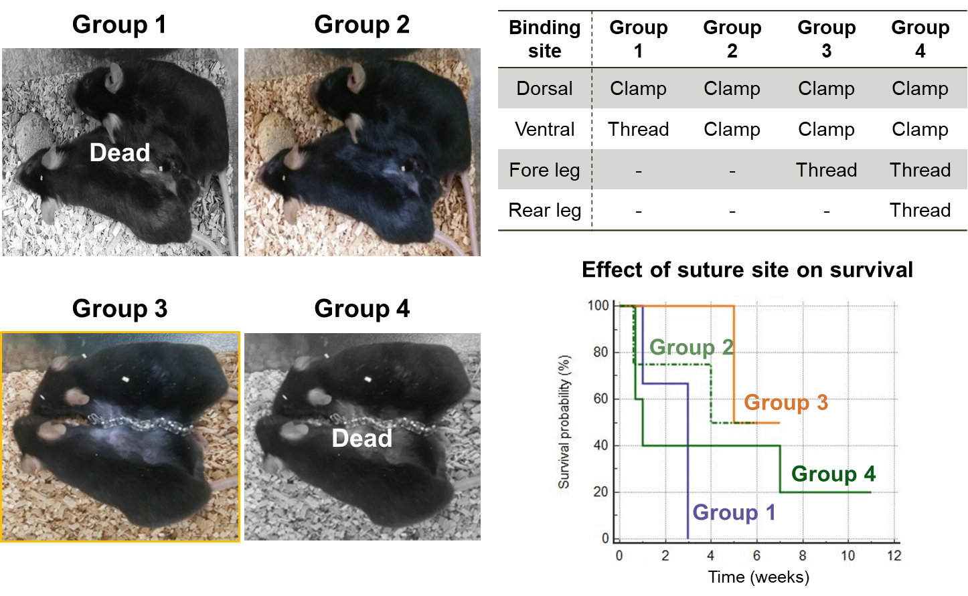
Figure S2. Effect of binding site and method on the survival of parabiotic pairs

