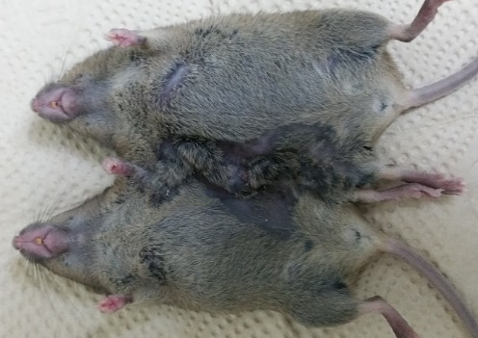
Figure S1. Actual photo for the parabiosis

