Supplementary Material
Supplementary Material 1. Questionnaire sequence and the School Burnout Inventory-9 (SBI-9)
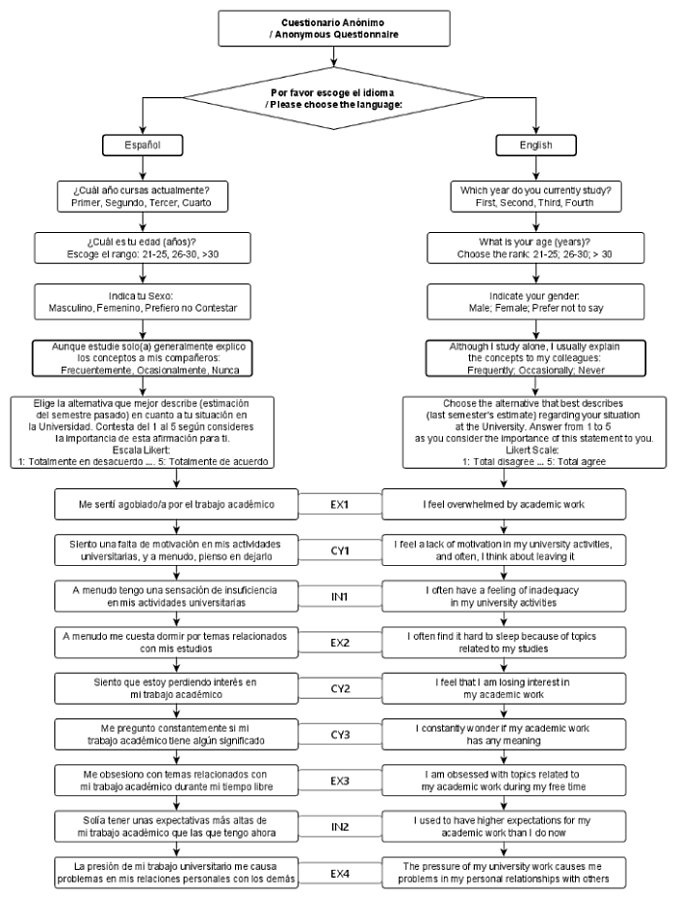
Supplementary Material 1.
The diagram illustrates the structured sequence of queries in the questionnaire. Initially, participants choose their preferred language. This is followed by a series of demographic questions including their academic year, age group, and gender. Subsequently, the questionnaire addresses a key topic on Informal Peer Assisted Learning, before delving into the core section comprising the nine questions of the School Burnout Inventory (SBI-9).

Supplementary Material 2. Demographics data’ summary by language (upper part), gender (middle part), and age (lower part). Means of percent of ABO.
LANGUAGE |  | EX-SP | CY-SP | IN-SP | ABO-SP | EX-EN | CY-EN | IN-EN | ABO-EN
 | N | 111 | 111 | 111 | 111 | 40 | 40 | 40 | 40
 | Mean (%) | 53.68 | 33.18 | 55.07 | 47.31 | 52.08 | 33.13 | 56.88 | 47.36
 | SD (%) | 22.41 | 28.63 | 27.51 | 21.82 | 22.63 | 27.25 | 30.08 | 20.94
GENDER |  | FEM | MALE | FEM-SP | MALE-SP | FEM-EN | MALE-EN | PNR-SP | PNR-EN
 | N | 76 | 71 | 59 | 50 | 17 | 21 | 2 | 2
 | Mean (%) | 48.684 | 44.758 | 50.448 | 43.112 | 42.565 | 48.677 | __ | __
 | SD (%) | 23.453 | 19.156 | 23.548 | 19.38 | 22.736 | 18.474 | __ | __
AGE (range) |  | ≤25 | ≥26 | ≤25 SP | ≥26 SP | ≤25 EN | 26≥ EN
 | N | 98 | 48 | 82 | 29 | 16 | 19
 | Mean (%) | 49.901 | 42.448 | 49.628 | 40.757 | 51.301 | 45.029
 | SD (%) | 20.121 | 23.86 | 20.374 | 24.67 | 19.342 | 22.981

Supplementary Material 2. The summary of demographic data is segmented by language (upper section), gender (middle section), and age (lower section). In every category, rows present the number of values, the mean percentage, and the standard deviation, respectively. Regarding language, the percentages for the parameters of exhaustion (EX), cynicism (CY), and inadequacy (IN) are specified for both Spanish (SP) and English (EN). For gender and age, the overall academic burnout percentage (%ABO) is calculated using the SBI-8 in which EX3 is excluded. In the gender category, SP and EN denote Spanish and English, respectively, while PNR represents students who preferred not to specify their gender. In the age category, all students were categorized into two age groups: ≤25 and ≥26. Across all categories, no significant statistical differences were observed when analyzed using the Ordinary One-way ANOVA for Multiple Comparisons. The Mean (%) indicates the average values for each parameter (EX, CY, IN) in Spanish (SP) or English (EN), or the % of ABO as applicable. The number of values (N), Mean (%), and Standard Deviations (SD) are detailed for each category.

Supplementary Material 3. Analysis using the Gaussian Graphical Model showing the factors determine the evaluation of ABO.
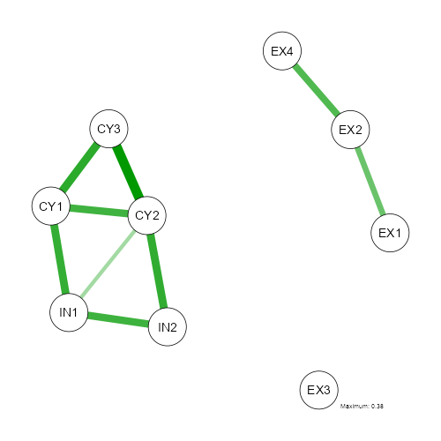
Supplementary Material 3.
The figure presents the Gaussian Graphical Model (Bhushan N, Mohnert F, Sloot D, Jans L, et al., 2019), which provides a detailed visualization of the interconnected elements influencing the factors that shape the ABO, as determined by the SBI-9. Factor 1 (Fc1) is constituted by items 1, 2, and 4, which represent aspects of exhaustion (EX). In contrast, Factor 2 (Fc2) emerges from the merger of items 1, 2, and 3 of cynicism (CY), in conjunction with items 1 and 2, representing inadequacy (IN). This confluence of items, representing both cynicism and inadequacy, is collectively referred to as CYIN. Exhaustion item 3 (EX3) is outside the interconnectivity of factors.

Supplementary Material 4. Evaluation of IPAL's mediation in inhibiting the development of ABO: The implications of this effect of factor 2 -Fc2 (CYIN)- on the IPAL.

 |  |  |  | 95% C.I. (a)
Type | Effect | Estimate | SE | Lower | Upper | β | z | p
Indirect | EX ⇒ IPAL ⇒ ABO | -2.46e−4 | 8.53E-04 | -0.00192 | 0.00143 | -2.56e−4 | -0.288 | 0.773
 | CYIN ⇒ IPAL ⇒ ABO | 0.00163 | 0.00132 | -9.64e−4 | 0.00422 | 0.00192 | 1.231 | 0.218
Component | EX ⇒ IPAL | 0.03563 | 0.12136 | -0.20224 | 0.2735 | 0.02712 | 0.294 | 0.769
 | IPAL ⇒ ABO | -0.00689 | 0.00464 | -0.01599 | 0.00221 | -0.00943 | -1.485 | 0.138
 | CYIN ⇒ IPAL | -0.23604 | 0.10729 | -0.44633 | -0.02575 | -0.20323 | -2.2 | 0.028
Direct | EX ⇒ ABO | 0.33108 | 0.00693 | 0.31750 | 0.34465 | 0.34456 | 47.805 | < .001
 | CYIN ⇒ ABO | 0.65975 | 0.00622 | 0.64756 | 0.67193 | 0.77668 | 106.102 | < .001
Total | EX ⇒ ABO | 0.33083 | 0.00700 | 0.31712 | 0.34455 | 0.34431 | 47.281 | < .001
 | CYIN ⇒ ABO | 0.66137 | 0.00619 | 0.64925 | 0.67350 | 0.77860 | 106.919 | < .001
Note. Confidence intervals computed with method: Standard (Delta method). Betas are completely standardized effect sizes.

Supplementary Material 4
The table shows the lack of a mediating role played by Informal Peer-Assisted Learning (IPAL) in the context of Academic Burnout (ABO). Notwithstanding, a pronounced direct relationship is evident between cynicism/inadequacy (CYIN) and IPAL. This is quantified by a correlation coefficient (r) of -0.23604, accompanied by a beta coefficient (β) of -0.203, and further substantiated by a statistically significant p-value of 0.028. These findings underscore that while IPAL significantly mitigates CYIN, it does not act as an intermediary in reducing ABO. Furthermore, the influence of CYIN on ABO is both direct and statistically substantial, as indicated by a p-value of less than 0.001.

