Original Article
Synthetic polyploidization induces enhanced phytochemical profile and biological activities in Thymus vulgaris L. essential oil.
Neha Gupta¹, Adrish Dutta¹, Soham Bhattacharya², Jan Tauchen³, Přemysl Landa⁴, Klára Urbanová⁵, Eloy Fernández-Cusimamani^{1*} and Olga Leuner¹

¹Department of Crop Sciences and Agroforestry, Faculty of Tropical AgriSciences, Czech University of Life Sciences Prague, Kamýcká 129, Suchdol, 165 00 Prague 6, Czech Republic.
²Department of Agroecology and Crop Production, Faculty of Agrobiology, Food and Natural Resources, Czech University of Life Sciences Prague, Kamýcká 129, Prague 6 – Suchdol, 165 00, Czech Republic.
³Department of Food Science, Faculty of Agrobiology, Food and Natural Resources, Czech University of Life Sciences, Prague, Czech Republic.
⁴Laboratory of Plant Biotechnologies, Institute of Experimental Botany of the Czech Academy of Sciences, Rozvojova 263, 165 02, Prague 6 – Lysolaje, Czech Republic
⁵Department of Sustainable Technologies, Faculty of Tropical AgriSciences, Czech University of Life Sciences Prague, Prague, Czech Republic.
*Address correspondence to:
Eloy Fernández-Cusimamani
Department of Crop Sciences and Agroforestry, Faculty of Tropical AgriSciences, Czech University of Life Sciences Prague, Kamýcká 129, Suchdol, 165 00 Prague 6, Czech Republic.
Email: eloy@ftz.czu.cz

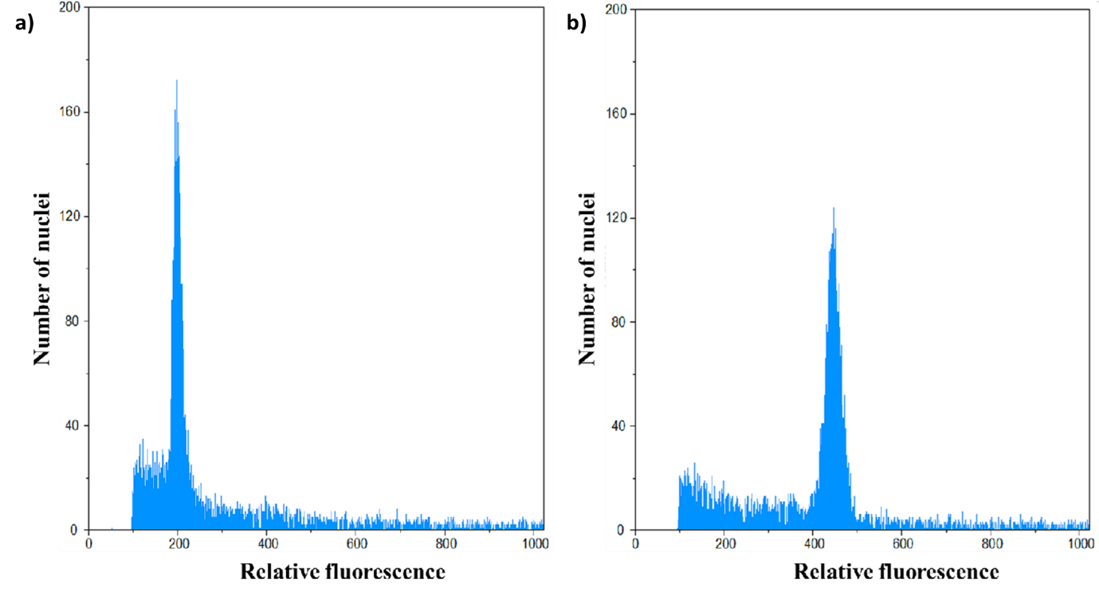Supplementary Fig. S1.: Flowcytometric analysis of T. vulgaris (a) histogram of relative DNA content of control diploid and (b) tetraploid plant.

