Supplementary material

Self-perceived impact of COVID-19 measures and adolescent mental health: gender, age and socioeconomic differences in 22 Countries

Authors: Franziska Reiss ª*, Alina Cosma ^{b,c}*, Michela Bersia^{d}, Michael Erhart ^{a, e}, Paola Dalmasso^{d}, Janine Devine ª, Sabina Hulbert ^{f}, Carolina Catunda^{g}, Inese Gobina^{h,i}, Ariela Giladi^{k}, Helena Jeriček Klanšček^{l}, Ulrike Ravens Sieberer ª

* Shared first Authorship
ª Department of Child and Adolescent Psychiatry, Psychotherapy, and Psychosomatics, University Medical Center Hamburg-Eppendorf, Hamburg, Martinistraße 52, 20246 Hamburg, Germany
^{b} Department of Sociology, Trinity College Dublin, Dublin, Ireland
^{c} School of Psychology, Trinity College Dublin, Dublin, Ireland
^{d} Department of Public Health and Pediatrics, University of Torino, Via Santena 5 bis, 10126 Torino, Italy
^{e} Alice-Salomon University, Alice-Salomon-Platz 5, 12627 Berlin, Germany
^{f} Centre for Health Services Studies, University of Kent, UK
^{g} Department of Social Sciences, University of Luxembourg, Esch-sur-Alzette, Luxembourg
^{h} Department of Public Health and Epidemiology, Riga Stradiņš University, Latvia
^{i} Education and Research Unit, Childrens’ Clinical University Hospital, Riga, Latvia
^{k} Faculty of Education, Bar Ilan University, Ramat Gan, Israel
^{l} National Institute of Public Health, Trubarjeva 2, 1000 Ljubljana, Slovenia

Figure S1 Dates on which the 22 countries conducted the survey 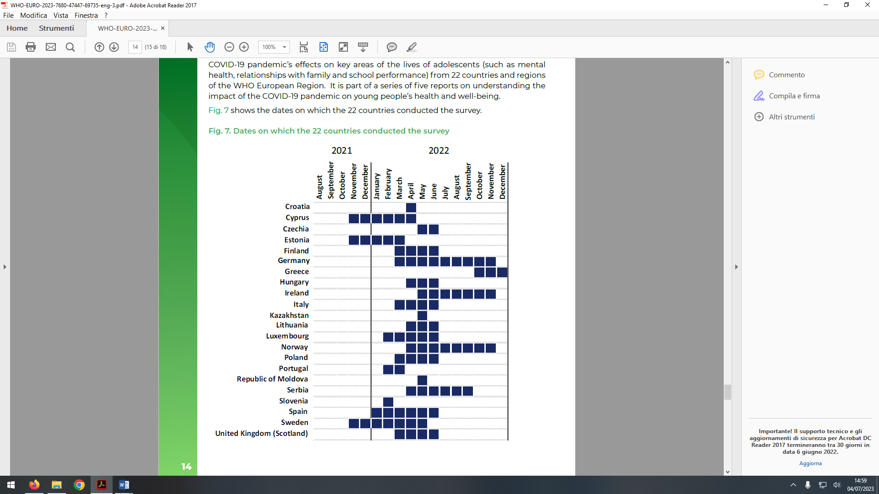
Reprinted from Residori et al. (2023) with permission.

Table S1 Goodness of fit of the MLCA solutions
 | AIC | CAIC | BIC | entropy | Res.Df
2 class solution | 1709219 | 1710252 | 1710150 | 0.92 | 67441
3 class solution | 1616330 | 1617990 | 1617826 | 0.89 | 67379
4 class solution | 1564721 | 1567008 | 1566782 | 0.88 | 67317
5 class solution | 1530704 | 1533619 | 1533331 | 0.87 | 67255

Table S2 Distribution of the COVID-19 impact items by impact class
Negative impact class
 | life | health | family | friends | mental | school | physical | eating | future | finances
Very Negative | 35.1 | 28.2 | 25.9 | 26.2 | 49.6 | 39.5 | 40.9 | 34.7 | 37.6 | 23.7
Quite negative | 33.7 | 30.9 | 23.4 | 25.8 | 25.3 | 24.5 | 24.4 | 25.2 | 26.5 | 20.3
Neither negative or positive | 22.4 | 27.7 | 27.9 | 24.0 | 14.0 | 18.7 | 17.3 | 23.9 | 23.1 | 37.7
Quite Positive | 5.8 | 8.3 | 14.5 | 15.4 | 5.9 | 10.8 | 9.8 | 9.6 | 7.6 | 10.6
Very positive | 3.0 | 5.0 | 8.4 | 8.5 | 5.2 | 6.4 | 7.7 | 6.6 | 5.3 | 7.7
Neutral impact class
 | life | health | family | friends | mental | school | physical | eating | future | finances
Very negative | 2.9 | 1.3 | 1.0 | 1.6 | 6.0 | 4.8 | 5.3 | 2.6 | 2.0 | 1.5
Quite negative | 19.1 | 13.8 | 7.8 | 13.4 | 23.6 | 23.6 | 25.3 | 15.9 | 14.4 | 10.3
Neither negative or positive | 65.7 | 68.6 | 60.1 | 57.1 | 56.8 | 50.6 | 47.1 | 64.2 | 69.7 | 72.6
Quite positive | 9.9 | 12.8 | 24.0 | 21.2 | 10.2 | 15.8 | 16.2 | 13.6 | 10.5 | 11.6
Very positive | 2.4 | 3.5 | 7.1 | 6.7 | 3.5 | 5.2 | 6.0 | 3.8 | 3.4 | 4.0
Positive impact class
 | life | health | family | friends | mental | school | physical | eating | future | finances
Very Negative | 3.3 | 1.6 | 1.3 | 1.4 | 4.3 | 3.1 | 3.5 | 2.3 | 2.4 | 1.5
Quite negative | 7.4 | 4.8 | 3.3 | 4.2 | 9.0 | 9.0 | 8.5 | 5.2 | 5.5 | 3.7
Neither negative or positive | 29.6 | 20.2 | 14.3 | 16.2 | 22.7 | 28.4 | 19.6 | 22.7 | 27.6 | 24.8
Quite Positive | 37.3 | 41.1 | 35.0 | 37.8 | 33.8 | 35.5 | 31.6 | 37.7 | 36.3 | 36.6
Very positive | 22.5 | 32.3 | 46.1 | 40.4 | 30.3 | 24.0 | 36.8 | 32.1 | 28.2 | 33.5

Table S3 Distribution of impact classes by country
 | Impact class
 | Negative | Neutral | Positive
Cyprus | 29,9 | 48,8 | 21,3
Czechia | 17,8 | 44,2 | 38,1
Germany | 12,1 | 56,6 | 31,3
Estonia | 11,7 | 68,2 | 20,1
Spain | 14,2 | 47,1 | 38,7
Finland | 10,1 | 58,3 | 31,6
Scotland | 8,5 | 69,7 | 21,7
Greece | 26,8 | 59,6 | 13,6
Croatia | 10,9 | 42,3 | 46,8
Hungary | 26,4 | 60,6 | 13,0
Ireland | 18,6 | 53,7 | 27,7
Italy | 23,1 | 47,5 | 29,4
Kazakhstan | 33,0 | 39,2 | 27,8
Lituania | 20,0 | 71,6 | 8,4
Luxemburg | 11,4 | 44,1 | 44,5
Moldova | 8,3 | 40,2 | 51,5
Norway | 9,6 | 44,1 | 46,4
Poland | 26,7 | 61,4 | 11,9
Portugal | 13,6 | 54,9 | 31,5
Serbia | 18,1 | 52,8 | 29,1
Sweden | 9,7 | 50,4 | 39,9
Slovenia | 13,2 | 36,9 | 49,9

Table S4 Gender, age, and SES distribution by impact class
 | Positive impact class | Neutral impact class | Negative impact class | p
Gender
Boys | 57.8 | 44.9 | 39.0 | <0.001
Girls | 42.2 | 55.1 | 61.0 | <0.001
Age
13 yrs | 55.9 | 42.8 | 42.5 | <0.001
15 yrs | 44.1 | 57.2 | 57.5 | <0.001
SES
Low | 22.1 | 24.9 | 31.1 | <0.001
Medium | 62.5 | 63.6 | 58.4 | <0.001
High | 15.4 | 11.5 | 10.5 | <0.001
Abbreviations. SES, socioeconomic status; yrs, years.

Table S5 Percentage predicted probability of the explored mental outcomes by impact class among girls and boys
 |  | Boys (OR) |  |  |  |  |  |  | Girls (OR)
 |  | mean |  |  | 95% CI |  |  |  | mean |  |  | 95% CI
Loneliness
Positive impact |  | 5,8 |  |  | 4,5 - 7,2 |  |  |  | 9,7 |  |  | 7,9 - 11,6
Neutral impact |  | 9,8 |  |  | 8,2 - 11,3 |  |  |  | 19,4 |  |  | 17,4 - 21,3
Negative impact |  | 17,8 |  |  | 14,1 - 21,4 |  |  |  | 44,3 |  |  | 40,0 - 48,6
PHC (>=2 at least twice a week)
Positive impact |  | 24 |  |  | 21,3 - 26,6 |  |  |  | 49,7 |  |  | 46,1 - 53,4
Neutral impact |  | 31,2 |  |  | 28,5 - 33,9 |  |  |  | 62,7 |  |  | 60,3 - 65,1
Negative impact |  | 45,1 |  |  | 40,0 - 50,1 |  |  |  | 80,9 |  |  | 77,3 - 84,5
High LS (>=9)
Positive impact |  | 19,5 |  |  | 17,0 – 22,0 |  |  |  | 19,1 |  |  | 16,4 - 21,7
Neutral impact |  | 16,2 |  |  | 14,2 - 18,3 |  |  |  | 12,5 |  |  | 10,8 - 14,1
Negative impact |  | 11,2 |  |  | 8,1 - 14,3 |  |  |  | 6,4 |  |  | 4,4 - 8,4
Note. Results adjusted by age and socioeconomic status.

