Extended data
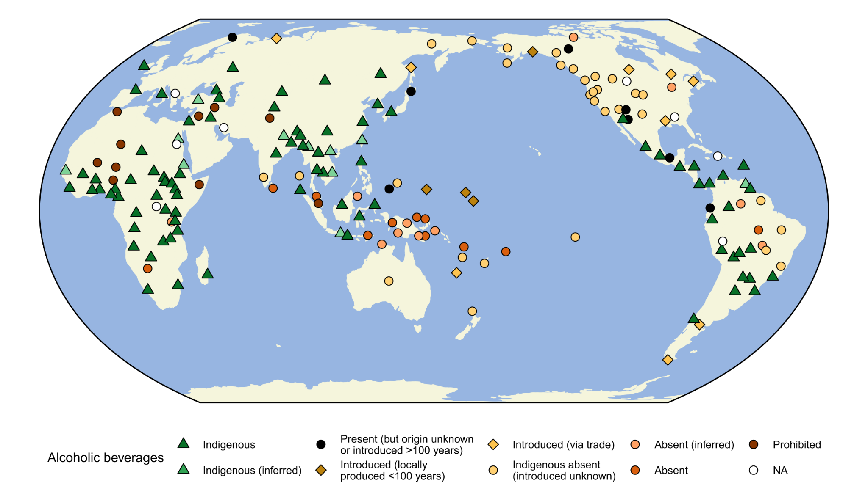

Extended Data Fig. 1 | Presence of alcoholic beverages among 186 SCCS societies. For each culture, the data refer to its focal time specified in the Supplementary Data. See Methods for detailed definition of the codes.

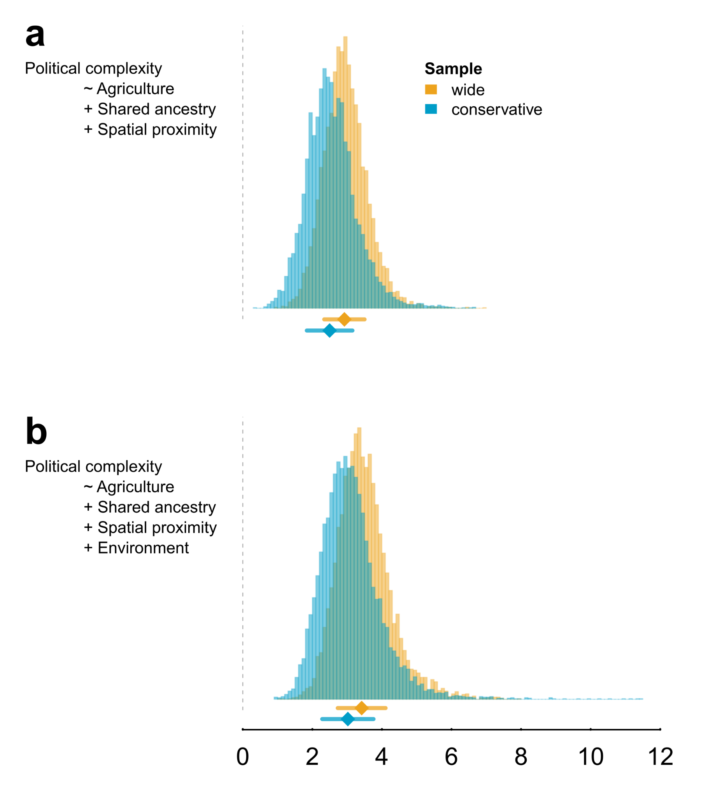
Extended Data Fig. 2 | Posterior coefficient estimates of the association between political complexity and agriculture. We ran separate models to estimate the total (unmediated) effect of agriculture on political complexity. These models mirror models 4 (panel a) and 5 (panel b) from Fig. 2, but alcohol is excluded as a predictor. The median and interquartile range of each posterior distribution are shown.

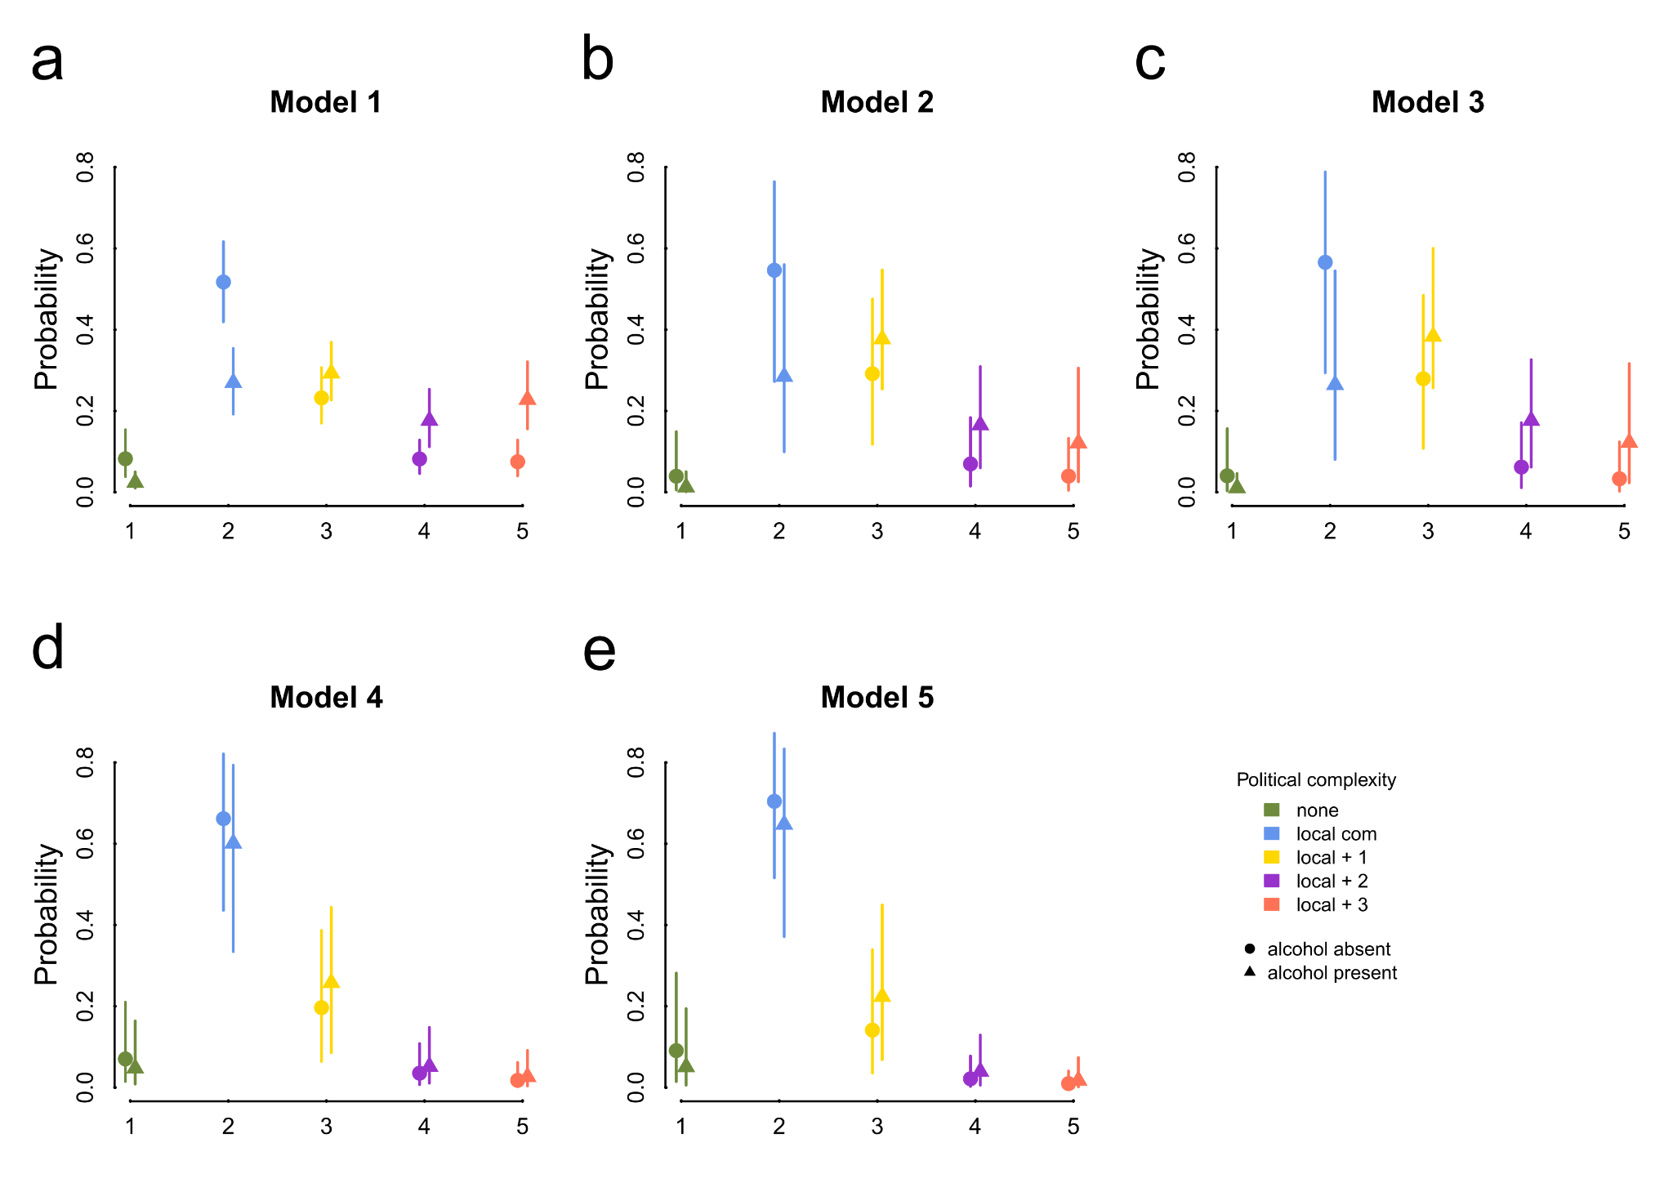
Extended Data Fig. 3 | Probabilities of values in each political complexity category for presence and absence of alcohol. The five panels (a-e) correspond to the five causal structures from Fig. 2, with the “wide” sample. The estimate is plotted, alongside the lower and upper interval limits.
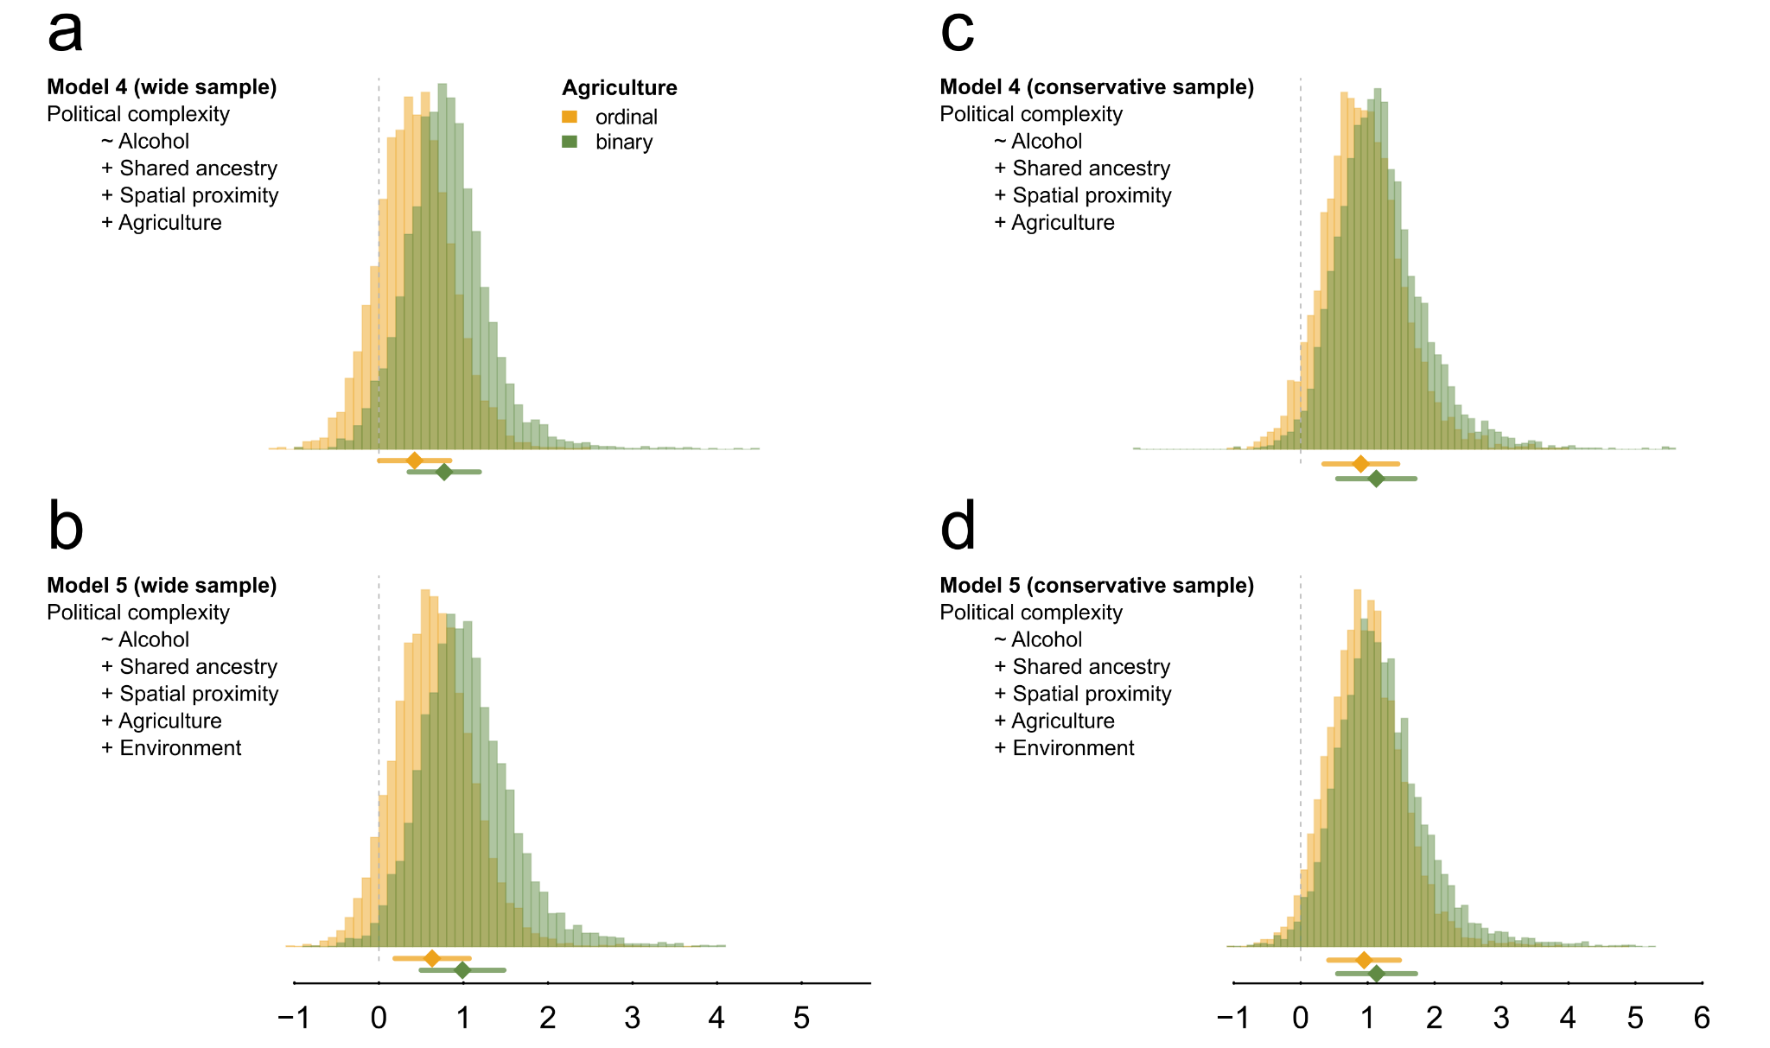
Extended Data Fig. 4 | Posterior coefficient estimates of the association between political complexity and alcohol. We ran separate models coding agriculture as a binary predictor (presence versus absence). The panels compare the effects of alcohol on political complexity when agriculture is modelled as a binary (green) versus ordinal (orange) predictor, on both the “wide” and “conservative” samples. The median and interquartile range of each posterior distribution are shown.

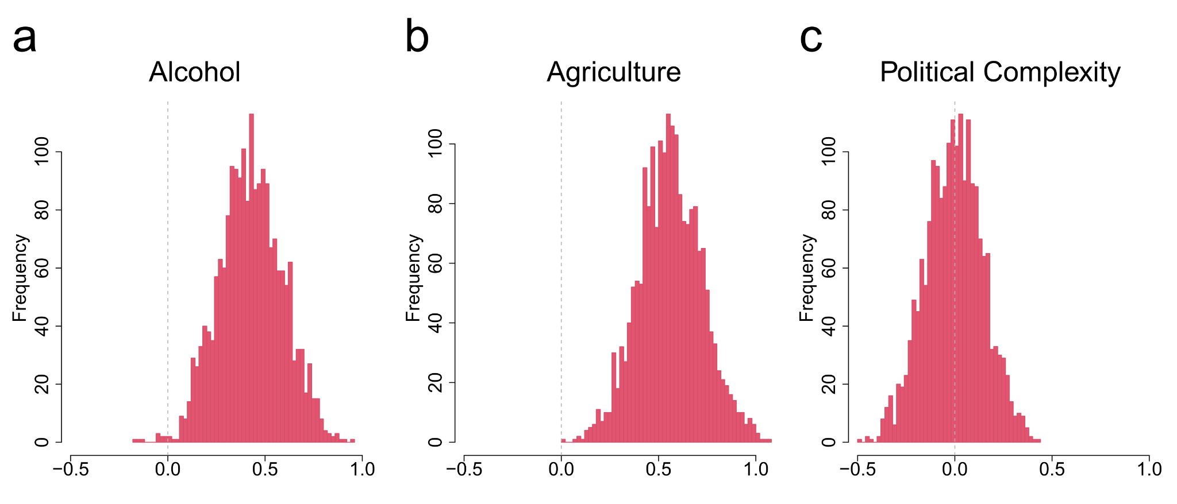
Extended Data Fig. 5 | Posterior coefficient estimates of the association between environmental productivity and a) alcohol, b) agriculture intensity, and c) political complexity.

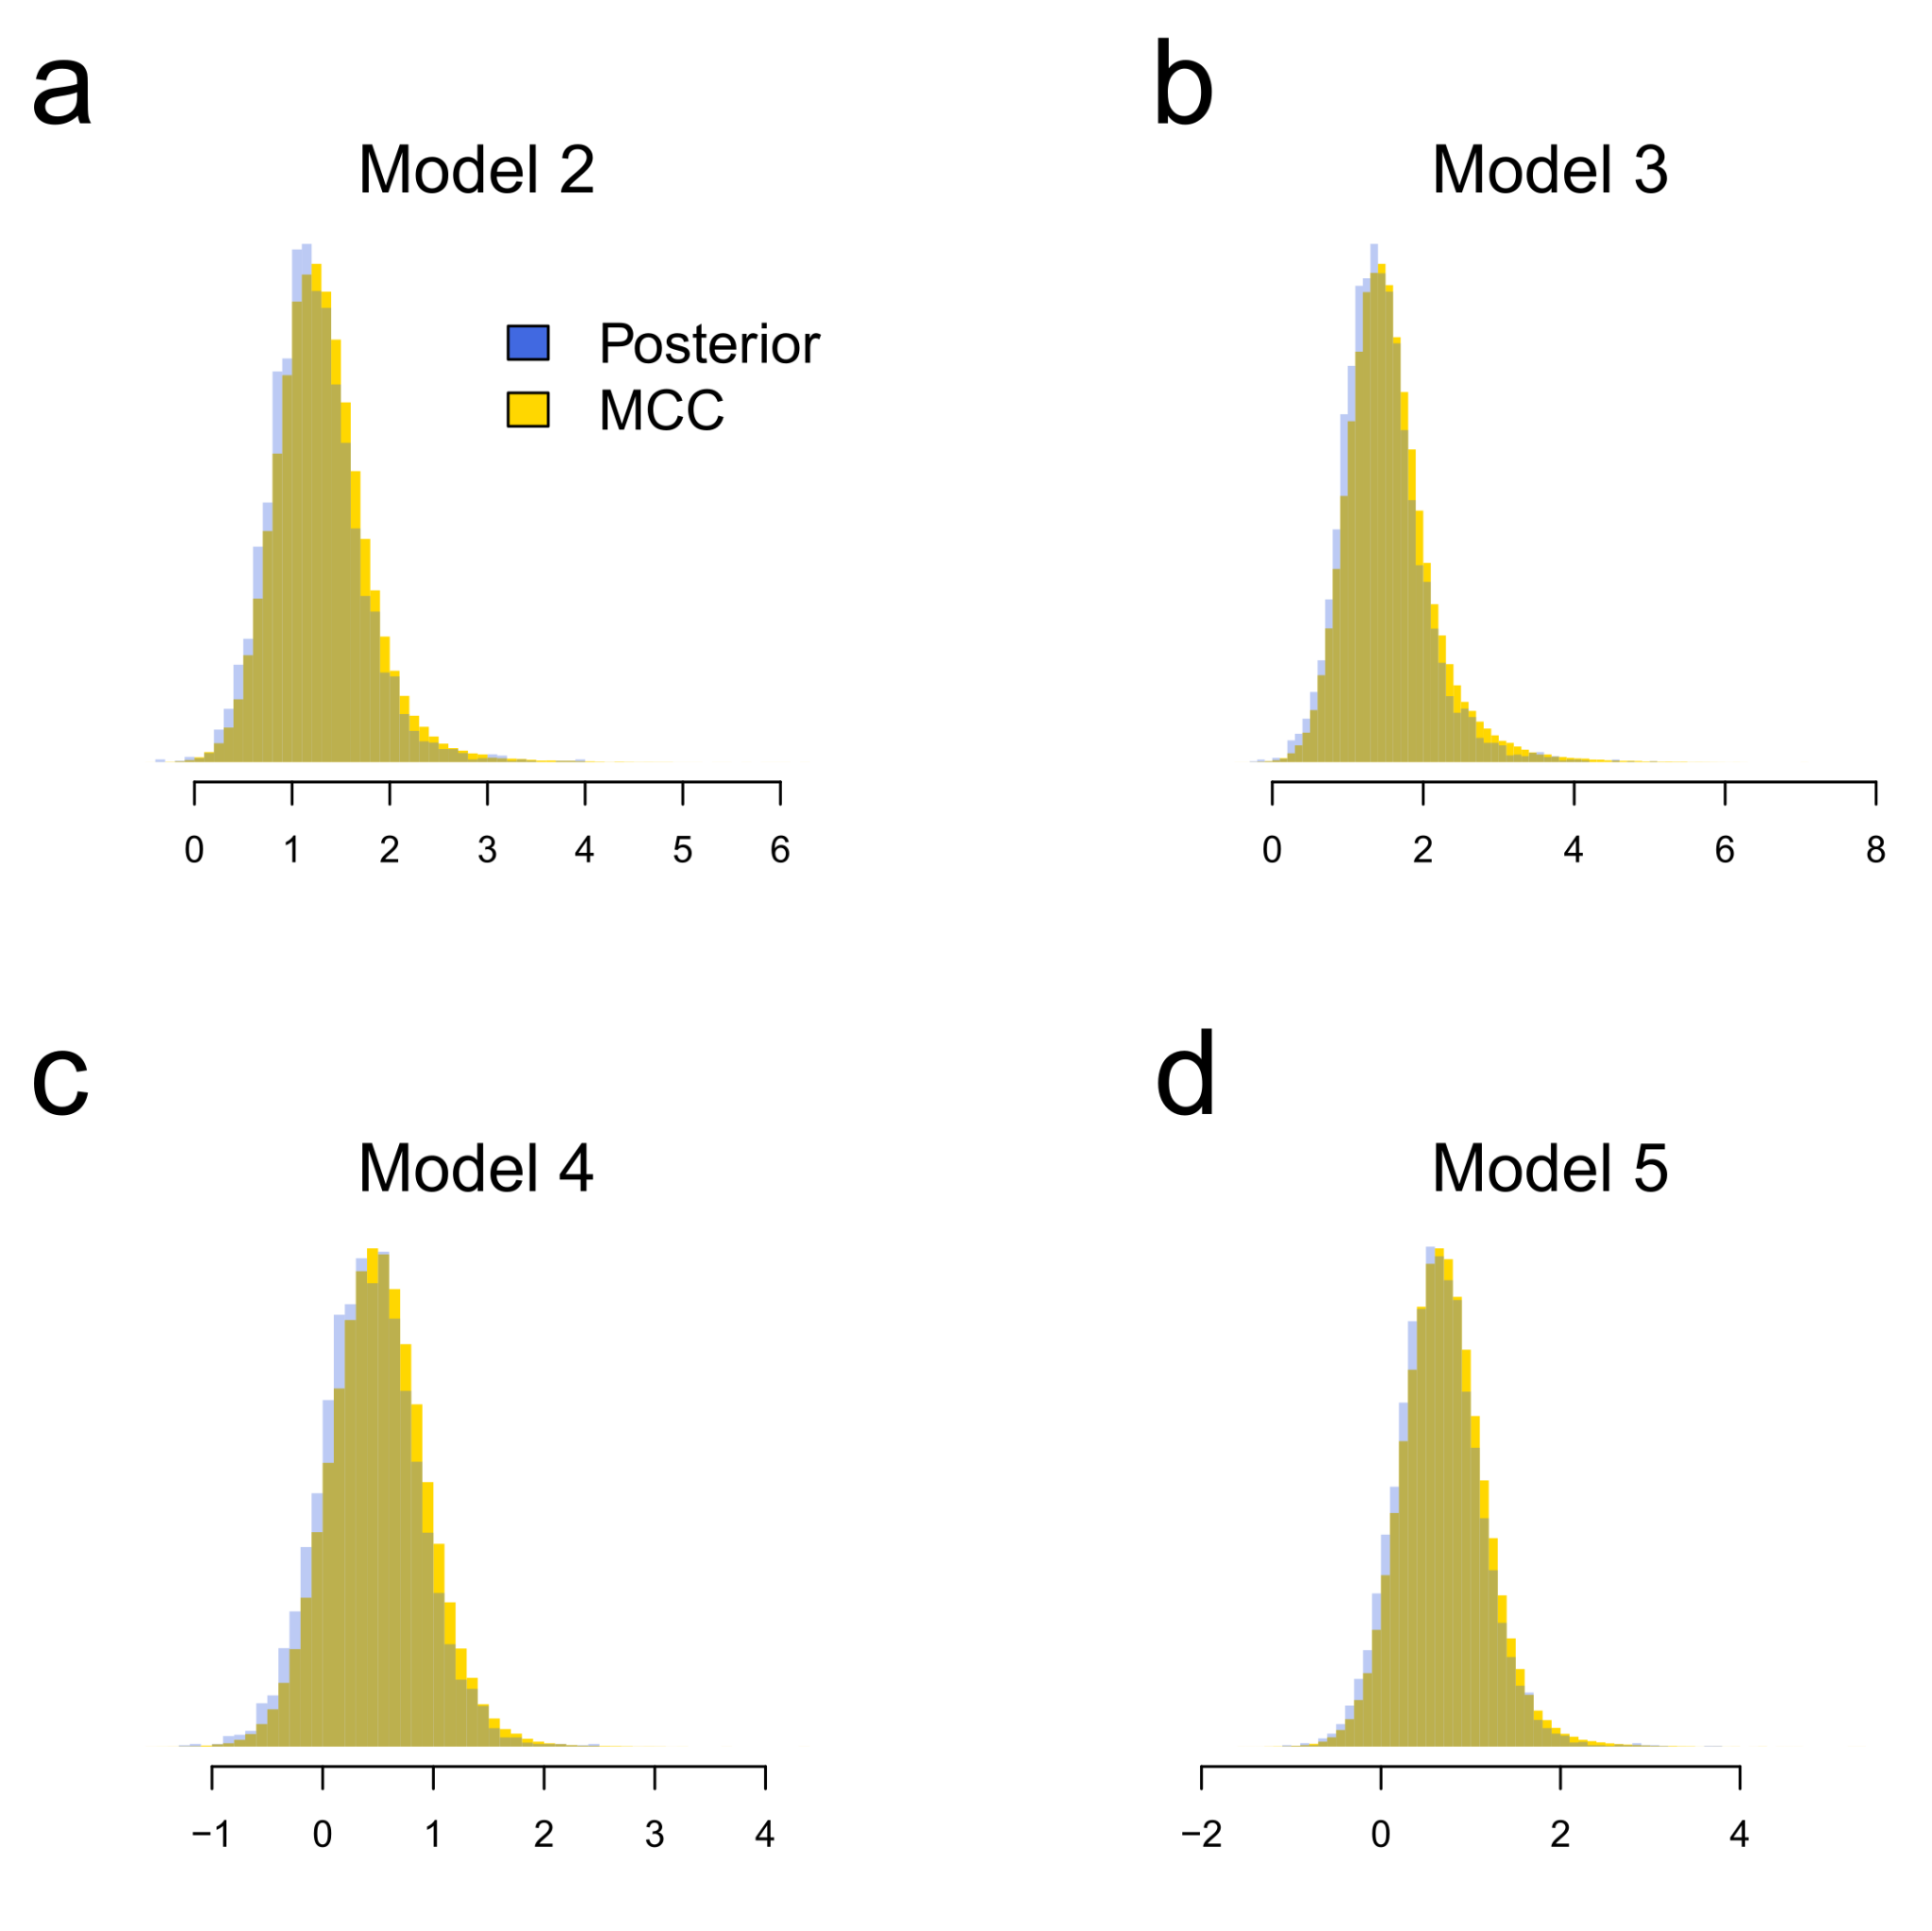
Extended Data Fig. 6 | Posterior coefficient estimates of the association between alcohol and political complexity, using a summary tree (yellow) versus a sample of 50 random trees from the posterior of alternative language trees (blue). The panels mirror models 2-5 from Fig. 2. The overlapping histograms show minute differences in the link between alcohol and political complexity when the models are run with alternative trees.

Extended Data Table 1 | Presence of alcohol among 186 SCCS societies. Both the detailed coding and the binarized versions used for the analysis. Data refers to each society's focal time (FT).

