Genome sequencing analysis of the endophytic fungus Aspergillus tamarii TPD11
Qing Zhang^{1 #}, Hai Liu^{2 #}, Xiaojun Zhao², Jili Yang², Weidi Tang², Ying Yang³, Sheng Chang³, Bo Cai³, Juan Liu¹, Yaoshun Zhu¹, Bo Zhou^{3 *}, Tao Liu^{1 *}
* Correspondence: Bo Zhou and Tao Liu
Tao Liu: yantao618@126.com
Bo Zhou: 12725301@qq.com

Supplementary Table

Table S1. Annotation Statistics of coding gene from the A. tamarii TPD11 genome.
Protein coding genes | Value
Total number of genes | 11 305
Average genes length (bp) | 1 673.37
Average CDS length (bp) | 1 483.71
Average exon length (bp) | 463.59
Average intron length (bp) | 86.19

Table S2. Statistics of A. tamarii TPD11 transposable elements annotation results.
Genetic Structure | Number of elements | Total length (bp)
Transposable elements
DNA | 1 133 | 565 733
LINE | 486 | 194 822
LTR | 705 | 197 157
SINE | 103 | 1 133
SSR | 2535 | 31 961
Simple repeat | 217 | 16 890
Total Repeats | 8 401 | 1 234 306
Non-Coding RNA
tRNA | 255 | 22 081
rRNA | 105 | 147 706
SnRNA | 8 | 1 358
sRNA | 37 | 5924
cis-regulatory elements | 3 | 309
DNA is transposons; LINE is Long scattered element; LTR is long terminal repetition, mainly include two types, Gypsy and Copia; SINE is short scattered element; SSR is simple sequence repeat element. tRNA is transport RNA; rRNA is ribosomal RNA; SnRNA is nucleolar small RNA; sRNA is small regulatory RNA.

Table S3: The polysaccharide biosynthetic candidate genes in A. tamarii TPD11 genome.
Annotation | Accession Number | Class
beta-galactosidase | AHI44625.1 | GH35
beta-galactosidase | BAE57053.1 | GH3
beta-galactosidase | BAE63197.1 | GH1
endo-beta-1,4-glucanase / cellulase | AFG25592.1 | GH5;GH4
endo-beta-1,4-glucanase / cellulase | BAA22588.1 | GH12
endo-beta-1,4-glucanase / cellulase | BAE66197.1 | GH7
endo-beta-1,4-glucanase / cellulase | BAE58099.1 | GH5;GH9
endo-beta-1,4-xylanase | BAB20794.1 | GH11
endo-beta-1,4-xylanase | AFP43760.1 | GH10
pectin lyase | AAW03313.1 | PL4;PL1
beta-xylosidase | BAE55732.1 | GH43;GH1
beta-xylosidase | BAA28267.1 | GH3
alpha-glucosidase | BAA08125.1 | GH31
alpha-glucosidase | BAB59003.1 | GH40;GH13
glucose 1-oxidase | AFA42947.1 | AA2;AA3
beta-primeverosidase | BAG70961.1 | GH5;GH23
endo-beta-1,3-galactanase | EED49498.1 | GH16;GH10
exo-polygalacturonase | EAA60554.1 | GH28
lytic starch monooxygenase / starch oxidase | XP_001823115.2 | AA13
copper-dependent lytic polysaccharide monooxygenases (LPMOs) | BAE61530.1 | AA11
alpha-1,3-glucosidase | BAE61578.1 | GH31
alpha-amylase | CAA36967.1 | GH1;GH13
alpha-mannosidase | BAE57653.1 | GH47
beta-hexosaminidase | AAM13977.1 | GH20
branching enzyme | BAB69770.1 | GH8;GH13
chitin synthase | BAB8820.1 | GT2
chitinase | AAO61686.1 | GH18
chitosanase | BAD08218.2 | GH75
cutinase | BAE55151.1 | CE5
exo-beta-glucosaminidase | AHJ61328.1 | GH2
Glucan-endo-1,6-beta-glucosidase | EAA59985.1 | GH5;GH15
glucoamylase | BAE57516.1 | GH15
invertase | AHY94898.1 | GH32
pectin methylesterase | BAE60873.1 | CE8
polygalacturonase | BAA03244.2 | GH28

Table S4. The Overview of the predicted results for secreted proteins in A. tamarii TPD11 genome.
type | number | Proportion (%)
protein with signal peptide | 1,118 | 9.89
protein without transmembrane domain | 9,031 | 79.89
secreted protein | 925 | 8.18

Table S6. The class of CYP450 in A. tamarii TPD11 genome.
Name | Class | Name | Class | Name | Class | Name | Class
contig000001.154 | CYP504 | contig000001.2124 | CYP5116 | contig000007.894 | CYP56 | contig000004.162 | CYP630
contig000003.1025 | CYP504 | contig000003.1076 | CYP5116 | contig000001.2405 | CYP57 | contig000004.347 | CYP630
contig000003.367 | CYP5042 | contig000006.65 | CYP5116 | contig000003.55 | CYP573 | contig000005.206 | CYP630
contig000007.878 | CYP5042 | contig000003.6 | CYP5148 | contig000003.361 | CYP577 | contig000006.1012 | CYP630
contig000001.1040 | CYP505 | contig000007.770 | CYP52 | contig000001.1752 | CYP578 | contig000006.429 | CYP630
contig000002.412 | CYP505 | contig000008.297 | CYP52 | contig000001.515 | CYP578 | contig000007.465 | CYP630
contig000003.731 | CYP505 | contig000005.933 | CYP5285 | contig000004.1067 | CYP578 | contig000008.142 | CYP630
contig000005.496 | CYP505 | contig000006.99 | CYP5285 | contig000006.455 | CYP578 | contig000005.52 | CYP631
contig000005.923 | CYP5053 | contig000002.398 | CYP5286 | contig000001.963 | CYP58 | contig000008.36 | CYP631
contig000006.973 | CYP5053 | contig000002.899 | CYP5286 | contig000001.966 | CYP58 | contig000001.1578 | CYP643
contig000008.513 | CYP5053 | contig000004.1171 | CYP5288 | contig000005.137 | CYP58 | contig000003.1506 | CYP643
contig000001.1402 | CYP5061 | contig000007.27 | CYP5288 | contig000007.859 | CYP58 | contig000004.78 | CYP643
contig000001.566 | CYP5068 | contig000001.553 | CYP5289 | contig000006.920 | CYP584 | contig000001.2501 | CYP65
contig000002.1592 | CYP5068 | contig000002.1269 | CYP5289 | contig000007.146 | CYP584 | contig000002.1417 | CYP65
contig000003.1595 | CYP5070 | contig000002.373 | CYP5289 | contig000003.1497 | CYP59 | contig000002.1609 | CYP65
contig000003.162 | CYP5070 | contig000003.123 | CYP5289 | contig000006.833 | CYP59 | contig000003.1079 | CYP65
contig000001.96 | CYP5075 | contig000005.145 | CYP5289 | contig000007.643 | CYP59 | contig000003.124 | CYP65
contig000006.22 | CYP5075 | contig000005.599 | CYP5289 | contig000001.109 | CYP595 | contig000003.1548 | CYP65
contig000001.2240 | CYP5076 | contig000006.21 | CYP5289 | contig000007.109 | CYP60 | contig000004.1472 | CYP65
contig000007.455 | CYP5076 | contig000006.605 | CYP5289 | contig000001.1180 | CYP6001 | contig000005.24 | CYP65
contig000006.270 | CYP5078 | contig000008.141 | CYP5289 | contig000003.1124 | CYP6001 | contig000006.484 | CYP65
contig000007.732 | CYP5080 | contig000004.282 | CYP53 | contig000003.1322 | CYP6001 | contig000006.999 | CYP65
contig000001.899 | CYP5087 | contig000005.76 | CYP53 | contig000004.148 | CYP6001 | contig000008.309 | CYP65
contig000006.623 | CYP5087 | contig000005.1150 | CYP531 | contig000004.488 | CYP6001 | contig000004.1022 | CYP653
contig000005.46 | CYP5089 | contig000006.968 | CYP531 | contig000006.131 | CYP6001 | contig000002.1551 | CYP655
contig000002.17 | CYP5093 | contig000006.218 | CYP532 | contig000008.174 | CYP6001 | contig000004.853 | CYP657
contig000005.23 | CYP5093 | contig000006.424 | CYP532 | contig000003.421 | CYP6002 | contig000002.32 | CYP660
contig000005.30 | CYP5093 | contig000004.1454 | CYP535 | contig000006.844 | CYP6002 | contig000004.1071 | CYP660
contig000006.223 | CYP5094 | contig000001.1097 | CYP539 | contig000001.1503 | CYP61 | contig000005.136 | CYP660
contig000006.472 | CYP5095 | contig000001.2404 | CYP539 | contig000001.478 | CYP61 | contig000003.632 | CYP666
contig000004.1094 | CYP5096 | contig000004.1073 | CYP539 | contig000003.230 | CYP61 | contig000003.213 | CYP671
contig000001.2265 | CYP5099 | contig000004.578 | CYP539 | contig000001.15 | CYP613 | contig000005.1146 | CYP672
contig000001.1469 | CYP51 | contig000001.1204 | CYP540 | contig000005.37 | CYP613 | contig000003.1585 | CYP675
contig000002.900 | CYP51 | contig000002.1065 | CYP540 | contig000001.1479 | CYP617 | contig000006.550 | CYP68
contig000002.443 | CYP5102 | contig000002.1285 | CYP540 | contig000006.17 | CYP617 | contig000007.452 | CYP68
contig000008.115 | CYP5102 | contig000002.901 | CYP540 | contig000001.2446 | CYP62 | contig000008.847 | CYP68
contig000001.2175 | CYP5105 | contig000003.716 | CYP540 | contig000001.1035 | CYP620 | contig000001.2548 | CYP682
contig000008.745 | CYP5105 | contig000007.183 | CYP540 | contig000001.2549 | CYP620 | contig000003.866 | CYP682
contig000006.998 | CYP5106 | contig000004.1093 | CYP541 | contig000001.2588 | CYP620 | contig000004.732 | CYP682
contig000007.80 | CYP5106 | contig000005.980 | CYP541 | contig000002.1508 | CYP620 | contig000007.739 | CYP684
contig000005.5 | CYP5107 | contig000006.408 | CYP547 | contig000004.411 | CYP620 | contig000005.261 | CYP687
contig000005.828 | CYP5107 | contig000002.478 | CYP548 | contig000004.60 | CYP620 | contig000008.266 | CYP687
contig000005.829 | CYP5107 | contig000004.628 | CYP548 | contig000007.594 | CYP620 | contig000008.448 | CYP687
contig000001.2481 | CYP5112 | contig000008.794 | CYP548 | contig000008.511 | CYP620
contig000002.259 | CYP5112 | contig000004.1421 | CYP55 | contig000004.1146 | CYP628
contig000007.694 | CYP5112 | contig000002.511 | CYP551 | contig000004.1348 | CYP628

Table S7. The gene cluster in A. tamarii TPD11 genome.
Region | Type | From | To | Most similar cluster | Similarity
Region1.1 | NRPS-like | 32,298 | 63,551 | aspergillic acid | 57%
Region1.2 | NRPS-like | 395,180 | 436,115
Region1.3 | NRPS | 1,173,876 | 1,217,104
Region1.4 | NRPS-like | 1,601,738 | 1,643,012
Region1.5 | T1PKS | 2,186,624 | 2,223,720
Region1.6 | T1PKS | 3,333,379 | 3,381,282 | eupenifeldin | 36%
Region1.7 | NRPS-like | 3,678,023 | 3,718,173
Region1.8 | NRPS-like | 6,685,295 | 6,714,381
Region1.9 | NRPS | 7,110,659 | 7,149,559
Region1.10 | NRPS | 7,498,073 | 7,537,092
Region1.11 | NRPS-like | 7,950,070 | 7,981,948
Region1.12 | fungal-RiPP | 8,058,251 | 8,105,480
Region1.13 | NRPS | 8,288,571 | 8,348,495
Region2.1 | T1PKS | 4,981,860 | 5,017,610
Region2.2 | T1PKS | 5,385,668 | 5,459,680 | cyclopiazonicacid | 71%
Region3.1 | NRPS-like | 1,109,004 | 1,147,660
Region3.2 | NRPS | 1,333,973 | 1,382,207
Region3.3 | betalactone | 2,105,050 | 2,139,844
Region3.4 | NRPS | 2,411,798 | 2,453,629 | serinocyclin | 100%
Region3.5 | NRPS-like | 5,237,388 | 5,280,472
Region4.1 | T1PKS | 879,003 | 921,893 | Fusaridione A | 12%
Region4.2 | siderophore | 972,105 | 983,426
Region4.3 | NRPS-like | 1,448,920 | 1,485,073
Region4.4 | T1PKS | 3,180,403 | 3,225,590 | naphthopyrone | 100%
Region4.5 | NRPS | 3,675,056 | 3,718,523
Region5.1 | NRPS-like | 64,794 | 86,244
Region5.2 | NRPS,indole | 143,951 | 205,985 | aspirochlorine | 45%
Region5.3 | NRPS | 1,292,767 | 1,338,504 | nidulanin A | 75%
Region5.4 | NRPS | 1,814,460 | 1,865,637 | penicillin | 18%
Region5.5 | terpene | 2,634,860 | 2,655,522 | clavaric acid | 100%
Region5.6 | NRPS-like | 2,740,958 | 2,781,752
Region5.7 | NRPS-like | 3,350,124 | 3,399,610
Region6.1 | T1PKS | 46,547 | 84,635
Region6.2 | NRPS | 907,691 | 948,770 | AbT1 | 100%
Region6.3 | NRPS-like | 2,320,418 | 2,362,875
Region6.4 | NRPS-like | 2,548,326 | 2,589,378
Region6.5 | terpene | 2,717,921 | 2,739,526 | Squalestatin S1 | 40%
Region6.6 | NRPS | 2,780,202 | 2,860,604 | asperfuranone | 18%
Region7.1 | NRPS | 52,419 | 72,987
Region7.2 | T1PKS | 379,588 | 421,473 | Asparasone A | 50%
Region7.3 | T3PKS | 551,564 | 592,887
Region7.4 | T1PKS | 1,420,351 | 1,463,703 | depudecin | 33%
Region7.5 | indole | 1,495,675 | 1,516,841 | Notoamide A | 11%
Region7.6 | T1PKS | 2,890,923 | 2,938,468
Region7.7 | NRPS | 3,078,581 | 3,126,056
Region8.1 | T1PKS | 1,025,107 | 1,064,350
Region8.2 | T1PKS | 2,222,071 | 2,263,843
Region8.3 | NRPS | 2,677,731 | 2,718,436
Region8.4 | NRPS | 2,769,489 | 2,830,709 | oxaleimide C | 10%

Supplementary Figure
Figure S1. Contig length cumulative map.
Figure S2. BUSCO Assessment and CEGMA Assessment of TPD11.
Figure S3. Statistics of A. tamarii TPD11 protein-coding gene annotation. Nr is the gene that is annotated to the Non-Redundant Protein Sequence database; GO is the gene annotated to the Gene Ontology database; KOG is the gene that is annotated to the EuKaryotic Orthologous Groups database; KEGG is the gene that is annotated to the Kyoto Encyclopedia of Genes and Genomes database; SwissProt is the gene annotated to the Protein Sequence database
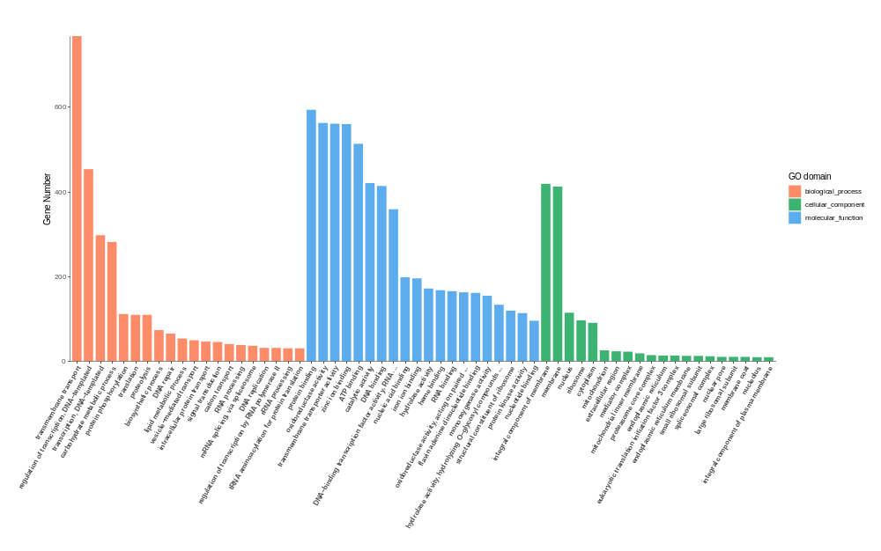
Figure S4. Statistical map of functional annotation classification based on GO database.

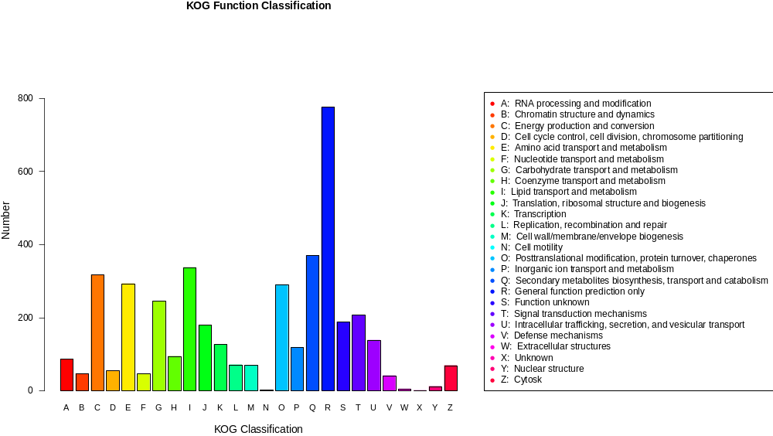
Figure S5. KOG Functional Annotated Classification.

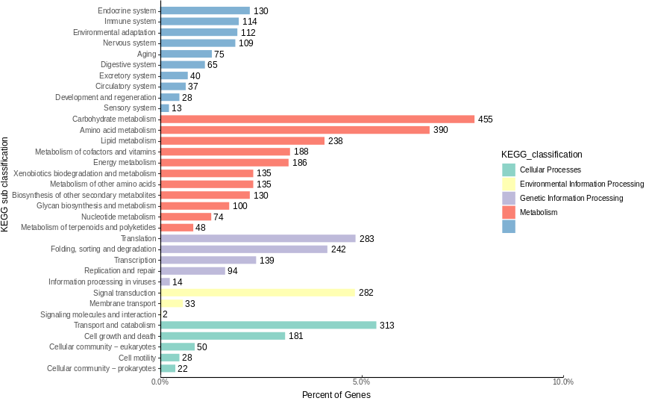
Figure S6. KEGG Pathway Functional Classification Chart.
Figure S7. Venn diagrams for comparing genomes of A. tamarii.
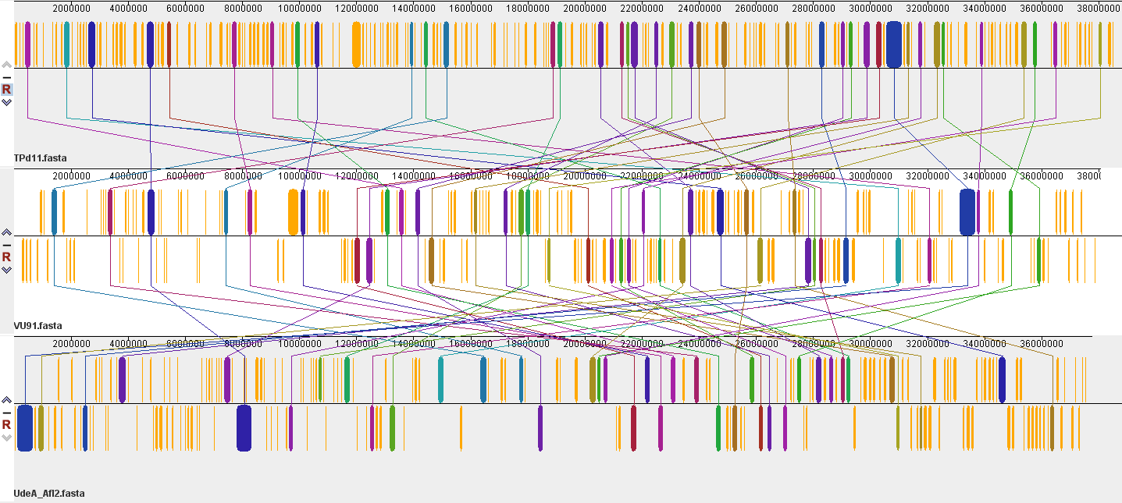
Figure S8. Genome-wide covariance analysis based on protein-coding genes of TPD11, VU91 and UdeA_Afl2 A. tamarii species.
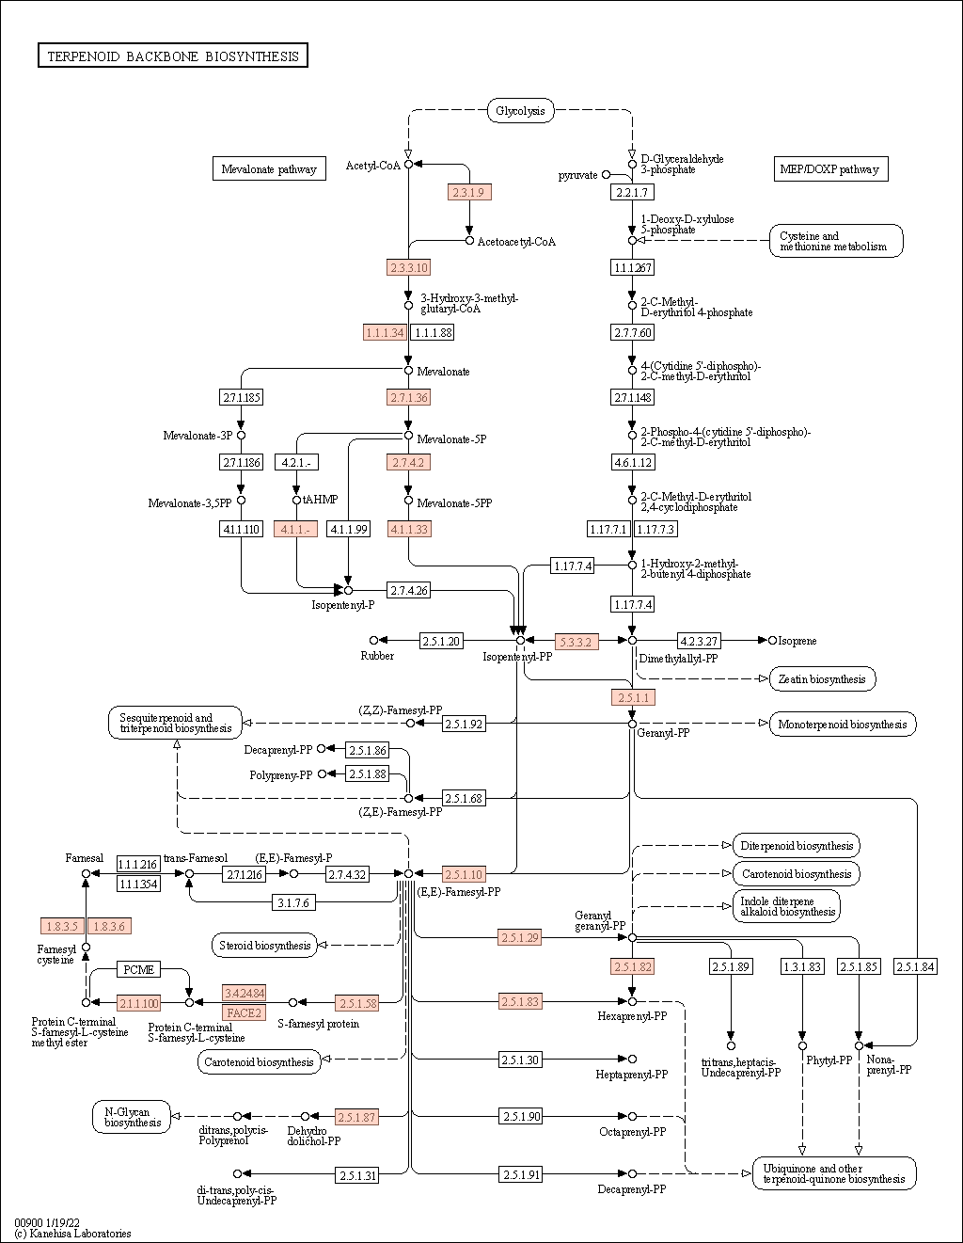
Figure S9. Annotation of the terpenoid backbone biosynthetic pathway of A. tamarii TPD11 genome. 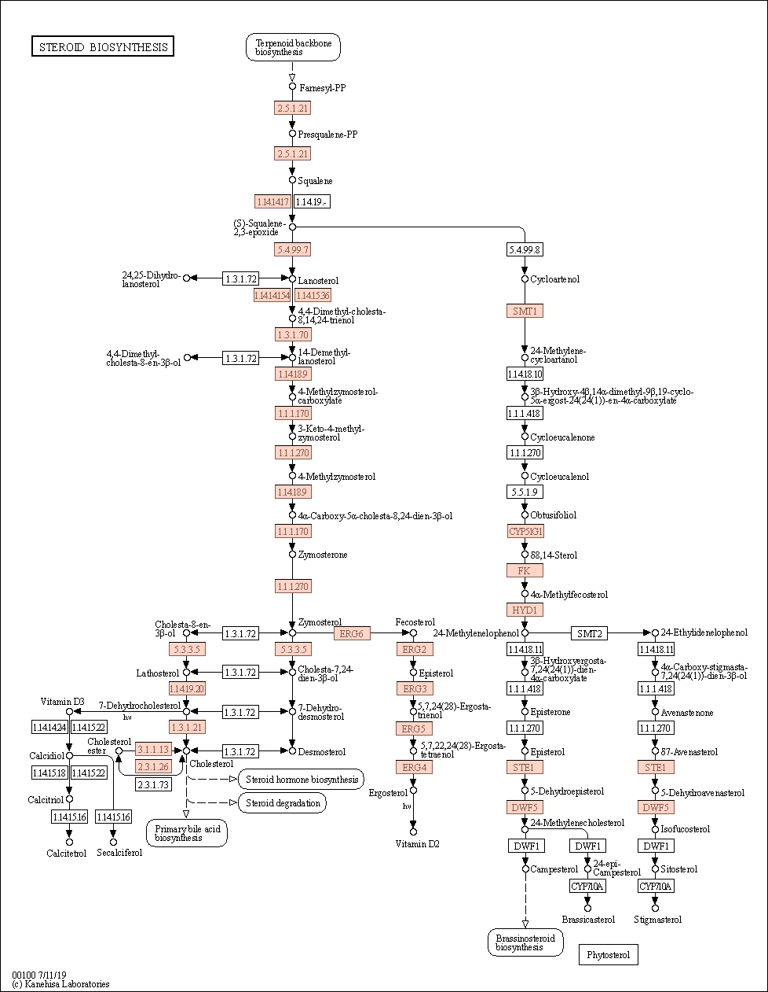
Figure S10. Annotation of the steroid biosynthetic pathway of A. tamarii TPD11 genome.

