Supporting Information for
Insight into the Action Mechanism of Ce⁴⁺ Doping in Improving Cycling Stability of LiNi0.5Mn1.5O4 from Internal Stress and Structure Stability
Jian Zhangª, Haiyao Liª, Hui Huang^{a, b, c}, Chao Gao^{a, b, c}
ª Kunming University of Science and Technology, Kunming 650093, China
^{b} Kunming Hendera Science and Technology Co. Ltd, Kunming 650106, China
^{c} Metallurgical Electrode Material Engineering Technology Research Center of Yunnan Province, Kunming 650106, China
* Corresponding author. Tel/Fax.: +86 871 68406327
E-mail: E-mail: chaogaohit@163.com(C. Gao);

2.1 Material characterization
The phase identification and composition were characterized by X-ray diffraction (XRD, Cu-Kα radiation, DX2700, Dandong Haoyuan, China), and Raman spectroscopy (Renishaw in Via Britain) using 532 nm excited laser. The morphology and micro structure were obtained using scanning electron microscopy (SEM, EVO HD 15, Zeiss, German) and transmission electron microscope (TEM, JEOL2100) with EDS equipment.
2.3 Electrochemical measurements
Electrochemical properties of the prepared LNMO and LNMCO-x samples were studied using CR2025 coin-type cells within voltage ranged from 3.5 to 4.9 V. Galvanostatic charge-discharge performance was measured on Land 2000T (China) at several current densities. The cells were assembled in a glove box filled with argon (Universal 2440/750, Mikrouna), with the content of oxygen and moisture less than 0.1 ppm. The electrode was prepared by the obtained LNMO or LNMCO-x (80 wt.%), acetylene black (10 wt.%) and polyvinylidene fluoride (PVDF, 10 wt.%) dispersed in N-methyl-2-pyrrolidinone (NMP).

Cyclic voltammograms (CVs) were evaluated using CHI760a electrochemical workstation at a scan rate of 0.1 mV·s⁻¹. Electrochemical impedance spectroscopies (EIS) were conducted on the same instrument with the frequency ranged from 0.01 to 100 kHz ac signal amplitude of 5 mV. Electrodes after the cycle process were gathered in a glove box filled with argon. Then, SEM, TEM and HRTEM were carried out to investigate the composition and morphology after cleaning with pure dimethyl carbonate (DMC).

In-situ-XRD experiments were used to investigate structure changes and phase transition of LNMO and LNMCO-x during charge-discharge process in a specially designed cylindrical-type cell under 0.1 C charge-discharge (1 C=147 mA g⁻¹) in the voltage ranged from 3.5 to 4.9 V. The specially designed cylindrical-type cell’s composition was similar as CR2025 coin-type cells. The data was continuously recorded ranged 2θ degree from 16 ° to 70 ° with a scan-step size 0.03 ° during charge-discharge processes.

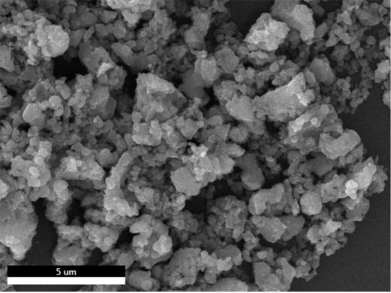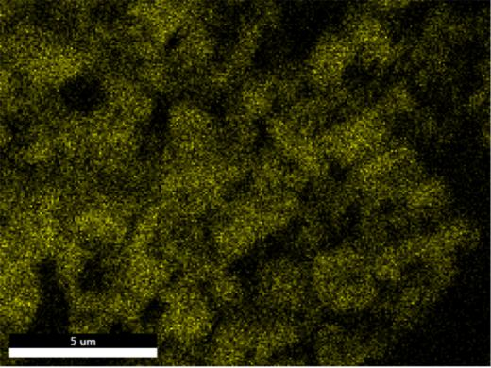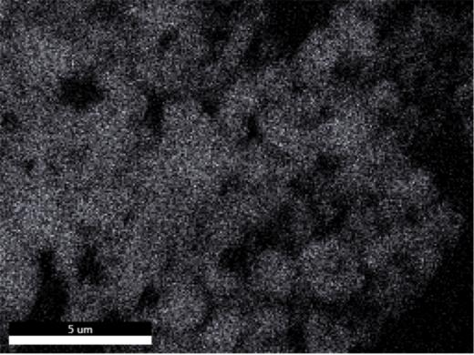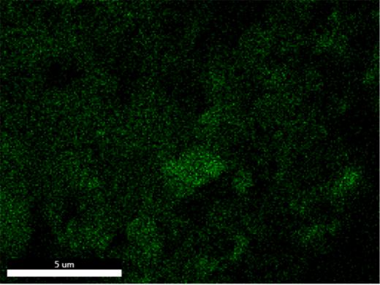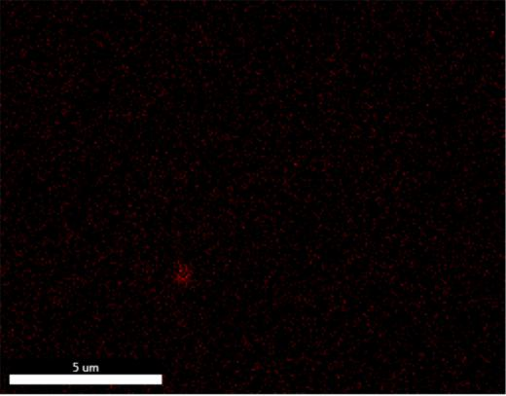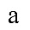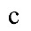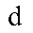
Fig.S1 EDS mapping of LNMCO-0.01, SEM image (a); Ni (b), Mn (c), O (d) and Ce (e).

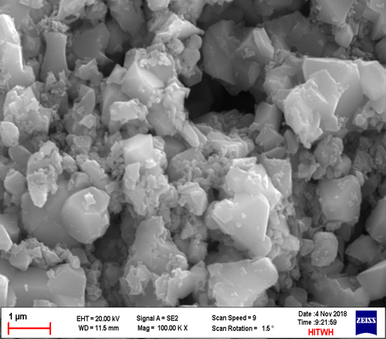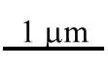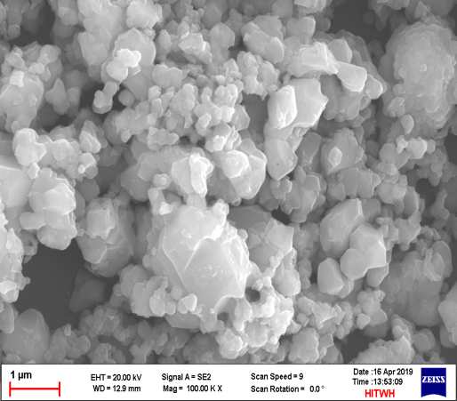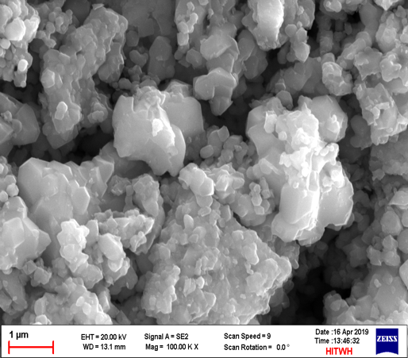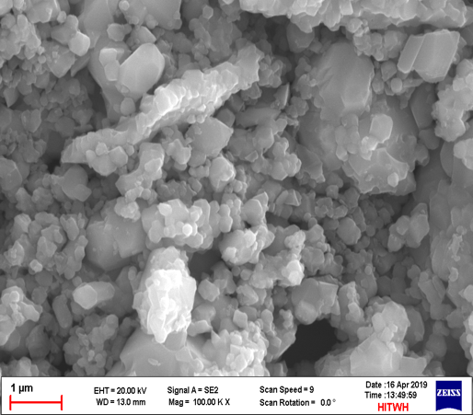
Fig. S2 SEM images of LNMO (a), LNMCO-0.005 (b), LNMCO-0.01 (c) and LNMCO-0.02 (d).

