Additional file 2: Coronary angiogram (a) left coronary angiogram in RAO caudal view showing 70% ostial and distal LM stenosis, 80% in-stent restenosis in proximal edge of proximal LAD, and 80% distal left circumflex artery stenosis (b) right coronary angiogram in RAO view showing 100% chronic total obstruction of proximal RCA (c) left coronary angiogram after stent placement in ostial LM to proximal LAD showing TIMI 3 flow
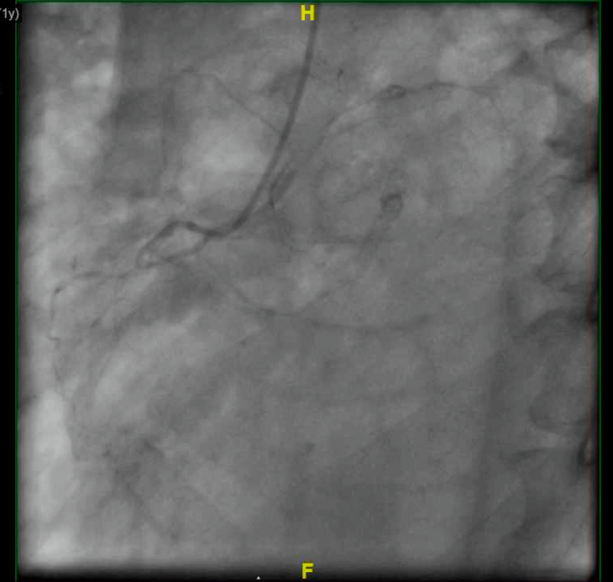
(a) (b)
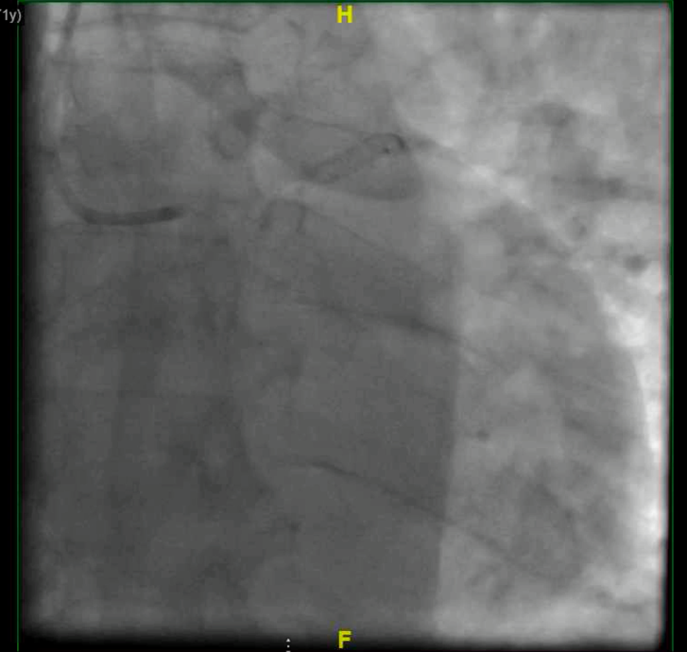
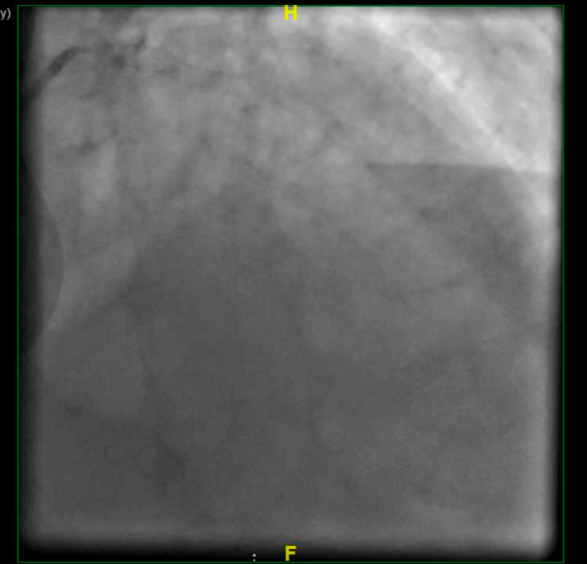
(c)

