Enrichment analysis of gene from the network analysis
Enrichment analysis of hub genes of the abiotic DEGs
Supplementary Fig. 1
Cluster 1
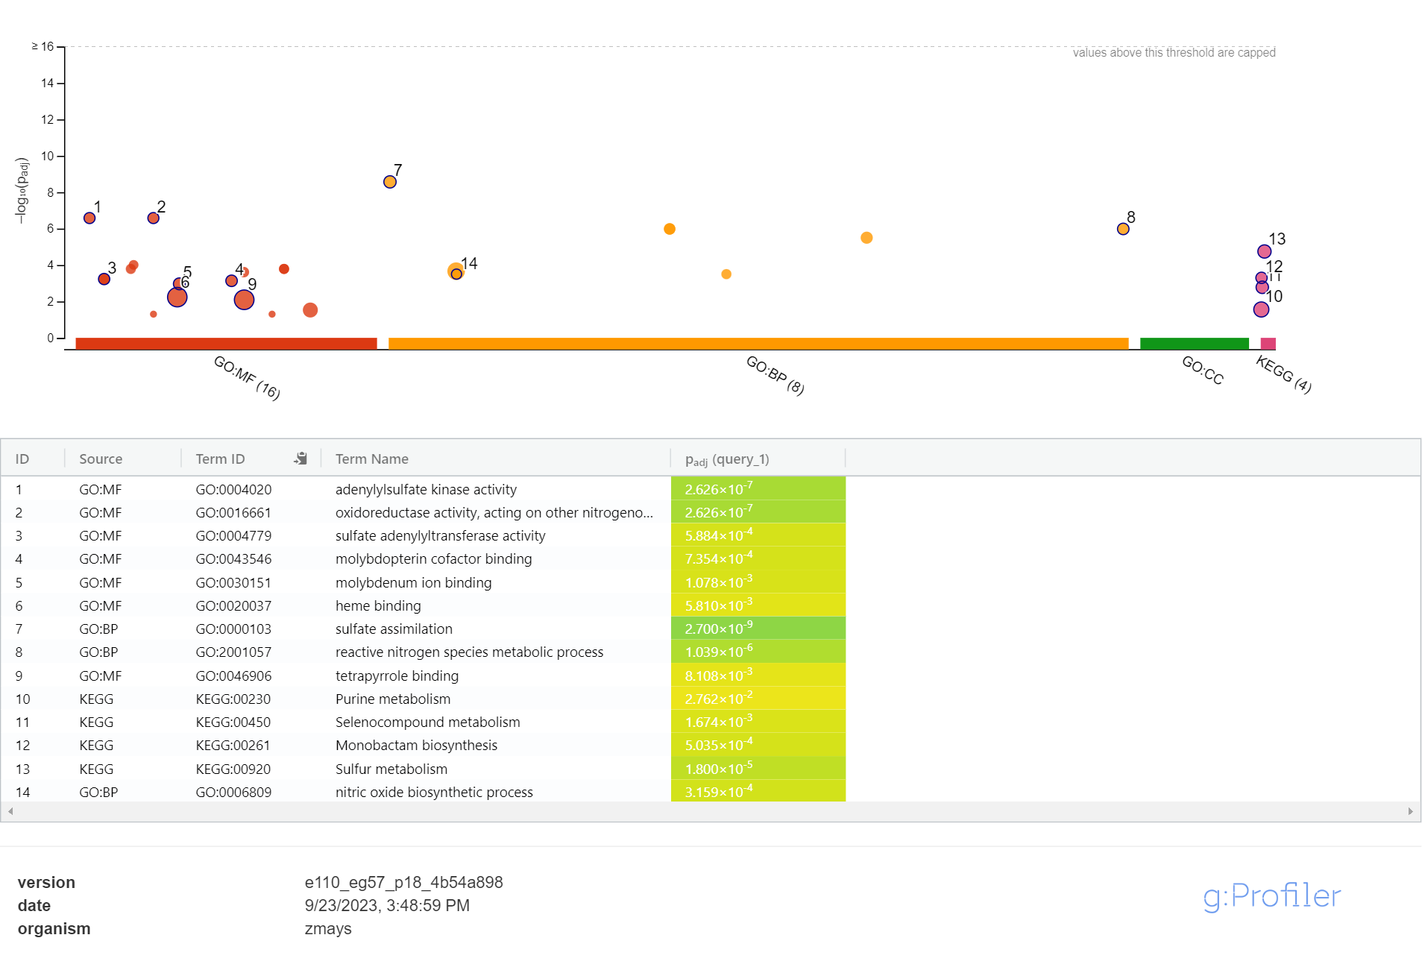
Supplementary Figure 1. Enrichment analysis of genes from cluster 1 of the abiotic DEGs. Cluster 1 comprised on nine genes

Supplementary Fig. 2

Cluster 2
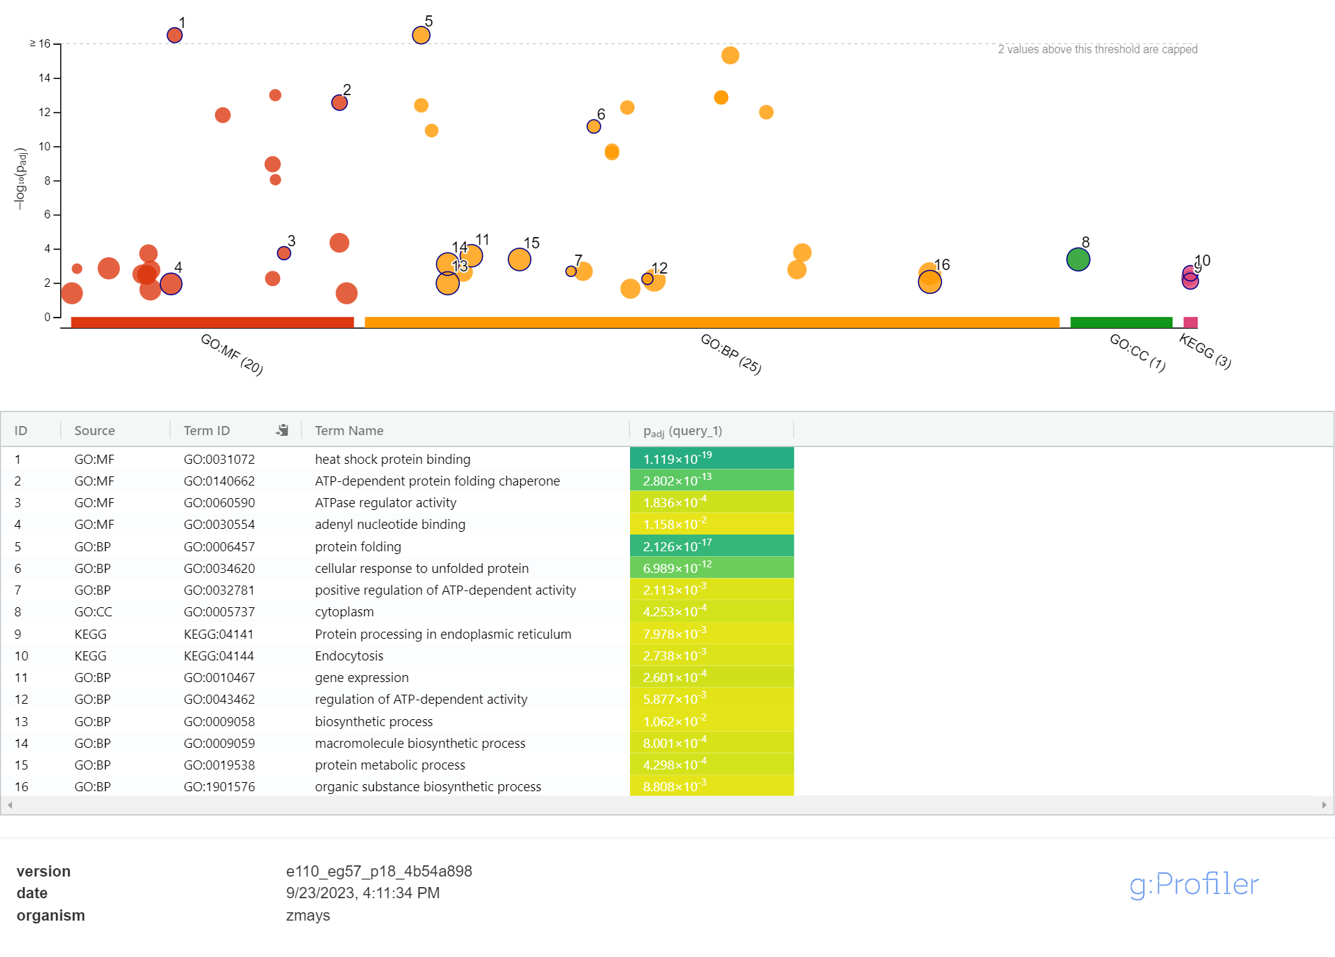
Supplementary Figure 2. Enrichment analysis of genes from cluster 2 of the abiotic DEGs. Cluster 2 comprised of 15 genes

Supplementary Fig. 3

Cluster 3

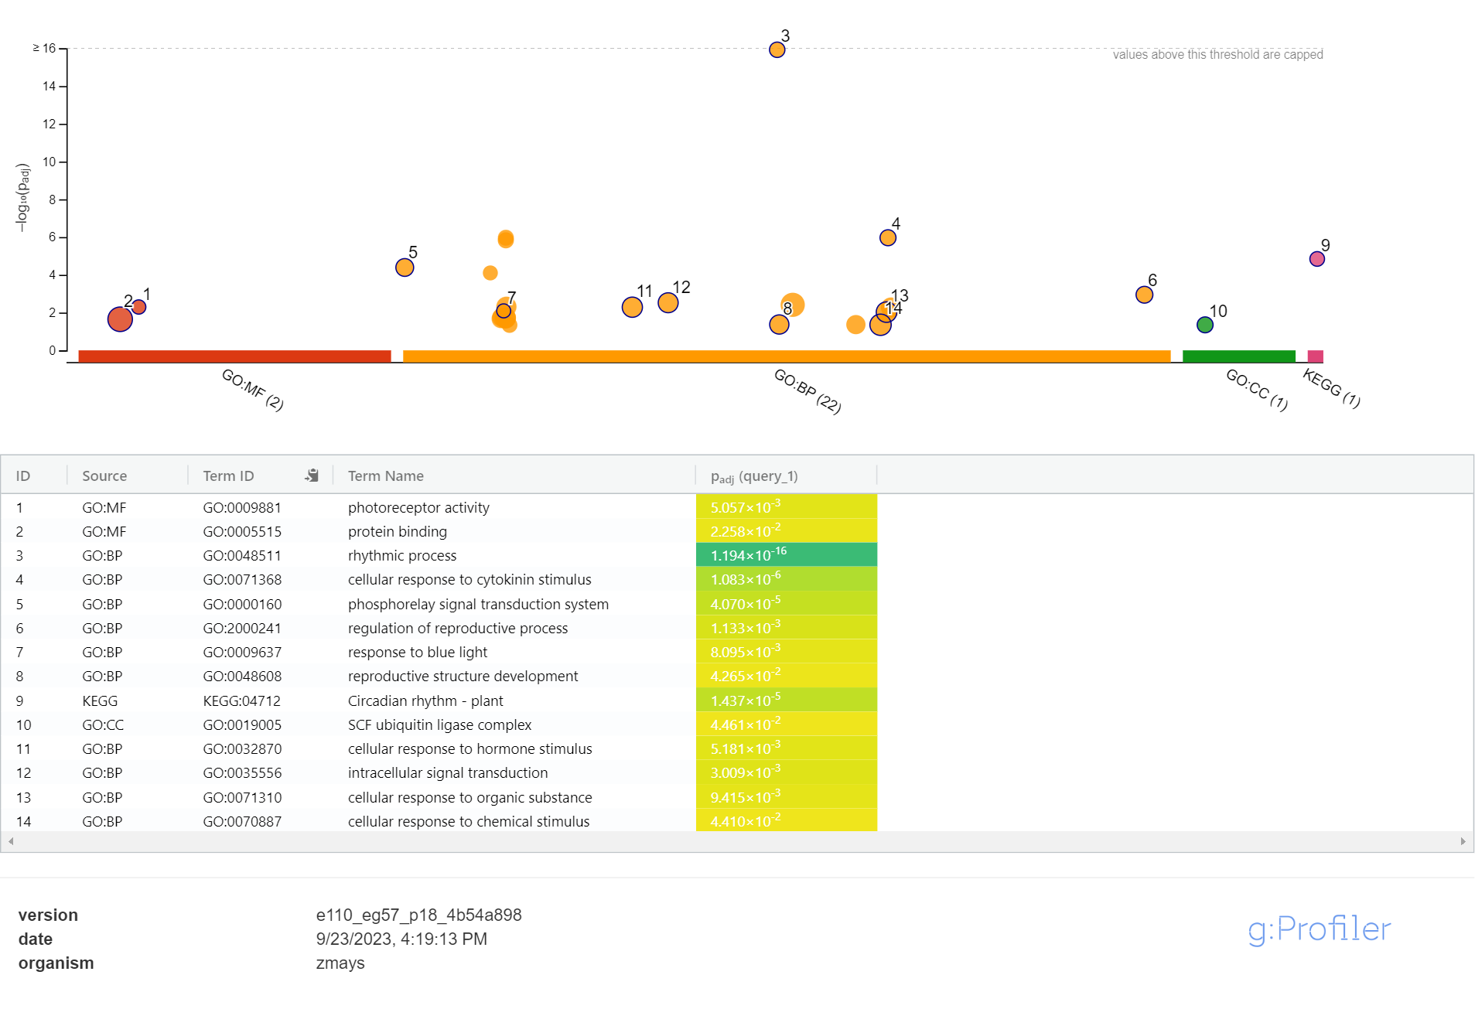
Supplementary Figure 3. Enrichment analysis of genes from cluster 3 of the abiotic DEGs. Cluster 3 comprised of 8 genes

Supplementary Fig. 4

Cluster 4

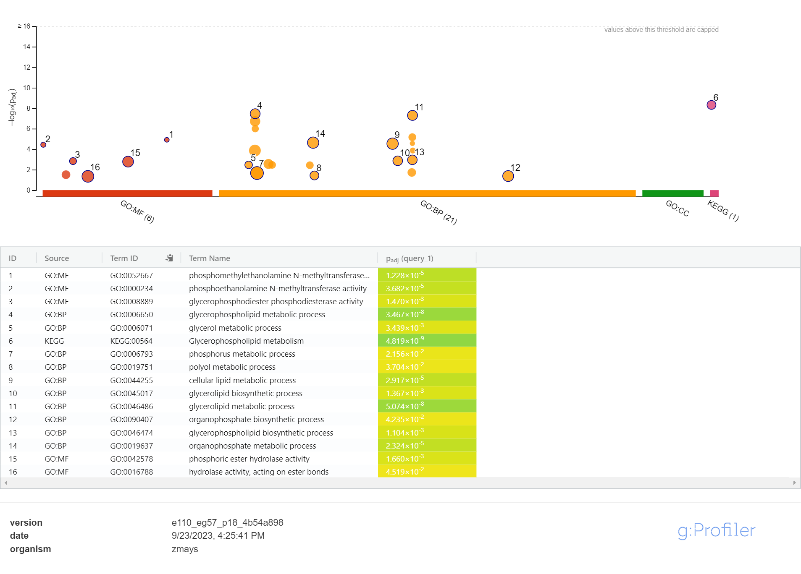
Supplementary Figure 4. Enrichment analysis of genes from cluster 4 of the abiotic DEGs. Cluster 4 comprised of 7 genes

Supplementary Fig. 5

Enrichment analysis of hub genes of the biotic DEGs
Cluster 1
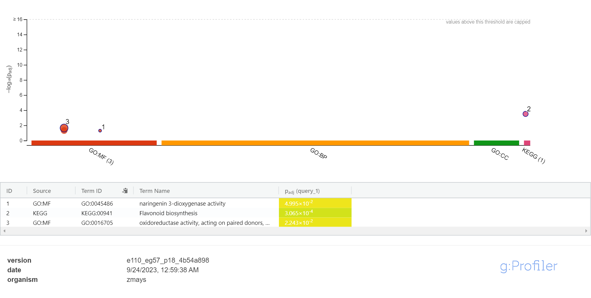

Supplementary Figure 5. Enrichment analysis of genes from cluster 1 of the biotic DEGs. Cluster 1 of the network analysis of biotic DEGs comprised of 5 genes

Supplementary Fig. 6

Cluster 2
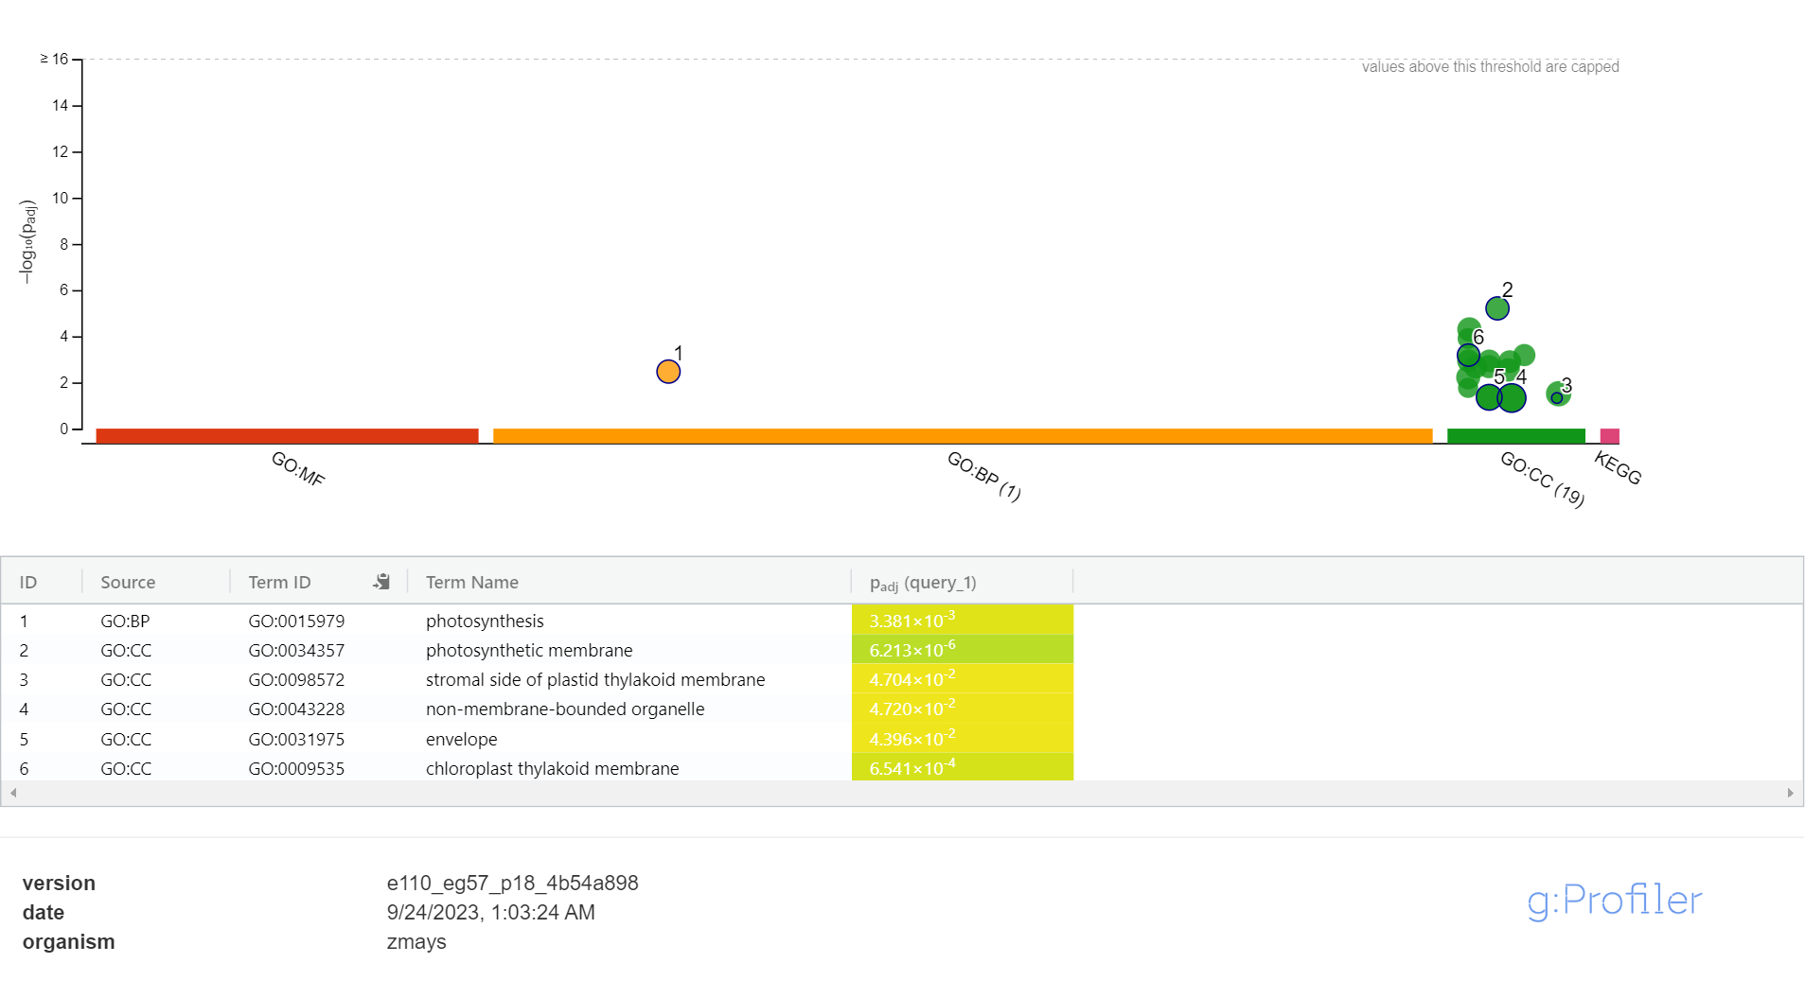

Supplementary Figure 6. Enrichment analysis of genes from cluster 2 of the biotic DEGs. Cluster 2 of the network analysis of biotic DEGs comprised of 4 genes

Supplementary Fig. 7

Cluster 3
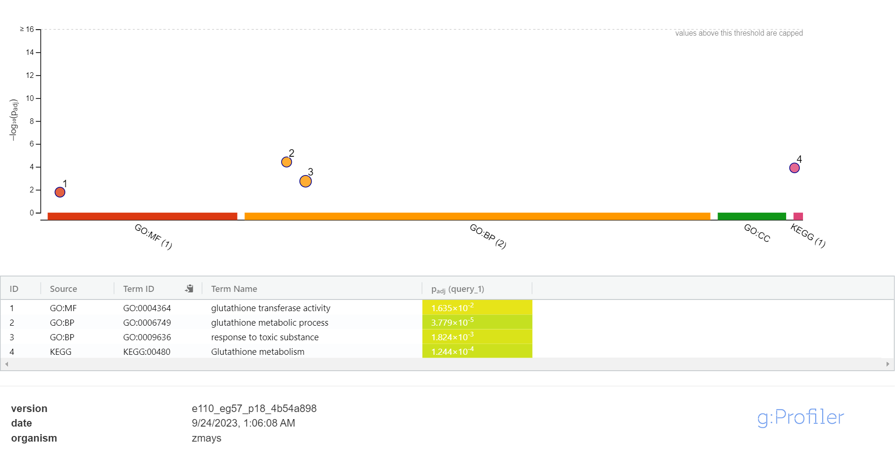
Supplementary Figure 7. Enrichment analysis of genes from cluster 3 of the biotic DEGs. Cluster 3 of the network analysis of biotic DEGs comprised of 3 genes

Supplementary Fig. 8

Enrichment analysis of hub genes of the co-DEGs
Cluster 1

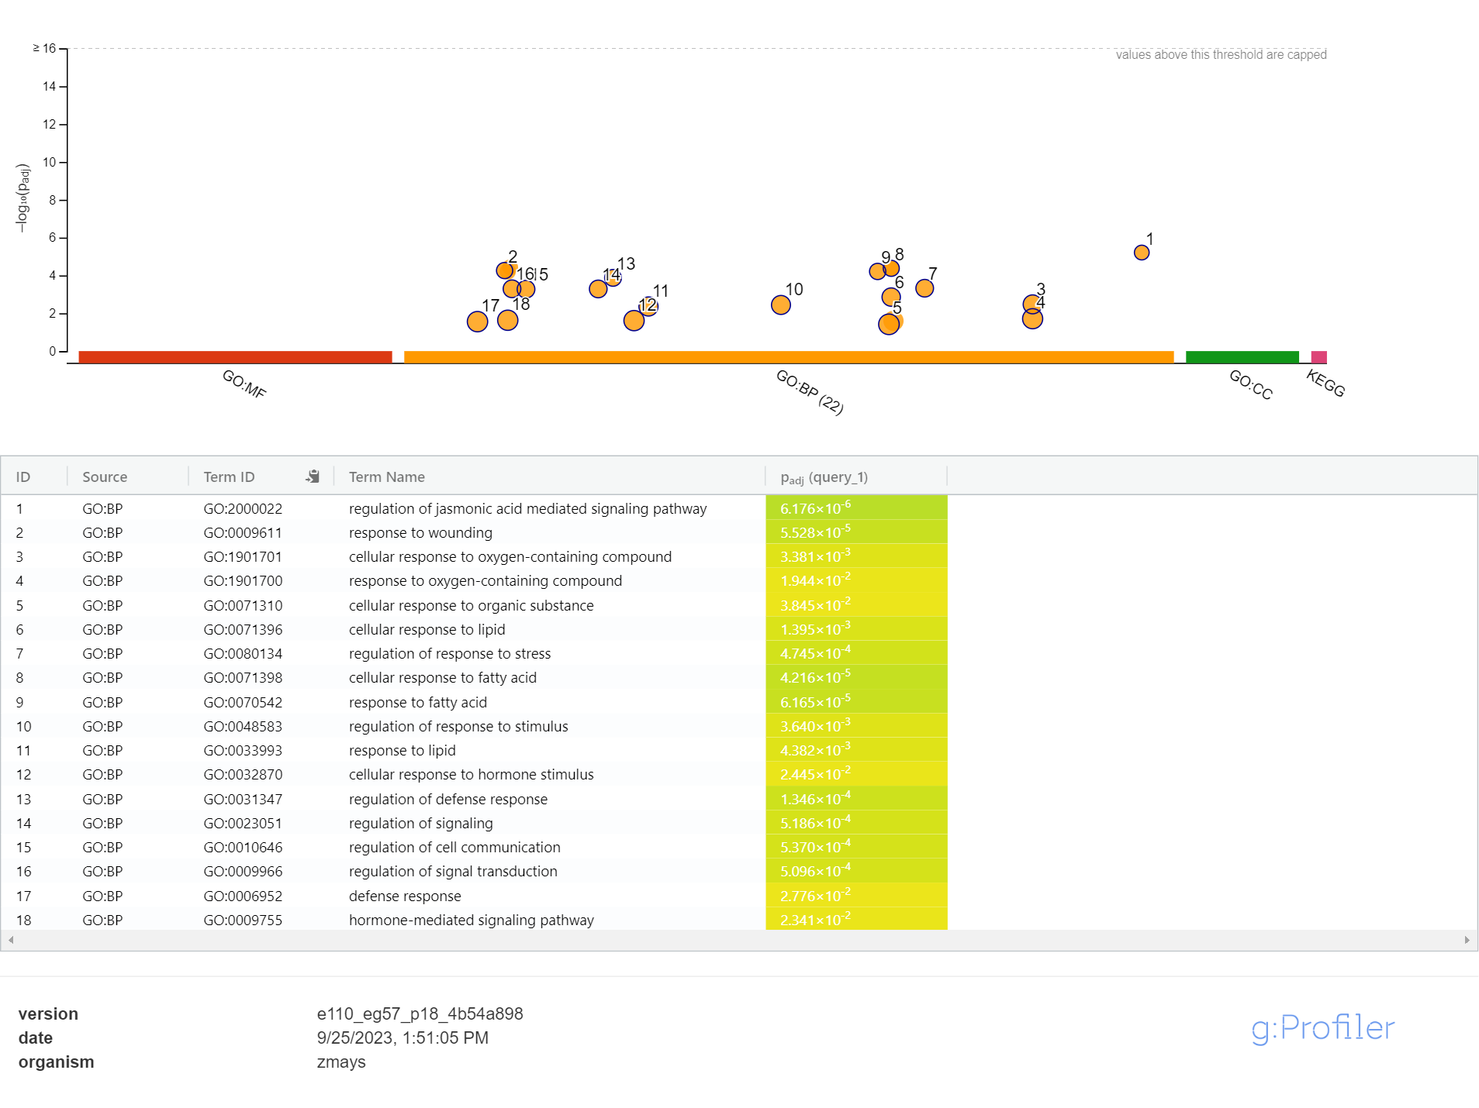
Supplementary Figure 8. Enrichment analysis of genes from cluster 1 of the co-DEGs. Cluster 1 of the network analysis of the co-DEGs comprised of 4 genes

Supplementary Fig. 9

Cluster 2

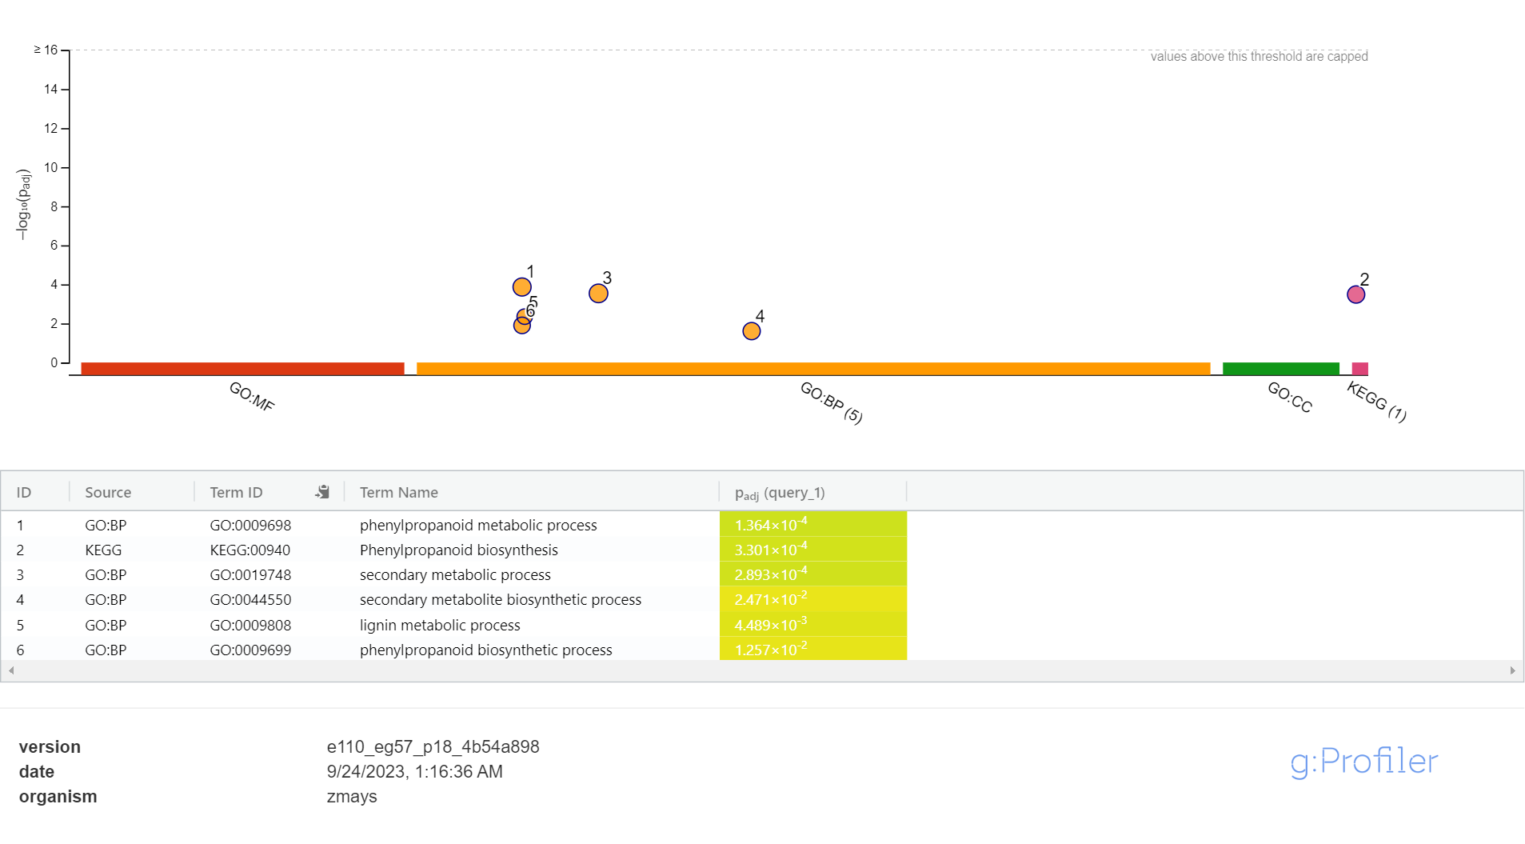
Supplementary Figure 9. Enrichment analysis of genes from cluster 2 of the co-DEGs. Cluster 2 of the network analysis of the co-DEGs comprised of 3 genes

