Supporting Information
A comprehensive investigation of the interactions of human serum albumin with polymeric and hybrid nanoparticles

Merve Seray Ural ^{a,b}, Joice Maria Joseph ^{a,b}, Frank Wien ^{c}, Xue Li ª, My-An Tran ª, Myriam Taverna, Claire Smadja ^{b*}, Ruxandra Gref ^{a*}

ª Université Paris-Saclay, Institute of Molecular Sciences of Orsay, French National Center for Scientific Research, Orsay, France
^{b} Université Paris-Saclay, Institute Galien, French National Center for Scientific Research, Châtenay-Malabry, France
^{c} Université Paris-Saclay, Synchrotron Soleil, 91190 Saint-Aubin, France

Corresponding authors : Dr. Ruxandra Gref: ruxandra.gref@universite-paris-saclay.fr and Prof. Claire Smadja: claire.smadja@universite-paris-saclay.fr

Table SI1. Characteristics of the NPs: surfactant, hydrodynamic size, PDI and surface charge.
NP | PLGA | PLGA-PEG | nanoMOF | nanoMOF-PEG
Surfactant | PVA | PVA | - | -
Hydrodynamic size (nm) | 310 ± 15 | 418± 30 | 234 ± 16 | 286 ± 20
PDI | 0.1 | 0.4 | 0.2 | 0.2
Surface Charge (mV) | ̴0 | ̴0 | -18 | -16

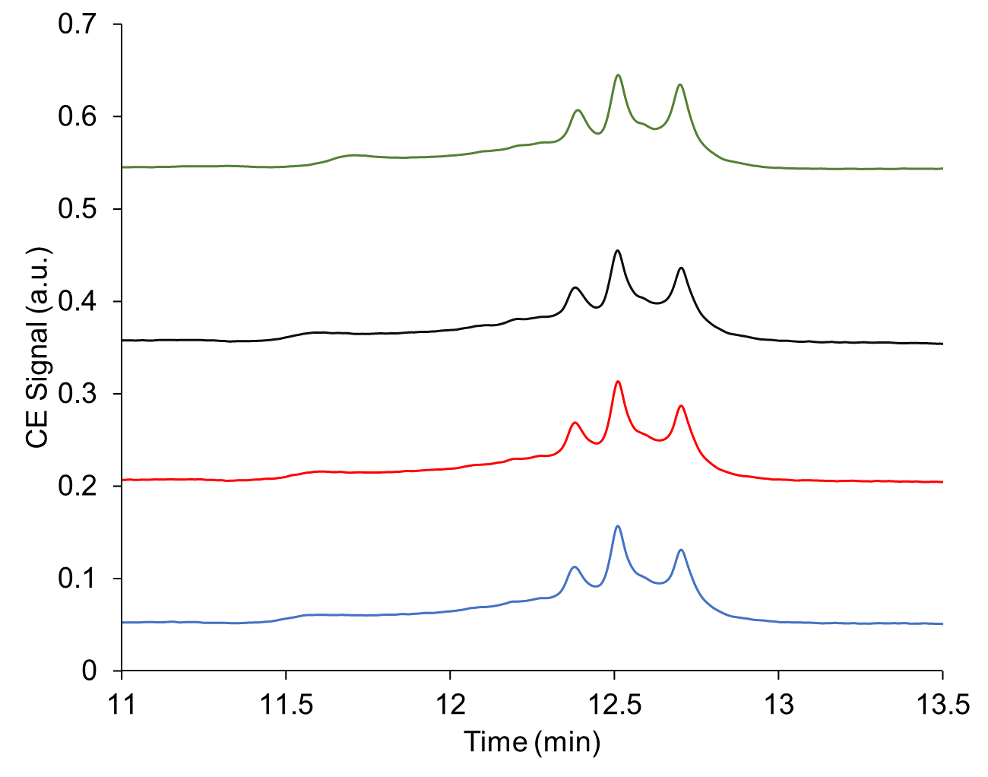

Fig. SI1. HSA stability study carried on with 1 mg/mL HSA analysed by CE-UV without centrifugation and incubation (blue); after centrifugation without incubation (red); after centrifugation after 1 day incubation (black); after centrifugation after 3 days incubation (green).

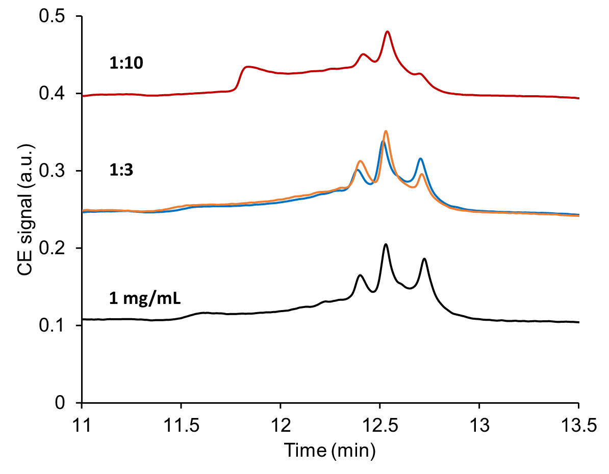
Fig. SI2. CE-UV electropherograms of unbounded HSA recovered from supernatants after incubation with PLGA-PEG (orange) and PLGA (red, blue) and NPs during 1 day with a HSA: NP ratio of 1:3 and 1:10. Black line is the reference HSA solutions of 1 mg/mL.
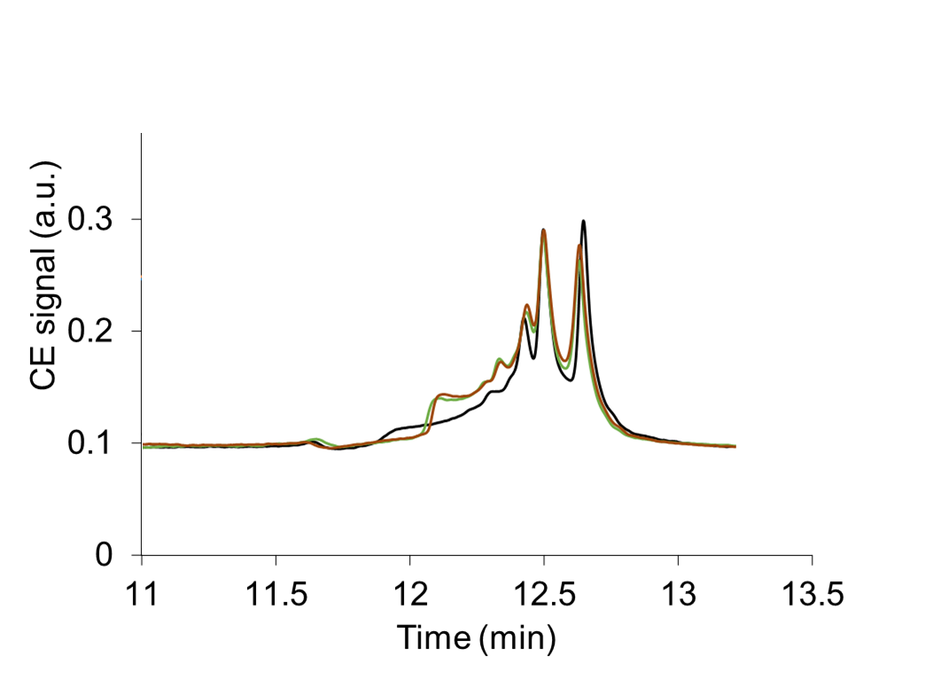

Fig. SI3. CE-UV electropherograms of unbounded HSA recovered from supernatants after incubation with PLGA (green) and PLGA-PEG (orange) and NPs during 1 day with a HSA: NP ratio of 1:3 and 1:10. Black line is the reference HSA solutions of 1 mg/mL.

A
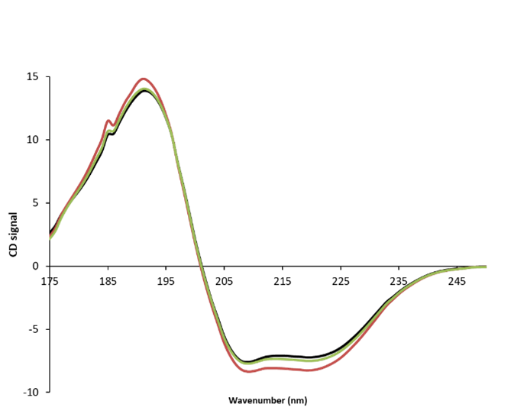

Fig. SI4: The SR-CD spectra of the PLGA (red) and PLGA-PEG (green) NPs incubated with HSA with 1:3 (HSA:NPs) ratio during 3 days. Black line is the reference HSA solutions of 1 mg/mL incubated without NPs during 3 days.

