Supplemental materials

S1. Fairness metrics definition
Several performance metrics are used to quantify the fairness of the iPsRS, which are detailed as below. The fundamental fairness metrics are predictive parity, predictive equality (false positive rate [FPR] balance), equalized odds, conditional use accuracy equality, treatment equality, equality of opportunity (false negative rate [FNR] balance)², and overall accuracy equality. To well explain the metrics, we define sensitive attributes (e.g., race-ethnicity: White [NHW] as the reference group, and Black [NHB] or Hispanic as protected groups) as G, the actual outcome as Y (hospitalization = 1 or not = 0), and the predicted outcome as d (hospitalization = 1 or not = 0).
Predictive parity: both protected and privileged groups have equal positive predictive value (PPV) – the probability of a subject with positive predictive value truly belonging to the positive class.
- In our case, the probability of NHW or NHB/Hispanic predicted to be hospitalized (i.e., predicted to be positive) actually having the outcome should be the same.
  - P (Y = 1 | d = 1, G = NHW) = P (Y = 1 | d = 1, G = NHB)
Predictive equality (a.k.a., false positive error rate balance): both protected and privileged groups have an equal FPR – the probability of a subject in the negative class having a positive predictive value.
- In our case, the probability of NHW or NHB/Hispanic predicted to be hospitalized (i.e., predicted to be positive) actually do not have the disease should be the same.
  - P (d = 1 | Y = 0, G = NHW) = P (d = 1 | Y = 0, G = NHB)
Equalized odds (a.k.a. conditional procedure accuracy equality and disparate mistreatment): protected and privileged groups have equal true positive rate (TPR) and equal FPR.
- In our case, the probability of an individual that (a) does not have the hospitalization label but is incorrectly predicted to be hospitalized; and (b) does have the hospitalization outcome but is incorrectly predicted to not be hospitalized, should be the same between NHW vs. NHB/Hispanic.
  - (P(Y = 1|d = 1,G = NHW) = P(Y = 1|d = 1,G = NHB )) ∧ (P(Y = 0|d = 1,G = NHW) = P(Y = 0|d = 1,G = NHB ))
Conditional use accuracy equality: protected and privileged groups equal PPV and Negative Predictive Value (NPV) – the probability of subjects with positive predictive value truly belonging to the positive class and the probability of subjects with negative predictive value truly belonging to the negative class.
- In our case, the probability of a subject predicted to be hospitalized to actually have the outcome, and the probability of a subject predicted to not be hospitalized to actually not have the hospitalization outcome, should be the same between NHW vs. NHB/Hispanic.
  - (P(Y = 1|d = 1,G = NHW) = P(Y = 1|d = 1,G = NHB )) ∧ (P(Y = 0|d = 0,G = NHW) = P(Y = 0|d = 0,G = NHB ))
Treatment equality: both protected and privileged groups have an equal ratio of false negatives (FN) and false positives (FP).
- In our example, the ratio of FP to FN is the same for NHW and NHB/Hispanic.
  - FN/FP (NHW) = FN/FP (NHB)

Equality of opportunity (a.k.a., false negative error rate balance): both protected and privileged groups have equal FNR – the probability of a subject in a positive class having a negative predictive value.
- In our case, the probability of an individual that has the hospitalization outcome but incorrectly predicted to not be hospitalized, should be the same between NHW vs. NHB/Hispanic.
  - P (d = 0 | Y = 1, G = NHW) = P (d = 0 | Y = 1, G = NHB)
Overall accuracy equality: both protected and privileged groups have equal prediction accuracy – the probability of a subject from either a positive or negative class being assigned to its respective class.W
- In our case, the probability of a subject with the disease being correctly predicted to have the hospitalization outcome and a subject without the disease to be correctly predicted to not be hospitalized is the same for NHW vs. NHB/Hispanic.
  - P (d = Y, G = NHW) = P (d = Y, G = NHB)

S2. Individual-level SDoH
We used SODA(i.e., SOcial DeterminAnts)³, a two-stage NLP extracting SDoH pipeline, including (1) concept extraction to identify SDoH concepts and attributes and (2) relation extraction to link the attribute to the targeted SDoH concepts, to extract individual-level SDoH from unstructured EHR data that cover a broad spectrum of social (e.g., food insecurity), behavioral (e.g., physical activities), and psychological (e.g., stress) information essential to T2D care and outcomes.

S3. Contextual-level SDoH
Table S1. Summary of contextual-level SDoH.
Category | Data source | Time period | Spatial scale | Temporal scale | Number of variables
Rurality | Federal Information Processing System and USDA | 2015–2020 | County | Cross-sectional | 1
Food access | Food Access Research Atlas, USDA | 2015, 2019 | Census tract | 1-year | 75
Walkability | Walkability Index, EPA | 2006–2013 | Census block group | Cross-sectional | 1
Vacant land | Aggregated USPS Administrative Data on Address Vacancies, HUD | 2015–2019 | Census tract | 3-month | 18
Socioeconomic status | Neighborhood Deprivation Index, ACS | 2015-2019 | Census block group | 5-year | 1
Social capital | Census Business Pattern | 2015–2019 | ZCTA5 | 1-year | 10
Crime and safety | Uniform Crime Reporting Program, FBI | 2015–2019 | County | 1-year | 8
Abbreviations:
ACS: American Community Survey; EPA: Environmental Protection Agency; USDA, US Department of Agriculture; HUD, Department of Housing and Urban Development; FBI: Federal Bureau of Investigation.
Table S1 presents information on the sources of data at the contextual-level, the period during which the data was collected, and the corresponding spatial and temporal scales. The data included 43 food access measures at the census tract level, obtained from the USDA's Food Access Research Atlas⁴ for the years 2015 and 2019. Walkability was evaluated using the National Walkability Index, developed by the US Environmental Protection Agency⁵, on a scale of 1 to 20 for each census block group. The assessment showed that 1 is the least walkable, while 20 is the most walkable. Data on vacant land measures at the census-tract level from 2015 to 2019 were obtained from the US Department of Housing and Urban Development⁶, combined with administrative data from the US Postal Service, and a total of 18 measures available across all years were included. The neighborhood deprivation index (NDI), a socioeconomic status measure, was obtained at the census block group level from the 2015 to 2019 American Community Survey (ACS). It provided information on income, education, employment, and housing quality of a neighborhood, allowing ranking by socioeconomic disadvantage⁷. Additionally, ten social capital measures were created based on the North American Industry Classification System (NACIS) codes⁸ using the Census Business Pattern data at the 5-digit ZIP code tabulation area (ZCTA5) level. Eight county-level annual measures of crime and safety were also obtained from the Uniform Crime Reporting Program from 2015 to 2019.⁹ Overall, the analysis included 114 social determinants of health (SDoH) measures.

S4. Ablation study
In the initial trial, we presented the results in Table S2 which compares the effectiveness of different combinations of three sampling techniques (ROS, RUS, MCC), two machine learning methodologies (linear models and XGBoost), and three feature sets (Full SDoH, Individual-level SDoH, and Contextual-level SDoH). Among all combinations, the best performance was achieved by RUS with the linear model (ridge regression) on Full SDoH, with an AUROC score of 0.7220. Upon examining the table, it can be seen that RUS produced satisfactory results in comparison to the other sampling methods. The linear models demonstrated comparable prediction capability with XGBoost in these experiments. Individual-level SDoH demonstrated promising prediction capability regarding features, but the optimal model is obtained by combining both contextual-level and individual-level SDoH. Based on the conclusion that RUS with full SDoH can deliver the best performance in this study, we will only present the results based on RUS with full SDoH in the following sections. To enhance expression conciseness, we select ridge regression over linear models in the subsequent sections due to its superior performance within the linear model family after hyperparameter tuning. The detailed results can be found in the supplemental materials.
Table S2 Overall performance (AUROC) for T2D hospitalization prediction on the independent testing set.
 |  | Full SDoH | Individual-level SDoH | Contextual-level SDoH
ROS | Xgboost | 0.7021 | 0.6972 | 0.6120
ROS | Ridge regression | 0.7174 | 0.7069 | 0.6136
RUS | Xgboost | 0.7022 | 0.7058 | 0.6002
RUS | Ridge regression | 0.7220 | 0.7105 | 0.6234
MCC | Xgboost | 0.6445 | 0.6341 | 0.5454
MCC | Ridge regression | 0.6500 | 0.6321 | 0.5844
Abbreviations:
ROS: Random over-sampling; RUS: Random under-sampling, MCC: Under-sampling by matching CCI flag.

After obtaining initial results, we proceeded to investigate the standard errors and confidence intervals of the proposed models by removing various sensitive features. We conducted 100 bootstrapping experiments on the testing set within the modeling set and computed the mean and standard deviation to assess the models. Table S3 displays the outcomes obtained by utilizing RUS on different models while utilizing full SDoH features. We observed that removing different sensitive features such as age, sex, and race did not have an impact on the model performance (both XGBoost and ridge regression), as evidenced by an AUROC ranging between 0.7090 to 0.7237, Recall ranging from 0.6959 to 0.7123, and Specificity ranging from 0.6141 to 0.6295. Moreover, the standard deviation of each experiment was less than 0.04, indicating that the model performance remained consistent during bootstrapping testing.
Table S3 Bootstrapping Prediction performance for different feature sets by random under-sampling.
 | Features |  | AUROC | Recall | Specificity
Xgboost | fullvar | mean | 0.7111 | 0.7062 | 0.6141
Xgboost | fullvar | std.dev | 0.0172 | 0.0360 | 0.0214
Xgboost | w/o age | mean | 0.7150 | 0.7123 | 0.6148
Xgboost | w/o age | std.dev | 0.0160 | 0.0354 | 0.0222
Xgboost | w/o age & sex | mean | 0.7090 | 0.6959 | 0.6172
Xgboost | w/o age & sex | std.dev | 0.0166 | 0.0386 | 0.0227
Xgboost | w/o age & sex & race | mean | 0.7129 | 0.7102 | 0.6139
Xgboost | w/o age & sex & race | std.dev | 0.0167 | 0.0390 | 0.0200
Ridge regression | fullvar | mean | 0.7237 | 0.7084 | 0.6295
Ridge regression | fullvar | std.dev | 0.0148 | 0.0270 | 0.0153
Ridge regression | w/o age | mean | 0.7237 | 0.7081 | 0.6290
Ridge regression | w/o age | std.dev | 0.0148 | 0.0262 | 0.0152
Ridge regression | w/o age & sex | mean | 0.7215 | 0.7077 | 0.6265
Ridge regression | w/o age & sex | std.dev | 0.0149 | 0.0279 | 0.0156
Ridge regression | w/o age & sex & race | mean | 0.7213 | 0.7076 | 0.6276
Ridge regression | w/o age & sex & race | std.dev | 0.0147 | 0.0293 | 0.0153

Figure S1 SHAP values from the ridge regression. We removed the features with an “unknown” category.

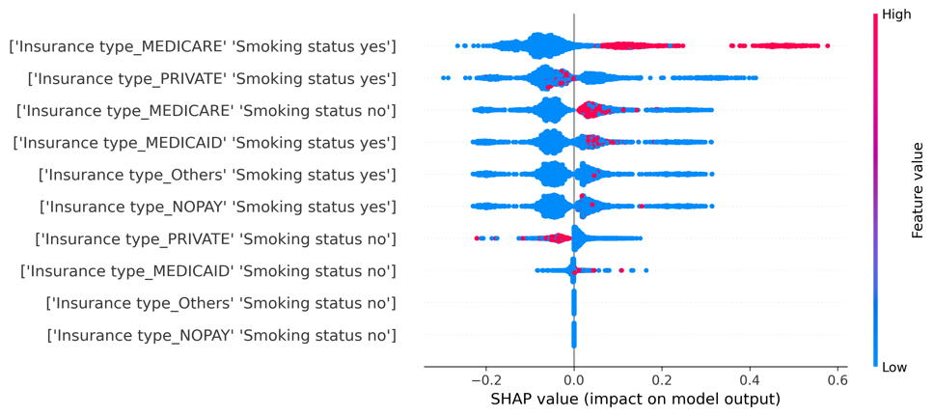 | 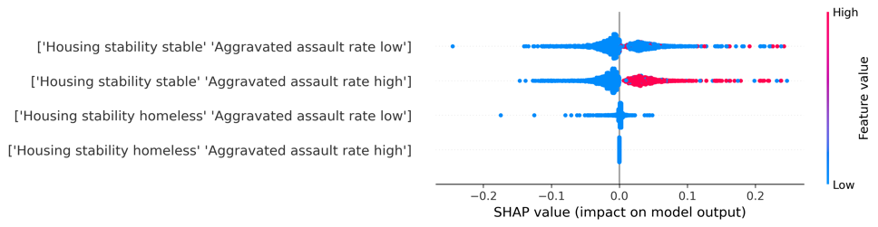
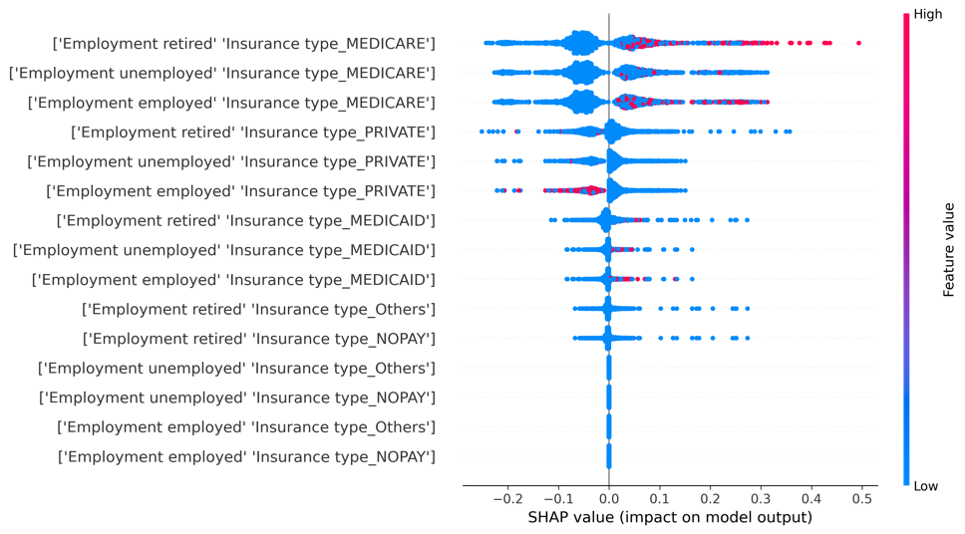 | 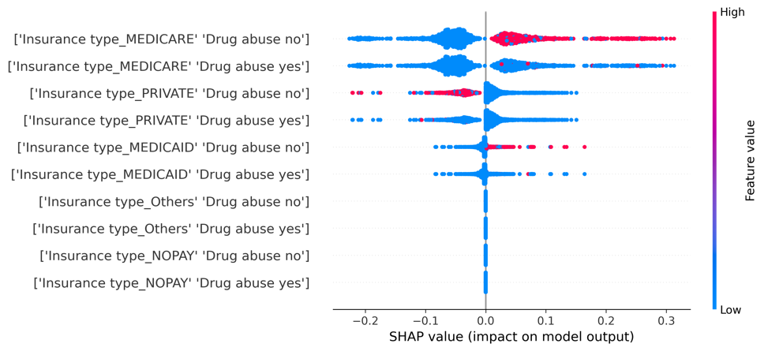
Figure S2 Combinational SHAP (combined 2 features) values from sensitivity analysis (Using the top 15 features from the original XGBoost to build a prediction model). We dichotomized the continuous contextual-level SDoH, such as the murder and motor theft rates, based on the online crime data explorer provided by Federal Bureau of Investigation¹.

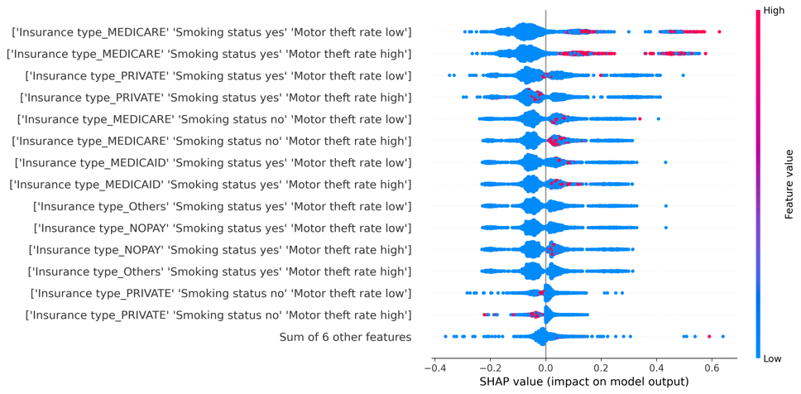 | 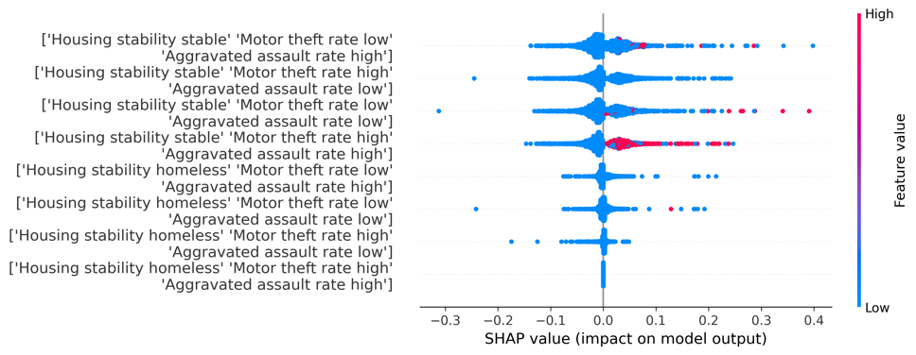

Figure S3 Combinational SHAP (combined 3 features) values from sensitivity analysis (Using the top 15 features from the original XGBoost to build a prediction model). We dichotomized the continuous contextual-level SDoH, such as the murder and motor theft rates, based on the online crime data explorer provided by Federal Bureau of Investigation¹.

Causal graph by different subgroups
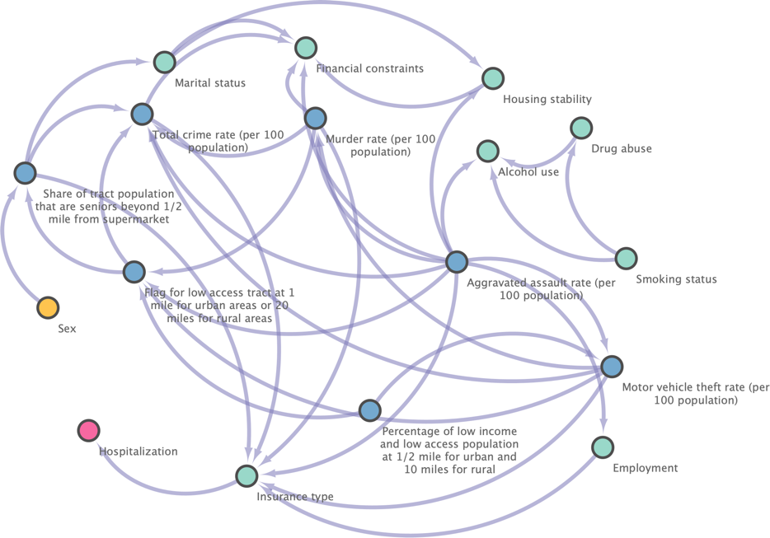
Figure S4 Causal graph generated by MGM-PC-Stable on the NHW group in the independent testing set.
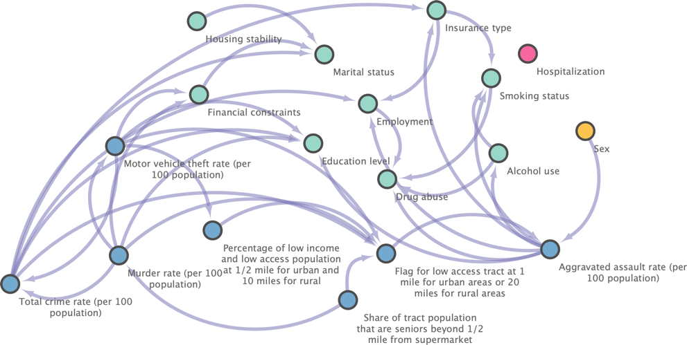
Figure S5 Causal graph generated by MGM-PC-Stable on the NHB group in the independent testing set.
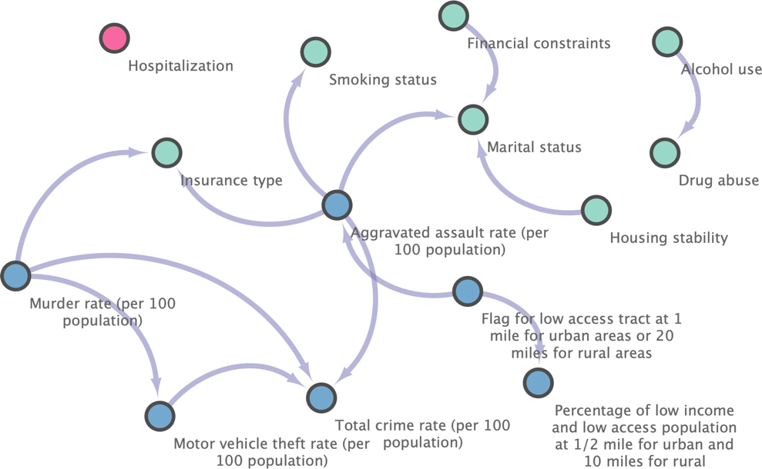
Figure S6 Causal graph generated by MGM-PC-Stable on the Hispanic group in the independent testing set.

Figure S4 – S6 shows the causal graphs generated by MGM-PC-Stable on different subgroups, with nodes lacking connections removed from each graph. In Figure S4, the causal graph for the NHW group indicates that insurance type is a factor influencing hospitalization. However, in Figures S5 and S6, there are no causal links found between the hospitalization to any other features in both the NHB and Hispanic groups. This observation suggests that the NHW group is primarily affected by individual-level SDoH (e.g., insurance type). Furthermore, it is important to note that the causal links in the Hispanic group are less pronounced compared to the other two groups, primarily due to the significantly smaller sample size of the Hispanic group.

References

1. Federal Bureau of Investigation. Crime Data Explorer. Federal Bureau of Investigation - Crime Data Explorer. Accessed August 5, 2023. https://cde.ucr.cjis.gov/LATEST/webapp/
2. Castelnovo A, Crupi R, Greco G, Regoli D, Penco IG, Cosentini AC. A clarification of the nuances in the fairness metrics landscape. Sci Rep. 2022;12(1):1-21.
3. Yu Z, Yang X, Dang C, et al. SODA: A Natural Language Processing Package to Extract Social Determinants of Health for Cancer Studies. arXiv [csCL]. Published online December 6, 2022. http://arxiv.org/abs/2212.03000
4. Rhone A. Food Access Research Atlas. Accessed March 9, 2023. https://www.ers.usda.gov/data-products/food-access-research-atlas/
5. Thomas J, Zeller L. National walkability index user guide and methodology. Environ Prot Agency: Washington, DC, USA. Published online 2017.
6. Garvin E, Branas C, Keddem S, Sellman J, Cannuscio C. More than just an eyesore: local insights and solutions on vacant land and urban health. J Urban Health. 2013;90(3):412-426.
7. Messer LC, Laraia BA, Kaufman JS, et al. The development of a standardized neighborhood deprivation index. J Urban Health. 2006;83(6):1041-1062.
8. Rupasingha A, Goetz SJ, Freshwater D. The production of social capital in US counties. J Socio Econ. 2006;35(1):83-101.
9. Barnett-Ryan C. Introduction to the uniform crime reporting program. Understanding crime statistics.

