Supplementary MATERIAL

Supplementary Table 1

Sociodemographic and neuropsychological characteristics of lower- and higher-SES dysfluent readers (all dysfluent readers, N = 36)
 | Lower-SES (n = 20) | Higher-SES (n = 16) | Test
Sex (girl / boy) | 11 / 9 | 9 / 7 | χ2 (1) = 0.01
Handedness ª (R / L / A) | 18 / 1 / 1 | 15 / 1 / 0 | FET = 1.03
Age (years) | 8.24 ± 0.35 | 8.19 ± 0.29 | t(34) = .45
Parental education (years) | 7.83 ± 2.49 | 11.50 ± 3.37 | t(34) = -3.76**
TIV (cm³) | 1386.37 ± 138.43 | 1385.50 ± 189.34 | t(34) = .02
Full-scale IQ ^{b} | 89.10 ± 14.15 | 89.13 ± 10.56 | t(34) = -.01
Verbal IQ | 89.55 ± 13.38 | 92.88 ± 11.44 | t(34) = -.79
Performance IQ | 93.40 ± 14.95 | 88.94 ± 9.62 | t(34) = 1.03
3DM reading tests ^{c}
High-frequency words | 84.20 ± 7.99 (94.90 ± 9.11) | 90.94 ± 8.62 (96.93 ± 5.11) | t(34) = -2.43* (t(34) = 0.79)
Low-frequency words | 85.95 ± 8.41 (93.00 ± 8.42) | 92.50 ± 7.10 (95.13 ± 5.58) | t(34) = -2.48* (t(34) = 0.87)
Pseudowords | 83.05 ± 9.86 (82.30 ± 11.98) | 90.63 ± 7.71 (90.15 ± 11.06) | t(34) = -2.52* (t(34) = 2.02)
Reading age test | 80.10 ± 12.65 | 89.63 ± 11.97 | t(34) = -2.30*
WCPM index | 73.05 ± 11.27 (91.82 ± 14.11) | 78.56 ± 9.58 (95.83 ± 4.32) | t(34) = -1.56 (t(34) = 1.10)
Discrepancy (IQ - WCPM score) | 16.05 ± 15.22 | 10.56 ± 11.15 | t(34) = 1.21
Note. Means and standard deviations are presented for all variables except sex and handedness. Test results are given in standard scores (M = 100, SD = 15), except an additional measure of accuracy for 3DM and WCPM tests given in parenthesis and showing the percentage of correctly read stimuli over total read.
R = right-handed; L = left-handed; A = ambidextrous. TIV = total intracranial volume. WCPM = words correct per minute.
ª Edinburgh Handedness Inventory. ^{b} Wechsler Intelligence Scale for Children, WISC-III. ^{c} Differential Diagnosis Dyslexia Maastricht Battery.
*p < .05; **p < .01.

Supplementary Table 2
Hierarchical linear regression of reading ability in matched dysfluent readers (N = 28, higher SES + lower SES)
Predictors | Model 1 |  |  |  | Model 2
Predictors | B | SE | β | t-test | B | SE | β | t-test
Age | .23 | .51 | .08 | .45 | .10 | .44 | .03 | .21
Sex | .85 | .34 | .43 | 2.49* | .58 | .31 | .30 | 1.89
Full-scale IQ | .03 | .01 | .40 | 2.26* | .03 | .012 | .42 | 2.79*
R AnC | - |  |  |  | 5.45 | 1.80 | .47 | 3.04**
R² | .30 |  |  |  | .50
F | 3.49* |  |  |  | 5.80**
ΔR² |  |  |  |  | .20
ΔF |  |  |  |  | 9.21**
Note. R AnC = right angular cluster. *p < .05; **p <.01.

Supplementary Table 3
Hierarchical linear regression of reading ability in matched dysfluent readers of higher-SES (n = 14)
Predictors | Model 1 |  |  |  | Model 2
Predictors | B | SE | β | t-test | B | SE | β | t-test
Age | -1.13 | .76 | -.30 | -1.49 | -1.30 | .63 | -.34 | -2.07
Sex | 1.69 | .45 | .76 | 3.74** | 1.08 | .45 | .48 | 2.41*
Full-scale IQ | .06 | .02 | .56 | 2.76* | .05 | .02 | .47 | 2.72*
R AnC |  |  |  |  | 5.81 | 2.41 | .47 | 2.41*
R² | .63 |  |  |  | .78
F | 5.75* |  |  |  | 7.84**
ΔR² |  |  |  |  | .14
ΔF |  |  |  |  | 5.81*
Note. R AnC = right angular cluster. *p < .05; **p <.01.

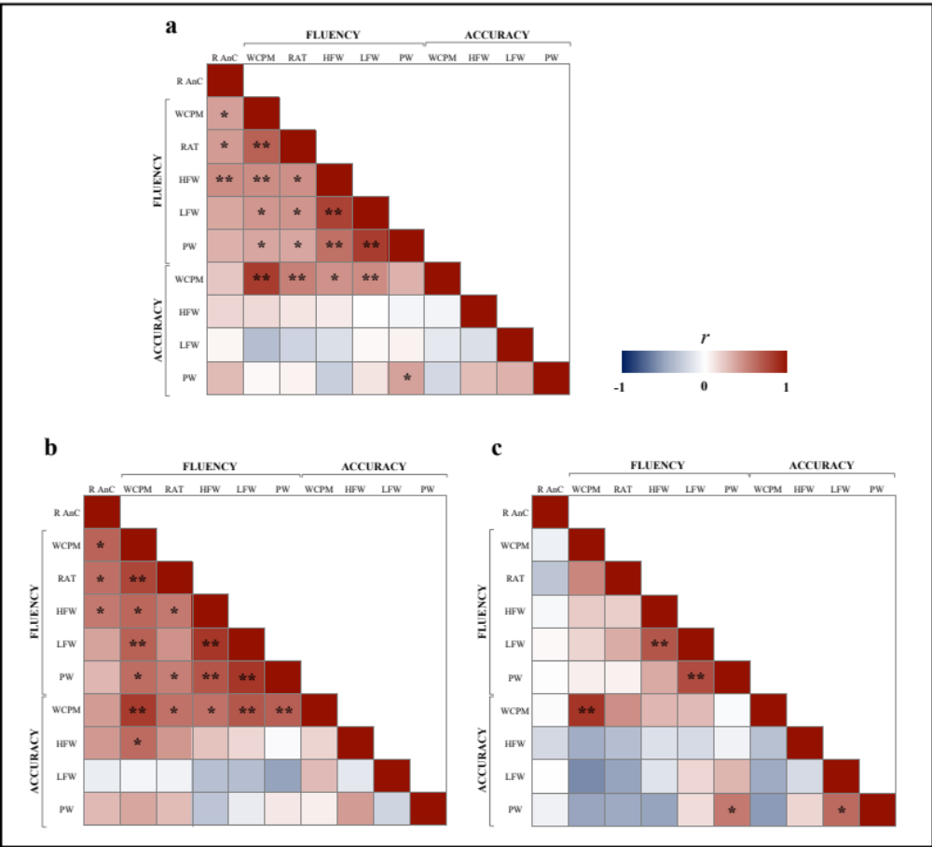
Supplementary Fig. 1 Correlation matrix between reading fluency and accuracy measures and the right angular cluster of matched dysfluent readers (a, N = 28), higher-SES (b, n = 14) and lower-SES (c, n = 14) subgroups. Note. *p < .05; **p < .01; R AnC = right angular cluster; WCPM = Word correct per minute; RAT = Reading Age Test; HFW = High-frequency Words; LFW = Low-frequency Words; PW = Pseudowords

