Population genomics of an accidental pathogen Streptococcus mitis from patients with invasive disease in the UK and Ireland

Kalizang’oma et al.

Supplementary Table 1. Species assignment for the 211 presumed and viable S. mitis isolates using the KRAKEN bioinformatic tool.

Species | Frequency | Proportion (%)
Streptococcus mitis | 129 | 61.1
Streptococcus oralis | 29 | 13.7
Streptococcus infantis | 27 | 12.8
Unidentified Streptococcal species | 7 | 3.3
Streptococcus timonensis | 3 | 1.4
Streptococcus pneumoniae | 3 | 1.4
Streptococcus sp. M334 | 2 | 0.9
Streptococcus sanguinis | 2 | 0.9
Streptococcus cristatus | 1 | 0.5
Streptococcus sp. F0442 | 1 | 0.5
Enterococcus faecalis | 1 | 0.5
Streptococcus pseudopneumoniae | 1 | 0.5
Streptococcus gordonii | 1 | 0.5
Streptococcus salivarius | 1 | 0.5
Streptococcus lutetiensis | 1 | 0.5
Streptococcus gallolyticus | 1 | 0.5
Streptococcus sp. A12 | 1 | 0.5

Supplementary Table 2. Characteristics of individuals with suspected infective endocarditis whose Streptococcus mitis isolates were analysed.

Age range (Years) | Frequency | Proportion (%)
0 | 7 | 5.4
1-9 | 8 | 6.2
10-19 | 5 | 3.9
20-29 | 11 | 8.5
30-39 | 14 | 10.9
40-49 | 15 | 11.6
50-59 | 26 | 20.2
60-69 | 14 | 10.9
70-79 | 16 | 12.4
80-89 | 11 | 8.5
90-99 | 2 | 1.6
Sex
Male | 70 | 54.3
Female | 58 | 45.0
Unknown | 1 | 0.7
Year of isolation
2001-2004 | 41 | 31.8
2005-2008 | 28 | 21.7
2009-2012 | 29 | 22.5
2013-2016 | 31 | 24.0

Supplementary Table 3. List of antibiotic abbreviations used by the British Society of Antimicrobial Chemotherapy (BSAC) and UK Health Security Agency in the Supplementary Data files.

Code | Antimicrobial
amx | amoxicillin
bpr | ceftobiprole
cip | ciprofloxacin
cli | clindamycin
ctx | cefotaxime
ery | erythromycin
etp | ertapenem
gen | gentamicin
ipm | imipenem
lin | linezolid
min | minocyline
oxa | oxacillin
pen | penicillin
tec | teicoplanin
tet | tetracycline
tig | tigecycline
tzp | piperacillin-tazobactam
van | vancomycin

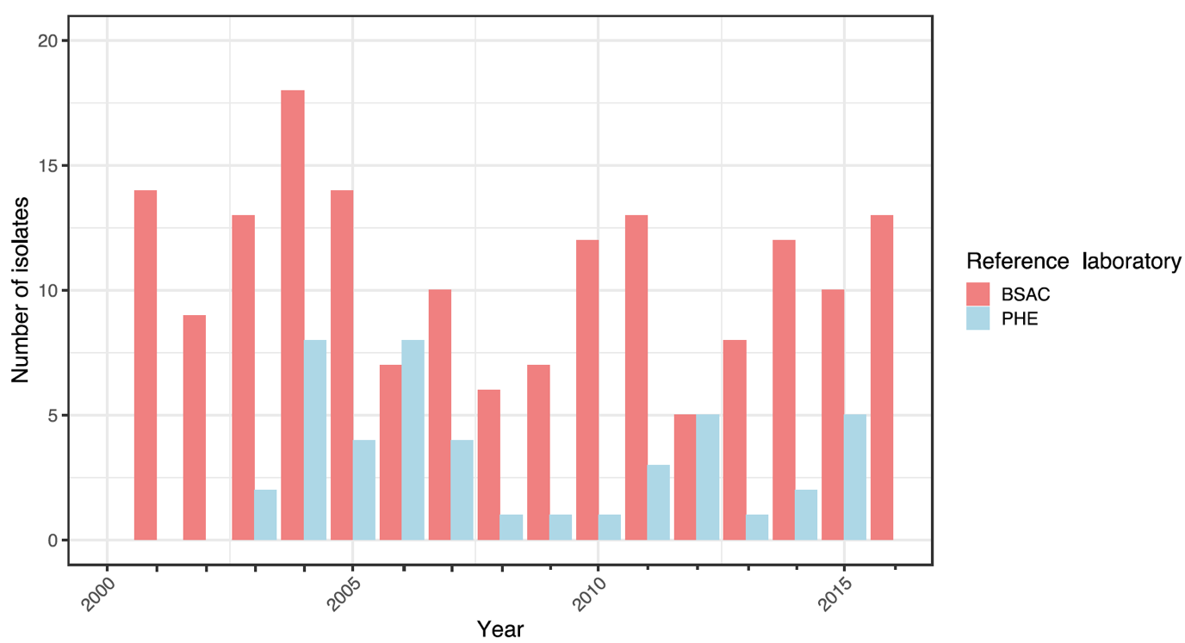
Supplementary Fig. 1. Laboratory source and yearly frequency for the 217 presumed Streptococcus mitis isolates. The bar plot shows the number of isolates obtained in each year, between 2001 and 2016, from BSAC and UKHSA.

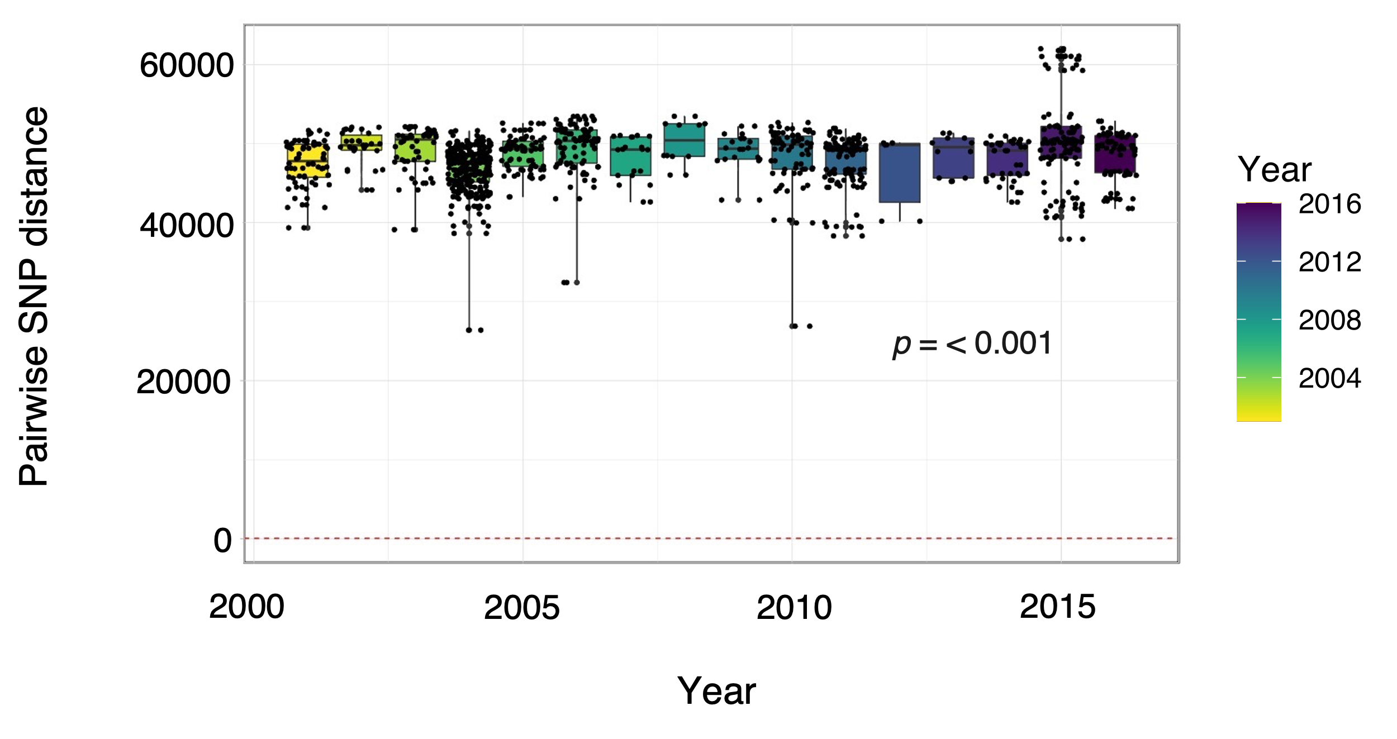
Supplementary Fig. 2. Pairwise SNP distances of S. mitis isolated from patients with infective endocarditis between 2001 and 2016. The strip charts and box plots show the number of SNPs calculated between isolates in each year between 2001 and 2016.

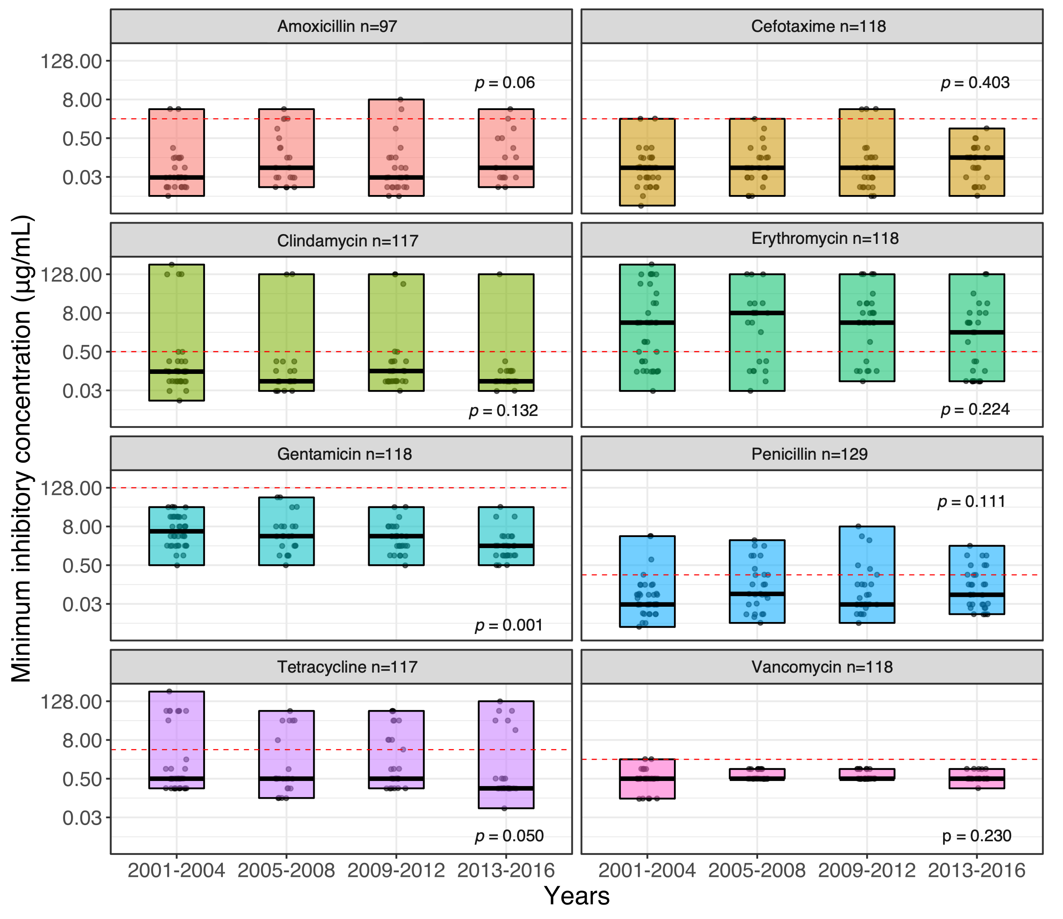
Supplementary Fig. 3. Trend in antibiotic minimum inhibitory concentrations among S. mitis isolated from patients with infective endocarditis at 4-yearly intervals between 2001 to 2016. The box plots show the distribution, range, and median penicillin MICs for each time interval. The MIC breakpoints are indicated by the red horizontal dotted line.

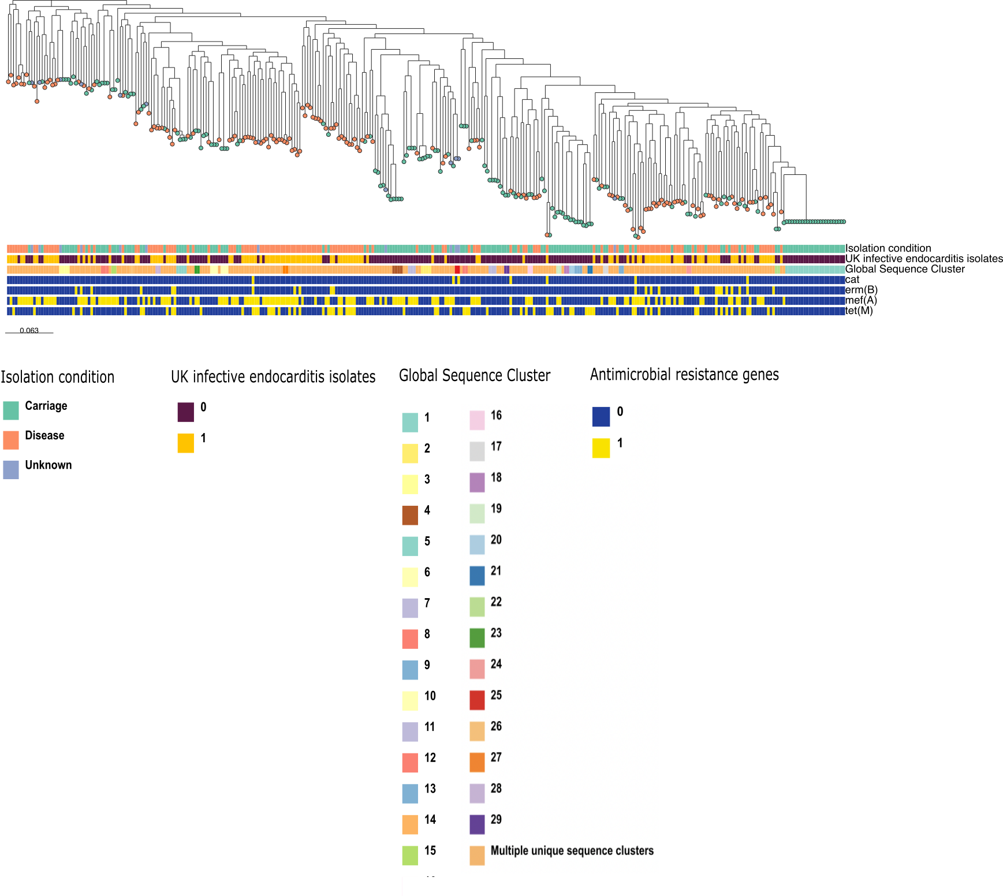
Supplementary Fig. 4. Population structure and AMR gene profiles of IE and global Streptococcus mitis. ML phylogeny of IE and global S. mitis is built using 473,175 SNPs. The coloured tips of the phylogeny show the suspected UK IE isolates. From the inner to outer rings, the isolate metadata shows the lineage, isolation source, geographical location, and antimicrobial resistance (AMR) gene matrices. From the inner to outer rings of the AMR gene matrix are chloramphenicol (cat), macrolide (ermB and mefA), and tetracycline (tetM) genes.

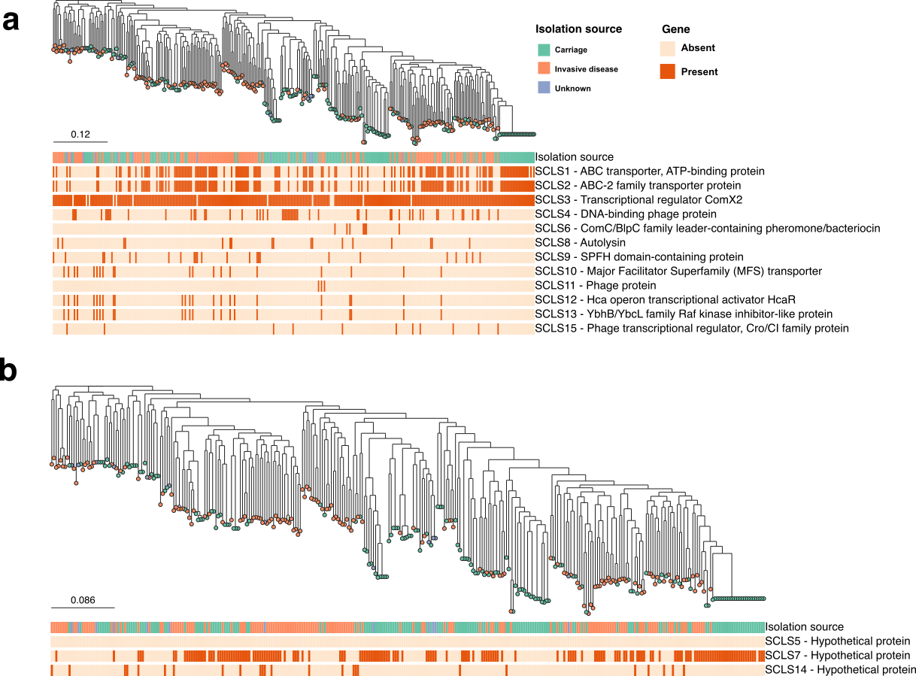

Supplementary Fig. 5. Differentially overrepresented orthologous gene clusters among invasive disease or carriage isolates a ML phylogeny of IE and global S. mitis is built using 473,175 SNPs. The coloured tips of the phylogeny and the first metadata row shows the isolation condition, while the subsequent 12 rows show the presence or absence of genes with known functions. b ML phylogeny of IE and global S. mitis is built using 473,175 SNPs. The coloured tips of the phylogeny and the first metadata row shows the isolation condition, while the subsequent 3 rows show the presence or absence of hypothetical genes.

