Supplementary Information
Manuscript: Inside the Matrix: A pancreas-derived hydrogel for the culture of hiPSC-derived pancreatic endocrine cells

Supplementary Figure 1
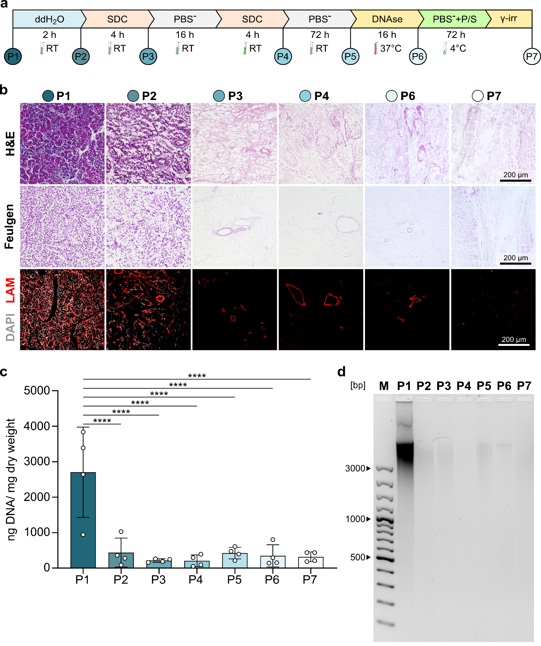
Supplementary Figure 1 Step-wise deconstruction of porcine pancreas decellularization using the shortened protocol. a Illustration of the shortened decellularization process used for the production of the PanMa. Encircled numbers correlate to the process step at which samples were taken and analyzed. b Tissue sections taken at different time points of decellularization and stained with Haematoxylin and Eosin (H&E) (upper panel), Feulgen (middle panel) and an antibody against laminin (red), counterstained with DAPI (grey) (lower panel). c Bar graph showing the amount of DNA per mg dry weight at different time points of pancreas decellularization. Data are shown as mean ± SD (n=4). ****P < 0.0001, one-way Anova with Tukey’s multiple comparisons test. d Samples of isolated DNA of the respective differentiation time points separated on an agarose gel. The presented images present only parts of the original gels. The uncropped images can be found in Supplementary figure 4.
Supplementary Figure 2
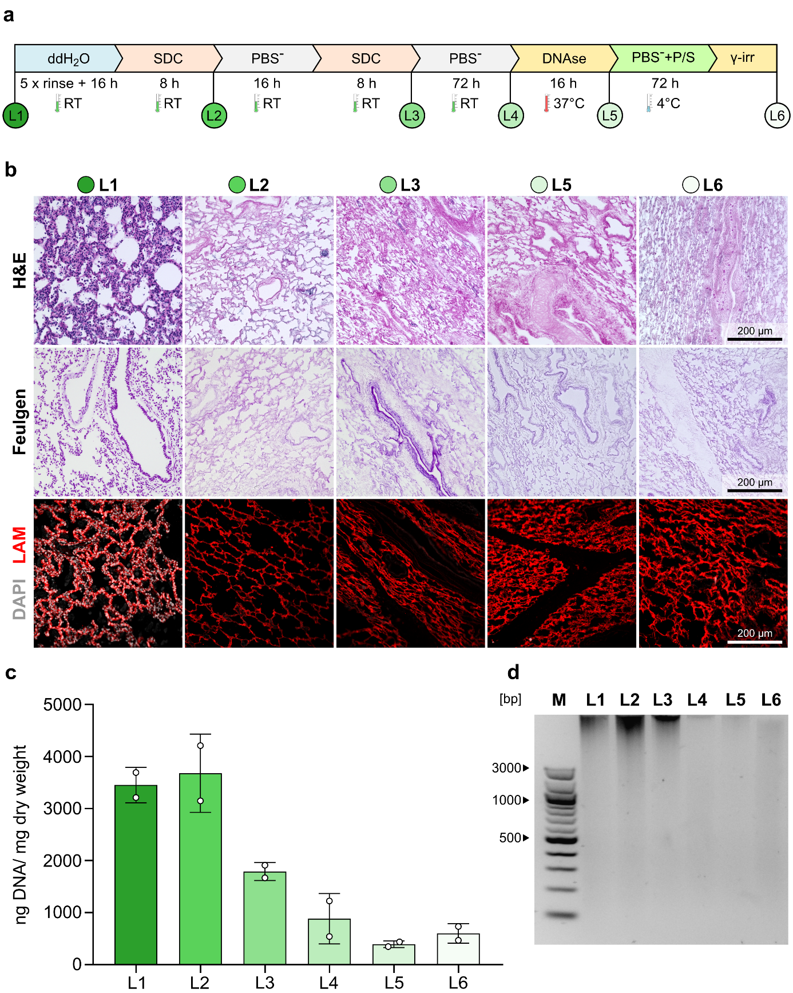
Supplementary Figure 2 Step-wise deconstruction of porcine lung decellularization. a Illustration of the decellularization process used for the production of the LungMa. Encircled numbers correlate to the process step at which samples were taken and analyzed. b Tissue sections taken at different time points of decellularization and stained with Haematoxylin and Eosin (H&E) (upper panel), Feulgen (middle panel) and an antibody against laminin (red), counterstained with DAPI (grey) (lower panel). c Bar graph showing the amount of DNA per mg dry weight at different time points of lung decellularization. Data are shown as mean ± SD (n=2). d Samples of isolated DNA of the respective differentiation time points separated on an agarose gel. The presented images present only parts of the original gels. The uncropped images can be found in Supplementary figure 4.

Supplementary Figure 3
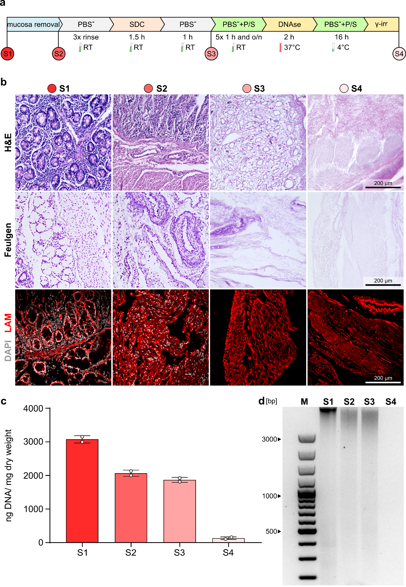
Supplementary Figure 3 Step-wise deconstruction of porcine intestine decellularization. a Illustration of the decellularization process used for the production of the SISser. Encircled numbers correlate to the process step at which samples were taken and analyzed. b Tissue sections taken at different time points of decellularization and stained with Haematoxylin and Eosin (H&E) (upper panel), Feulgen (middle panel) and an antibody against laminin (red), counterstained with DAPI (grey) (lower panel). c Bar graph showing the amount of DNA per mg dry weight at different time points of intestine decellularization. Data are shown as mean ± SD (n=2). d Samples of isolated DNA of the respective differentiation time points separated on an agarose gel. The presented images present only parts of the original gels. The uncropped images can be found in Supplementary figure 4.

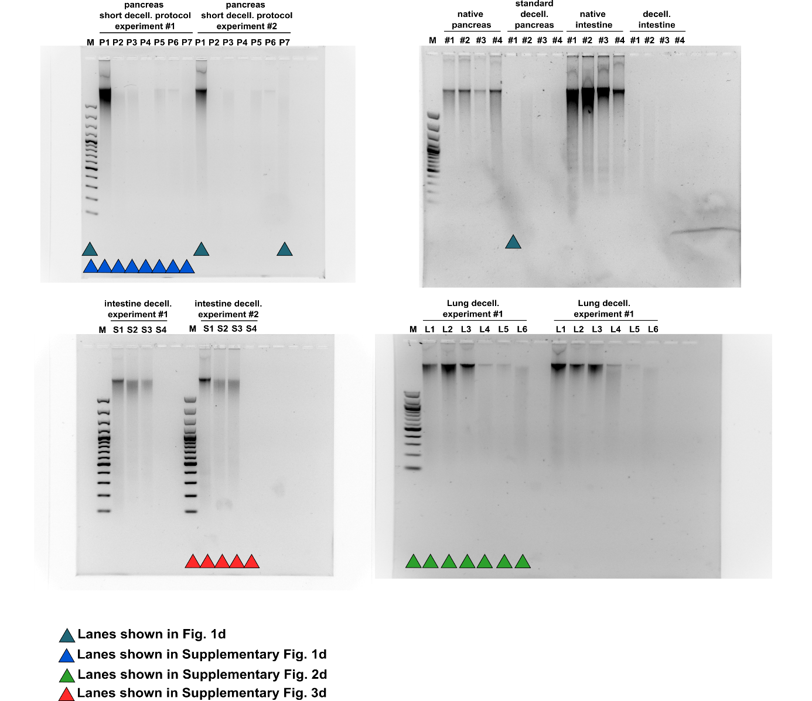
Supplementary Figure 4

Supplementary Figure 4 Full length agarose gels. Gels loaded with DNA isolated from the respective samples. # refers to biological replicates, whereas P1-7, L1-6 and S1-4 refer to different time points during the decellularization experiment. Color-coded triangles mark lanes that are presented in another figure of this manuscript.

