Additional File 2 Correlation of EQ-5D-5L utility score, EQ VAS score and IPOS total score at baseline and follow up
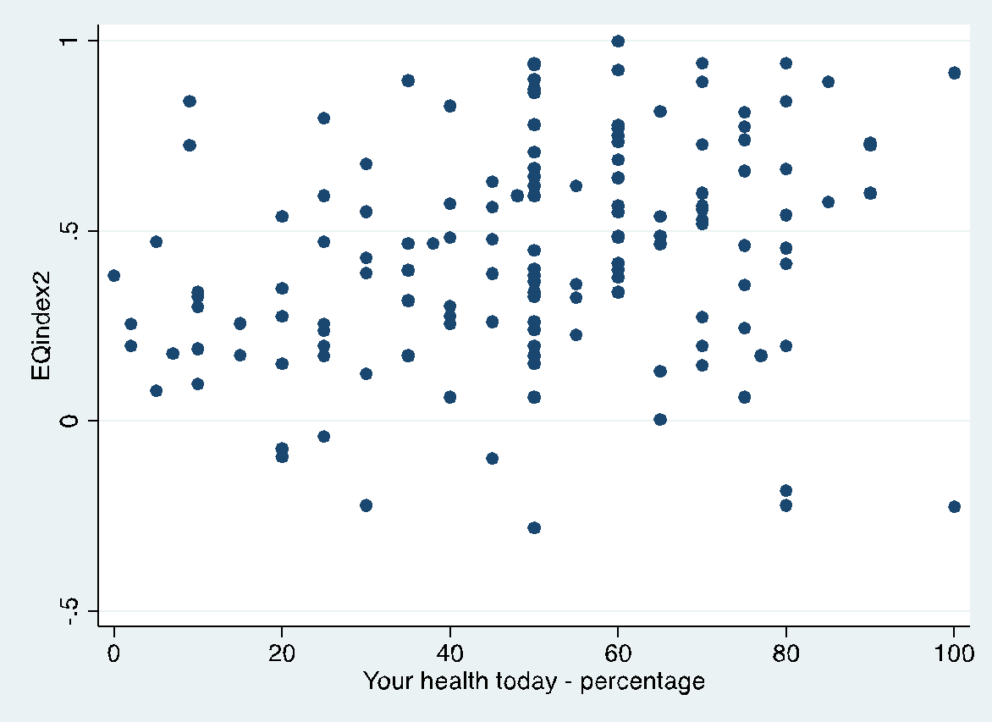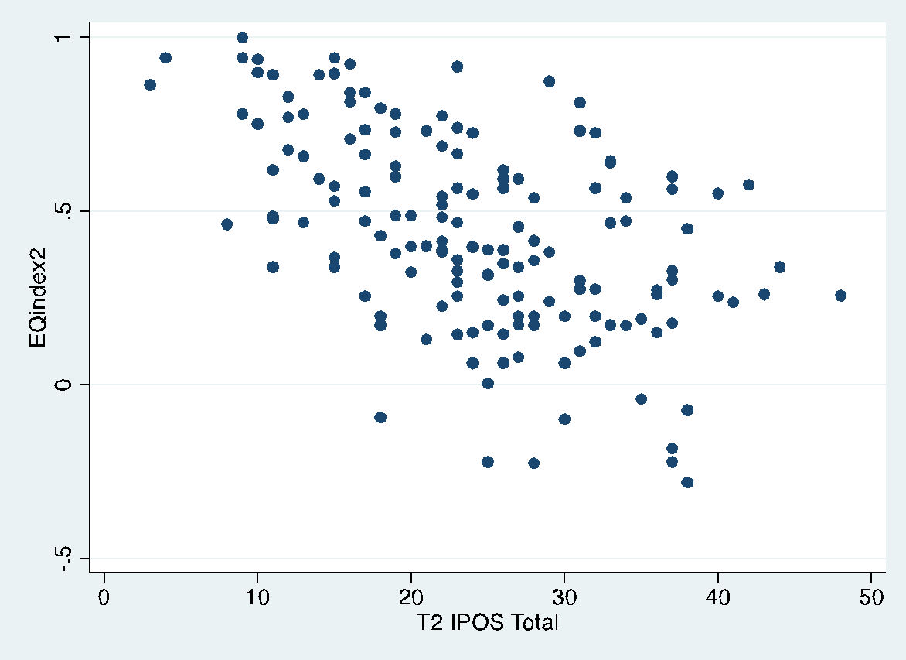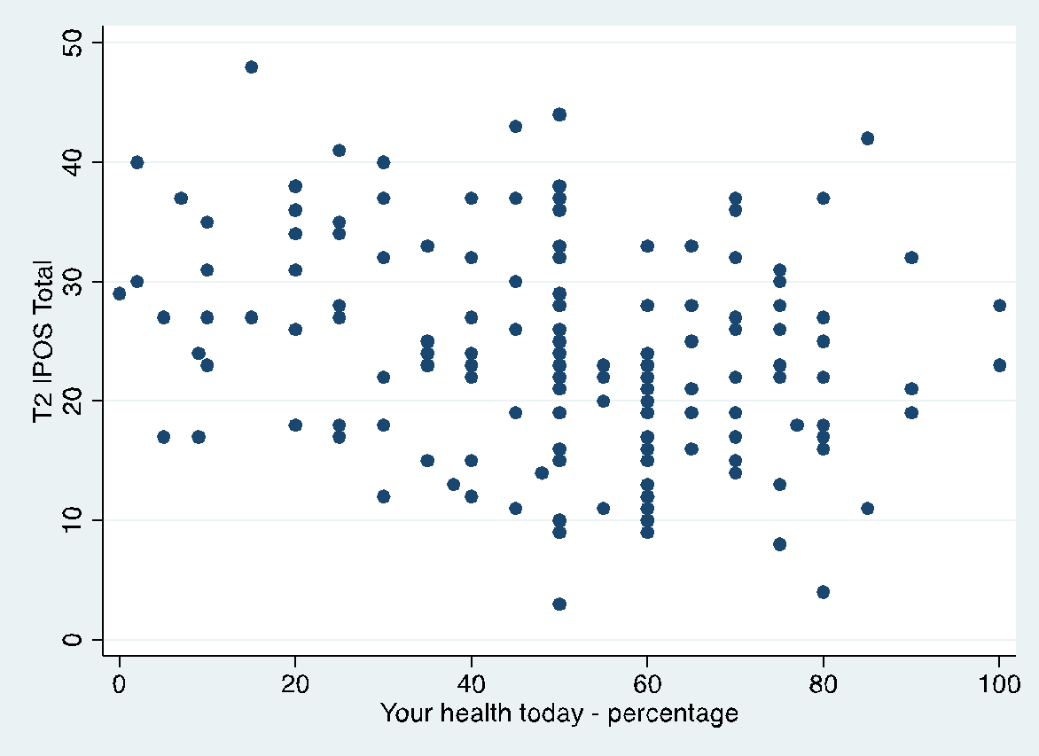
(ρ=-0.51, p<0.001)
(ρ=-0.27, p<0.001)
(ρ=-0.55, p<0.001)
(ρ=0.29, p<0.001)
(ρ=0.44, p<0.001)
(ρ=-0.54, p<0.001)

