Additional File 1a IPOS scores by item at baseline
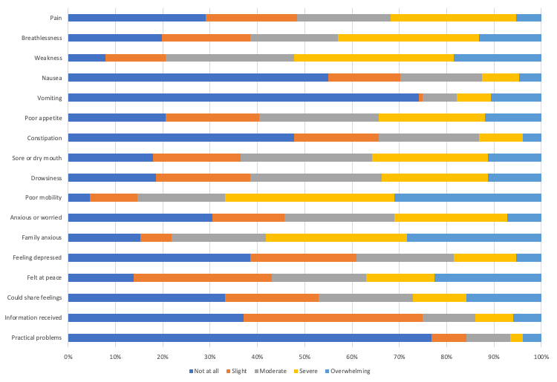
Additional File 1b IPOS scores by item at reassessment
