- Appendix
12.1 Appendix 1

Estimation of Rule of Law with Different Econometric Techniques
Rule of Law |  | Random Effects |  | Fixed-Effects |  | Pooled OLS |  | Average
 |  | Coefficient | p-Value | Coefficient | p-Value | Coefficient | p-Value | Average
 | Const | -0,765239 | *** | -0,6588370 | *** | -0,41340 | *** | -0,612492
A2 | Access to electricity (% of population) | -0,002770 | *** | -0,0027642 | *** | -0,00061 | * | -0,002048
A3 | Adjusted savings: natural resources depletion (% of GNI) | -0,002833 | *** | -0,0038019 | *** | 0,00163 | *** | -0,001668
A12 | Control of Corruption: Estimate | 0,219044 | *** | 0,1242020 | *** | 0,45840 | *** | 0,267216
A32 | Individuals using the Internet (% of population) | 0,000433 | * | 0,0012710 | *** | 0,00120 | *** | 0,000968
A34 | Life expectancy at birth, total (years) | 0,013853 | *** | 0,0182216 | *** | 0,00687 | *** | 0,012983
A47 | Political Stability and Absence of Violence/Terrorism: Estimate | 0,124325 | *** | 0,1089850 | *** | 0,13166 | *** | 0,121656
A48 | Population ages 65 and above (% of total population) | 0,010750 | *** | 0,0186308 | *** | -0,00642 | *** | 0,007655
A51 | Prevalence of overweight (% of adults) | -0,002404 | ** | -0,0137176 | *** | -0,00105 | ** | -0,005722
A55 | Regulatory Quality: Estimate | 0,358027 | *** | 0,3396790 | *** | 0,31152 | *** | 0,336408
A62 | Scientific and technical journal articles | 0,058489 | *** | 0,0475984 | * | 0,07946 | *** | 0,061850
A67 | Voice and Accountability: Estimate | 0,169535 | *** | 0,1778630 | *** | 0,11603 | *** | 0,154476

Variables | Meaning
Rule of Law: Estimate | Rule of Law captures perceptions of the extent to which agents have confidence in and abide by the rules of society, and in particular the quality of contract enforcement, property rights, the police, and the courts, as well as the likelihood of crime and violence. Estimate gives the country's score on the aggregate indicator, in units of a standard normal distribution, i.e. ranging from approximately -2.5 to 2.5.
Regulatory Quality: Estimate | Regulatory Quality captures perceptions of the ability of the government to formulate and implement sound policies and regulations that permit and promote private sector development. Estimate gives the country's score on the aggregate indicator, in units of a standard normal distribution, i.e. ranging from approximately -2.5 to 2.5.
Control of Corruption: Estimate | Control of Corruption captures perceptions of the extent to which public power is exercised for private gain, including both petty and grand forms of corruption, as well as "capture" of the state by elites and private interests. Estimate gives the country's score on the aggregate indicator, in units of a standard normal distribution, i.e. ranging from approximately -2.5 to 2.5.
Voice and Accountability: Estimate | Voice and Accountability captures perceptions of the extent to which a country's citizens are able to participate in selecting their government, as well as freedom of expression, freedom of association, and a free media. Estimate gives the country's score on the aggregate indicator, in units of a standard normal distribution, i.e. ranging from approximately -2.5 to 2.5.
Political Stability and Absence of Violence/Terrorism: Estimate | Political Stability and Absence of Violence/Terrorism measures perceptions of the likelihood of political instability and/or politically-motivated violence, including terrorism. Estimate gives the country's score on the aggregate indicator, in units of a standard normal distribution, i.e. ranging from approximately -2.5 to 2.5.
Scientific and technical journal articles | Scientific and technical journal articles refer to the number of scientific and engineering articles published in the following fields: physics, biology, chemistry, mathematics, clinical medicine, biomedical research, engineering and technology, and earth and space sciences.
Life expectancy at birth, total (years) | Life expectancy at birth indicates the number of years a new born infant would live if prevailing patterns of mortality at the time of its birth were to stay the same throughout its life.
Population ages 65 and above (% of total population) | Population ages 65 and above as a percentage of the total population. Population is based on the de facto definition of population, which counts all residents regardless of legal status or citizenship.
Individuals using the Internet (% of population) | Internet users are individuals who have used the Internet (from any location) in the last 3 months. The Internet can be used via a computer, mobile phone, personal digital assistant, games machine, digital TV etc.
Adjusted savings: natural resources depletion (% of GNI) | Natural resource depletion is the sum of net forest depletion, energy depletion, and mineral depletion. Net forest depletion is unit resource rents times the excess of roundwood harvest over natural growth. Energy depletion is the ratio of the value of the stock of energy resources to the remaining reserve lifetime (capped at 25 years). It covers coal, crude oil, and natural gas. Mineral depletion is the ratio of the value of the stock of mineral resources to the remaining reserve lifetime (capped at 25 years). It covers tin, gold, lead, zinc, iron, copper, nickel, silver, bauxite, and phosphate.
Access to electricity (% of population) | Access to electricity is the percentage of population with access to electricity. Electrification data are collected from industry, national surveys, and international sources.
Prevalence of overweight (% of adults) | Prevalence of overweight adults is the percentage of adults ages 18 and over whose Body Mass Index (BMI) is more than 25 kg/m2. Body Mass Index (BMI) is a simple index of weight-for-height, or the weight in kilograms divided by the square of the height in meters.

Random-effects (GLS), using 2696 observations
Included 177 cross-sectional units
Time-series length: minimum 3, maximum 16
Dependent variable: A59

 | Coefficient | Std. Error | z | p-value
const | −0.765239 | 0.0928035 | −8.246 | <0.0001 | ***
A2 | −0.00277038 | 0.000527456 | −5.252 | <0.0001 | ***
A3 | −0.00283262 | 0.000719967 | −3.934 | <0.0001 | ***
A12 | 0.219044 | 0.0147554 | 14.84 | <0.0001 | ***
A32 | 0.000432623 | 0.000249229 | 1.736 | 0.0826 | *
A34 | 0.0138528 | 0.00167421 | 8.274 | <0.0001 | ***
A47 | 0.124325 | 0.00826474 | 15.04 | <0.0001 | ***
A48 | 0.0107502 | 0.00300415 | 3.578 | 0.0003 | ***
A51 | −0.00240401 | 0.00114940 | −2.092 | 0.0365 | **
A55 | 0.358027 | 0.0138802 | 25.79 | <0.0001 | ***
A62 | 5.84888e-07 | 2.18627e-07 | 2.675 | 0.0075 | ***
A67 | 0.169535 | 0.0137171 | 12.36 | <0.0001 | ***

Mean dependent var | −0.097467 |  | S.D. dependent var | 0.965008
Sum squared resid | 219.1156 |  | S.E. of regression | 0.285670
Log-likelihood | −442.0796 |  | Akaike criterion | 908.1591
Schwarz criterion | 978.9534 |  | Hannan-Quinn | 933.7624
rho | 0.619791 |  | Durbin-Watson | 0.690472

'Between' variance = 0.0380941
'Within' variance = 0.0167052
mean theta = 0.830488
Joint test on named regressors -
Asymptotic test statistic: Chi-square(11) = 5408.27
with p-value = 0

Breusch-Pagan test -
Null hypothesis: Variance of the unit-specific error = 0
Asymptotic test statistic: Chi-square(1) = 7287.02
with p-value = 0

Hausman test -
Null hypothesis: GLS estimates are consistent
Asymptotic test statistic: Chi-square(11) = 223.825
with p-value = 8.23618e-42

Fixed-effects, using 2696 observations
Included 177 cross-sectional units
Time-series length: minimum 3, maximum 16
Dependent variable: A59

 | Coefficient | Std. Error | t-ratio | p-value
const | −0.658837 | 0.102372 | −6.436 | <0.0001 | ***
A2 | −0.00276417 | 0.000634221 | −4.358 | <0.0001 | ***
A3 | −0.00380188 | 0.000749058 | −5.076 | <0.0001 | ***
A12 | 0.124202 | 0.0161229 | 7.703 | <0.0001 | ***
A32 | 0.00127103 | 0.000317381 | 4.005 | <0.0001 | ***
A34 | 0.0182216 | 0.00193721 | 9.406 | <0.0001 | ***
A47 | 0.108985 | 0.00846487 | 12.88 | <0.0001 | ***
A48 | 0.0186308 | 0.00455252 | 4.092 | <0.0001 | ***
A51 | −0.0137176 | 0.00232340 | −5.904 | <0.0001 | ***
A55 | 0.339679 | 0.0146256 | 23.22 | <0.0001 | ***
A62 | 4.75984e-07 | 2.45567e-07 | 1.938 | 0.0527 | *
A67 | 0.177863 | 0.0156953 | 11.33 | <0.0001 | ***

Mean dependent var | −0.097467 |  | S.D. dependent var | 0.965008
Sum squared resid | 41.89668 |  | S.E. of regression | 0.129249
LSDV R-squared | 0.983306 |  | Within R-squared | 0.450288
LSDV F(187, 2508) | 789.9785 |  | P-value(F) | 0.000000
Log-likelihood | 1788.042 |  | Akaike criterion | −3200.084
Schwarz criterion | −2090.974 |  | Hannan-Quinn | −2798.966
rho | 0.619791 |  | Durbin-Watson | 0.690472

Joint test on named regressors -
Test statistic: F(11, 2508) = 186.763
with p-value = P(F(11, 2508) > 186.763) = 0

Test for differing group intercepts -
Null hypothesis: The groups have a common intercept
Test statistic: F(176, 2508) = 36.5188
with p-value = P(F(176, 2508) > 36.5188) = 0

Pooled OLS, using 2696 observations
Included 177 cross-sectional units
Time-series length: minimum 3, maximum 16
Dependent variable: A59

 | Coefficient | Std. Error | t-ratio | p-value
const | −0.413400 | 0.0622900 | −6.637 | <0.0001 | ***
A2 | −0.000609479 | 0.000317974 | −1.917 | 0.0554 | *
A3 | 0.00162961 | 0.000602505 | 2.705 | 0.0069 | ***
A12 | 0.458403 | 0.0108731 | 42.16 | <0.0001 | ***
A32 | 0.00119896 | 0.000294367 | 4.073 | <0.0001 | ***
A34 | 0.00687454 | 0.00114912 | 5.982 | <0.0001 | ***
A47 | 0.131659 | 0.00734270 | 17.93 | <0.0001 | ***
A48 | −0.00641677 | 0.00140125 | −4.579 | <0.0001 | ***
A51 | −0.00104570 | 0.000409541 | −2.553 | 0.0107 | **
A55 | 0.311517 | 0.0113467 | 27.45 | <0.0001 | ***
A62 | 7.94614e-07 | 1.20978e-07 | 6.568 | <0.0001 | ***
A67 | 0.116029 | 0.00905782 | 12.81 | <0.0001 | ***

Mean dependent var | −0.097467 |  | S.D. dependent var | 0.965008
Sum squared resid | 149.2664 |  | S.E. of regression | 0.235825
R-squared | 0.940524 |  | Adjusted R-squared | 0.940280
F(11, 2684) | 3858.496 |  | P-value(F) | 0.000000
Log-likelihood | 75.37339 |  | Akaike criterion | −126.7468
Schwarz criterion | −55.95249 |  | Hannan-Quinn | −101.1435
rho | 0.873429 |  | Durbin-Watson | 0.268576

9.2 Clusterization
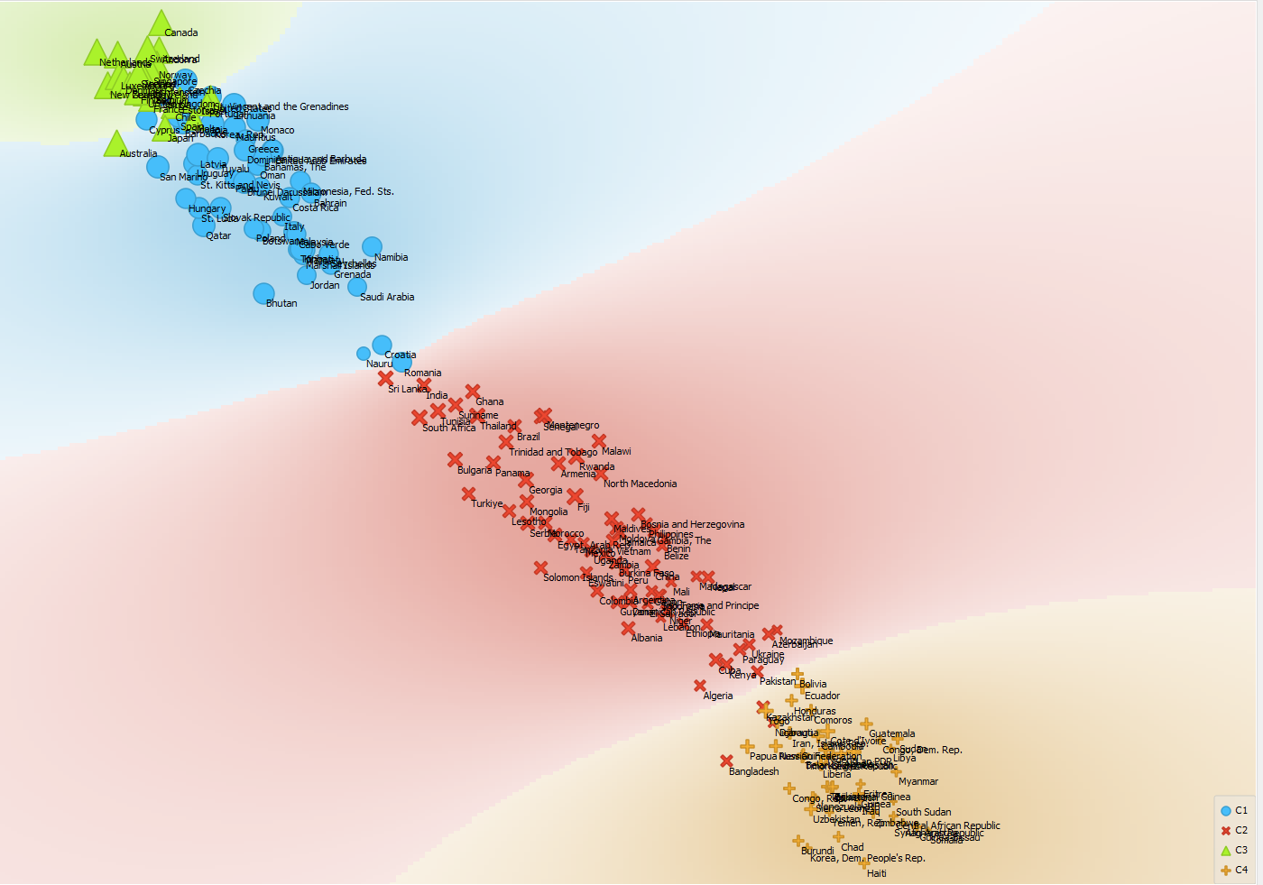
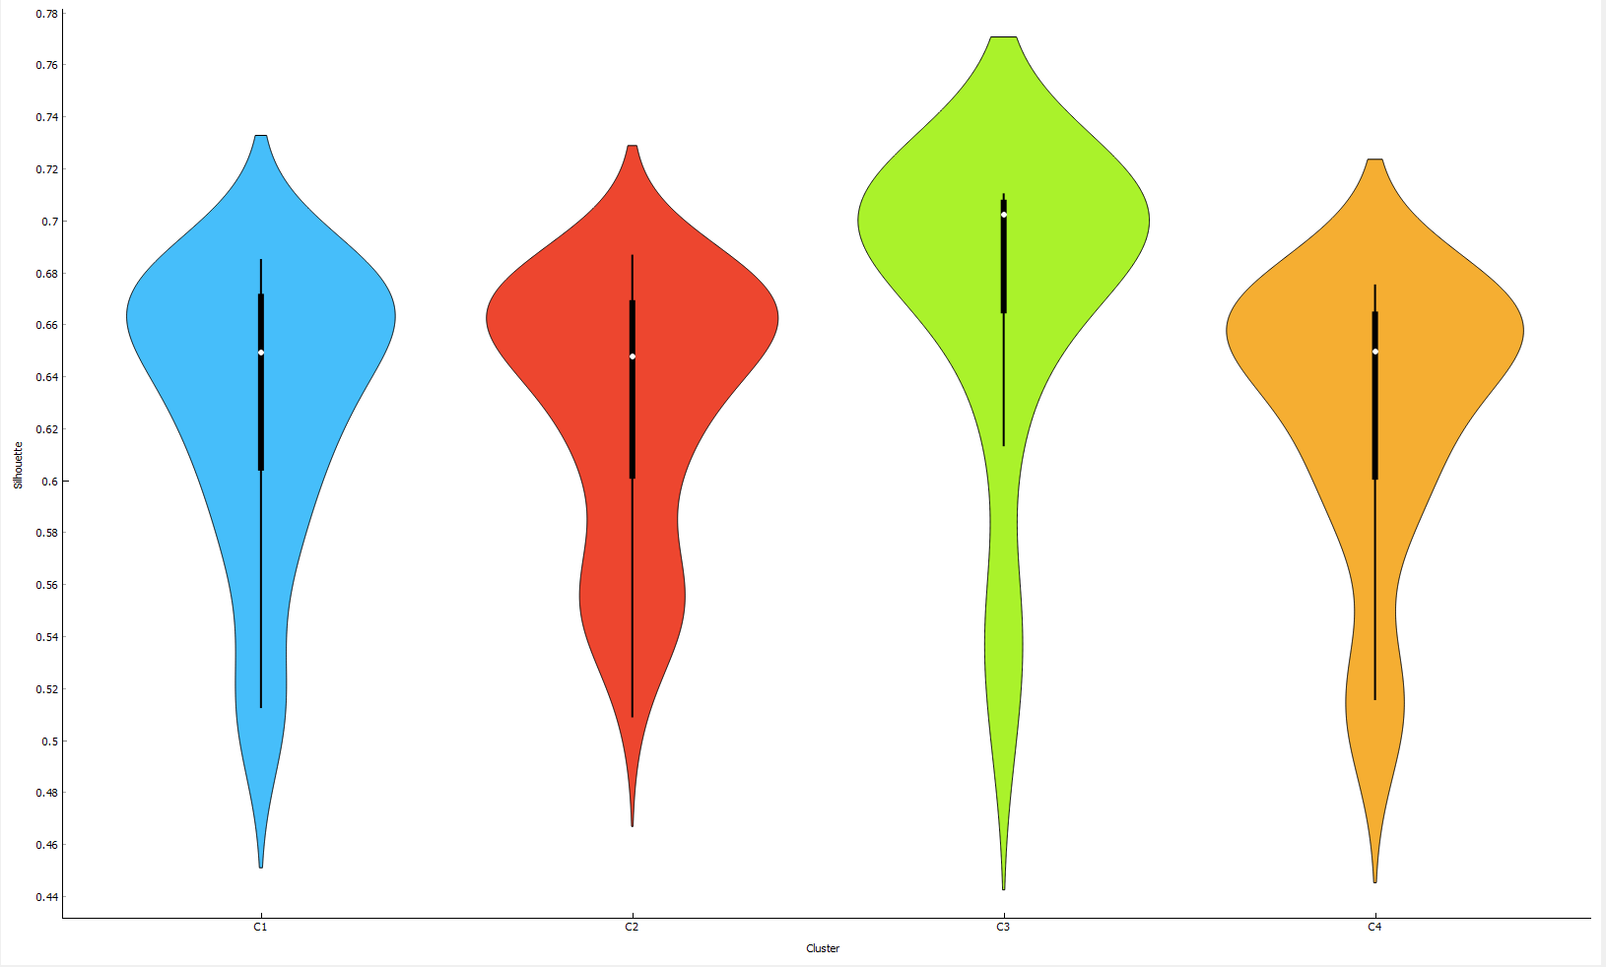
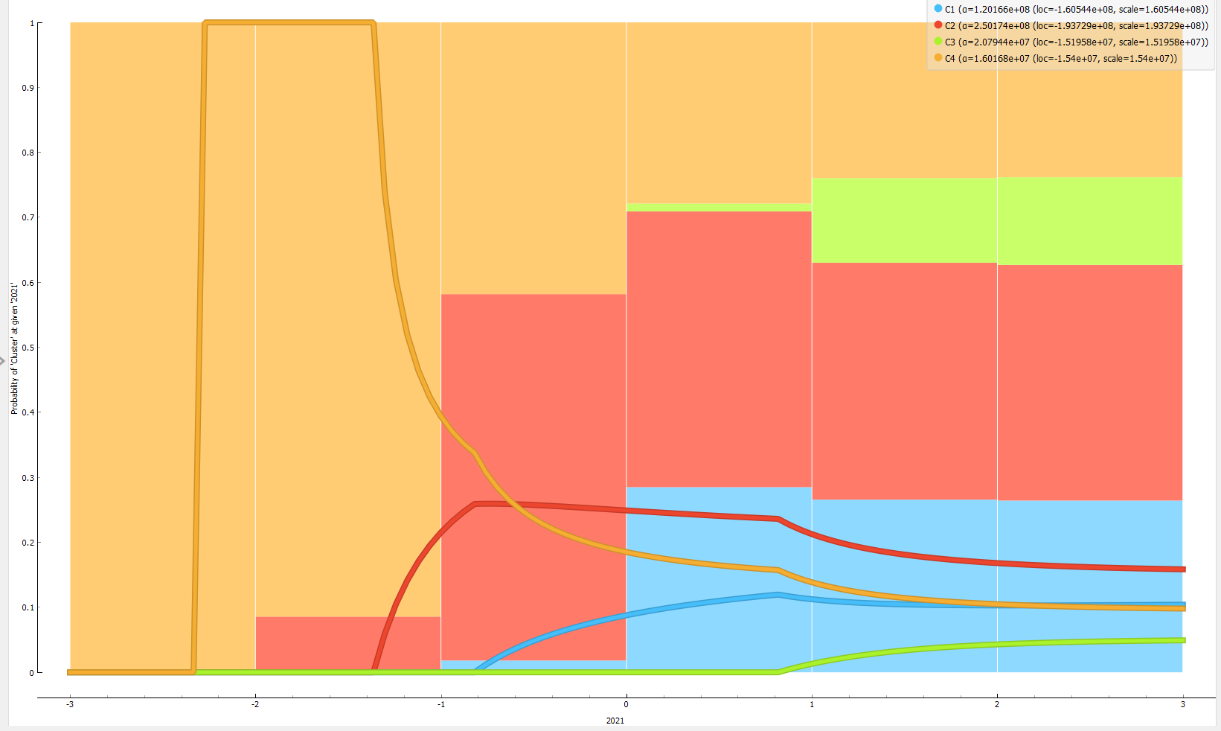

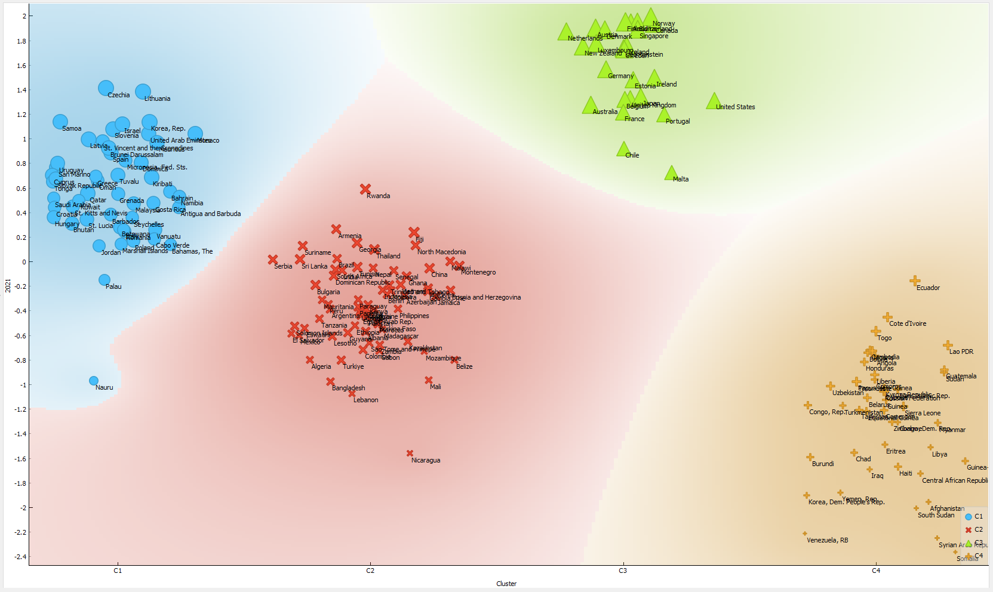
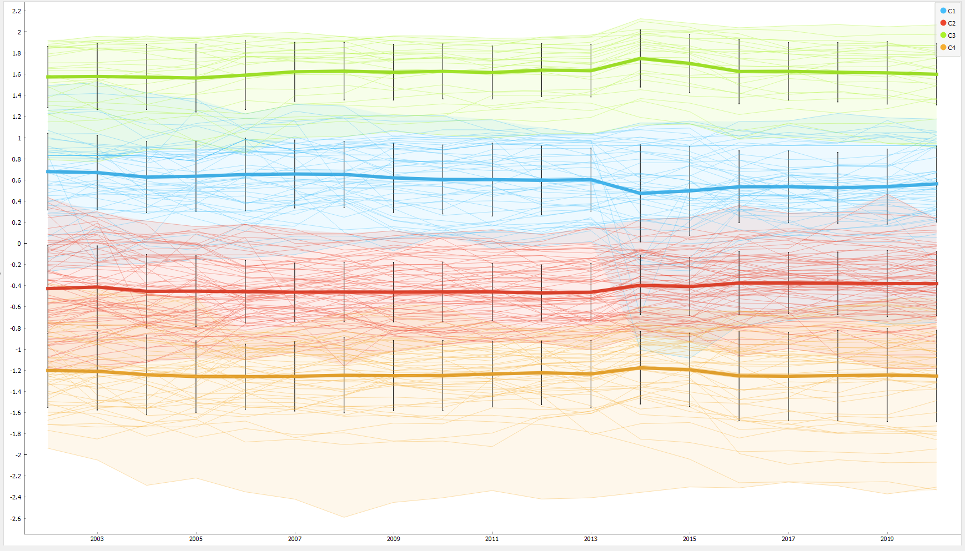
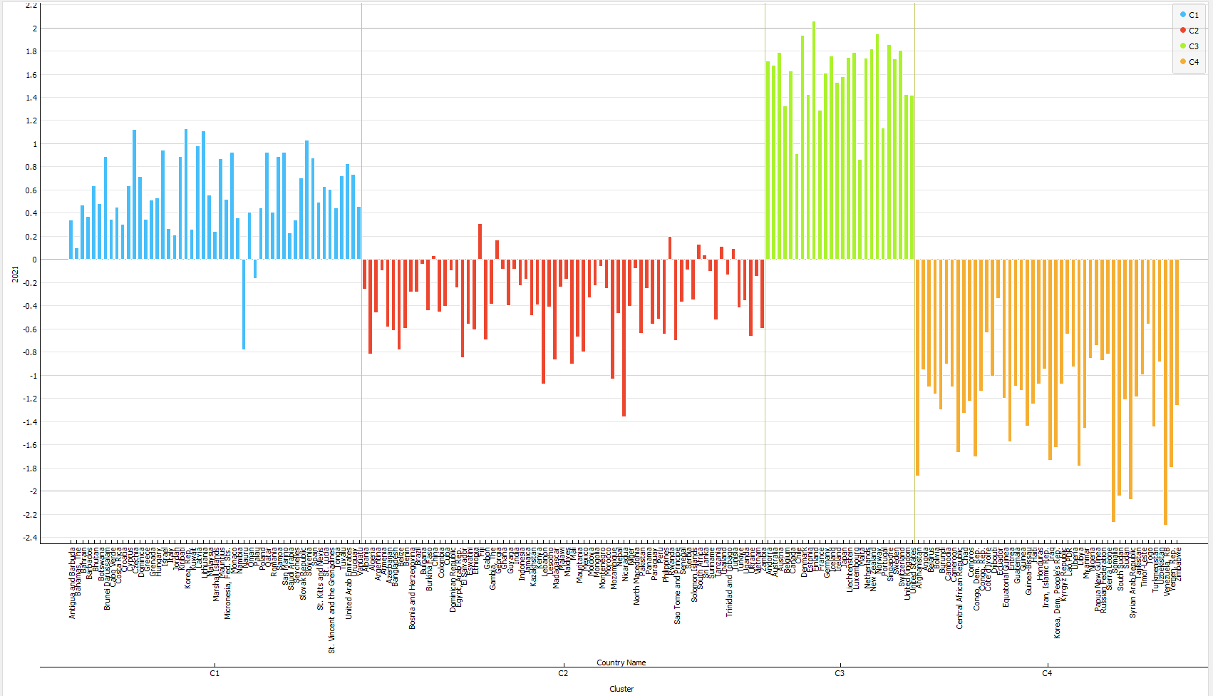

Machine Learning and Predictions
Ranking of Algorithms Based on Predictive Performance
Algorithm | R^2 | MAE | MSE | RMSE | SUM
Linear Regression | 1 | 1 | 1 | 1 | 4
Tree Ensemble Regression | 3 | 3 | 2 | 3 | 11
Polynomial Regression | 2 | 2 | 8 | 2 | 14
Gradient Boosted Tree | 4 | 4 | 3 | 4 | 15
Simple Regression | 5 | 5 | 4 | 5 | 19
PNN | 6 | 6 | 5 | 6 | 23
ANN | 7 | 7 | 6 | 7 | 27
Random Forest | 8 | 8 | 7 | 8 | 31

Statistical Results of Machine Learning Algorithms for the Prediction of Rule of Law
Metrics | ANN | PNN | Gradient Boosted Tree | Random Forest
R^2 | 0,900672 | 0,945300 | 0,955362 | 0,837283
MAE | 0,056753 | 0,045574 | 0,043613 | 0,081977
MSE | 0,004619 | 0,003756 | 0,002609 | 0,008671
RMSE | 0,067963 | 0,061282 | 0,051074 | 0,093117
Metrics | Tree Ensemble Regression | Linear Regression | Polynomial Regression | Simple Regression
R^2 | 0,967906 | 0,992175 | 0,986411 | 0,951016
MAE | 0,032218 | 0,018075 | 0,020903 | 0,043906
MSE | 0,002083 | 0,001000 | 0,029000 | 0,002908
RMSE | 0,045645 | 0,022701 | 0,028530 | 0,053930

