Supplementary Information 1

Figure S1. Multiple mediation analysis: indirect effects of eHEALS on EQ-5D
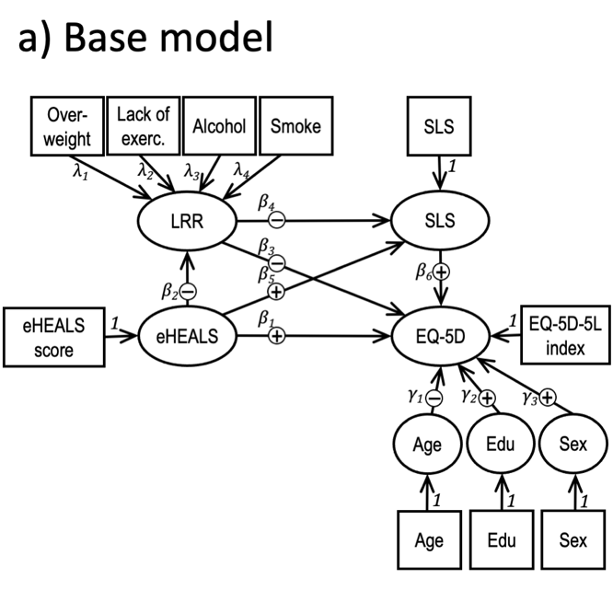 | 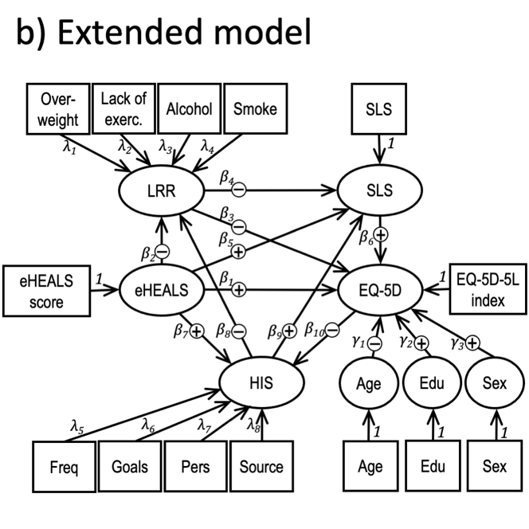
Alcohol: frequent drinking; Edu: education; eHEALS: eHealth Literacy Scale score; EQ-5D: EQ-5D-5L index score; Freq: frequency of health information seeking; Goals: number of health information seeking goals; HIS: health information seeking;; Lack of exerc.: lack of exercise; LRR: lifestyle-related risk; Overweight: BMI ≥ 30; Pers: number of persons health information is sought for; SLS: subjective lifestyle; Smoke: current smoker; Source: number of sources health information is sought from

Base model: indirect effect of eHEALS on EQ-5D mediated by LRR (objective component) | Eq.
$${MEb}_{LRR}^{eHEALS→EQ-5D}=β_{2}*β_{3}+β_{2}*β_{4}*β_{6}$$ | (1)
Base model: indirect effect of eHEALS on EQ-5D mediated by SLS (subjective component)
$${MEb}_{SLS}^{eHEALS→EQ-5D}=β_{5}*β_{6}+β_{2}*β_{4}*β_{6}$$ | (2)
Base model: total indirect effect of eHEALS on EQ-5D (mediated by LRR and SLS)
$${MEb}_{Total}^{eHEALS→EQ-5D}=β_{5}*β_{6}+β_{5}*β_{6}+β_{2}*β_{4}*β_{6}$$ | (3)
Base model: direct effect of eHEALS on EQ-5D
$${DEb}^{eHEALS→EQ-5D}=β_{1}$$ | (4)
Base model: total effect of eHEALS on EQ-5D (direct effect 3 indirect effect)
$${TEb}^{eHEALS→EQ-5D}={β_{1}+β}_{5}*β_{6}+β_{5}*β_{6}+β_{2}*β_{4}*β_{6}$$ | (5)
Extended model: mediation of the effect of eHEALS on LRR by HIS
$${ME}_{HIS}^{eHEALS→LRR}=β_{7}*β_{8}$$ | (6)
Extended model: mediation of the effect of eHEALS on SLS by HIS
$${MEe}_{HIS}^{eHEALS→SLS}=β_{7}*β_{9}$$ | (7)
Extended model: total effect eHEALS on LRR
$${TEe}^{eHEALS→LRR}=β_{7}*β_{9}$$ | (8)
Extended model: mediation of the effect of eHEALS on EQ-5D through HIS (activity component)
$${MEe}_{HIS}^{eHEALS→EQ-5D}=β_{7}*β_{8}*β_{3}+β_{7}*β_{8}*β_{4}*β_{6}+β_{7}*β_{9}*β_{6}$$ | (9)
Extended model: mediation of the effect of eHEALS on EQ-5D through LRR (objective component)
$${MEe}_{LRR}^{eHEALS→EQ-5D}=β_{2}*β_{3}+β_{2}*β_{4}*β_{6}+β_{7}*β_{8}*β_{3}+β_{7}*β_{8}*β_{4}*β_{6}$$ | (10)
Extended model: mediation of the effect of eHEALS on EQ-5D through SLS (subjective component)
$${MEe}_{SLS}^{eHEALS→EQ-5D}=β_{5}*β_{6}+β_{7}*β_{9}*β_{6}+β_{2}*β_{4}*β_{6}+β_{7}*β_{8}*β_{4}*β_{6}$$ | (11)
Extended model: total indirect effect of eHEALS on EQ-5D
$${MEe}_{SLS}^{eHEALS→EQ-5D}=β_{2}*β_{3}+β_{2}*β_{4}*β_{6}+β_{7}*β_{8}*β_{3}+β_{7}*β_{8}*β_{4}{*β}_{6}+β_{5}*β_{6}+β_{7}*β_{9}*β_{6}$$ | (12)
Extended model: direct effect eHEALS on EQ-5D
$${DEe}^{eHEALS→EQ-5D}=β_{1}$$ | (13)
Extended model: total effect of eHEALS on EQ-5D
$${TEe}^{eHEALS→EQ-5D}={β_{1}+β}_{2}*β_{3}+β_{2}*β_{4}*β_{6}+β_{7}*β_{8}*β_{3}+β_{7}*β_{8}*β_{4}{*β}_{6}+β_{5}*β_{6}+β_{7}*β_{9}*β_{6}$$ | (14)

MEb: moderated effects base model, DEb: direct effect base model, TEb: total effect base model, MEe: moderated effects extended model, DEe: direct effect extended model, TEe: total effect extended model
Supplementary Information 2
Figure S2. Moderated mediation analysis: moderation of the direct and indirect effect of eHEALS on EQ-5D by sociodemographic variables
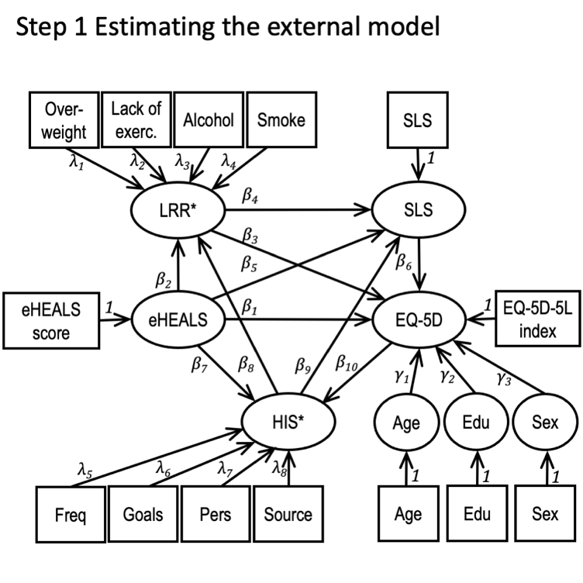 | 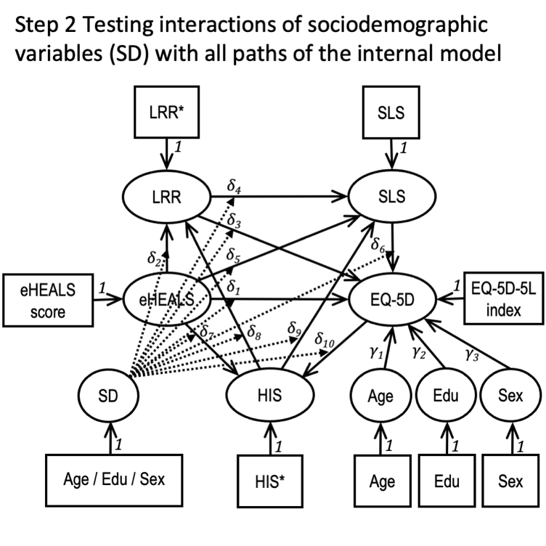
Alcohol: frequent drinking; Edu: education; eHEALS: eHealth Literacy Scale score; EQ-5D: EQ-5D-5L index score; Freq: frequency of health information seeking; Goals: number of health information seeking goals; HIS: health information seeking;; Lack of exerc.: lack of exercise; LRR: lifestyle-related risk; Overweight: BMI ≥ 30; Pers: number of persons health information is sought for; SLS: subjective lifestyle; Smoke: current smoker; Source: number of sources health information is sought from

When testing interactions, the full model is estimated first and latent variables’ scores from the external model are saved. In the second step, latent variable scores are entered and the interactions of the three sociodemographic variables with variables of the internal model are tested consecutively. The coefficients of eHEALS∗SD interactions are denoted as δ₁, δ₂, δ₅, and δ₇; of LRR∗SD interactions as δ₃ and δ₄; of the SLS∗SD interaction as δ₆; of the HIS∗SD interactions as δ₇, δ₈, and δ₉; and of the EQ-5D∗SD interaction as δ₁₀.
Extended model: moderation of the total indirect effect of eHEALS on EQ-5D by sociodemographic variables (age, education or sex) | Eq.
$${MMEe}_{SD}^{eHEALS→EQ-5D}=δ_{2}*δ_{3}+δ_{2}*δ_{4}*δ_{6}+δ_{7}*δ_{8}*δ_{3}+δ_{7}*δ_{8}*δ_{4}{*δ}_{6}+δ_{5}*δ_{6}+δ_{7}*δ_{9}*δ_{6}$$ | (15)
Extended model: moderation of the direct effect eHEALS on EQ-5D by sociodemographic variables (age, education or sex)
$${MDEe}_{SD}^{eHEALS→EQ-5D}=δ_{1}$$ | (16)
Extended model: moderation of the total effect of eHEALS on EQ-5D by sociodemographic variables (age, education or sex)
$${MTEe}_{SD}^{eHEALS→EQ-5D}={δ_{1}+δ}_{2}*δ_{3}+δ_{2}*δ_{4}*δ_{6}+δ_{7}*δ_{8}*δ_{3}+δ_{7}*δ_{8}*δ_{4}{*δ}_{6}+δ_{5}*δ_{6}+δ_{7}*δ_{9}*δ_{6}$$ | (17)
Extended model: moderation of the direct effect of EQ-5D on HIS by sociodemographic variables (age, education or sex)
$${MDEe}_{SD}^{eEQ-5D→HIS}=δ_{10}$$ | (18)

MMEe: moderated mediation effects extended model, MDEe: moderated direct effect extended model, MTEe: moderated total effect extended model

Supplementary Information 3

Table S1 Spearman correlation matrix of key variables

 | EQ-5D | eHEALS | Age | Education | Sex | Subjective lifestyle | Overweight | Lack of exercise | Alcohol | Smoking | HIS frequency | HIS goals | HIS persons | HIS sources
EQ-5Dª | 1
eHEALS^{b} | 0.06* | 1
Age^{c} | -0.21* | -0.10* | 1
Education^{d} | 0.13* | 0.05 | -0.02 | 1
Sex^{e} | -0.02 | -0.04 | 0.26* | 0.01 | 1
Subjective lifestyle^{f} | 0.28* | 0.10* | 0.08* | 0.17* | 0.01 | 1
Overweight^{g} | -0.18* | -0.07* | 0.23* | -0.06* | 0.08* | -0.17* | 1
Lack of exercise^{h} | -0.18* | -0.05 | 0.05 | -0.18* | 0.02 | -0.36* | 0.12* | 1
Alcohol^{i} | -0.12* | -0.02 | 0.18* | 0.02 | 0.20* | -0.04 | 0.02 | 0.04 | 1
Smoking^{j} | -0.06 | 0.02 | -0.2* | -0.20* | -0.12* | -0.22* | -0.11* | 0.08* | 0.03 | 1
HIS frequency^{k} | -0.14* | 0.24* | -0.02 | 0.01 | -0.13* | 0.03 | 0.00 | -0.07* | -0.09* | 0.01 | 1
HIS goals^{l} | -0.09* | 0.17* | -0.10* | 0.17* | -0.09* | 0.08* | -0.02 | -0.09* | -0.03 | -0.09* | 0.35* | 1
HIS persons^{m} | -0.11* | 0.18* | -0.02 | 0.09* | -0.09* | 0.01 | 0.01 | -0.06 | -0.05 | -0.04 | 0.37* | 0.43* | 1
HIS sources^{n} | -0.04 | 0.12* | -0.06 | 0.08* | -0.01 | 0.07* | -0.05 | -0.13* | -0.04 | -0.06 | 0.23* | 0.21* | 0.22* | 1
*p<0.05; **p<0.01, ***p<0.001
ªEQ-5D-5L index score (Hungarian value-set, range -0.865 - 1); ^{b}eHealth Literacy Scale (12 - 40) ; ^{c}Years (18 - 90); ^{d}Low: primary (0) / High: secondary or tertiary education (1) ; ^{e}Female (0) / Male (1); ^{f}Less healthy (-1) / as healthy (0) / healthier than others (1); ^{g}Body Mass Index (BMI) < 30 (0) / BMI ≥ 30 (1); ^{h}None (0) / ≥10 minutes exercise on any day per week (1); ^{i}Regular drinking: No (0) / Yes (Alcohol consumption ≥ 5 days per week); ^{j}No (0) / Yes (1); ^{k}Frequency of health information seeking over past year (0 - 5); ^{l}Number of health information seeking goals (0 - 5); ^{m}How many persons health information was sought for (0 - 5); ^{n}Number of health information sources (0 - 8)

Supplementary Information 4
Figure S3. Extended model: subgroup analysis by sociodemographic variables and health status
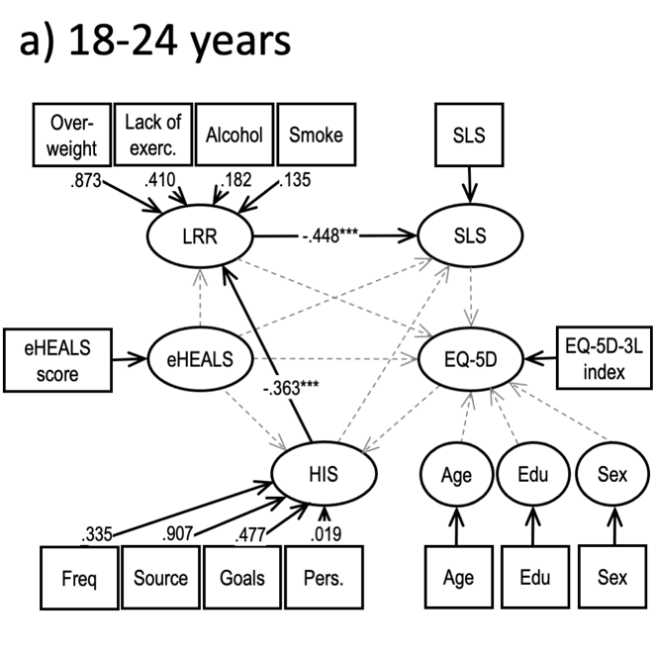 | 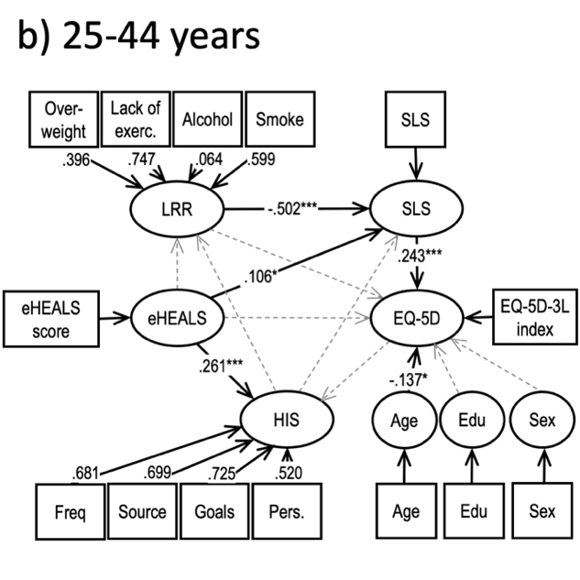
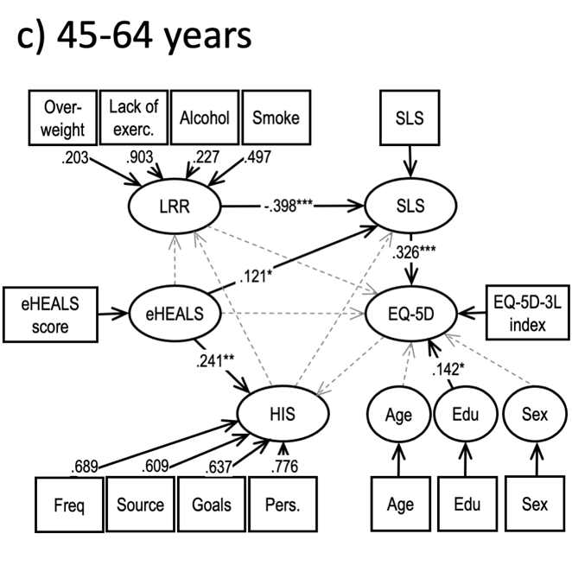 | 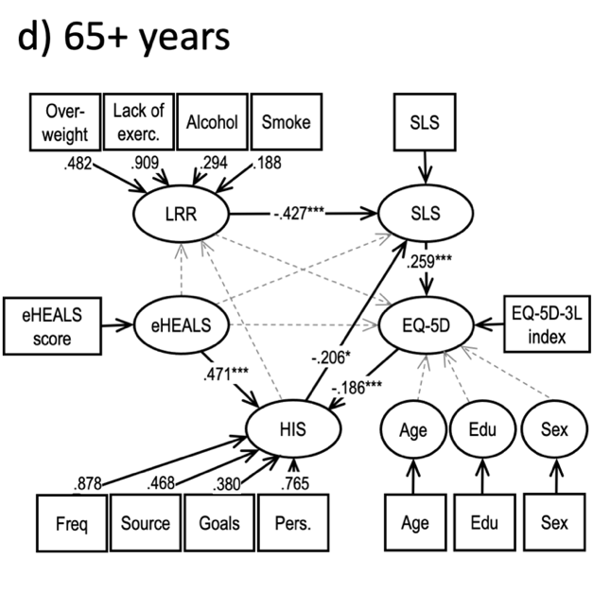
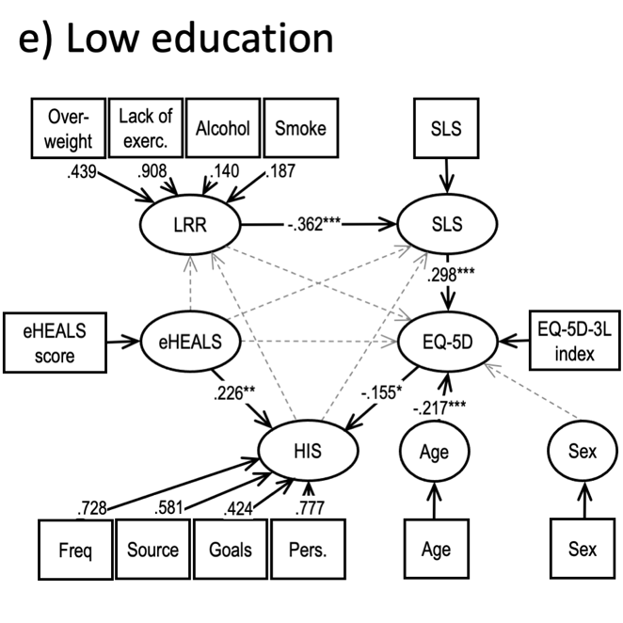 | 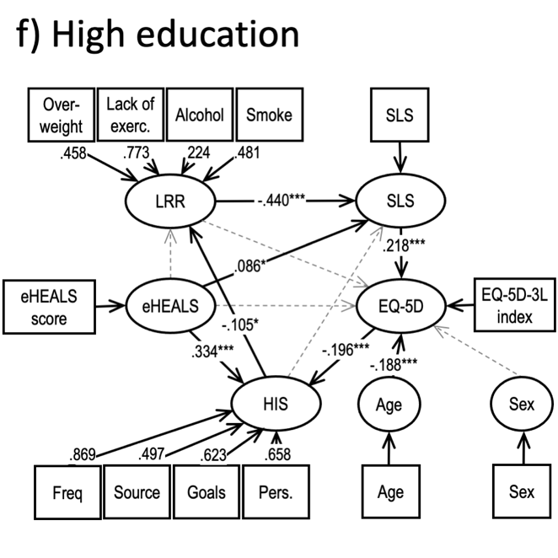
*p<0.05; **p<0.01, ***p<0.001
Alcohol: frequent drinking; Edu: education; eHEALS: eHealth Literacy Scale score; EQ-5D: EQ-5D-5L index score; Freq: frequency of health information seeking; Goals: number of health information seeking goals; HIS: health information seeking;; Lack of exerc.: lack of exercise; LRR: lifestyle-related risk; Overweight: BMI ≥ 30; Pers: number of persons health information is sought for; SLS: subjective lifestyle; Smoke: current smoker; Source: number of sources health information is sought from
Figure S3. continued
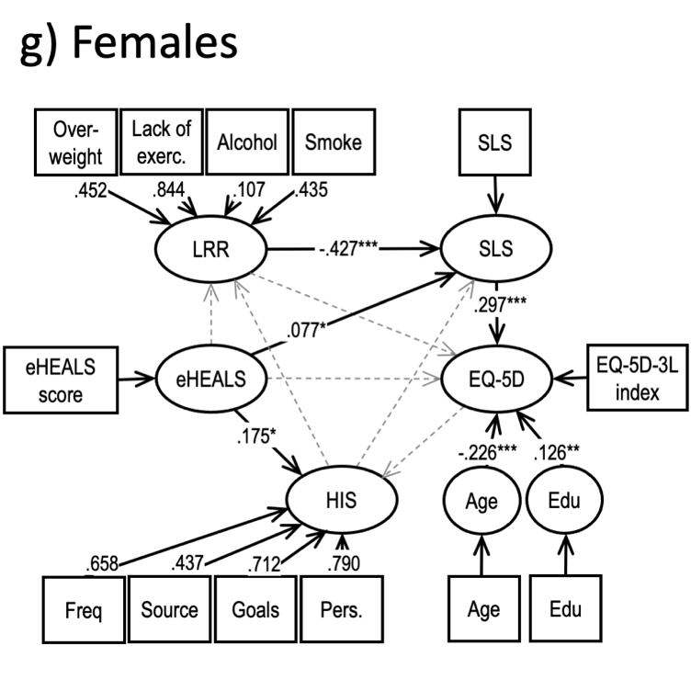 | 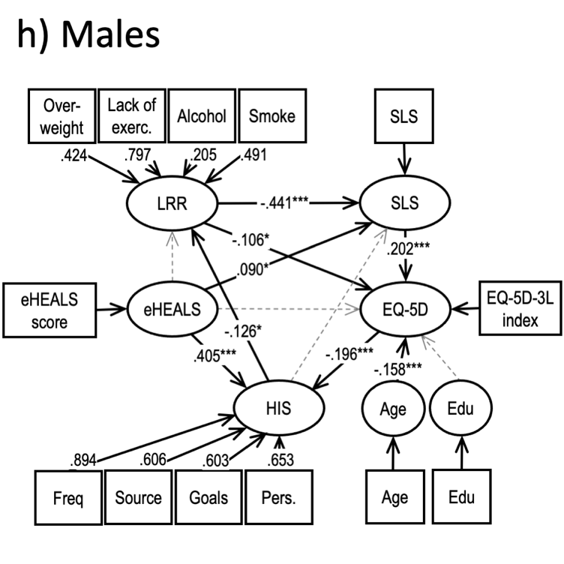
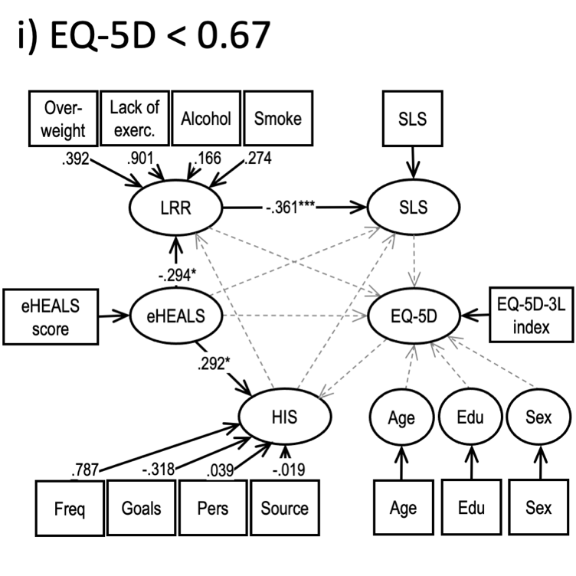 | 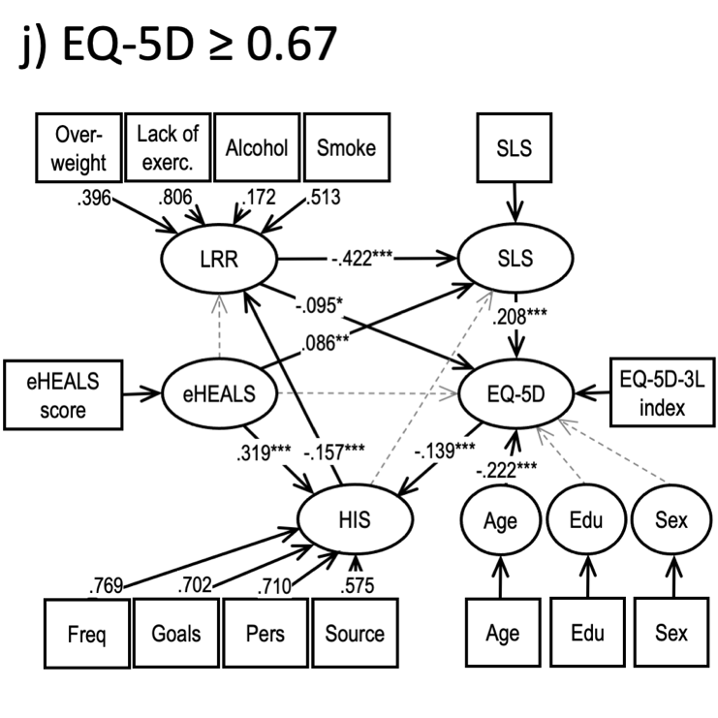
*p<0.05; **p<0.01, ***p<0.001
Alcohol: frequent drinking; Edu: education; eHEALS: eHealth Literacy Scale score; EQ-5D: EQ-5D-5L index score; Freq: frequency of health information seeking; Goals: number of health information seeking goals; HIS: health information seeking;; Lack of exerc.: lack of exercise; LRR: lifestyle-related risk; Overweight: BMI ≥ 30; Pers: number of persons health information is sought for; SLS: subjective lifestyle; Smoke: current smoker; Source: number of sources health information is sought from

Supplementary Information 5.

Table S2. Moderation of direct and indirect effects by sociodemographic variables

 | Total sample |  |  | Sample w poor health (EQ-5D<0.67) excluded
 | Age | Educationª | Sex^{b} | Age | Education | Sex
Moderation of indirect effect: eHEALS^{c} → EQ-5D^{c,e} | 0.002 | -0.003 | 0.008 | 0.021 | -0.013 | -0.014
Moderation of direct effect: eHEALS → EQ-5D^{f} | -0.219 | -0.091 | 0.039 | -0.094 | -0.21 | -0.303
Moderation of total effect eHEALS → EQ-5D^{g} | -0.216 | -0.095 | 0.047 | -0.073 | -0.223 | -0.316
Moderation of direct effect EQ-5D → HIS^{h} | -0.422* | -0.139 | -0.205 | -0.778* | 0.646 | -0.779*
*p<0.05; **p<0.01; ***p<0.001
ªLow: primary, High: secondary & tertiary; ^{b}Female(0) / Male(1); ^{c}eHealth Literacy Scale (eHEALS) score; ^{d}EQ-5D-5L index; ^{e}eq. 15, Supplementary Information 2, ^{f}eq. 16, Supplementary Information 2, ^{g}eq. 17, Supplementary Information 2, ^{h}eq. 18, Supplementary Information 2

