Supplementary Materials for
Comprehensive pan-cancer analysis reveals SIRT5 is a predictive biomarker for prognosis and immunotherapy response

Yacong Ji et al

Corresponding authors:

Shaomin Shi (Email: dermatologist_shi@163.com) and
Yaling Liu (Email: yzling_liu1214@126.com)

This file includes Supplementary Figure 1-4.

Supplementary Figures and Figure Legends:
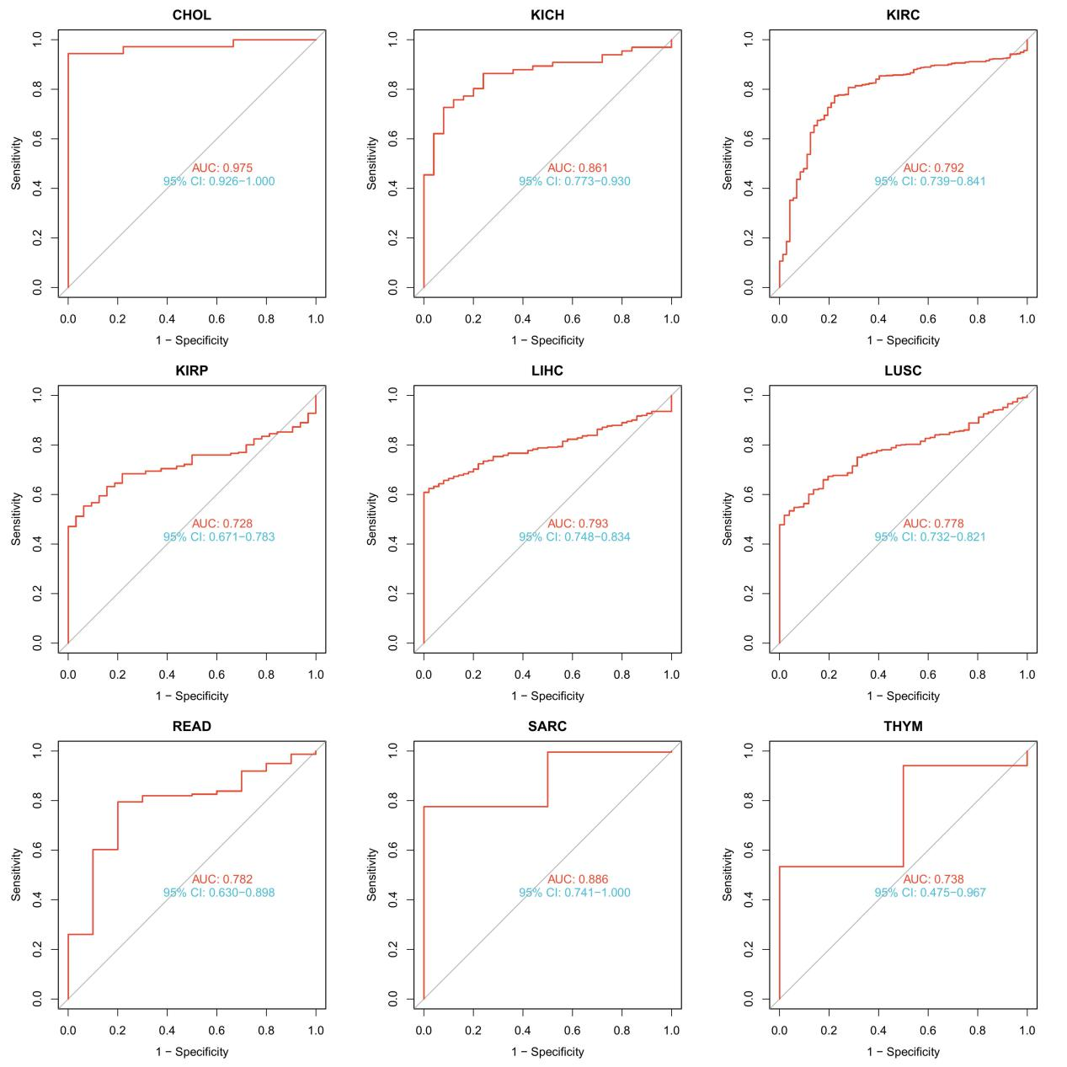
Fig S1. Diagnostic value of SIRT5 to distinguish tumor tissues from normal tissues. The AUC value was more than 0.7.
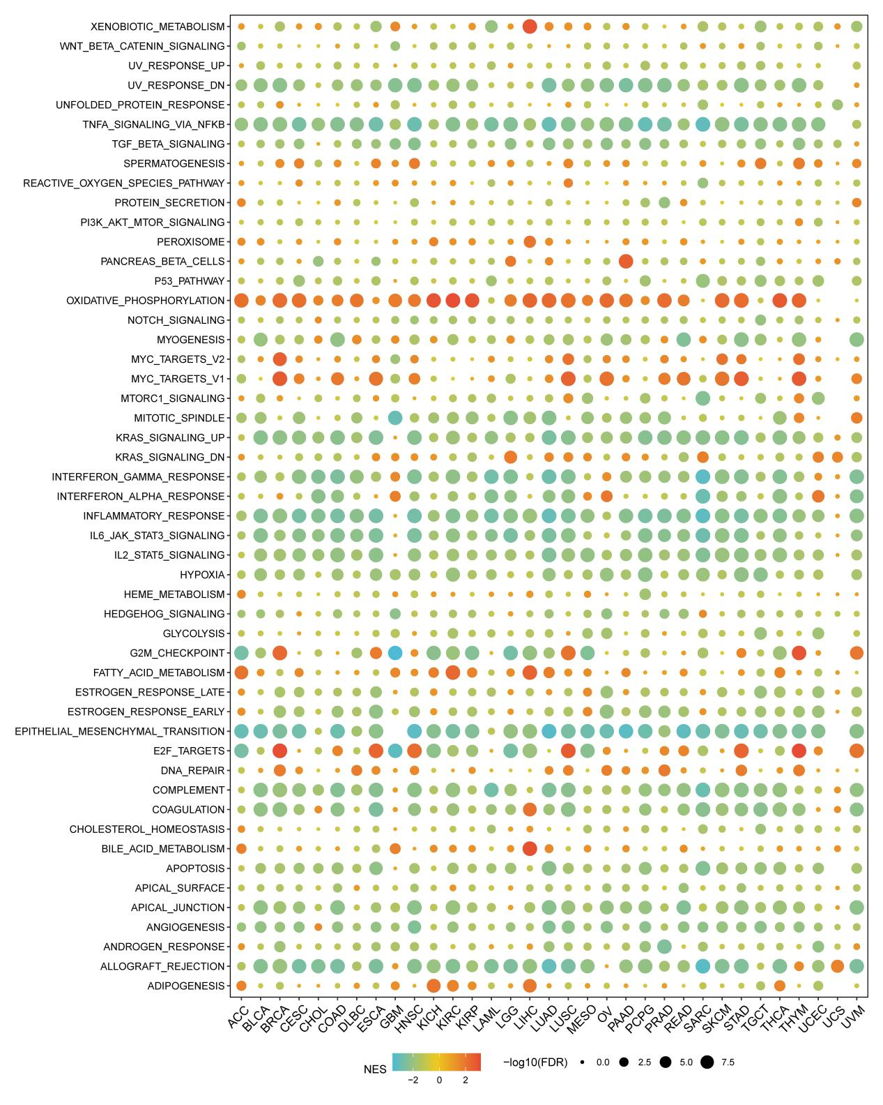
Fig S2. Relationships between SIRT5 and Signaling Pathways between high- and low-SIRT5 tumor tissues. NES is the normalized enrichment score in the GSEA algorithm.
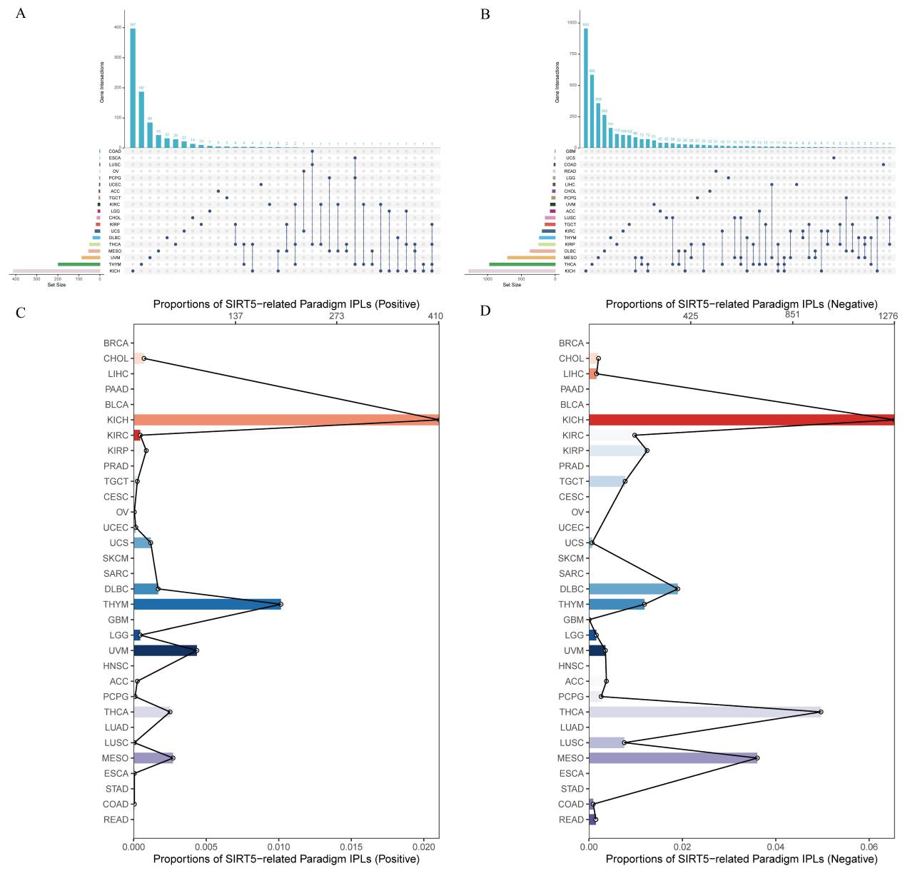
Fig S3. Correlation analysis of SIRT5 expression and IPL pathways activity. (A, B) The left bar chart shows the total number of elements contained in each original dataset; The part of the lower intersection point, through the horizontal correspondence, uses the point to refer to the corresponding dataset name on the left. By vertically implementing connections between points, it represents the intersection between corresponding datasets. That is, through the connection between points, it corresponds to the overlap of circles in traditional Wayne diagrams. Through the longitudinal correspondence, corresponding to the upper column chart, the number of intersection elements in this intersection case is represented. (C, D) The number of IPL pathways identified in each cancer type. The top y-axis shows the number of IPL pathways and the bottom y-axis shows the proportion of IPL pathways.

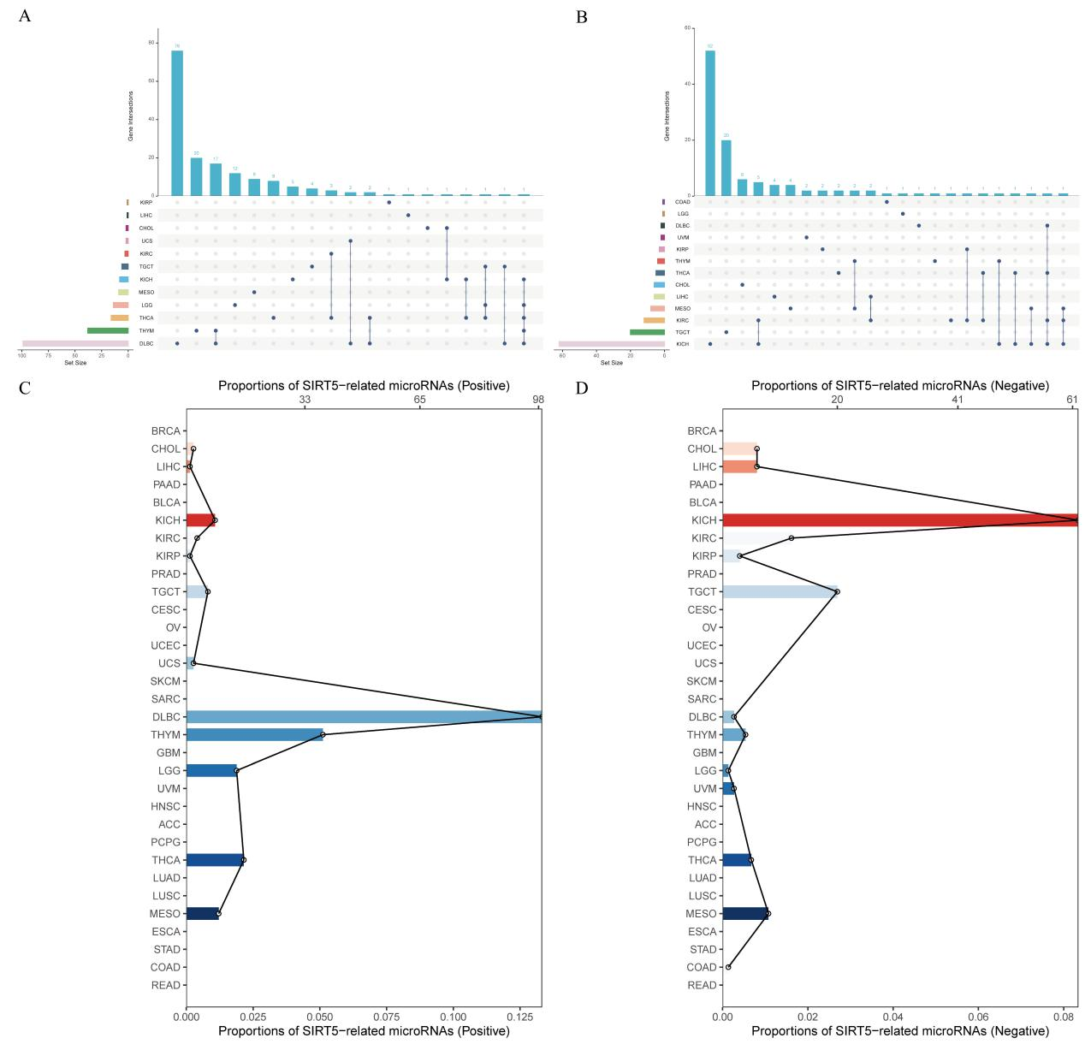
Fig S4. Correlation analysis of SIRT5 expression and microRNA expression. (A, B) The left bar chart shows the total number of elements contained in each original dataset; The part of the lower intersection point, through the horizontal correspondence, uses the point to refer to the corresponding dataset name on the left. By vertically implementing connections between points, it represents the intersection between corresponding datasets. That is, through the connection between points, it corresponds to the overlap of circles in traditional Wayne diagrams. Through the longitudinal correspondence, corresponding to the upper column chart, the number of intersection elements in this intersection case is represented. (C, D) The number of microRNAs identified in each cancer type. The top y-axis shows the number of microRNA and the bottom y-axis shows the proportion of microRNAs.

