Supplementary materials

Table S1 PRISM III Score Sheet
Organ function and parameters | Score
1. Systolic blood pressure (mmHg) | Score =3 |  | Score =7
Newborn | 40-55 |  | <40
Baby | 45-65 |  | <45
Child | 55-75 |  | <55
Juvenile | 65-85 |  | <65
2. Heart rate (beats / min) | Score =3 |  | Score =7
Newborn | 215-225 |  | >225
Baby | 215-225 |  | >225
Child | 185-205 |  | >205
Juvenile | 145-155 |  | >155
3. Body temperature | Score =3
All ages | <33 ℃ or >40 ℃
4. Pupil reflex | Score =7 |  | Score =11
All ages | One side fixed |  | Fixed on both sides
 |  |  | One side reacts
5. Mental state | Score =5
All ages | Coma (GCS<8)
6. Acid-base balance / blood gas
(1) PH or TCO₂ (mmol/L) | Score =2 |  | Score =6
All ages | PH 7.0-7.28 |  | PH <7.0
 | TCO₂ 5-16.9 |  | TCO₂ <5
 | Score =2 |  | Score =3
 | PH 7.48-7.55 |  | PH >7.55
 | Score =4
 | TCO₂ >34.0
(2) PaO₂ (mmHg) | Score =3 |  | Score =6
All ages | 42.0-49.9 |  | <42.0
(3) PaCO₂ (mmHg) | Score =1 |  | Score =3
All ages | 50.0-75.0 |  | >75.0
7. Biochemical indicators ^{1, 2, 9}
(1) Blood sugar | Score =2
All ages | >200 mg/dL or 11.0 mmol/L
(2) Serum potassium (mmol/L) | Score =3
All ages | >6.9
(3) Serum creatinine | Score =2
Newborn | >0.85 mg/dL or >75 μmol /L
Baby | >0.90 mg/dL or >80 μmol /L
Child | >0.90 mg/dL or >80 μmol /L
Juvenile | >1.30 mg/dL or >115 μmol /L
(4) Blood urea nitrogen | Score =3
Newborn | >11.9 mg/dL or >4.3 mmol/L
Other age | >14.9 mg/dL or >5.4 mmol/L
8. Hematology test
(1) White blood cell count (number of cells /mm³ ) | Score =4
All ages | <3000
(2) Platelet count (number of cells /mm³ ) | Score =2 | Score =4 |  | Score =5
All ages | 100000-200000 | 50000-99999 |  | <50000
(3) PT/APTT (sec) | Score =3
Newborn | PT > 22.0 or PTT > 85.0
Other age | PT > 22.0 or PTT > 57.0

Table S2 GCS Scoring System
Project | Score
Eye opening response
Automatic eye opening | 4
The language commanded to open the eyes | 3
Painful stimulus to open eyes | 2
Do not open your eyes to any stimuli | 1
verbal response
Smile, voice localization, interaction | 5
Crying, comforting, inaccurate interactions | 4
Moaning, unusual response to comfort | 3
Cannot comfort | 2
No verbal response | 1
Motor response
(≤ years) Spontaneous movement / (>1 years) Obedient movement | 6
Localization response to pain stimuli | 5
Retraction of limbs to painful stimuli | 4
Bend response to painful stimuli | 3
Straightening response to painful stimuli | 2
Nothing happens | 1

Table S3 PELOD-2 Scoring System
Severity score
Organ function and parameters
 | 0 | 1 | 2 | 3 | 4 | 5 | 6
1.Central nervous system
Glasgow Coma Score | ≥ 11 | 5-10 |  |  | 3-4
Pupillary response to light | Both |  |  |  |  | Fixed
2. Cardiovascular system
Lactic acidemia (mmol/L) | <5.0 | 5.0-10.9 |  |  | ≥ 11.0
Mean arterial pressure (mmHg)
0-< 1 month | ≥ 46 |  | 31-45 | 17-30 |  |  | ≤ 16
1-11 months | ≥ 55 |  | 39-54 | 25-38 |  |  | ≤ 24
12-23 months | ≥ 60 |  | 44-59 | 31-43 |  |  | ≤ 30
24-59 months | ≥ 62 |  | 46-61 | 32-45 |  |  | ≤ 31
60-143 months | ≥ 65 |  | 49-64 | 36-48 |  |  | ≤ 35
> 144 months | ≥ 67 |  | 52-66 | 38-51 |  |  | ≤ 37
3. Kidneys
Creatinine (μmol /L)
0-< 1 months | ≤ 69 |  | ≥ 70
1-11 months | ≤ 22 |  | ≥ 23
12-23 months | ≤ 34 |  | ≥ 35
24-59 months | ≤ 50 |  | ≥ 51
60-143 months | ≤ 58 |  | ≥ 59
> 144 months | ≤ 92 |  | ≥ 93
4. Breathe
Pa (O₂) / FiO₂ (mmHg) | ≥ 61 |  | ≤ 60
Pa (CO₂) | ≤ 58 | 59-94 |  | ≥ 95
Invasive mechanical ventilation | No |  |  | Yes
5. Blood
White blood cell count (×10 ⁹ /L) | >2 |  | ≤ 2
Platelet count (×10 ⁹ /L) | ≥ 142 | 77-141 | ≤ 76

Table S4 P-MODS Scoring System
Project | Score
Project | 0 | 1 | 2 | 3 | 4
Lactic acid (mmol/L) | <1 | 1-2 | 2-5 | 5.0-7.5 | >7.5
Pa (O2) / FiO2 | >150 | 150-100 | 100-75 | 75-50 | <50
Bilirubin
μmol/L | <8.5 | 8.5-34.2 | 34.2-85.5 | 85.5-171.0 | >171
mg/L | <5 | 5-20 | 20-50 | 50-100 | >100
Fibrinogen
μmol/L | >4.40 | 4.40-3.70 | 3.70-3.00 | 3.00-2.20 | <2.20
mg/L | >1500 | 1500-1250 | 1250-1000 | 1000-750 | <750
Urea nitrogen
μmol/L | <7.10 | 7.10-14.3 | 14.3-21.4 | 21.4-28.5 | >28.5
mg/L | <200 | 200-400 | 400-600 | 600-800 | >800

Table S5: Ranking of bacterial culture results (only the top 30 are listed)
Culture results | Quantity | ID | Gram stain results | Proportion
Enterobacteriaceae | 1100 | MIC1258 | G- | 0.297699
G+ cocci found | 890 | MIC578 | G+ | 0.240866
Klebsiella pneumoniae | 605 | MIC176 | G- | 0.163735
G-bacteria found | 524 | MIC574 | G- | 0.141813
Staphylococcus epidermidis | 496 | MIC308 | G+ | 0.134235
Escherichia coli | 392 | MIC108 | G- | 0.106089
G+ bacilli found | 284 | MIC584 | G+ | 0.076861
Staphylococcus aureus | 271 | MIC304 | G+ | 0.073342
Acinetobacter baumannii | 234 | MIC318 | G- | 0.063329
Enterococcus: dominant growth | 224 | MIC1132 | G+ | 0.060622
Pseudomonas aeruginosa | 216 | MIC250 | G- | 0.058457
Enterococcus faecium (group D) | 216 | MIC343 | G+ | 0.058457
Stenotrophomonas maltophilia (Xanthomonas) | 192 | MIC254 | G- | 0.051962
Streptococcus pneumoniae | 176 | MIC354 | G+ | 0.047632
Staphylococcus hominis | 167 | MIC310 | G+ | 0.045196
Acinetobacter baumannii complex | 128 | MIC318 | G- | 0.034641
Haemophilus influenzae | 119 | MIC153 | G- | 0.032206
Moraxella catarrhalis | 108 | MIC442 | G- | 0.029229
Streptococcus viridans | 105 | MIC746 | G+ | 0.028417
Staphylococcus capitis | 84 | MIC305 | G+ | 0.022733
Enterobacter cloacae | 83 | MIC94 | G- | 0.022463
Enterococcus faecalis (group D) | 77 | MIC344 | G+ | 0.020839
Staphylococcus hemolyticus | 63 | MIC309 | G+ | 0.01705
Enterobacter aerogenes | 59 | MIC85 | G- | 0.015968
Streptococcus viridans | 48 | MIC387 | G+ | 0.012991
Resembling Neisseria | 46 | MIC1138 | G- | 0.012449
Enterobacter cloacae complex | 46 | MIC2957 | G- | 0.012449
Burkholderia cepacia (Pseudomonas cepacia) | 38 | MIC251 | G- | 0.010284
Serratia marcescens | 27 | MIC291 | G- | 0.007307
Staphylococcus wornerii | 22 | MIC322 | G+ | 0.005954
Total/case | 7 040
Total/case after deduplication | 3 695
Gram stain classification (negative/positive) | 1385/1127

Table S6: Models’ functions:
 | Minimum feature number model | Best feature number model
Bacterial culture positive set: | Probability = sigmoid(0.0360*Lipase_6473_max + 0.1839*tCO2(P)_5256_max + 0.0906*Anion Gap_5213_min + 0.1507*Reference: APTT_5175_range + 0.0428*Protein, Total_5078_range + 0.2276*human IL-2_5602_min + (-0.7807*pH_5237_min) + 0.5199*Troponin T_6525_min + (-0.0089*Hemoglobin_5257_min) + 0.0430) | Probability = sigmoid(0.0145*Lipase_6473_max + 0.0033*tCO2(P)_5256_max + 0.0156*Anion Gap_5213_min + 0.0010*Reference: APTT_5175_range + 0.0046*Protein, Total_5078_range + 0.0060*human IL-2_5602_min + -0.0000*pH_5237_min + 0.0015*Troponin T_6525_min + -0.0069*Hemoglobin_5257_min + -0.0147*pO2(A-a,T)_5210_max + 0.0061*pCO2_5236_min + 0.0135*Lactate_5227_min + 0.0244*Lactate_5227_max + 0.0090*D-Dimer_5163_max + 0.0002*human IFN-r_5600_min + -0.0008*Monocyte Count_6316_range + 0.0100*Glucose_5223_min + -0.0024*thrombin time_5192_max + -0.0007*p50(T)_5233_max + 0.0233*pCO2_5235_max + -0.0027*Reference: APTT_5175_min + 0.0064*C-Reactive Protein_5626_min + 0.0151*Heart Rate_1003_min + -0.0109*Chloride, Whole Blood_5218_min + 0.0139*Bicarbonate_5248_range + 0.0073*Platelet distribution width_5128_min + -0.0002*Basophils Count_5493_max + -0.0010*Hemoglobin_5257_max + -0.0001*Cholinesterase_6236_max + 0.0015*Carboxyhemoglobin_5219_min + -0.0021*Platelet Count_5129_min + 0.0002*pH_5237_max + -0.0256*C-Reactive Protein_5626_range + -0.0006*Calcium, Total_5215_min + 0.0011*human IL-4_5603_min + -0.0011*Alkaline Phosphatase_5025_max + -0.0097*Eosinophils_5002_max + -0.0202*Heart Rate_1003_range + 0.0082*Creatine Kinase, MB Isoenzyme_5039_range + 0.0141*Lipase_6473_min + 0.0001)
Gram-positive set : | Probability = sigmoid(0.1938*Anion Gap_5213_min + 0.0188*pO2(A-a,T)_5210_range + 0.0949*D-Dimer_5163_min + (-1.9328*pH_5237_min) + 0.0440*Lactate_5227_max + 0.0249*Oxygen Saturation_5252_range + 11.2042) | Probability = sigmoid(0.1818*Anion Gap_5213_min + 0.0081*pO2(A-a,T)_5210_range + 0.0888*D-Dimer_5163_min + (-0.5159*pH_5237_min) + 0.0671*Lactate_5227_max + 0.0281*Oxygen Saturation_5252_range + 0.0002*human IL-10_5601_min + (-0.0017*Hemoglobin_5257_min) + 0.7205*Carboxyhemoglobin_5219_max +( -0.0559))
Gram-negative set : | Probability = sigmoid(0.0648*Lipase_6473_min + 0.0007*Lactate Dehydrogenase (LD)_5057_range + 0.1639*Lactate_5227_max + 0.0137*FShunt(T)_5250_range + (-0.0092*Hemoglobin_5257_min) + (-0.0043*Platelet Count_5129_max) + 1.1261) | Probability = sigmoid(0.0748*Lipase_6473_min + 0.0004*Lactate Dehydrogenase (LD)_5057_range + 0.1255*Lactate_5227_max + 0.0127*FShunt(T)_5250_range + (-0.0063*Hemoglobin_5257_min) + (-0.0031*Platelet Count_5129_max) + 0.0011*Urine Output_1008_max + 0.0223*PT_5186_max + 0.0313*pCO2_5236_range + (-0.0085*C1q_6857_max) + 0.1318*pH_5237_min + (-0.0393*Monocytes_6317_min) + 0.0092*C-Reactive Protein_5626_min + 0.0181)

Table S7: Delong test between all models in three set
Bacterial culture positive set
 | MIN Model | BEST model | ALL Model | PRISM III | PELOD-2 | P-MODS
Min Model |  | 0.89425 | 0.62608 | 0.01351 | 0.12778 | 0.00926
BEST Model |  |  | 0.64287 | 0.01711 | 0.11264 | 0.00942
ALL Model |  |  |  | 0.00472 | 0.05507 | 0.00327
PRISM III |  |  |  |  | 0.39626 | 0.53713
PELOD-2 |  |  |  |  |  | 0.17510
P-MODS
Gram-positive set
 | MIN Model | BEST model | ALL Model | PRISM III | PELOD-2 | P-MODS
Min Model |  | 0.67179 | 0.62699 | 0.57236 | 0.45280 | 0.24018
BEST Model |  |  | 0.37208 | 0.30042 | 0.21165 | 0.16112
ALL Model |  |  |  | 0.97866 | 0.85238 | 0.91658
PRISM III |  |  |  |  | 0.84393 | 0.92328
PELOD-2 |  |  |  |  |  | 0.89743
P-MODS
Gram-negative set
 | MIN Model | BEST model | ALL Model | PRISM III | PELOD-2 | P-MODS
Min Model |  | 0.99522 | 0.28788 | 0.01294 | 0.04462 | 0.01117
BEST Model |  |  | 0.29630 | 0.00403 | 0.03876 | 0.00429
ALL Model |  |  |  | 0.54979 | 0.34758 | 0.17921
PRISM III |  |  |  |  | 0.67631 | 0.29368
PELOD-2 |  |  |  |  |  | 0.63040
P-MODS

Table S8: common parameters of selected features in three set
 | Bacterial culture positive set & Gram-positive set | Bacterial culture positive set &  Gram-negative set | Gram-positive set &  Gram-negative set | Bacterial culture positive set & Gram-positive set & Gram-negative set
Common features | Lactate_5227_max  pH_5237_min  Hemoglobin_5257_min  Anion Gap_5213_min | Lactate_5227_max  pH_5237_min  Hemoglobin_5257_min  Lipase_6473_min  C-Reactive Protein_5626_min  Lactate_5227_min  LIC%_6842_range | Lactate_5227_max  pH_5237_min  Hemoglobin_5257_min | Lactate_5227_max  pH_5237_min  Hemoglobin_5257_min

Figure Legend
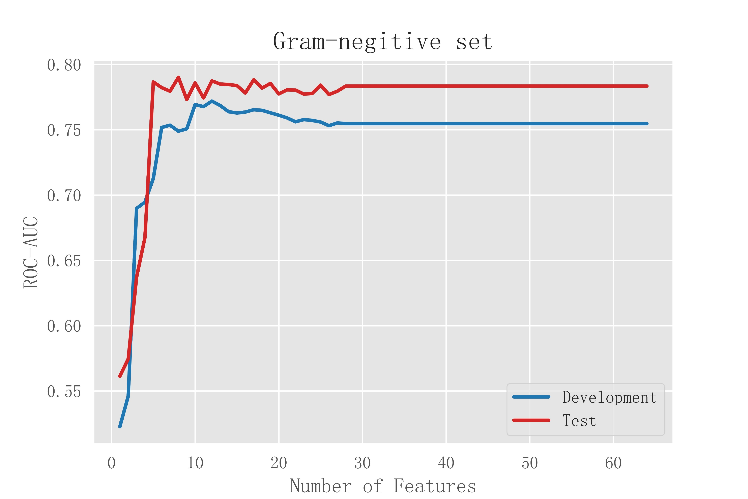
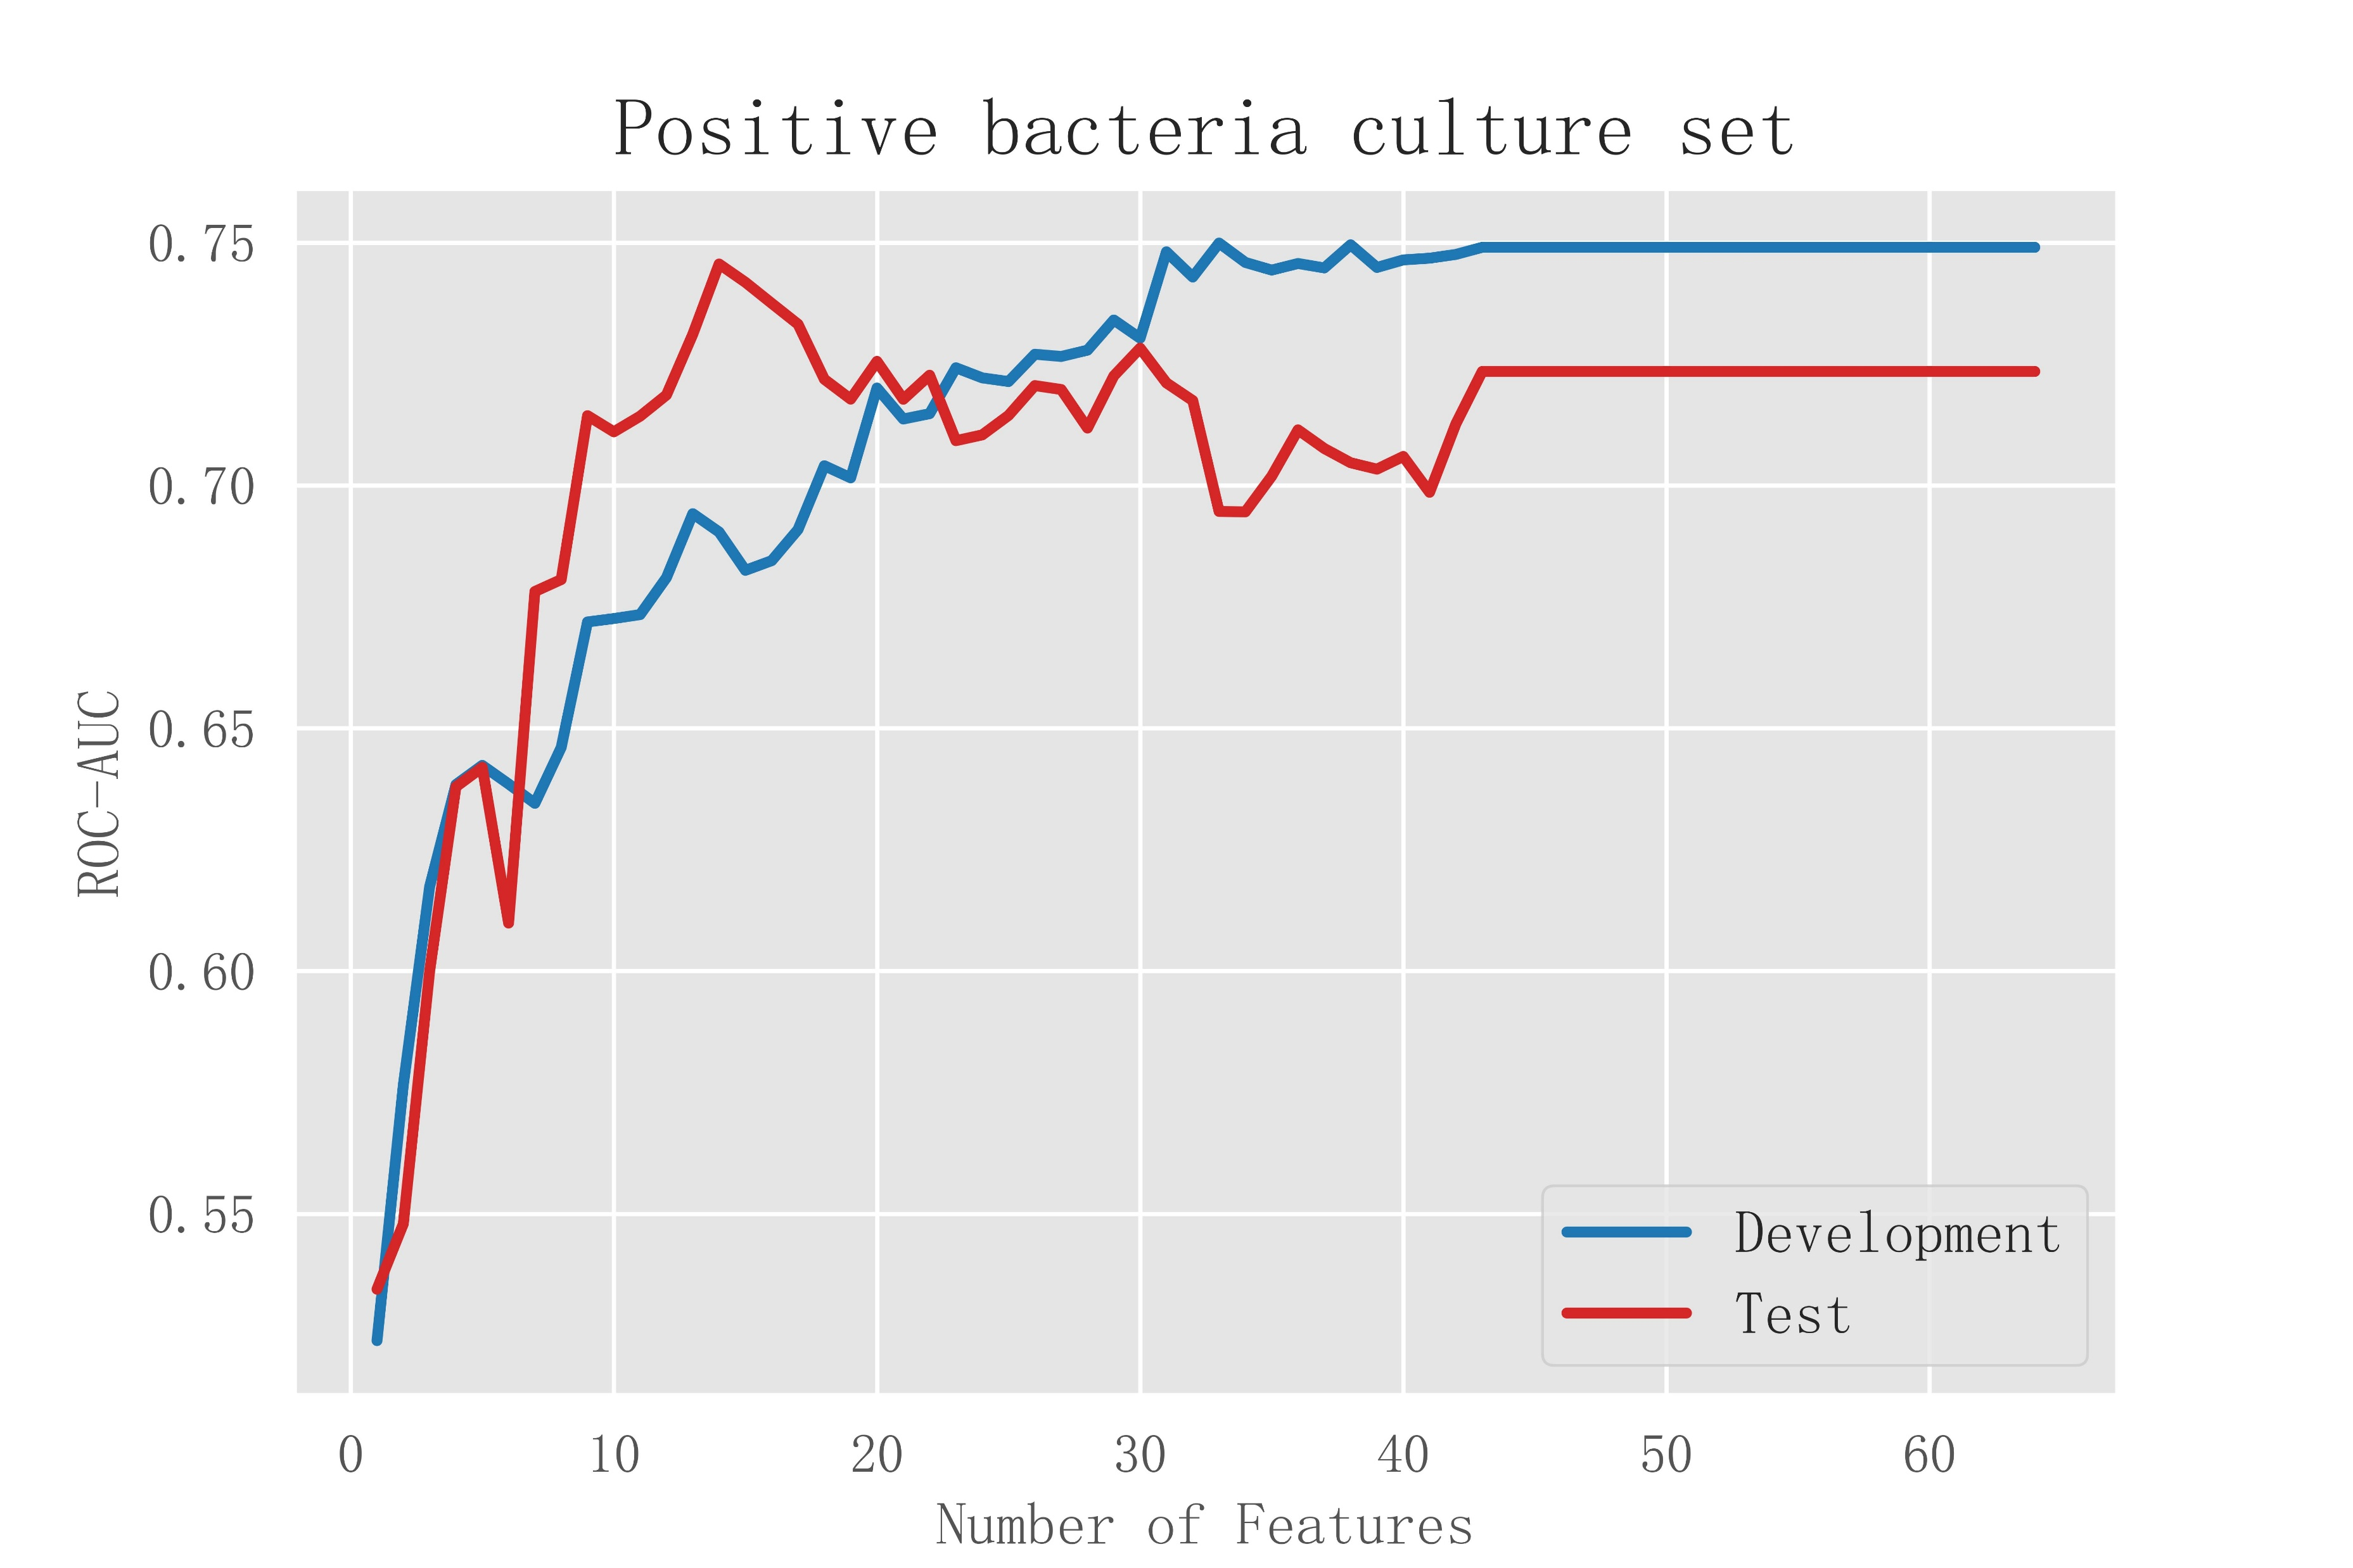
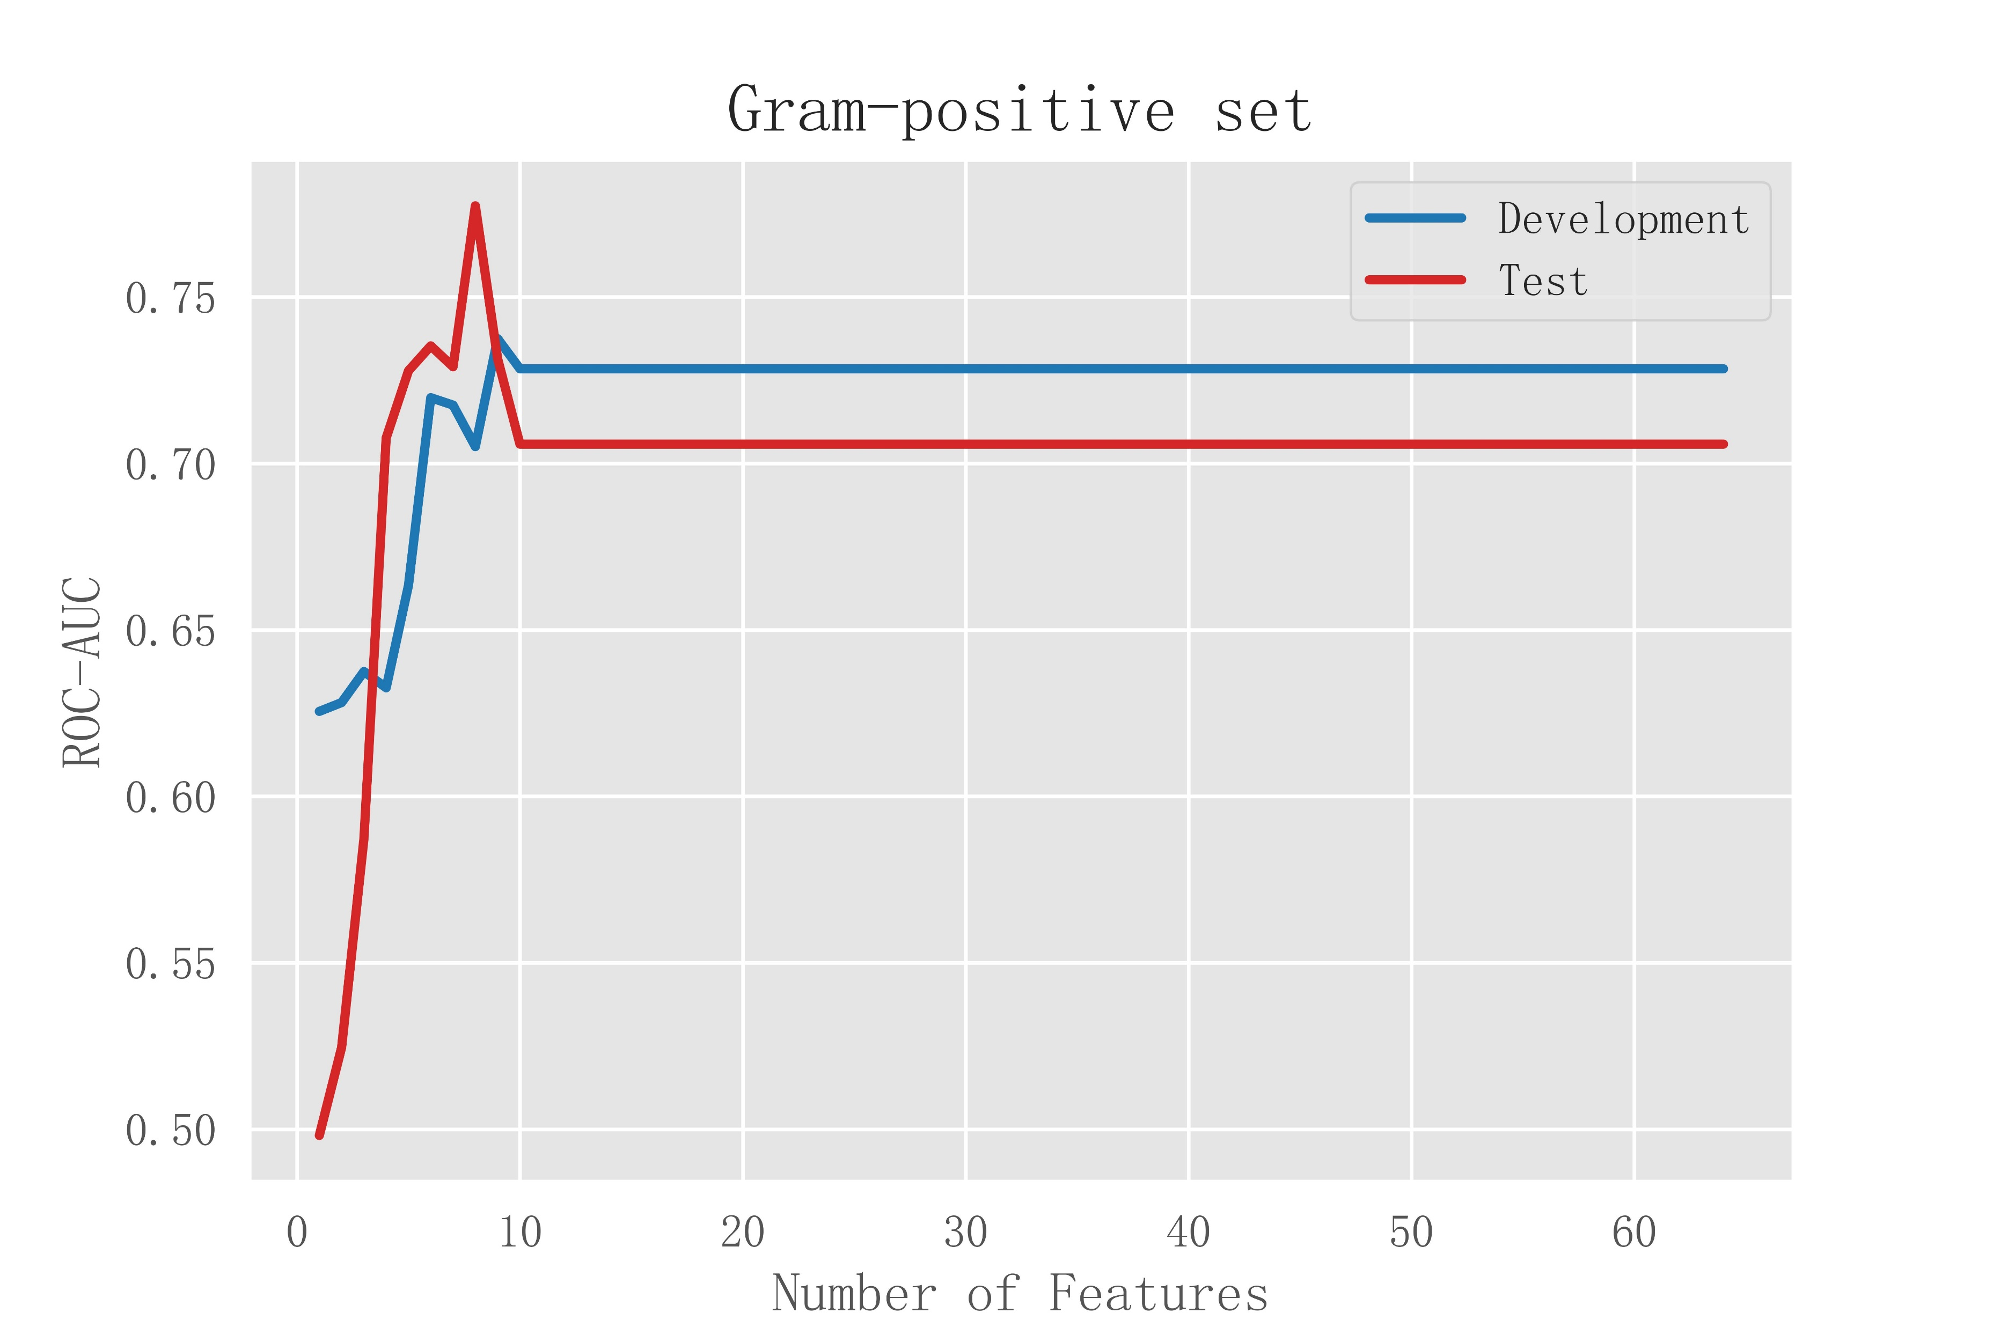
Figure S1 Ranking of importance scores for feature factors. S1a:
A
B
C

Figure S2 correlogram heatmaps of the three Min Models. S2a: the correlogram heatmaps of the min model of the bacterial culture positive set. S2b: the correlogram heatmaps of the min model of the gram-positive set. S2c: the correlogram heatmaps of the min model of the gram-negative set.
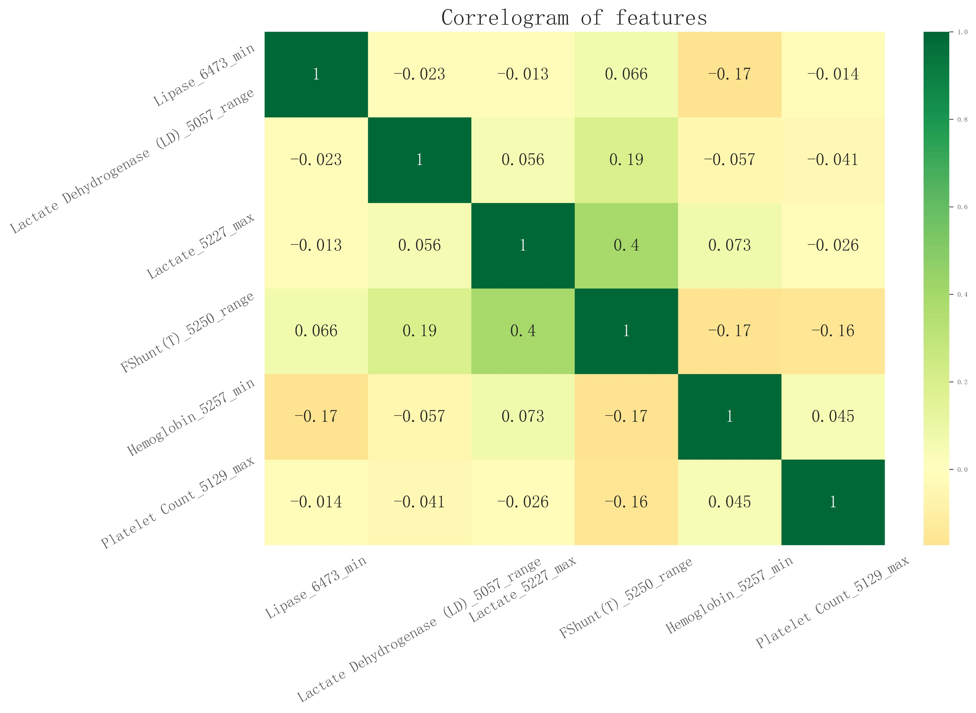
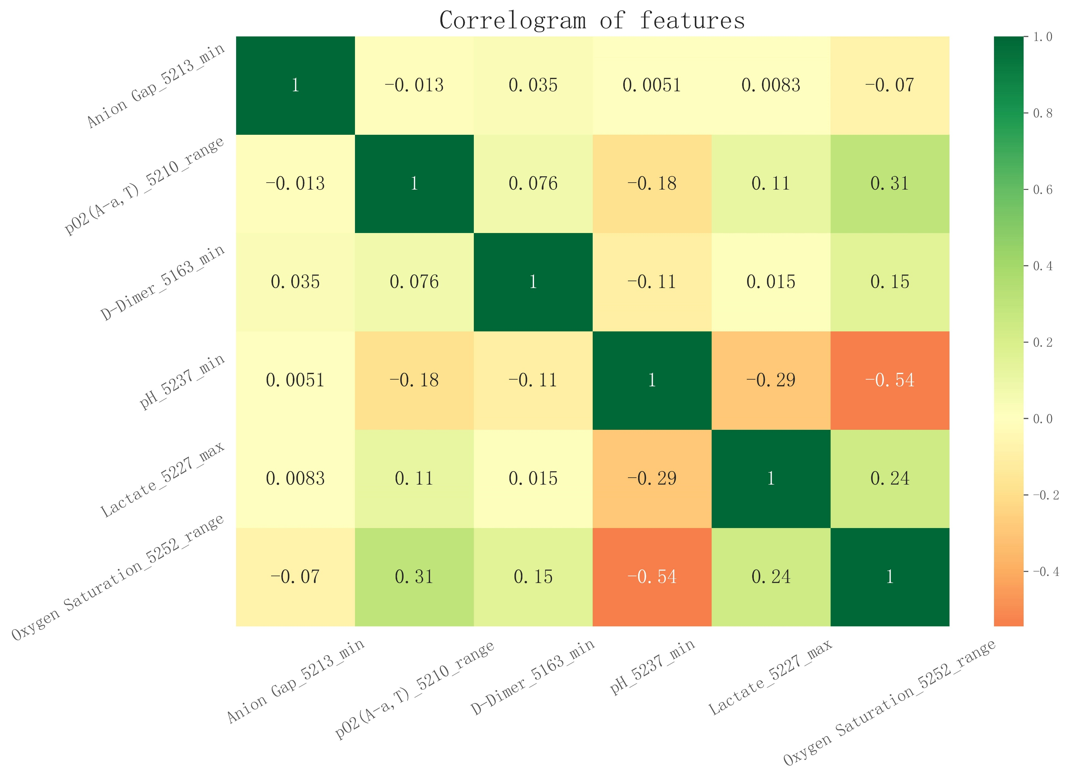
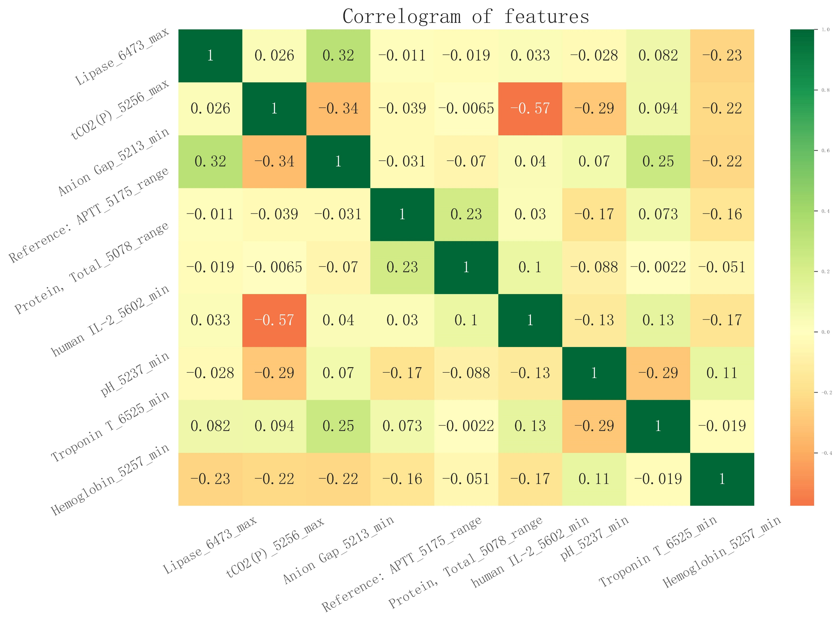
Figure S2 correlogram heatmaps of the three Min Models
S2a
S2b
S2c

