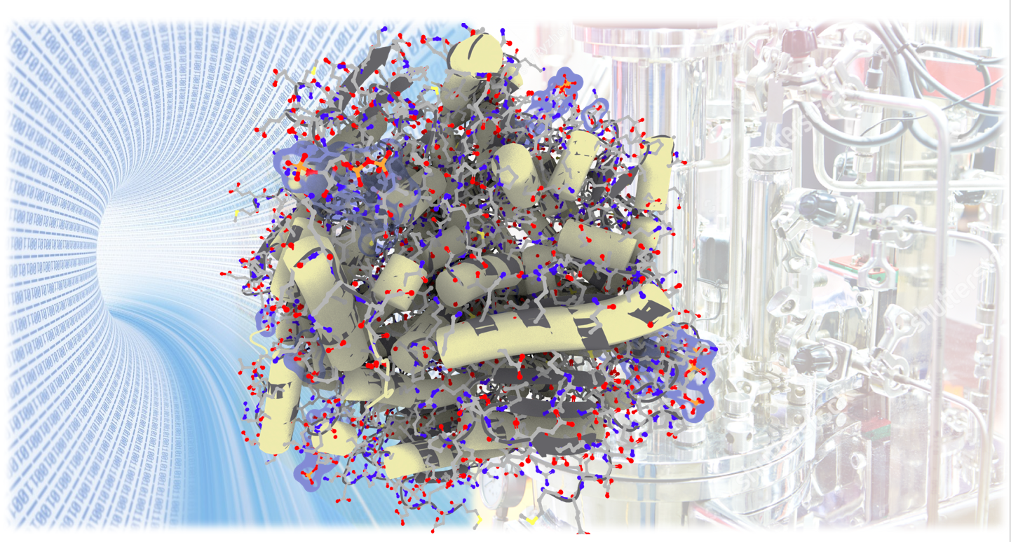

Background: To obtain high yields of recombinant insulin and advancing therapeutic avenues for diabetes patients, the development of innovative designer insulin analogs have critical importance. The modified insulin analog presents a cost-effective remedy by being produced as inclusion bodies (IBs) within Escherichia coli BL21 (DE3) Rosetta-2 strain. This approach to production not only offers reduced production time but also yields high recovery rates. The prime aim of this investigation was to optimize the composition of the cultivation media, thereby accomplishing higher cell density fermentation of the proinsulin.
Result: Various factors, including carbon and nitrogen sources, salts, metal ions, and pH, were systematically investigated through experimental screening using the BioLector multiwell bright plate. Additionally, computational analysis employing the Plackett-Burman Design within the Design Expert software was utilized to assess their effectiveness in terms of insulin concentration as a surrogate measure of insulin yield. Among the tested variables, glucose, glycerol, MgSO₄, and lower Luria-Bertani mix concentration have a significant influence on insulin production, as determined by the screening experiment. Subsequently, the Central Composite Design approach was operated to further evaluate and optimize the precise levels of these influential variables. This systematic methodology achieved an optimized cultivation media formulation, resulting in a remarkable enhancement of insulin production, with levels reaching up to 13 mg/ml when applied in BioLector fermentation.
Conclusion: The formulated cultivation media exhibited suitability for promoting high cell density fermentation of the modified insulin, thereby facilitating the attainment of optimal yields for the proinsulin expression.

