Supplementary Table 1. Created trial configurations using PBD to assess factors and obtained resultant data
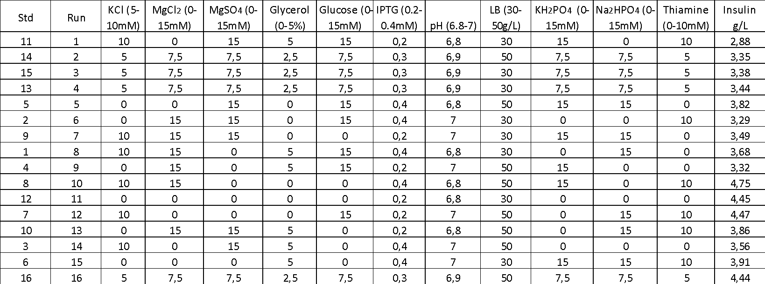

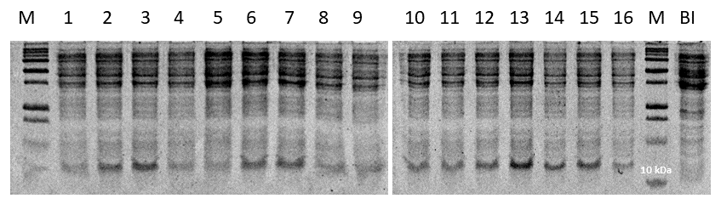
Supplementary Figure 1. SDS-PAGE result of 16 Parameters.

